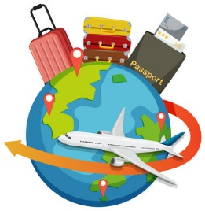Travel and Tourism Revision Checklist

Component 3 - Influences on Global Travel and Tourism

***Factors influencing global travel and tourism Economic factors – an understanding of how:***

* Recession/boom can affect the amount of money people are willing to spend on holidays and travel
* Political factors – an understanding of: the different types of legislation: health and safety laws; employment laws; planning laws developing services and facilities. (ABTA/ATOL)
* Natural factors – an understanding of how severe weather events can create natural disasters.
* Media factors – an understanding of: different types of media: print – newspaper reports/articles
* Safety and security factors – an understanding of: risks relating to personal safety and security in an unfamiliar environment.
* Health risk factors – an understanding of the causes and symptoms of infectious diseases and illnesses: endemic – a disease that is present permanently in a region or population.

***Travel and tourism organisations – an understanding of possible responses.***

* Government: local, regional, national – an understanding of possible responses.
* Voluntary organisations – an understanding of possible responses.
* Sociocultural impacts of tourism are the changes to the everyday lives of people living in global destinations (host communities) and to their values, customs, traditions, arts and way of life. The changes result from direct and indirect contact with tourists and interactions with travel and tourism.
* Economic impacts of tourism include the effect of the actual amount spent by tourists and indirect effects on the local and wider economies and other sectors.
* Environmental impacts of tourism are the result of the strain tourism can place on local land use and resources as well as the natural and built environments of global destinations.

***What is sustainable tourism? By its very nature, tourism values the things that are most precious in our world.***

* The aim of sustainable tourism is to increase the benefits and to reduce the negative impacts caused by tourism for destinations.
* Transport and essential infrastructure can be established/improved to benefit local people/communities
* Local communities can be consulted/involved in the decision-making stage of tourism development
* Local communities have a share or ownership of a resort/lodge and provide staffing
* Taxes are imposed on incoming visitors and the money raised used for community projects.
* Stages of tourism development as suggested by Butler’s Tourist Area Life Cycle (TALC) model.
* Emerging destinations – destinations that have recently (within the last ten years.
* Characteristics of emerging destinations may include: o visitors seek adventure, ‘authentic’ experience