

St. Michael’s Nursery and Infant School
Key Stage 1 Calculation Policy
2026 – 2027
Overview
Our calculation policy is based on the White Rose Maths Hub policy as this aligns with the scheme of learning that we use across school. This document is broken down into addition, subtraction, multiplication and division.

There is an overview of different models that can support the teaching of the different concepts and shows the links between different operations.

Each operation is broken down into skills, showing the models and images that can be used to effectively teach that concept. The skills are linked to year groups to support consistency throughout our school.

A glossary of terms is included to support the understanding of key language used.





Addition and Subtraction
Glossary
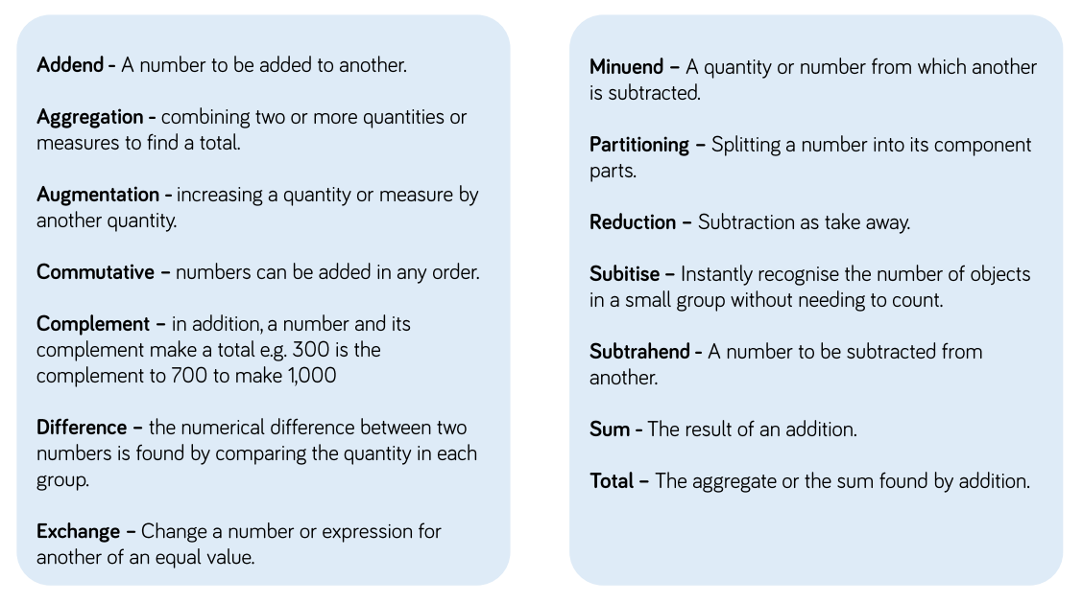

Addition and Subtraction Models

Cubes
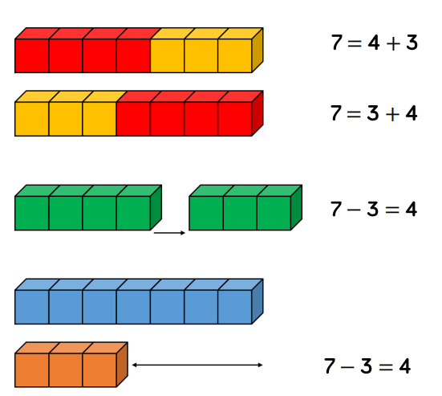 | 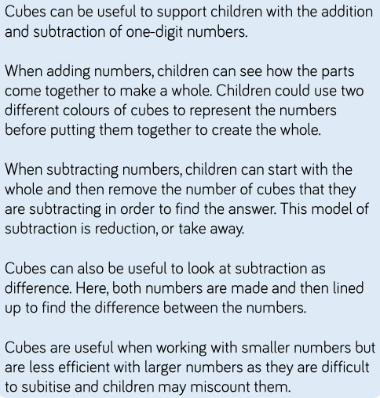

Number Shapes
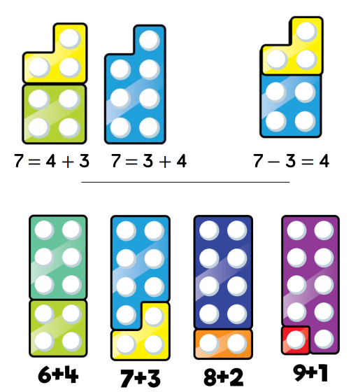 | 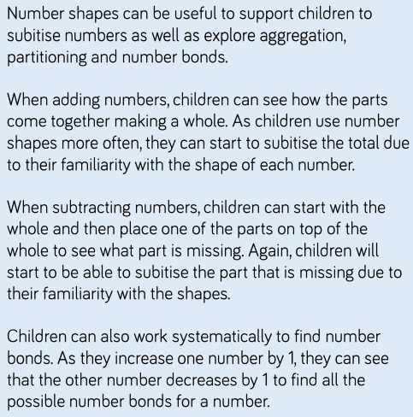

Tens Frame (within 10)
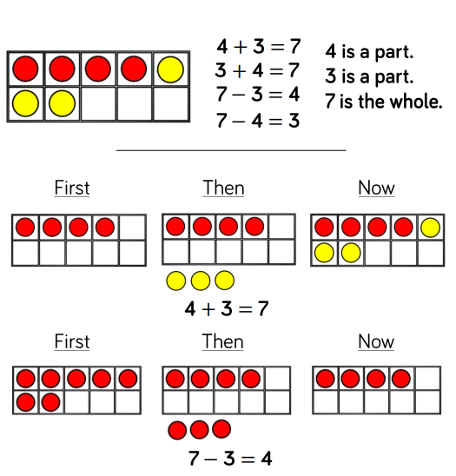 | 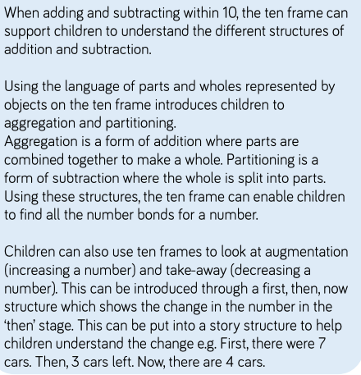

Tens Frame (within 20)
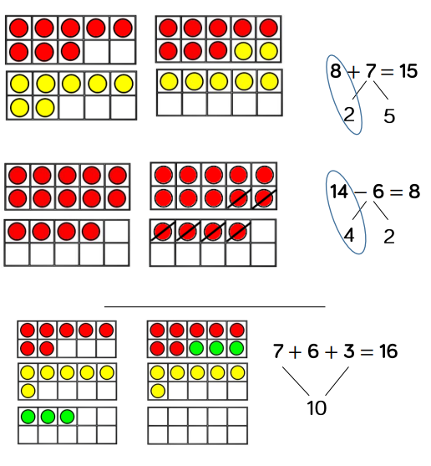 | 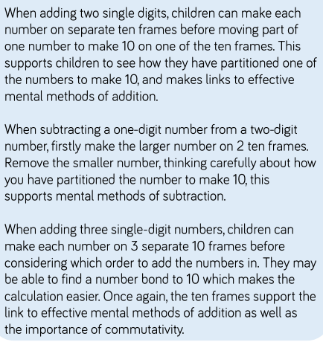

Bead String
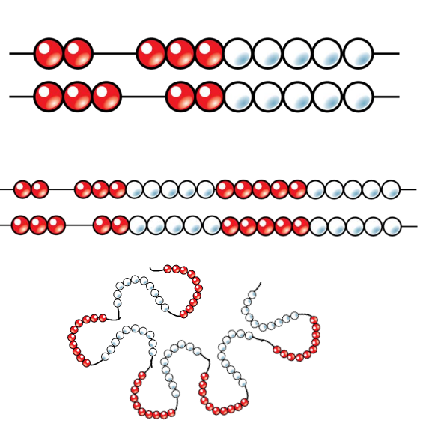 | 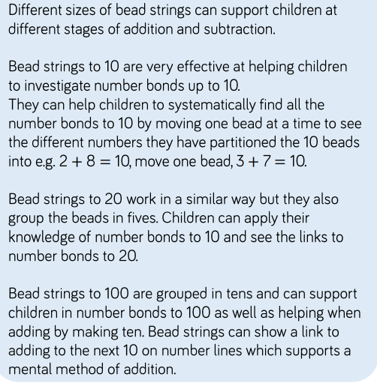

Part-Whole Model
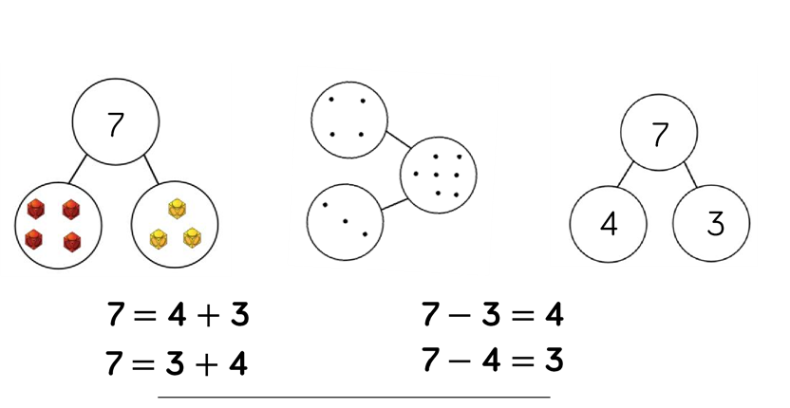  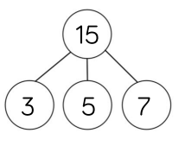 | 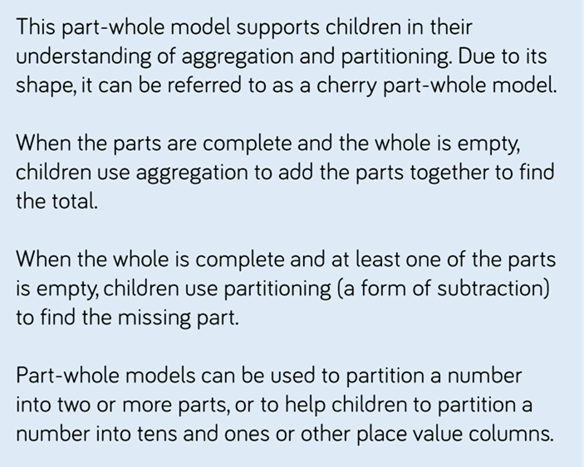    

Bar Model (single)
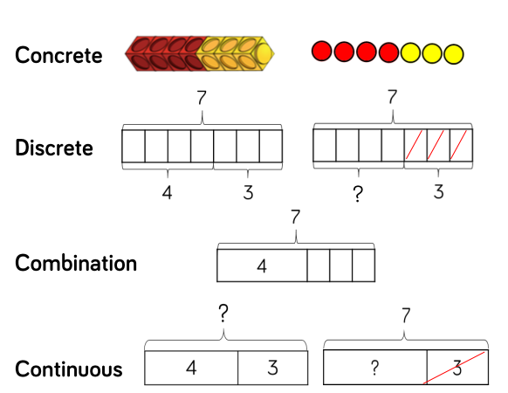 | 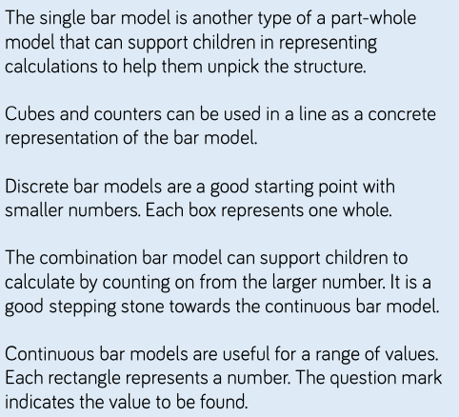
Bar Model (multiple)
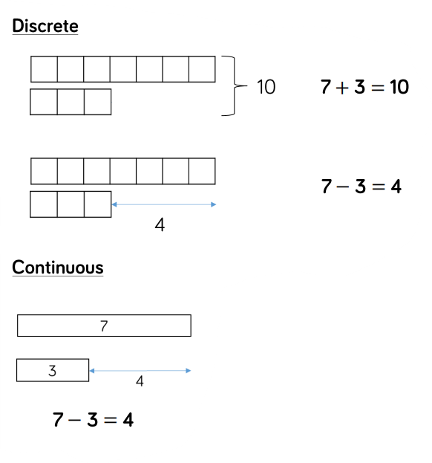 | 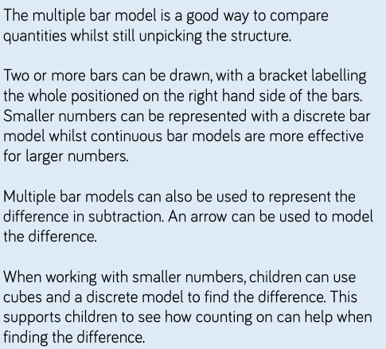

Number Tracks
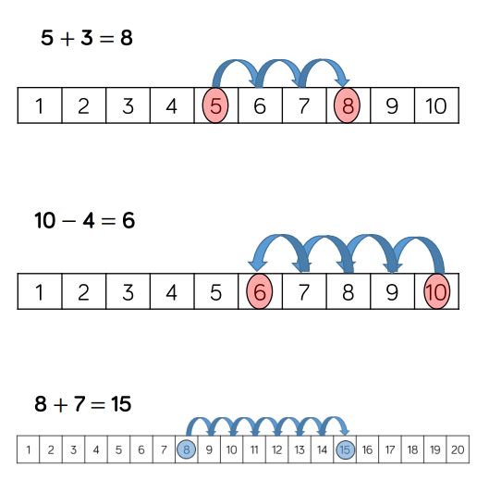 | 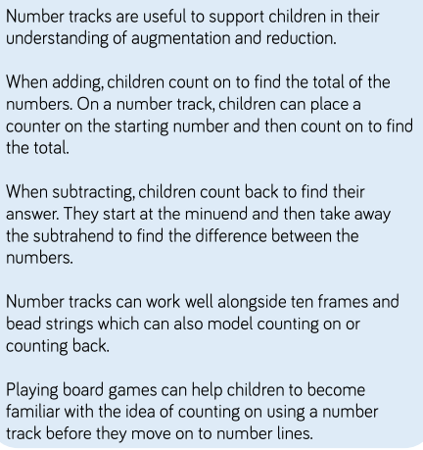

Number Lines (labelled)
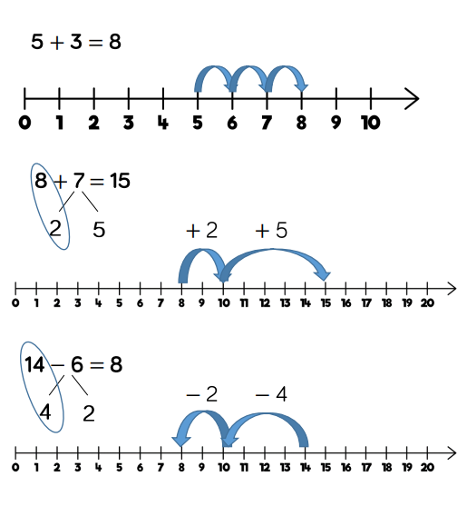 | 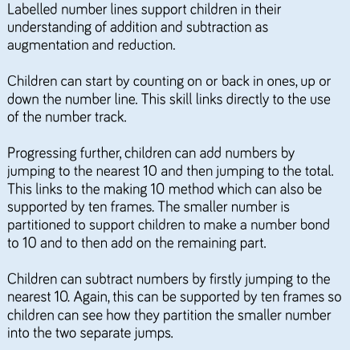

Number Lines (blank)
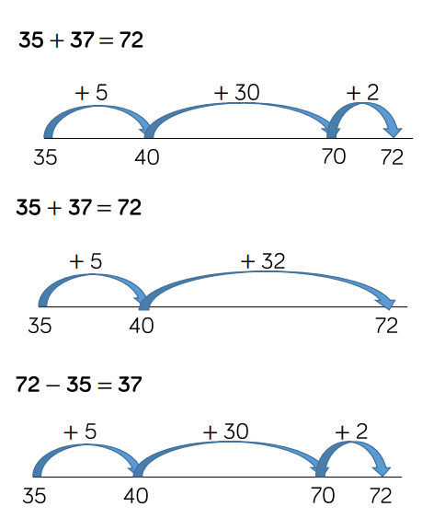 | 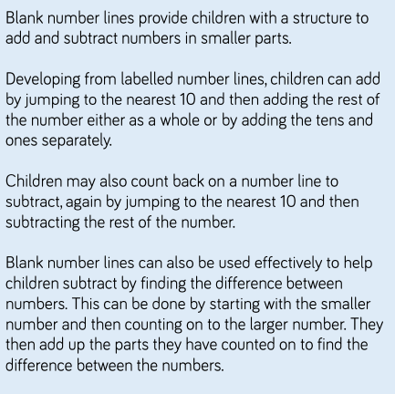

Straws
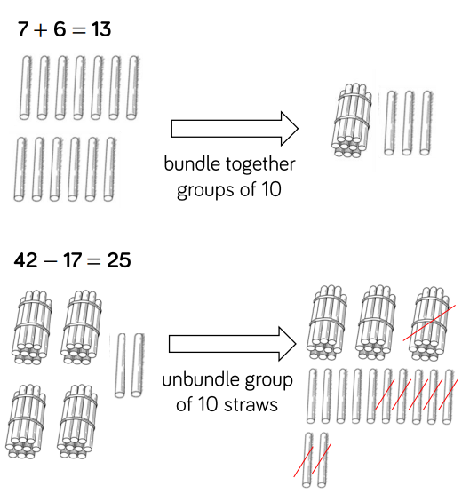 | 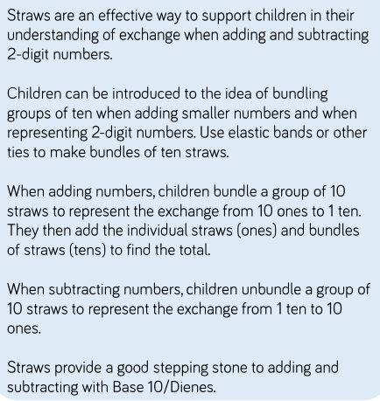

Base 10 (addition)
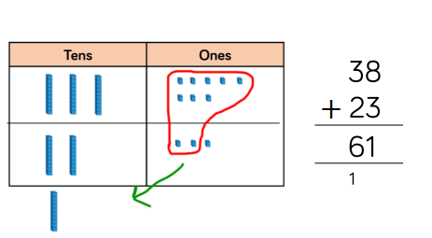 | 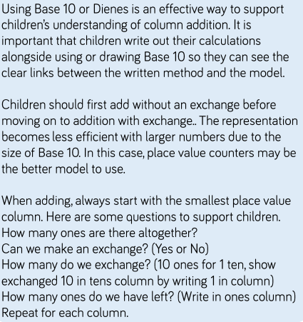
Base 10 (subtraction)
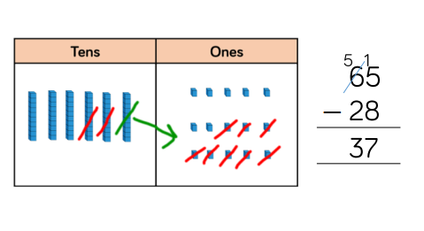 | 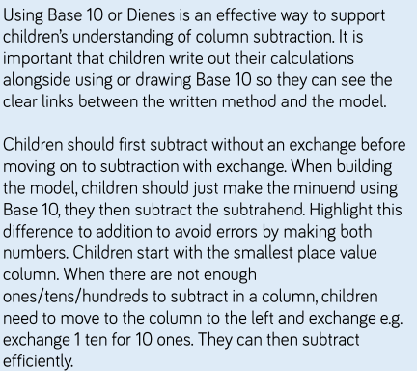

Place Value Counters (addition)
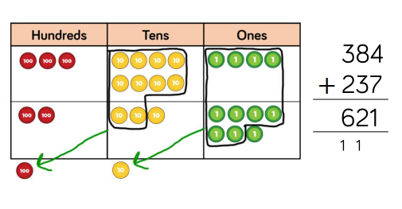 | 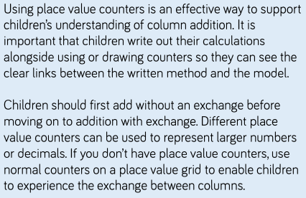
Place Value Counters (subtraction)
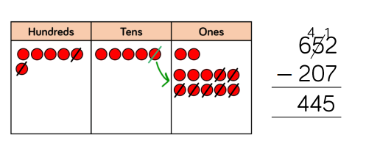 | 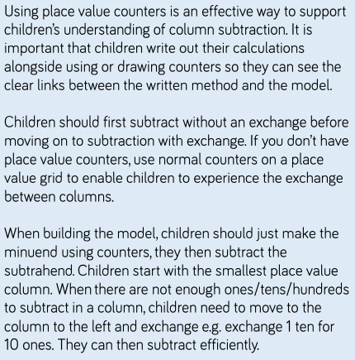

ADDITION

Overview of Skills
Skill | Year | Reprentation and Models
Add two 1-digit numbers to 10 | 1 | Part-Whole Model  Bar Model  Number Shapes | Ten Frames (within 10)  Bead String (10)  Number Tracks)
Add 1 and 2 digit numbers to 20 | 1 | Part-Whole Model  Bar Model  Number Shapes  Ten Frames (within 20) | Bead strings (20)  Number Tracks  Number Lines (labelled)  Straws
Add three 1-digit numbers | 2 | Part-Whole Model  Bar Model | Ten Frames (within 20)  Number Shapes
Add 1 and 2-digit numbers to 100 | 2 | Part-Whole Model  Bar Model  Number Lines (labelled) | Number Lines (blank)  Straws  Hundred Square
Add two 2-digit numbers | 2 | Part-Whole Model  Bar Model  Number Lines (blank)  Straws | Base 10  Place Value Counters  Column Addition

Skill: Adding two 1-digit numbers to 10 - Year 1
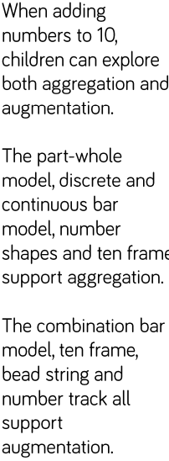
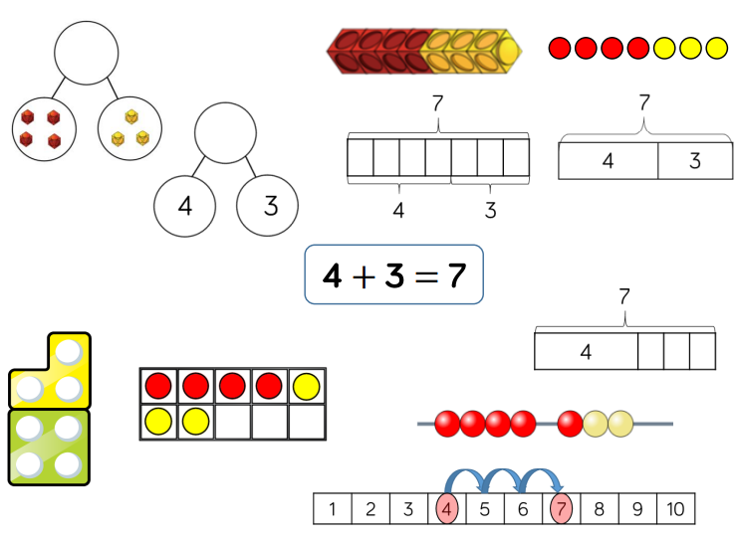

Skill: Add 1 and 2 digit numbers to 20 – Year 1/2
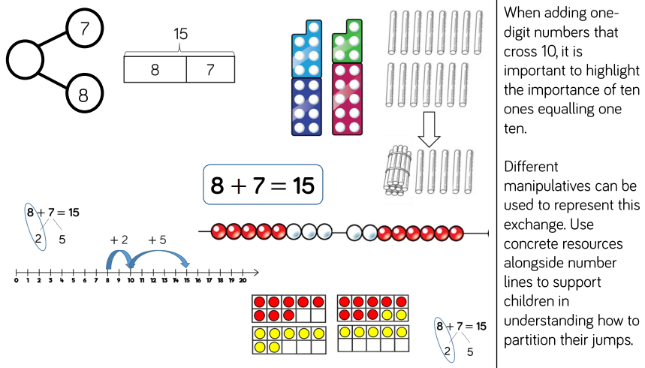

Skill: Add three 1-digit numbers – Year 2
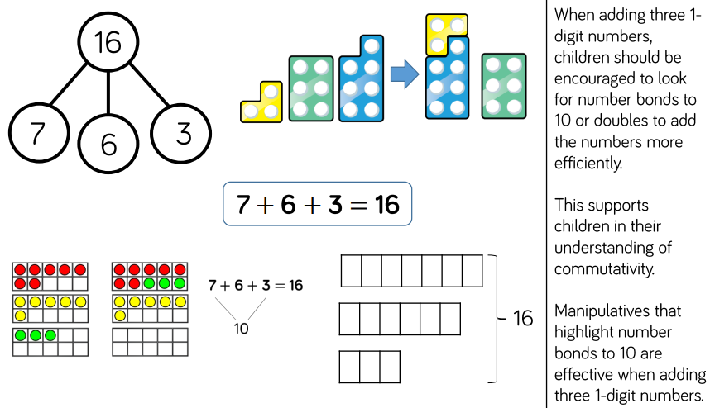

Skill: Add 1 and 2-digit numbers to 100 – Year 2
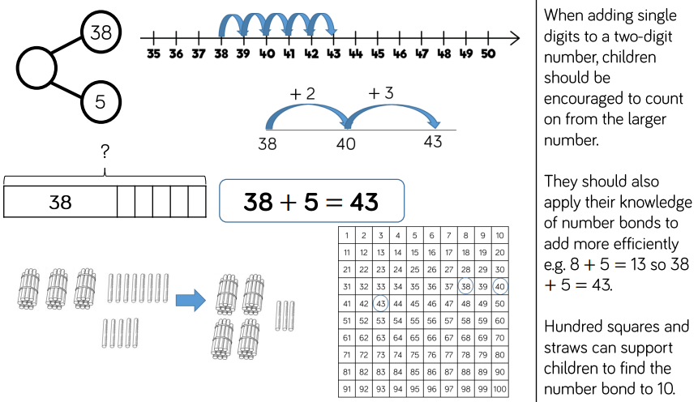

Skill: Add two 2-digit numbers – Year 2
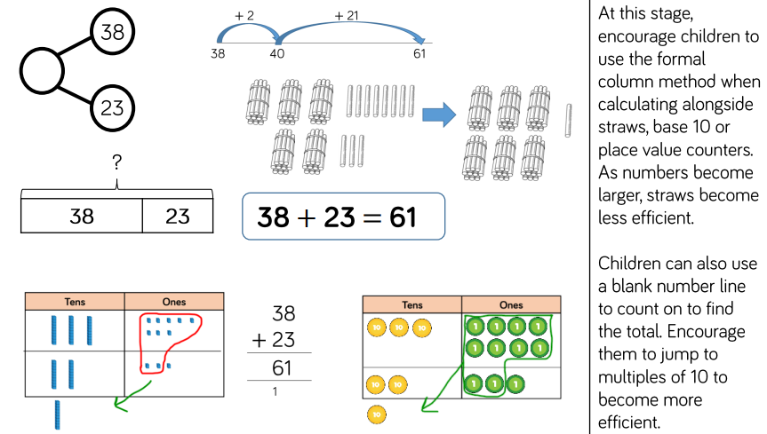

Subtraction

Overview of Skills
Skill | Year | Reprentation and Models
Subtract two 1-digit numbers to 10 | 1 | Part-Whole Model  Bar Model  Number Shapes | Ten Frames (within 10)  Bead String (10)  Number Tracks
Subtract 1 and 2-digit numbers to 20 | 1 | Part-Whole Model  Bar Model  Number Shapes  Ten Frames (within 20) | Bead String (20)  Number Tracks  Number Lines (labelled)  Straws
Subtract 1 and 2-digit Numbers to 100. | 2 | Part-Whole Model  Bar Model  Number Lines (labelled) | Number Lines (blank)  Straws  Hundred Square
Subtract two 2-digit numbers | 2 | Part-Whole Model  Bar Model  Number Lines (blank)  Straws | Base 10  Place Value Counters  Column Addition

Subtract two 1-digit numbers to 10 – Year 1
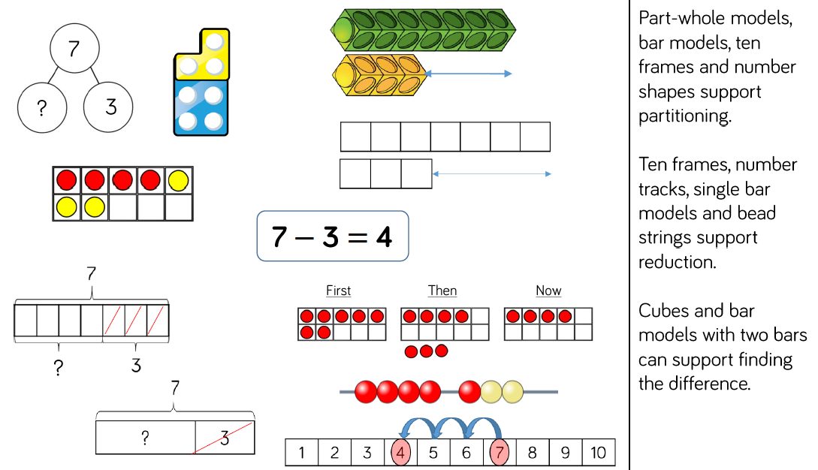

Subtract 1 and 2-digit numbers to 20 – Year 1/2
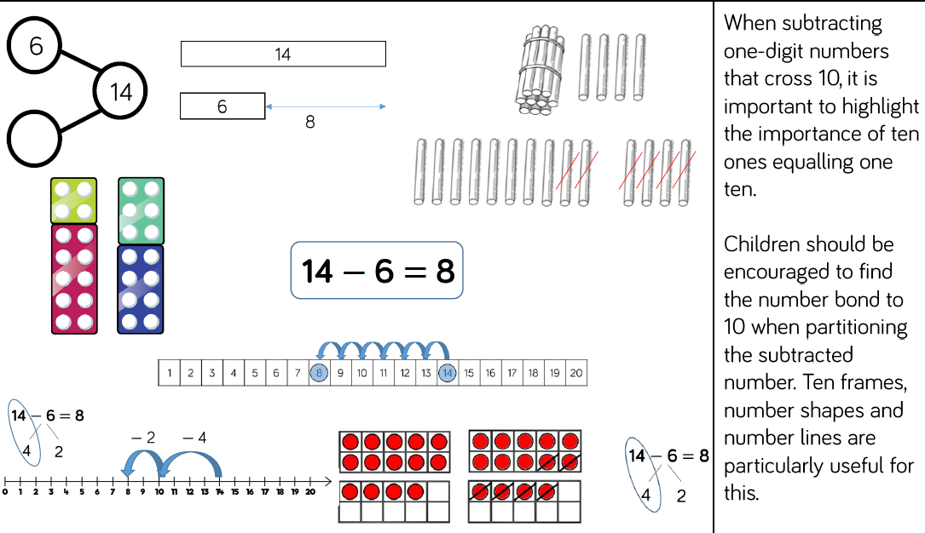

Subtract 1 and 2-digit Numbers to 100 – Year 2
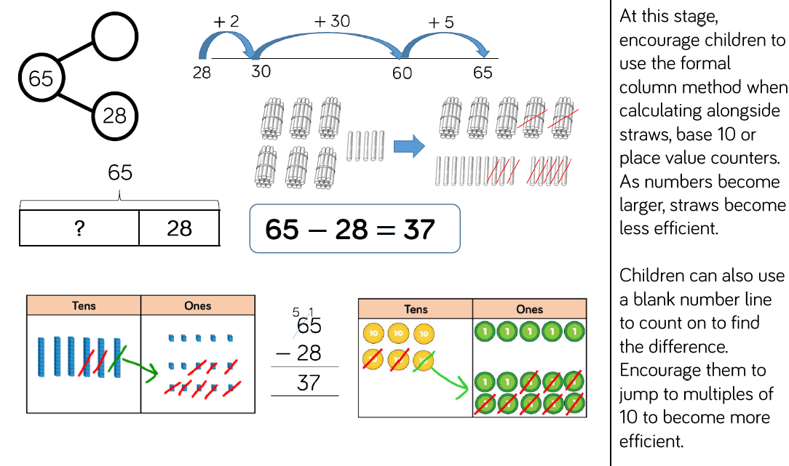

Multiplication and Division
Glossary
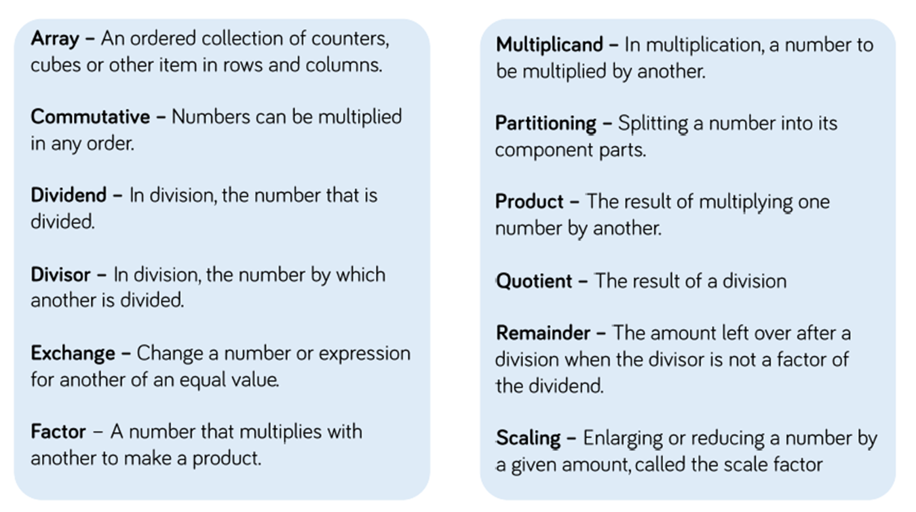

Multiplication and Division Models

Bar Model
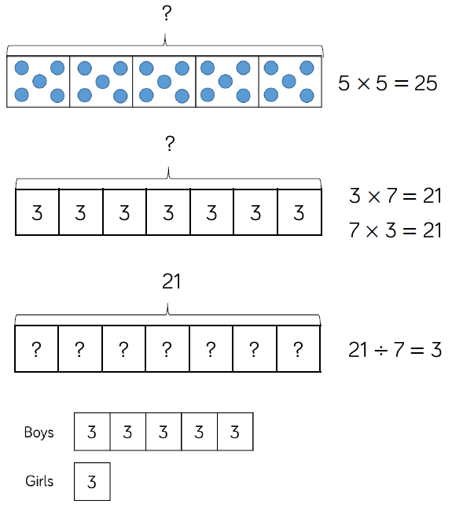 | 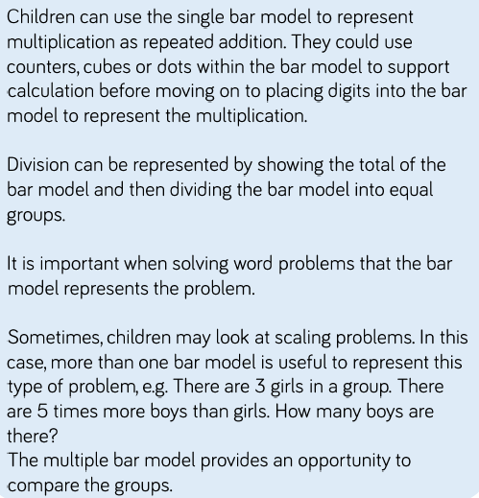

Number Shapes
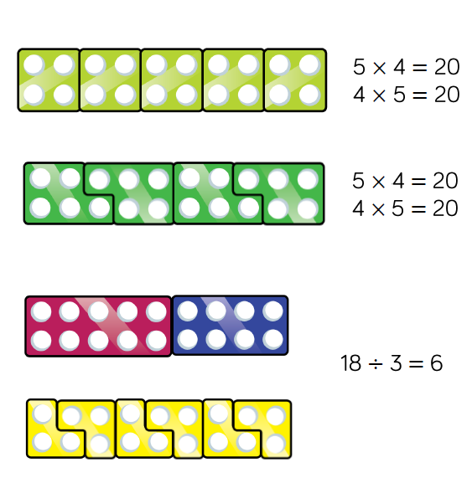 | 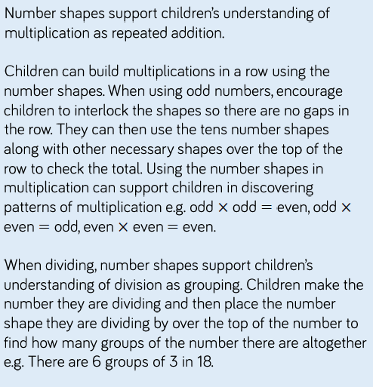

Bead String
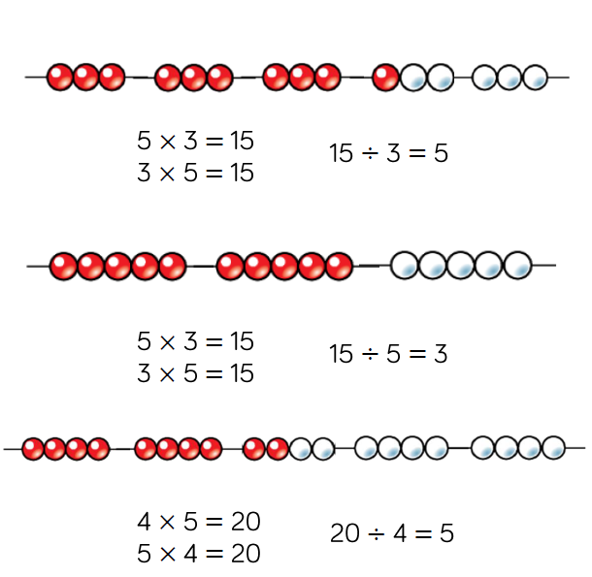 | 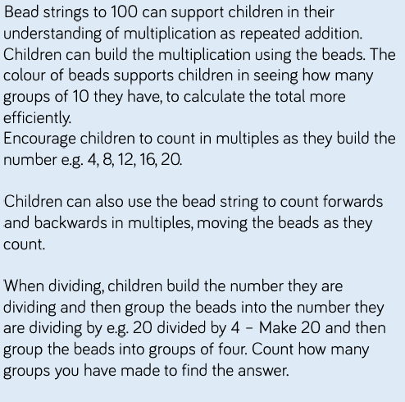

Number Tracks
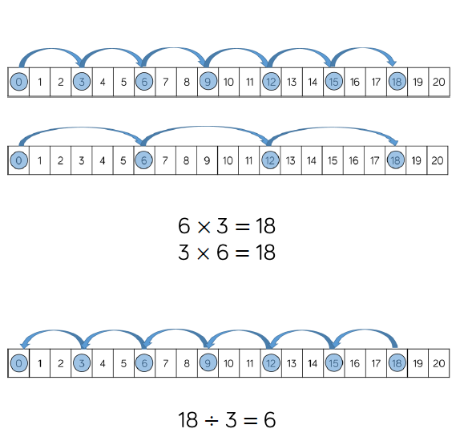 | 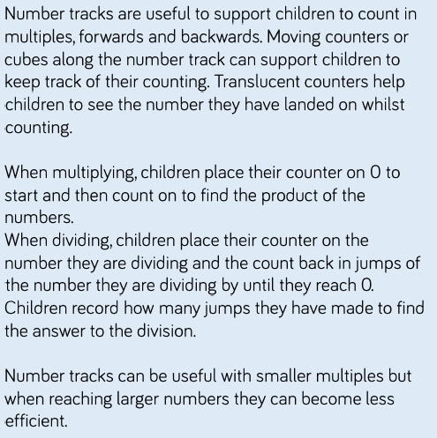

Number lines (labelled)
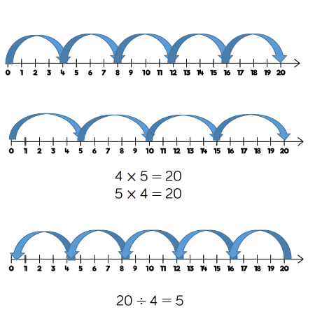 | 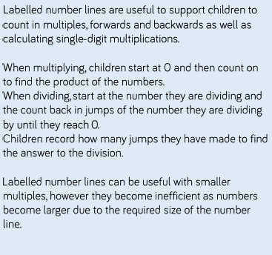

Number Lines (blank)
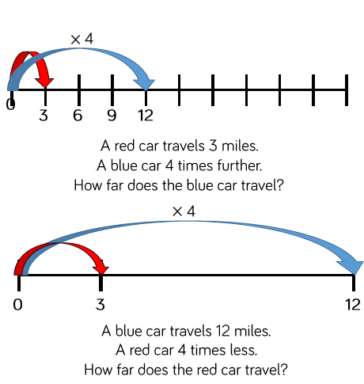 | 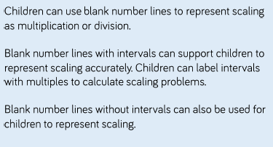

Base Ten (multiplication)
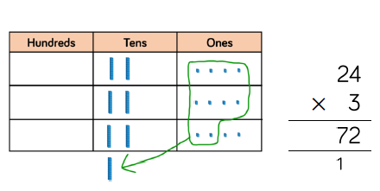 | 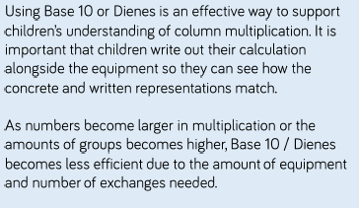
Base Ten (division)
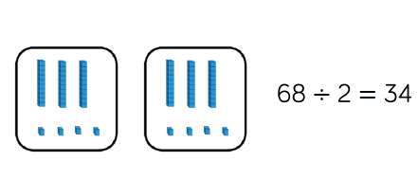 | 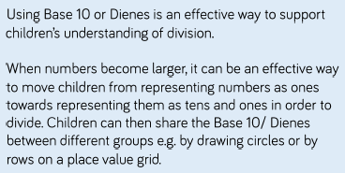

Times Tables

Overview of Skills
Skill | Year | Reprentation and Models
Recall and use mulitplication and division facts for the 2-times tables | 2 | Bar Model  Number Shapes  Counters  Money | Ten Frames  Bead Strings  Number lines  Everyday Objects
Recall and use mulitplication and division facts for the 5-times tables | 2 | Bar Model  Number Shapes  Counters  Money | Ten Frames  Bead Strings  Number lines  Everyday Objects
Recall and use mulitplication and division facts for the 10-times tables | 2 | Bar Model  Number Shapes  Counters  Money | Ten Frames  Bead Strings  Number lines  Everyday Objects

Skill - Recall and use mulitplication and division facts for the 2 -times tables - Year 2
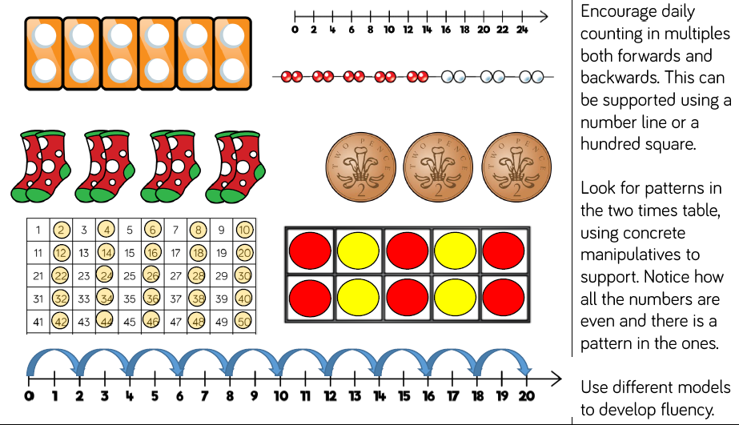

Skill - Recall and use mulitplication and division facts for the 5 -times tables - Year 2
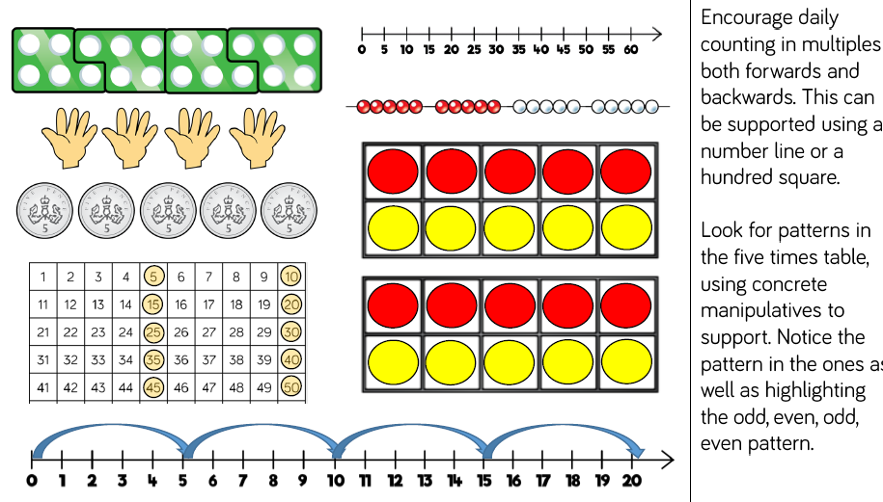

Skill - Recall and use mulitplication and division facts for the 10 -times tables - Year 2
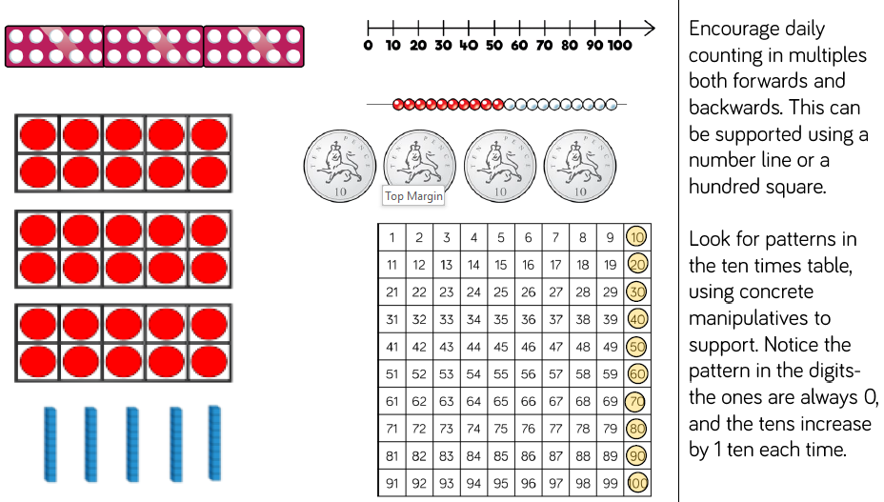

Multiplication and Division

Overview of Skills
Skill | Year | Reprentation and Models
Solve one-step problems using multiplication | 1/2 | Bar Model  Number Shapes  Counterss | Ten Frames  Bead Strings  Number lines
Solve one-step problems with division | 1/2 | Real life objects  Number Shapes  Bead String  Ten Frames | Number Lines  Arrays  Counters

Skill: Solve one-step problems using multiplication - Year 1/2
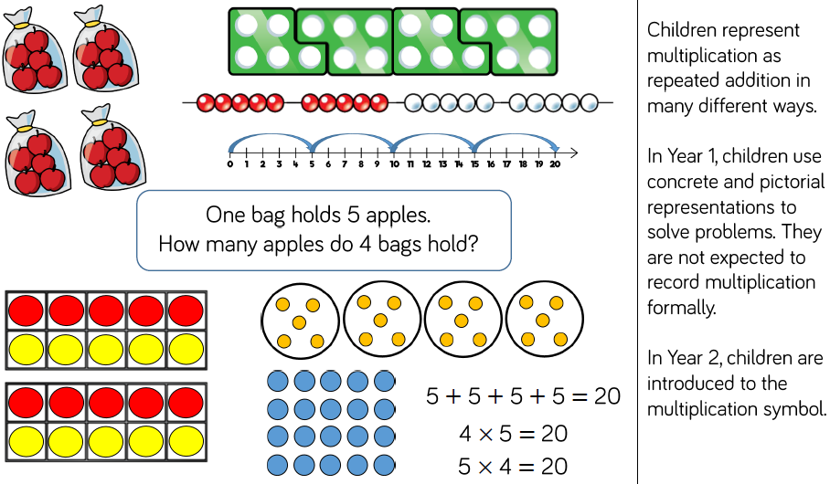

Skill: Solve one-step problems with division – Year 1/2
