Religious Education – Long term, Whole School Planning 2025 - 2026
Based on the Cumbria Syllabus for RE
Subject Lead = Miss. N Birch
Two chosen KS1 religions as well as Christianity = Islam and Buddhism

Autumn term 2022
Reception | Year 1 | Year 2
Weeks 1 to 3;  What feelings can we talk about?  -Children show curiosity about feelings  -Children can reflect on and talk about their own feelings - what makes them happy, sad, angry, frightened etc and what can help  -When looking at photos children use words appropriately to describe faces ;happy, sad, angry etc  -Children can begin to recognise and understand other people’s feelings  -Children begin to understand the value of prayer  -Children can describe how Jesus helped his friends and retell the story of Jesus Calming the Storm  -Children will understand that you can feel more than one emotion at a time e.g. sad and angry  -Children will begin to understand the difference between a question & a statement  Weeks 4 to 6;  Why do we have Harvest Festivals?  - Children use a range of words to talk about harvest  - Children communicate their ideas about harvest using pictures  - Children talk about how and why some people say thank you to God for the harvest by holding a harvest festival  - Children can identify occasions when they want to say thank you for something, and talk about the reasons why  - Children talk about their school's harvest festival and explain why it is being held  - Children can talk about and suggest reasons why some people want to help others at harvest time  - Children can describe their own experience of helping  - Children will begin to understand that we need certain foods to be healthy  Weeks 7 to 9;  Where do I belong?  -Children can talk about different ways in which they belong  -Children can describe how different people care for them  -Children begin to be aware that not everyone has the same family and home life as they do  -Children can describe religious and non- religious customs surrounding a new baby such as what might happen at a baptism. Some children may give simple explanations about why this happens.  -Children can re-tell the story of Jesus’ baptism or Jesus at the Temple  Weeks 10 to 12;  Why do Christians celebrate the birth of Jesus?  -Children can talk about the reasons for cards; presents; party; cake; blowing out candles, making a wish, songs etc. at birthday celebrations.  -Children can reflect on and express the feelings associated with a new baby  -Children know they are one year older each birthday  -Children can identify Mary, Joseph and Jesus in Nativity role play  -They recognise them as a family and that the story is found in the Bible  -Children can show their understanding of other people in the Christmas story  -Can begin to explain link the celebration of the birth of Jesus to Christmas | What does it mean to belong?  Week 1;  What does it mean to belong to a family?  Most in Y1: I can find out about signs of belonging. I can ask and respond to questions about belonging to my family and my class.  GD - Many in Y1: I can connect the idea of belonging with a symbol or a sign.  GD - Many in Y1: I can express ideas about the feelings associated with being part of a group.  Week 2;  What does it mean to belong to our class?  Most in Y1: I can ask and respond to questions about pieces of the ‘jigsaw of my life’ and talk about them.  Week 3;  What does it mean to belong to the Muslim Community?  Most in Y1: I can recall and name Muslim customs and practices.  Week4;  When, what and why might Muslims shout?  Most in Y1:I can ask and respond to questions about religious practices like the call from a Minaret.  Week 5;  What does it mean to belong to the Christian Community?  Most in Y1: I can recall and name special events in things we do.  GD - Many in Y1: I can recall the story of Jesus’ last days  Week 6;  What does it mean to belong to the Buddhist Community?  Most in Y1: I can recall and name ways a Buddhist learns from observing the world around them.  GD - Many in Y1: I can ask and respond to questions about what I think is helpful about being calm and kind.  Week 7;  Where and what are symbols of belonging?  Most in Y1: I can recall and name religious artefacts from two religions.  GD - Many in Y1: I can find out how religious meaning is expressed through an artefact.  Week 8;  What have we learned about symbols of belonging?  Most in Y1: I can recall and name how symbols are used in religions.  GD - Many in Y1: I express my ideas about meanings in religious and natural objects.  Week 9;  What have we learned about Muslim symbols?  Most in Y1: I can recall and name symbols used by different religions and talk about them.  Most in Y1: I can decorate symbols to show what is special about two religions.  GD - Many in Y1: I can ask and respond to questions about symbols  Week 10;  What have we learned about Christian symbols?  Most in Y1: I can recall and name symbols used by different religions and talk about them.  Most in Y1: I can decorate symbols to show what is special about two religions.  GD - Many in Y1: I can ask and respond to questions about symbols  Week 11;  What have we learned about Buddhist symbols?  Most in Y1: I can recall and name symbols used by different religions and talk about them.  Most in Y1: I can decorate symbols to show what is special about two religions.  GD - Many in Y1: I can ask and respond to questions about symbols  Week 12;  Assessment of the unit | What does it mean to belong?  Week 1;  How do we show that we belong to our school?  Many in Y2: I can recall and name meanings for different symbols.  Week 2;  Who am I?  Most in Y2; I express my own ideas and opinions about the meanings to the jigsaws of other people’s lives  GD - Some in Y2: I can name and recall different ways of showing where and how we belong  Week3;  When, what and why might Muslims whisper?  Most in Y2: I can express my own ideas about two or more Muslim practices of belonging.  Week 4;  What is worth shouting about?  Most in Y2: I can recall and name religious words and ideas about the Muslim call to prayer.  GD - Some in Y2: I can express my ideas about Muslim prayer  Week 5;  What do Christians remember at Easter?  Most in Y2: I can express my own ideas from the stories of Holy Week and Easter festival  Week 6;  What are some things that Buddha taught?  Most at Y2: Talk and ask questions about what is good about being kind and calm, loving or peaceful.  GD - Some at Y2: I can express my own ideas that show what Buddha taught about being kind, peaceful, loving and calm.  Week 7;  Where and what are symbols of belonging?  Most in Y2: I can ask and respond to questions about the difference between literal and non-literal meanings.  GD - Many in Y2: I can express ideas about why, to a believer, some objects are worth more than the money they cost  Week 8;  What have we learned about symbols of belonging?  Many in Y2: I can express why they are important  Week 9;  What have we learned about Muslim symbols?  Most in Y2: I can ask and respond to questions about stories from religions.  GD - Some in Y2: I can express my ideas about meanings of stories, symbols and actions linked to belonging.  Week 10;  What have we learned about Christian symbols?  Most in Y2: I can ask and respond to questions about stories from religions.  GD - Some in Y2: I can express my ideas about meanings of stories, symbols and actions linked to belonging.  Week 11;  What have we learned about Buddhist symbols?  Most in Y2: I can ask and respond to questions about stories from religions.  GD - Some in Y2: I can express my ideas about meanings of stories, symbols and actions linked to belonging.  Week 12;  Assessment of the unit
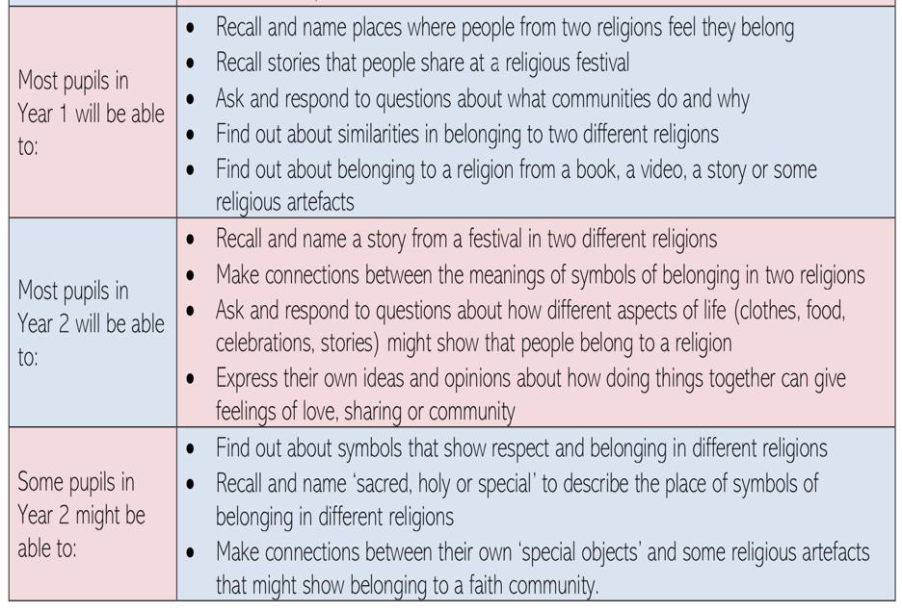
By the end of this KS1 unit;

Spring term 2023
Reception | Year 1 | Year 2
Weeks 1 to 3;  How did Jesus affect some of the people he met?  -Children can describe someone they have met and are aware of what they do for them  -Children know that Jesus chose 12 disciples to be his helpers and followers  -Children can talk about the feelings of the disciples  -Children can talk about why they think Jesus liked and valued children  -Children retell the story of Zacchaeus through drama and role play  -Children give some reasons why Jesus chose Zacchaeus  -Children explain in simple terms how Jesus' friendship affected Zacchaeus  -Children can explain the concept of 'friend', the qualities that make someone a friend and what being a friend means to them  -Children explain in simple terms that true friendship is about behaviour and feelings, eg being kind  -Children identify what they have learned about the different friends of Jesus  Weeks 4 to 6;  How can we use our hands?  -Children understand that they are unique  -Children understand that they can communicate and express their feelings through their hands  -Children reflect on the way they can use their hands to benefit other people  -Children know something of the way Jesus used his hands to help people  -Children join in the greeting and washing of feet, and can talk about why they are doing it  -Children are aware that hands can hurt and help  -Children can explain how hands were important in the Easter story  Weeks 7 to 9;  Why do we talk about New Life at Easter?  -Children develop an understanding of spring and are able to find signs of new life: uncurling leaves or bracken, opening flowers, mung beans sprouting. -Children reflect on feelings related to new life  -Children use movement and expression to explore and describe new life  -Children can talk about the difference between sad times and happy times  -Children are able to role play or use puppets to retell a story  -Children are able to recognise Easter as the most important event in the Christian calendar  -Children recognise and develop an understanding of Christian symbols  -Children are aware that Easter is a time of sadness and celebration for Christians  Weeks 10 to 12;  Who helps us? Who can we help?  -Children can reflect on caring and on helping others  -Children can explain who may be a source of help in everyday life and in times of difficulty  -Children can talk about the work of local religious people  -Children are able to explain that religious commitment is part of many people’s lives  -Children appreciate that helpfulness can unselfish motivation | Why are some books and stories special?  Week 1;  Why are some books and stories special?  Most in Yr1: I can recall what some religions call their special books.  GD - Many in Yr1: I can ask and respond to questions which address why some books are special.  GD - Many in Yr 1: I can express my ideas about what matters to other people.  Week 2;  How and why is respect shown for a book?  Most in Year 1: I can recall and name some books that are special to some groups of people.  Most in Year 1: I can find out about the Muslim and Christian special books.  GD - Many in Year 1: I can ask and respond to questions which address why books are special.  Week 3;  What can we find out about a story from Islam of Mohammad at the gates of Makkah?  Most in Y1: I can recall and name what happened in the story.  Most in Y1: I can find out why the woman changed her mind.  Most in Y1: I can ask and respond to questions about meaning in the story.  GD - Many in Y1: I can express ideas about meanings for the emotions in the story.  GD - Many in Y1: I can ask and respond to questions about the idea that we sometimes need to change our minds.  Week4;  How and why do Muslims use the Qur’an?  Most in Year 1: I can find out about who or what guides Muslims in their lives.  Most in Year 1: can identify some things that are important to Muslims.  Most in Year 1: I can find out about the revelation of the Qur’an to Muhammad [PBUH].  GD - Many in Year 1: I can recall the key Muslim belief that there is no other God but Allah.  Week 5;  What can we find out about Buddhism from the story of Siddhartha and the Swan?  Most in Year 1: I can recall a story that is special to Buddhists.  Most in Year 1: I can find out about the Buddha and a story about him.  GD -Many in Year 1: can ask and respond to questions about the story, suggesting a meaning.  Week 6;  What book of stories do Christians love to remember? Why?  Most in Yr1: I can ask and respond to questions about ideas and beliefs about God.  GD - Many in Yr1: I can ask and respond to questions about Bible stories about God.  Week 7;  Why did Jesus tell a parable about building houses?  Most in Year 1: can recall the parable and talk about what it might mean.  GD - Many in Year 1: I can ask and respond to questions about thinking carefully before making decisions and choosing things.  Week 8;  Why did Jesus tell a parable about lost sheep?  Most in Year 1: I can recall and name the key concepts in the story.  GD - Many in Year 1: I can ask and respond to questions about meanings in the story.  GD - Many in Year 1: I can ask and respond to questions about the idea that God might be like a shepherd.  Week 9;  What is similar and what is different in the sacred books and holy stories we have learned about?  Most in Year 1: I can recall and name religious stories.  Most in Year 1: I can ask and respond to questions about my favourite story and characters.  Most in Year 1: I can ask and respond to questions about what I like about each story.  GD - Many in Year 1: I can express my own ideas about a meaning for one of the stories.  Week 10;  What is similar and what is different in the sacred books and holy stories we have learned about?  Most in Year 1: I can recall and name religious stories.  Most in Year 1: I can ask and respond to questions about my favourite story and characters.  Most in Year 1: I can ask and respond to questions about what I like about each story.  GD - Many in Year 1: I can express my own ideas about a meaning for one of the stories.  Week 11;  What have we learned about holy books and stories in this unit of RE?  Most in Year 1: I can ask and respond to questions about the topic of ‘Holy Books’.  Most in Year 1: I can recall outlines of the stories.  GD - Many in Year 1: I can find out about stories and suggest meanings.  GD - Many in Year 1: I can express my own ideas about life’s most important words and about holy writings.  Week 12;  Assessment of the unit | Why are some books and stories special?  Week 1;  How do Muslims respect their holy book?  Most in Year 2: I can express my own ideas and opinions on the idea of a ‘holy book’.  Week 2;  What can we find out about a story from Islam of Mohammad at the gates of Makkah?  Some in Y2: I can express my ideas about this story and the way some people think of other religions.  Week3;  What do Muslims learn from the Qur’an about God?  Most in Year 2: I can ask and respond to questions about why the Qur’an is important to Muslims and how it makes a difference to what they do.  Week 4;  What can we find out about Buddhism from the story of Siddhartha and the Swan?  Most in Year 2: I can express my own ideas about the story and its characters.  Week 5;  What can we find out about Buddhism from quotations from Buddhist texts?  Most in Year 2: I can express my own ideas about quotations from Buddhist texts.  GD - Many in Year 2: I can ask and respond to  questions  quotations  Buddhist  suggesting my own meanings.  Week 6;  What book of stories do Christians love to remember? Why?  Most in Yr 2: I can express ideas about some key themes in Bible stories and say what a Christian might do.  Week 7;  Why did Jesus tell a parable about building houses?  Most in Year 2: I can express my own ideas about the parable and about the wisdom of listening to advice and thinking hard before deciding.  Week 8;  Why did Jesus tell a parable about lost sheep?  Most in Year 2: I can express my own ideas about the lost sheep and other things being lost – like people for example.  Week 9;  What is similar and what is different in the sacred books and holy stories we have learned about?  Most in Year 2: I can express my own ideas and opinions about stories.  Week 10;  What is similar and what is different in the sacred books and holy stories we have learned about?  Most in Year 2: I can express my own ideas and opinions about stories.  Week 11;  What have we learned about holy books and stories in this unit of RE?  Most in Year 2: I can find out about stories and suggest meanings.  Most in Year 2: I can express my own ideas about life’s most important words and about holy writings.  Week 12;  Assessment of the unit

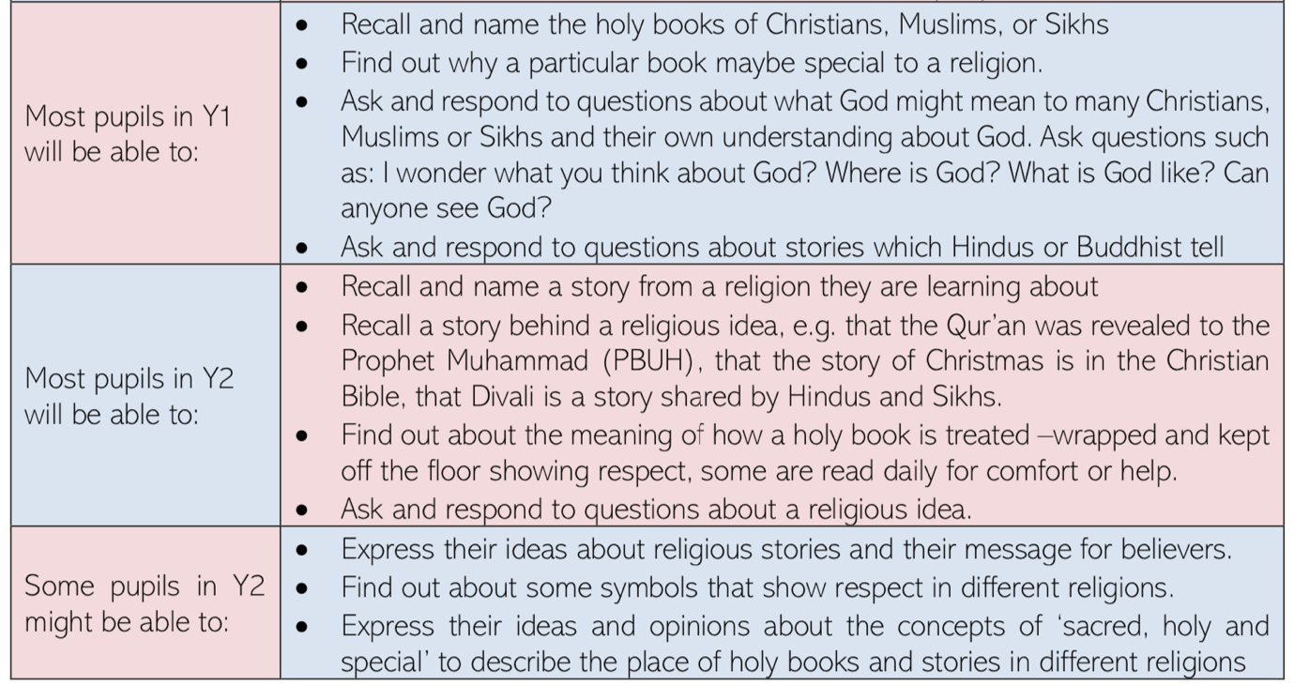
By the end of this KS1 unit;

Summer term 2023
Reception | Year 1 | Year 2
Weeks 1 to 3;  How and why are weddings celebrated?  -Children understand that a wedding is usually a special event and a celebration & that it can take place in a variety of places including places of worship  -Children use appropriate vocabulary to identify what is happening at a wedding  -Children can reflect on and discuss a range of feelings associated with a wedding.  -Children can use the knowledge acquired in a role play  -Children develop their  understanding of the importance of promises  - Children identify similarities and differences among people, families, communities and traditions  -Children are able to recognise that wonderful things can happen with miracles  Weeks 4 to 6;  How is light used in celebrations?  -Children can recount their birthday experiences  -Children can recognise the main characters in the Christmas story and know that the story is found in the Bible  -Children can talk about how Christmas is celebrated in a church and in some homes  -Children can recognise the simple symbols associated with Christmas – candles, star, Advent crown  -Children understand that candles and light are important to people from a range of faiths e.g. Hanukkah menorah or Divali diva.  Weeks 7 to 9;  What are special clothes?  - Children recognise that special clothes can be  worn for occasions  significant  -Children understand and  demonstrate empathy through role play and contributions to  discussion  -Children are able to recall similarities and differences between the clothes worn in church and in other holy places.  -Children are able to identify special occasions when special clothes are worn  -Children are able to use key words appropriately.  Weeks 10 to 12;  How do we feel on a journey?  -Children exhibit awe and wonder, anticipation, excitement and can talk about their own experience and the connected feelings  -Children are able to note similarities and differences between their experiences and that of other children  -Children can show empathy with other people involved in journeys  -Children can predict, sequence, and describe the events in the story of the child Jesus at the Temple and other Bible stories. | Who is Jesus? Why do some people think Jesus is inspiring?  Week 1;  What is an inspiring person?  Most in Y1: I can ask and respond to questions about examples of heroes.  Week 2;  Who was Jesus?  Most in Y1: I can ask and respond to questions about my own ideas and beliefs about Jesus.  Week 3;  When Jesus wanted to feed a crowd, what happened to a boy’s packed lunch?  Most in Y1; I can ask and respond to questions: Who is kind in the story? What is a miracle?  Week4;  How did a ‘meany’ turn into a generous man?  Most in Y1: I can recall and name a key feature from the story.  Most in Y1: I can recall the outline of the story.  Week 5;  How and why do Christians pray?  Most in Y1: I can recall how some Christian people pray.  Week 6;  What is the Lord’s Prayer?  Most in Y1: I can recall the Lord’s Prayer as a special prayer for Christians.  Week 7;  What images could go in a book or a PowerPoint about the Lord’s Prayer?  Most in Y1: I can ask and respond to questions about the meaning of parts of Jesus’ prayer.  Week 8;  What happened when Jesus went to a wedding?  Most in Y1: I can ask and respond to questions about my own experience of a wedding.  Week 9;  What happens at a wedding in Church today?  Most in Y1: I can recall and name different types of wedding ceremonies.  Week 10;  What did Jesus so do with his powers?  Most in Y1: I can recall that Christians believe Jesus used his power to help people.  Week 11;  What are my powers?  Most in Y1: I can recall ways in which Christians pray.  Week 12;  Assessment of the unit | Who is Jesus? Why do some people think Jesus is inspiring?  Week 1;  Who is an inspiring person?  Most in Y2: I can express my own ideas about heroes and inspiring people and choose inspiring people of my own.  GD - Some in Y2: I can express my own ideas about inspiring people in different settings.  Week 2;  How might a Bible story show Jesus is inspiring?  Most in Y2: I can find out about Jesus from Bible stories.  GD - Some in Y2: I can express my own ideas and opinions about themes in the stories about Jesus and say what a Christian might do.  Week3;  When Jesus wanted to feed a crowd, what happened to a boy’s packed lunch?  Most in Y2: I can recall the story of feeding 5000, one of Jesus’ miracles.  GD - Some in Y2: I express my own ideas about the story and the way Jesus inspired people.  Week 4;  Is it inspiring to help someone be generous?  Most in Y2: I can ask and respond to questions about the story of Zacchaeus.  GD - Some in Y2: I can express my ideas about the story and my own life.  GD - Some in Y2: I can express my own ideas and opinions about the values of fairness and generosity.  Week 5;  Do some people find inspiration and power through praying?  Most in Y2: I can ask and respond to questions about praying and meditating.  GD - Some in Y2: I can express my own ideas about some different kinds or purposes of prayer.  Week 6;  Did Jesus inspire people by teaching them to pray?  Most in Y2: I can express my ideas about the Christian idea that praying can be powerful by giving an example.  Forensic image of Jesus.  Week 7;  What images could go in a book or a PowerPoint about the Lord’s Prayer?  Most in Y2: I can express my ideas about matching music and images to some phrases in the Lord’s Prayer.  Most in Y2: I can give examples and express ideas about the Christian belief that praying is powerful.  Most in Y2: I can ask and respond to questions about the meaning of the prayer.  Week 8;  What happened when Jesus went to a wedding? Did Jesus inspire people by this miracle?  Most in Y2: I can express my own ideas about the story of the wedding at Cana and what it might mean.  Week 9;  Why is Jesus’ story at a wedding still often told?  Most in Y2: I can find out some key features of wedding celebrations.  Most in Y2: I can ask and respond to questions about what is really important at a wedding.  Most in Y2: I can express my own ideas about the story of Jesus at the wedding in Cana and why it might be read at Christian weddings.  Week 10;  Was Jesus’ kindness inspiring?  Most in Y2: I can express my own ideas about Jesus using his power to help others.  Week 11;  What are my ideas about prayer?  Most in Y2: I can respond to questions about changing.  GD - Some in Y2: I can express my own ideas about praying and power, or between personal choices to help others and power.  Week 12;  Assessment of the unit

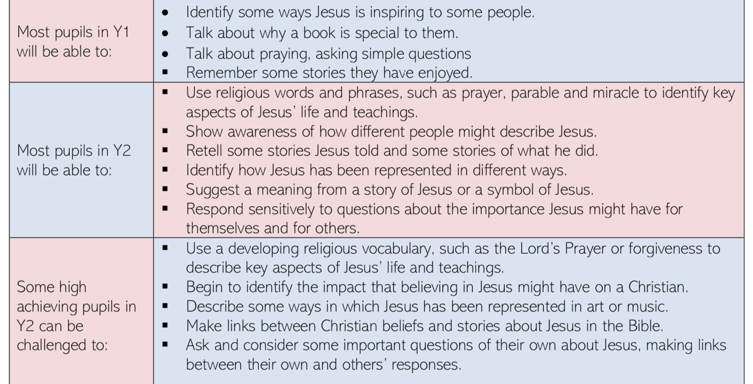
By the end of this KS1 unit;

