Maths Policy
2026 - 2027

St. Michael’s Nursery and Infant School


Subject Lead – Mrs. Stacey Hudson
Introduction
At St. Michael’s we believe that all pupils can achieve in mathematics. We believe that at each stage of learning, children should be able to demonstrate deep, conceptual understanding of a topic and build on this over time. We want children to be able to not only recall and use the maths taught but to also be able to transfer and apply it in different contexts, being able to reason and problem solve. Children’s chances of success are maximised if they develop deep and lasting understanding of mathematical procedures and concepts. This deep learning is what we are aiming for by teaching maths using the mastery approach.

What Is Maths Mastery?
Mathematics teaching for mastery assumes everyone can learn and enjoy mathematics. As stated by the National Centre for Excellence in Teaching in Maths (NCETM), Mathematical learning behaviours are developed such that pupils focus and engage fully as learners who reason and seek to make connections. Teachers continually develop their specialist knowledge for teaching mathematics, working collaboratively to refine and improve their teaching. Our Maths Lead – Stacey Hudson works collaboratively with Local Leaders in Maths Education as part of the NCTEM’s North North West Maths Hub, working alongside Local Leaders in Maths Education. Our curriculum ensures a coherent and detailed sequence of essential content to support sustained progression over time.
Lesson design links to prior learning to ensure all can access the new learning and identifies carefully sequenced steps in progression to build secure understanding. Examples, representations and models are carefully selected to expose the structure of mathematical concepts and emphasise connections, enabling pupils to develop a deep knowledge of mathematics.
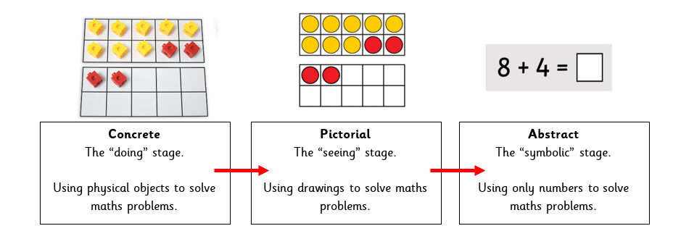
We use the Concrete Pictorial Abstract (CPA) approach. When children are introduced to a new concept, working with concrete physical resources and pictorial representations leads to a better understanding of abstract concepts.

Procedural fluency and conceptual understanding are developed in tandem because each supports the development of the other. It is recognised that practice is a vital part of learning, but the practice must be designed to both reinforce pupils’ procedural fluency and develop their conceptual understanding.
Pupils are taught through whole-class interactive teaching, enabling all to master the concepts necessary for the next part of the curriculum sequence. In a typical lesson, the teacher leads back and forth interaction, including questioning, short tasks, explanation, demonstration, and discussion, enabling pupils to think, reason and apply their knowledge to solve problems. Use of precise mathematical language enables all pupils to communicate their reasoning and thinking effectively. If a pupil fails to grasp a concept or procedure, this is identified quickly, and gaps in understanding are addressed systematically to prevent them falling behind. Significant time is spent developing deep understanding of the key ideas that are needed to underpin future learning. Key number facts are learnt to automaticity, and other key mathematical facts are learned deeply and practised regularly, to avoid cognitive overload in working memory and enable pupils to focus on new learning.

Our Curriculum
Our maths curriculum is split into year group specific units that are taught in a sequence whereby previous learning can be used to support new learning. The sequence in which the units are taught also supports the teaching of, and the children’s ability to create links between different concepts and therefore deepen their understanding.
We follow the NCETM’s Mastering Number Scheme from Reception to Year 2. This scheme aims to secure firm foundations in the development of good number sense for all children from Reception through to Year 1 and Year 2. The aim is that children will leave KS1 with fluency in calculation and a confidence and flexibility with number. Attention will be given to key knowledge and understanding needed in Reception classes, and progression through KS1 to support success in the future.

Early Years
In Early Years we use The Development Matters Framework to ensure that we meet the Early Years Foundation Stage Educational Programme for Maths. Staff make the most of the opportunities for maths in all that the children do.
In Tiny Teds and Nursery, maths is taught by making links to mathematical contexts during play and daily routines. Teachers use the Development Matters Framework as a guidance as to what to teach and use their professional knowledge to plan the next steps for the children.
In Reception, Maths is taught through daily discrete teaching. Number and Numerical Patterns are taught through the delivery of the NCETM 'Mastering Number Programme' five times a week.

Key Stage 1
In Key Stage one we follow the White Rose Maths (WRM) Scheme of Learning which is a mastery approach to maths teaching. This is a research-driven teaching and learning method that meets the goals of the National Curriculum.
The WRM scheme puts numbers first believes that confidence with numbers is the first step to competency in the curriculum as a whole. The scheme ensures depth before breadth, reinforcing knowledge again and again. It encourages collaboration, children progress through the schemes as a group, supporting each other as they learn. It focuses on fluency, reasoning and problem solving, giving children the skills they need to become competent mathematicians. The CPA approach is at the heart of the scheme.
Teachers deliver four 10-15minute ‘Mastering Number’ sessions per week, in addition to their daily maths lesson.

Assessment, Reporting, Recording
Assessment is used to inform planning and to facilitate differentiation. The assessment of children’s work is on-going to ensure that understanding is being achieved and that progress is being made. Feedback is given to the children as soon as possible, and marking work will be guided by the school’ Marking Policy.
Formative assessment tools are used during the lesson to judge the impact that the teaching is having on the children’s learning.
Children who have not developed a deep understanding of a concept, will work in small groups later in the day to explore the concept further and address any misconceptions that may have arisen during the lesson.
Summative assessments are carried out at the end of each term to measure how deep the children have learned a concept when it is assessed out of context and at a later date to the initial teacher input.
Where assessments have shown that understanding may not be as deep, these ideas are covered further in either small group intervention sessions or through further coverage in the main maths sessions.
Differentiation:
We believe that all children can achieve in maths you will not see ‘typical differentiation’. Instead, you will see support mechanisms put in place to ensure all children can access the lesson and that challenges are put in place to ensure children can deepen their understanding. Teachers differentiate in a variety of ways to meet the needs of the children. They think about different groups of children within their class and subtly planning for different levels of questioning, different follow-up tasks, or some additional questions to stretch those children who grasp new concepts quickly.
Collaboration and group work using class floor books empowers children who lack confidence to share and explore ideas. It provides opportunity for children to work in pairs or small groups enabling them to vocalise their ideas.

Marking
Maths is marked inline with the school’s marking policy. The RAG traffic light system is used to show if a learning objective has been achieved. Work should be marked during the lesson to monitor pupils progress. Pupils should be provided with opportunities to reflect on the marking, often verbally.
The following abbreviations are used when marking:
I – Independent Work
S – Supported Work
SC – Self corrected work

Inclusion
We are committed to equality of opportunity in all aspects of school life. Our aim is to offer all our pupils a maths curriculum that enables all our pupils may reach their full potential. Children with additional needs are included in whole class lessons and teachers provide scaffolding and relevant support as necessary. Teachers work alongside the SENCO and advisory teachers to tailor the curriculum to meet individual needs.

Monitoring
Monitoring takes place regularly through sampling children’s work, and teacher planning, through book scrutiny and lesson observations. Feedback and Coaching is then given to staff to improve practice and strive for quality first teaching always.

Role of the Subject Leader
• To develop the Maths policy throughout the school
• To monitor progress in the Maths across the school
• To keep up to date with development in Maths
• To offer support and advice to colleagues
• To complete orders for equipment and resources needed

Reviewed by: Stacey Hudson

Date: 7th September 2026
Next Review Date: September 2027

