

Nursery Class Newsletter
Summer 2 - 2026
Welcome back to our final half term before the Summer holidays and it’s going to be a busy one! We will be off out on our trip to The Lake District Animal Park (Trotters Farm) to see and learn about different animals and explore their soft play and outdoor play area. We will also be adopting caterpillars and watching their amazing metamorphosis as they turn into butterflies as well as enjoying Sports day and our Community Party and Summer Disco to name just a few things!
Also, throughout this half term we will be helping to prepare children for their next steps whether that be continuing on in Nursery, moving into our Reception or moving to a new school. All of which makes this an exciting term with lots of learning.
Along with exploring the interests of our children, we will be exploring the themes of:
- Caring and Sharing  - Movers and Shakers | - Animals  - I’m and Artist  - Moving on! | - What’s my score? (counting games)
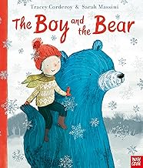
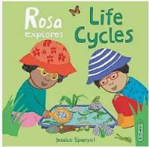

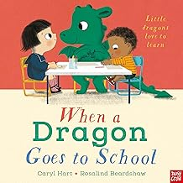
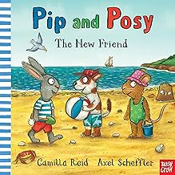
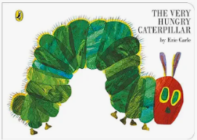
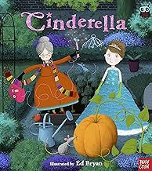
To help us do this, we will be looking at these books:


Over this half term, we will be developing our skills through:
Communication and Language
- Knowing many rhymes, talking about familiar books, and being able to tell a long story.
- Being able to express a point of view and to debate when we disagree with an adult or a friend, using words as well as actions.
Personal, Social and Emotional Development
- Helping to find solutions to conflicts and rivalries. For example, accepting that not everyone can be Spider-Man in the game, and suggesting other ideas.
Physical Development
- Being able to use and remember sequences and patterns of movements which are related to music and rhythm.
- Matching our developing physical skills to tasks and activities in the setting. For example, they decide whether to crawl, walk or run across a plank, depending on its length and width.
Literacy
- Using some of our print and letter knowledge in our early writing. For example: writing a pretend shopping list that starts at the top of the page; write ‘m’ for mummy.
Mathematics
- Linking numerals and amounts: for example, showing the right number of objects to match the numeral, up to 5.
- Experimenting with our own symbols and marks as well as numerals.
- Describe a sequence of events, real or fictional, using words such as ‘first’, ‘then...’
Understanding the World
- Understanding the key features of the life cycle of a plant and an animal.
Expressive Arts and Design
- Drawing with increasing complexity and detail, such as representing a face with a circle and including details.
- Using drawing to represent ideas like movement or loud noises.
Some extra information:
PE
Our PE sessions this half term will be MONDAY AFTERNOONS. Children will NOT NEED a change of clothes for these sessions, but for their safety will need to have earrings removed on this day or covered with plasters.
On PE days children will be removing shoes and socks, to help develop our independence skills, please consider which footwear your child wears on these days (Velcro fastenings are a brilliant confidence booster for children)
Snack
This half term, snack fees are £7 and can be paid to a member of the Nursery team or via the office either in a lump sum or £1 per week. Please send snack money in cash, in a labelled envelope.
Library Books
On Tuesday and Friday mornings, we will be placing out our Lending Library books for you to browse and select a book to borrow. This book can be returned the following Tuesday or Friday and swapped for another book for you and your child to enjoy.

Spare Clothing
All children can have an accident from time to time. Please can all children have a spare set of clothing with them each day, including underwear and socks.

Sun Protection
As the weather improves, we will be making the most of our outdoor spaces. To help protect children from sun damage please can children bring with them a sun cap/hat (with their name added to the label) and have sun cream applied for the beginning of the day.
Sun cream can be kept in children’s bags (please label the bottle) and we will help children to top this up through the day.

Punctuality and Time Keeping
To help children to get off to a good start in the morning it is great if they can have some settling time in the classroom. Our nursery door opens at 8:45am and closes at 8:55am ready for us to make a start. If your child arrives after 8:55am they need to go to the main entrance and be signed in.
The end of morning session is 11:55am and children need to be collected promptly as the main school gates are closed at 12 sharp. The end of the afternoon session is 3:05pm

Clothing
It can be very upsetting when children lose jumpers or cardigans, to help us get items back to their correct owner please label all your children’s belongings.

Should you have any concerns or require any more information, please feel free to speak to one of our nursery team members either before or after school. Or you can also message me directly via the Class Dojo or contact our school office.
Many thanks for your continued support,
Miss Routledge and the Nursery Team

