

Nursery Class Newsletter
Spring Term 1 - 2026
We were very pleased to see to see all our children return after our festive break and are excited to welcome our new Nursery friends. We have a busy half term ahead of us, with Internet Safety Day, Chinese New Year, our ‘Meet a Stranger’ art project as well as a trip to our local café to name just a few things!
We will also be having two new special friends joining our nursery class, our Travelling Teddies, called ‘Eric’ and ‘Hassan’. Each week the teddies will be looking for a kind classmate to take them home for the weekend and look after them. We would love to see what the teddies get up to so would really appreciate it if you could share a photo on our dojo app. Have a look out in the upcoming weeks from Eric and Hassan’s adventures with the teachers!
Along with exploring the interests of our children, we will be exploring the themes of:
- Journeys  - Chinese New Year | - Animals  - Winter | - Weather  - Brilliant Builders!
To help us do this, we will be looking at these books, which make up our ‘Super 6’:
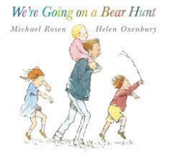
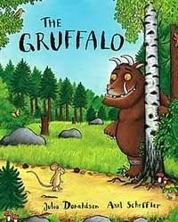
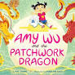
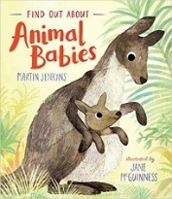
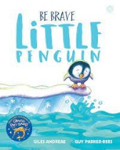
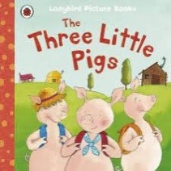

Over this half term, we will be developing our skills through:
Communication and Language
- Understanding ‘why’ questions, like: “Why do you think the caterpillar got so fat?”
- Using longer sentences of four to six words.
Personal, Social and Emotional Development
- Showing more confidence in new social situations.
- Playing with one or more other children, extending and elaborating play ideas.
- Be increasingly independent in meeting their own care needs, e.g. brushing teeth, using the toilet, washing and drying their hands thoroughly.
- Making healthy choices about food, drink.
Physical Development
- Taking part in some group activities which they make up for themselves, or in teams.
- Choosing the right resources to carry out their own plan. For example, choosing a spade to enlarge a small hole they dug with a trowel.
Literacy
- Understanding that print can have different purposes.
- Developing phonological awareness by counting and clapping syllables in words
Mathematics
- Saying one number for each item in order: 1,2,3,4,5.
- Extending and creating ABAB patterns – stick, leaf, stick, leaf.
- Describing a familiar route.
- Discussing routes and locations, using words like ‘in front of’ and ‘behind’.
Understanding the World
- Talking about the differences between materials and changes they notice.
- Exploring and talking about different forces they can feel.
Expressive Arts and Design
- Making imaginative and complex ‘small worlds’ with blocks and construction kits, such as a city with different buildings and a park.
- Developing their own ideas and then decide which materials to use to express them.
- Responding to what they have heard, expressing their thoughts and feelings.

Some further information:

PE
Our PE sessions this half term will be MONDAY AFTERNOONS. Children will NOT NEED a change of clothes for these sessions, but for their safety will need to have earrings removed on this day or covered with plasters.
On PE days children will be removing shoes and socks, to help develop our independence skills, please consider which footwear your child wears on these days (Velcro fastenings are a brilliant confidence booster for children)

Snack
This half term, snack fees are £5 and can be paid to a member of the Nursery team or via the office either in a lump sum or £1 per week. Please send snack money in cash, in a labelled envelope.

Lending Library
On Tuesday and Friday mornings, we will be placing out our Lending Library books for you to browse and select a book to borrow. This book can be returned the following Tuesday or Friday and swapped for another book for you and your child to enjoy.

Spare Clothing and Lost Property
All children can have an accident from time to time. Please can all children have a spare set of clothing with them each day, including underwear and socks.

Please ensure that ALL CLOTHING is labelled with your child’s name. Alongside our Lending Library on Tuesday and Fridays, we will place out any lost property that we find in class. Please look through this and reclaim your child’s belongings.

Coats, Hats, Gloves and Playing Outside
Our Nursery curriculum includes us using our outdoor provision. To help us do this, children will need to have with them a warm waterproof coat, as well a hat and gloves every day. Please make sure that all these items have children’s names added to them.

Should you have any concerns or require any more information, please feel free to speak to one of our nursery team members either before or after school. Or you can also message me directly via the Class Dojo or contact our school office.
Many thanks for your continued support,
Miss Routledge and the Nursery Team

