
The children are busy settling into their new classroom and becoming familiar with their new routine.
In all our classrooms in school, we have super six books to read and enjoy!
Our Super Six – Autumn 1
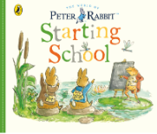 | 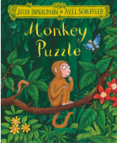 | 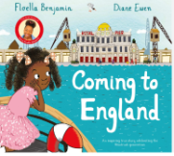 | 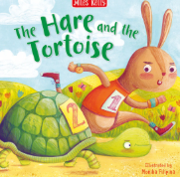 | 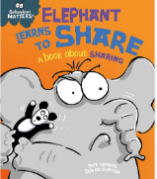 | 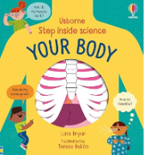

PE  - In our class, we have PE every Monday and Friday. Please can any earrings be removed or covered with plasters on those days. We are unable to cover earrings in line with county policy. All PE kits remain in school until half term. | Snack  - This term, snack money is £7. This can be paid at once or instalments. The money can be handed to a member of staff on the door and this MUST be in a named envelope please.
Independence Skills  - We are continuing to promote independence skills. Please can your child continue to practice zipping up their own coat as this really helps during play, lunch and home time. Also getting dressed/undressed as really helps during PE. | Read Write Inc  - We will be starting Read Write Inc on Monday 7th September.  - All children will have a library book which will be changed every Friday.  - It is vital that clear books bags are brought into school every day.

- On dojo, there is the welcome to Year 1 PowerPoint with lots of information. If you do have any questions/queries, please do not hesitate to get in touch, either in school on the door in the morning or after school or via dojo.
Miss Birch and the Year 1 Team 😊



Year 1- Autumn 1

English | Maths | Science | Computing
Read Write Inc | Place Value (within 10)  Addition and Subtraction  (within 10) | Animals, including Humans | Introduction to Purple Mash  Technology Around Us
PE | Design and Technology | Art and Design | RE
Ball Skills  Gymnastics | Moving Minibeasts | Painting | Christianity  Buddhism  Islam
PSHE | History | Geography | Music
Golden Rules  Pupil Voice  All About Me | Who was Charles Darwin? | Let’s go to the Jungle | Hey You!

