Year 1 Class Newsletter - Summer 2 2026
Our topic-’We’re all going on a summer holiday’

I cannot believe that we are in the last term of the school year! There are many specials events/dates that will listed on the school newsletter, please keep an eye out for this.

Some key dates are:
Week beginning 8th June- Phonics Screening Check
25th June- Sports Day
2nd July- KS1 school trip to Whinlatter

Here are our Super Six books that we will be sharing and enjoying this term:
Our Super Six
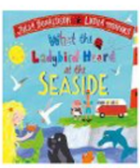 | 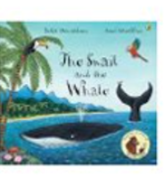 |  |  | 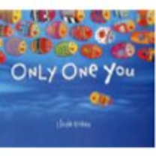 | 

PE
Please can PE kits be brought back into school to stay on your child’s peg. PE days remain the same- Tuesday and Wednesday. Please can earrings be removed on those days.
Snack
Snack money is £7 this term. Please can this be put in a labelled envelope and handed into a member of staff on the KS1 door. This can be paid in instalments or lump sum.
Homework
Homework will continue to be handed out every Friday and due in every Wednesday. This could be a task set in their red book, via Purple Mash/dojo home learning links.
Reading
Please can Read Write Inc clear bags be brought into school every day.

This is a polite reminder that our KS1 door does close at 8.45 in order to start our lessons promptly. Please ensure your child arrives in plenty of time, the door does open at 8.35 and every child is offered a drink and breakfast, then the children complete a morning task before the register at 8.45.
If you do have any questions/queries, please do not hesitate to get in touch, either on the door during the morning or after school or via dojo.
Miss Birch and the Year 1 Team
English | Maths | Science | Computing
Read Write Inc | Place Value within 100  Money  Time | Plants  Seasonal Changes | Data Explorers- creating and following instructions
PE | Design and Technology | Art and Design | RE
Yoga  Sports Day Practice  Multi-skills | Seaside Snacks | Textiles | Christianity  Buddhism  Islam
PSHE | History | Geography | Music
World Environment Day  Armed Forces Day  Countryside Code | ‘The first aeroplane flight’ | Seas and Coasts | Reflect, Rewind and Replay

