Year 1 Newsletter- February 2026
In all our classrooms in school, we have super six books to read and enjoy!
Our Super Six
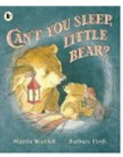 | 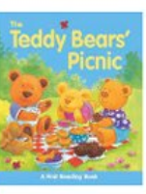 | 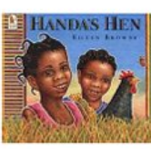 | 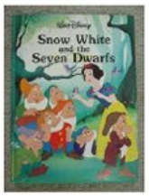 | 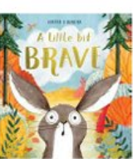 | 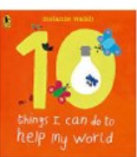

PE  - Please return your child’s PE kit if you haven’t already done so and this will remain in school until the end of term.  PE days are every Tuesday and Wednesday. Every child should have a PE kit in school, shorts and a  t-shirt. The kit does not have to include the school logo. This also promotes independence during the lessons, getting dressed and undressed. | Snack  - This term, snack money is £5. This can be paid at once or instalments. The money can be handed to a member of staff on the door.
Homework  - There is a slight change to homework.  This is going to be handed out every Friday and due in every Wednesday. If your child completes their homework earlier, their book can be put into the box. | Read Write Inc  - It is so important that clear book bags are brought into school every day.  - Please can library books be returned to allow your child to swap their book every Friday. This encourages reading for pleasure.
World Book Day  - We will be celebrating World Book Day on Thursday 8th March. Children are welcome to come to school dressed in PJs and bring along their favourite bedtime story. | Easter Service  - The children will begin to learn songs and this will be performed in church.

If you do have any questions/queries, please do not hesitate to get in touch, either in school on the door in the morning or after school or via dojo. Miss Birch and the Year 1 Team 😊

English | Maths | Science | Computing
Read Write Inc | Place Value (within 20)  Addition and Subtraction (within 20) | Everyday Materials | Data Explorers  Keyboard Skills
PE | Design and Technology | Art and Design | RE
Athletic Development  Football  Yoga | Paper Toys | Collage | Christianity  Buddhism  Islam
PSHE | History | Geography | Music
Diseases  Staying safe around medicines  Fairtrade | Childhood | Around the World | Round and Round

