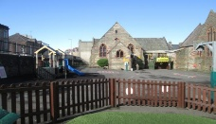 Year 2 – Spring 2 – Childhood 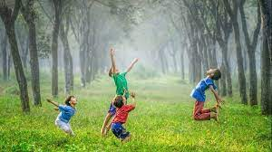
English | Maths | Science | Computing
Read Write Inc | Multiplication and Division  Length and Height, Mass, Capacity and Temperature | Working Scientifically | Creating Pictures
PE | Design and Technology | Art and Design | RE
Multi-skills  Yoga | Creating Paper Toys | Collage | Christianity  Islam  Buddhism
PSHE | History | Geography | Music
Diseases spread and can be controlled,  Staying safe around medicines, Fairtrade | Childhood | Our Country | Zootime  Easter Performance
- Snack money is £5 this term.
- PE days are Tuesday and Wednesday.
- Library day is Friday.
- Homework will be given out on Monday and should be returned by Friday.
Please bring book bags into school every day.

