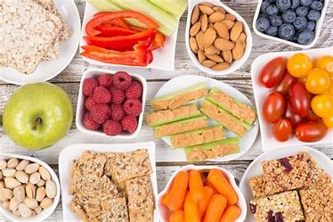 Year 2 – Summer 2 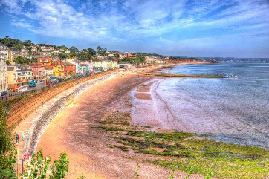
English | Maths | Science | Computing
Read Write Inc | Statistics  Geometry: Position and Direction | Working Scientifically | Creating Pictures  Coding
PE | Design and Technology | Art and Design | RE
Sports Day Practice  Yoga | Seaside Snacks | Textiles | Christianity  Islam  Buddhism
PSHE | History | Geography | Music
Countryside Code  Armed Forces Day  Sun Safety | We’re all going on a Summer Holiday | Seas and Coasts | Reflect, Rewind and Replay  Leavers’ Assembly Practice
- Snack money is £7 this term.
- PE days are Tuesday and Wednesday.
- Library day is Friday.
- Homework will be given out on Monday and should be returned by Friday.
Please bring book bags into school every day.

