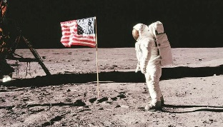 Year 2 – Spring 1 – Space 
English | Maths | Science | Computing
Read Write Inc | Money  Multiplication and Division | Living Things and Their Habitats | Internet
PE | Design and Technology | Art and Design | RE
Invasion Games  Dodgeball  Yoga | Space Mobiles | Collage | Christianity  Islam  Buddhism
PSHE | History | Geography | Music
New Year’s Resolutions  Children’s Mental Health  Safer Internet | The life of Neil Armstrong | Out of This World | I Want to Play in a Band
- Snack money is £5 this term.
- PE days are Tuesday and Wednesday.
- Library day is Friday.
- Homework will be given out on Monday and should be returned by Friday.
Please bring book bags into school every day.

