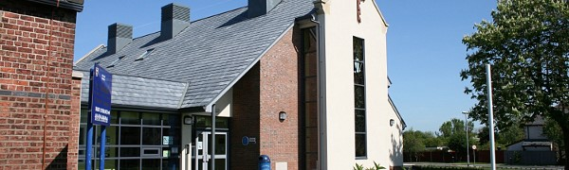
St. Nicholas Church of England Primary School Newsletter Autumn 1
I hope you and your family have had a wonderful start to the new school year and your child is settling in to their new class routine, and a very warm welcome to the new families joining ou…
Go to this Sway

