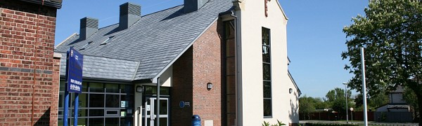
St. Nicholas Church of England Primary School Newsletter 17th March 2022
Parents' Evening Consultations.
Go to this Sway

