[St. Nicholas Church of England Primary School Newsletter November 2022](https://sway.office.com/VAaAIvuJRQpr4X36?ref=email)

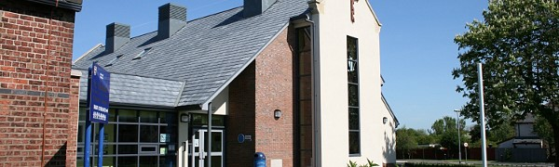

[Go to this Sway](https://sway.office.com/VAaAIvuJRQpr4X36?ref=email)