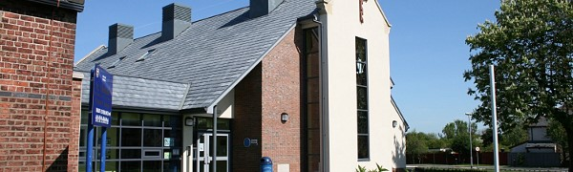

[St. Nicholas Church of England Primary School Newsletter March 2022](https://sway.office.com/SAapKZVifTGcpCfy?ref=email)