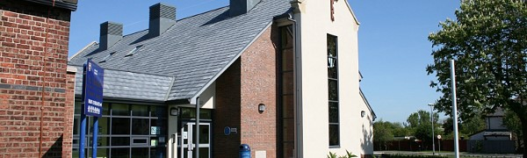
St. Nicholas Church of England Primary School Newsletter Winter 1
Go to this Sway

