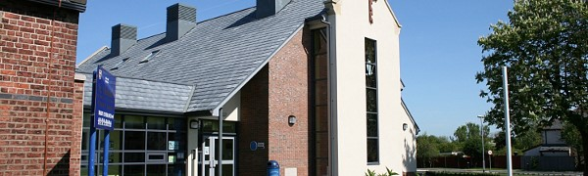
St. Nicholas Church of England Primary School Newsletter 1st April 2022 - EASTER
Dear Parents,
Go to this Sway

