
Key Skills for Reception
Reading, Writing and Maths
The following areas of learning are known as Key Skills. They have a specific role in helping children meet the year group expectations.
The Key Skills are designed to identify the essential components that children need to become confident with i.e. be able to demonstrate in independent tasks and be able to apply in other contexts.
By the end of this academic year, most children will be able to do the following:

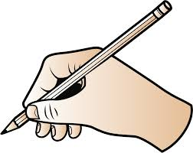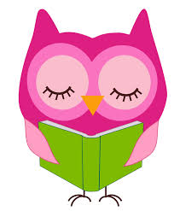
Key Skills for Maths
- Count to 20.
- Recognise written numerals 1 to 10 then 1 to 20.
- Touch count reliably at least 10 objects.
- Say one more/less (to at 10 then to 20)
- Use ‘more’ and ‘less’ to compare two numbers.
- Add two small groups of objects (to 10 then to 20).
- Beginning to use mathematical names for 2D and 3D shapes.
- Use everyday language to talk about size, weight, capacity, position, distance, time and money.

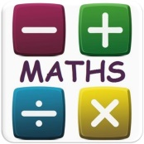
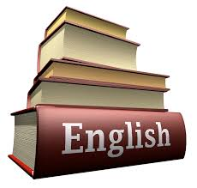

Key Skills for Writing
- Write words in ways which match spoken sounds.
- Write numbers 1-10.
- Write simple sentences which can be read by themselves and others.
- Write name (correct upper and lower case)
- Spell some words correctly and others in a phonetically plausible way.
Key Skills for Reading
- Read some common irregular words.
- Apply phonic knowledge to decode regular words & read aloud accurately.
- Identify rhymes and alliteration.
- Join in with rhyming patterns.
- Read & understand simple sentences.
- Demonstrate understanding when talking with others about what they have read.
- Make basic predictions.

