Key Skills for Maths
- Count to and across 100, forwards and backward from any number.
- Read and write numbers to 20 in digits and words.
- Read and write numbers to 100 in digits.
- Say 1 more/ 1 less to 100.
- Count in multiples of 1, 2, 5 and 10.
- Know bonds and subtracting facts to 20.
- Add and subtract:
  - 1 digit and 2 digit numbers to 20, including zero.
- Add and three 1-digit numbers with a total up to 20.
- Solve simple multiplication and division with apparatus and arrays.
- Recognise half and quarter of object, shape or quantity.
- Sequence events in order using appropriate time language.
- Use language of day, week, month and year.
- Tell time to hour and half past.

Key Skills for Year 1
Reading, Writing and Maths
The following areas of learning are known as Key Skills. They have a specific role in helping children meet the year group expectations.
The Key Skills are designed to identify the essential components that children need to become confident with i.e. be able to demonstrate in independent tasks and be able to apply in other contexts.
By the end of this academic year, most children will be able to do the following:

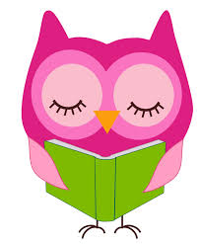

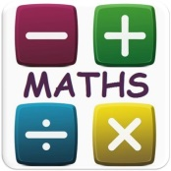

Key Skills for Writing
- Use ‘and’ to join ideas.
- Introduce use of:
- capital letters
- full stops
- question marks
- exclamation marks
- Use capital letters for names and personal pronoun ‘I’.
- Write a sequence of sentences to form a short narrative [as introduction to paragraphs].
- Use correct formation of lower case – finishing in right place.
- Use correct formation of capital letters.
- Use correct formation of digits.
- Read aloud their writing clearly enough to be heard by peers and teacher.
- To correctly spell the days of the week.
- To correctly spell words containing the 40+ phonemes.
- To correctly spell words containing the following prefixes and suffixes: -s –es –un –ing –ed –er –est (where no change is needed in the spelling of the root word.)

Key Skills for Reading
- Identify which words appear again and again.
- Correctly identify graphemes for all 40+ phonemes.
- Recognise and join in with predictable phrases.
- Relate reading to own experiences.
- Re-read if reading does not make sense.
- Re-tell with considerable accuracy.
- Discuss significance of title and events.
- Make predictions on basis of what has been read.
- Make inferences on basis of what is being said and done.
- Read aloud with pace and expression, i.e. pause at full stop; raise voice for question.
- Recognise:
- capital letters
- full stops
- question marks
- exclamation marks
- ellipsis
- Know why the writer has used the above punctuation in a text.
- Know difference between fiction and non-fiction texts.

