
Key Skills for Year 2
Reading, Writing and Maths
The following areas of learning are known as Key Skills. They have a specific role in helping children meet the year group expectations.
The Key Skills are designed to identify the essential components that children need to become confident with i.e. be able to demonstrate in independent tasks and be able to apply in other contexts.
By the end of this academic year, most children will be able to do the following:

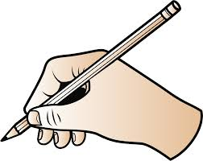
Key Skills for Maths
•Compare and order numbers up to 100.
•Read and write all numbers to 100 in digits and words.
•Say 10 more/less than any number to 100.
•Count in multiples of 2, 3, 5 and 10 from any number up
to 100.
•Recall and use multiplication and division facts for2, 5
and 10 tables.
•Recall and use addition and subtraction facts to 20.
•Derive and use related facts to 100.
• Recognise place value of any 2-digit number.
•Use the <> and = signs correctly.
•Add and subtract:
- 2-digit numbers and ones
- 2-digit numbers and tens
-Two 2-digit numbers
-Three 1-digit numbers
•Recognise and use inverse for addition and subtraction
•Calculate and write multiplication and division
calculations using multiplication tables.
•Recognise and use inverse for multiplication and division
•Recognise, find, name and write; ½ ¼ ¾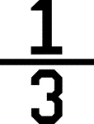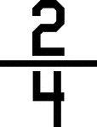
•Recognise equivalence of simple fractions.
•Tell time to five minutes, including quarter past and to
the hour.

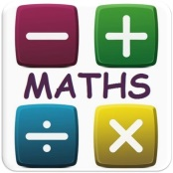
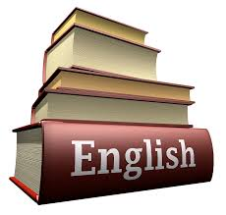
Key Skills for Writing
- Write different kinds of sentence: statement,
question, exclamation, command.
- Distinguish between homophones and near homophones.
- Use expanded noun phrases to add description and specification.
- Write using subordination (when, if, that, because) and co-ordination (or, and, but).
- Correct and consistent use of present tense & past tense.
- Correct use of verb tenses.
- Write with correct and consistent use of:
- capital letters
- full stops
- question marks
- exclamation marks
- Use commas in a list.
- Use apostrophe to mark omission and singular possession in nouns. (contractions)
- Write under headings.
- Write lower case letters correct size relative to one another.
- Show evidence of diagonal and horizontal strokes to join handwriting.
- Add suffixes to spell longer words: -ment, -ness, -ful, -less and –ly.
- To be proficient in using the correct terminology when discussing grammar and punctuation.

Key Skills for Reading
- Be secure with year group phonic expectations.
- Read words with common suffixes, to include s, es, ing, ed, er, est.
- Recognise simple recurring literary language.
- Read ahead to help with fluency and expression.
- Comment on plot, setting & characters in familiar & unfamiliar stories.
- Recount main themes and events.
- Comment on structure of the text.
- Use commas, question marks and exclamation marks to vary expression.
- Read aloud with expression and intonation.
- Recognise:
- commas in lists
- apostrophe of omission and possession (contractions)(singular noun)
- Identify past/present tense and why the writer has used a tense.
- Use content and index to locate information.
- Discuss and clarify the meanings of words.
- Discuss favourite words and phrases.

