
Key Skills for Year 3
Reading, Writing and Maths
The following areas of learning are known as Key Skills. They have a specific role in helping children meet the year group expectations.
The Key Skills are designed to identify the essential components that children need to become confident with i.e. be able to demonstrate in independent tasks and be able to apply in other contexts.
By the end of this academic year, most children will be able to do the following:

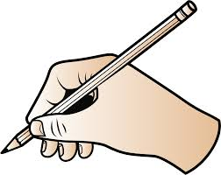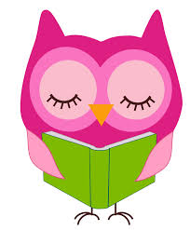
Key Skills for Maths
- Compare and order numbers up to 1000
- Read and write all numbers to 1000 in digits and words.
- Find 10 or 100 more/ less than a given number.
- Count from 0 in multiples of 4, 8, 50 and 100.
- Recall and use multiplication and division facts for 3, 4, 8 tables.
- Recognise place value of any 3-digit whole number.
- Add and subtract;
- 3-digit numbers and ones
- 3-digit numbers and tens
-3–digit numbers and hundreds.
- Add and subtract;
- Numbers with up to 3-digit using efficient written method.
- Use inverse to check
- Multiply;
- 2-digit by 1-digit
- Count up/ down in tenths.
- Compare and order fractions with same the denominators.
- Addition and subtraction of fractions with same denominator within one whole.
- Know pairs of fractions that total 1.
- Tell time using 12 and 24 hour clocks; and using Roman numerals.
- Tell time to nearest minute.
- Know number of days in each month.

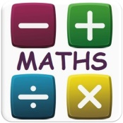
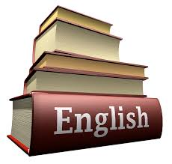

Key Skills for Writing
- Have a positive attitude and stamina for writing.
- Use conjunctions (when, so, before, after, while, because).
- Use adverbs (e.g. then, next, soon).
- Use prepositions (e.g. before, after, during, in, because).
- Experiment with adjectives to create impact.
- Correctly use verbs in 1st, 2nd and 3rd person.
- Use perfect form of verbs to mark relationships of time and cause.
- Use inverted commas to punctuate direct speech.
- Group ideas into basic paragraphs.
- Write under headings and sub-headings.
- Write with increasing legibility, consistency and fluency.
- In narratives, create setting, characters and plot.
- In non-narrative material, use appropriate organisational devices.

Key Skills for Reading
- Develop a positive attitude to reading.
- Comment on the way characters relate to one another.
- Know which words are essential in a sentence to retain meaning.
- Draw inferences such as inferring characters’ feelings, thoughts and motives from their actions.
- Recognise how commas are used to give more meaning.
- Recognise inverted commas
- Recognise:
- plurals
- pronouns and how used
- collective nouns
- adverbs
- Explain the difference that the precise choice of adjectives and verbs make.
- Discuss words that capture the reader’s interest.
- Increase familiarity within a range of books.
- Identify main ideas drawn from more than one paragraph.

