
Key Skills for Year 4
Reading, Writing and Maths
The following areas of learning are known as Key Skills. They have a specific role in helping children meet the year group expectations.
The Key Skills are designed to identify the essential components that children need to become confident with i.e. be able to demonstrate in independent tasks and be able to apply in other contexts.
By the end of this academic year, most children will be able to do the following:


Key Skills for Maths
- Count backwards through zero to include negative numbers.
- Compare and order numbers beyond 1000.
- Compare and order numbers with the same number of decimal places up to 2 decimal places.
- Read Roman numerals to 100.
- Find 1000 more/ less than a given number.
- Count in multiples of 6, 7, 9, 25 and 1000
- Recall and use multiplication and division facts all table to 12x12.
- Recognise place value of any 4-digit whole number.
- Round any number to the nearest 10, 100 or 1000.
- Round decimals with 1 decimal place to nearest whole number.
- Add and subtract:
- Numbers with up to 4-digits using efficient written methods (column)
- Numbers with up to 1decimal place.
- Multiply:
- 2-digit by 1-digit
- 3-digit by 1-digit
- Count up/down in hundredths.
- Write equivalent fractions.
- Add and subtract fractions with same denominator.
- Read, write and convert time between analogue and digital 12 and 24 hour clocks.

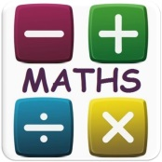
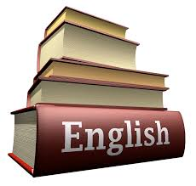

Key Skills for Writing
- Continue to have a positive attitude and stamina for writing.
- Vary sentence structure, using different openers.
- Use adjectival phrases (e.g. biting cold wind).
- Use appropriate choice of noun or pronoun.
- Use fronted adverbials.
- Use apostrophe for plural possession.
- Use a comma after fronted adverbial (e.g. Later that day, I heard bad news.).
- Use commas to mark clauses.
- Use inverted commas and other punctuation to punctuate direct speech.
- Use paragraphs to organise ideas around a theme.
- Use fronted adverbs to introduce paragraphs.
- Write with increasing legibility, consistency and fluency.
- In narratives, create setting, characters and plot.
- In non-narrative material, use appropriate organisational devices.

Key Skills for Reading
- Have a positive attitude to reading.
- Give a personal point of view on a text.
- Re-explain a text with confidence.
- Justify inferences with evidence, predicting what might happen from details stated or implied.
- Use appropriate voices for characters within a story.
- Recognise apostrophe of possession (plural)
- Identify how sentence type can be changed by altering word order, tenses, adding/deleting words or amending punctuation.
- Explain why a writer has used different sentence types or a particular word order and the effect it has created.
- Skim & scan to locate information and/or answer a question.
- Discuss words and phrases that capture the reader’s imagination.
- Read for a range of purposes.

