
Key Skills for Year 6
Reading, Writing and Maths
The following areas of learning are known as Key Skills. They have a specific role in helping children meet the year group expectations.
The Key Skills are designed to identify the essential components that children need to become confident with i.e. be able to demonstrate in independent tasks and be able to apply in other contexts.
By the end of this academic year, most children will be able to do the following:

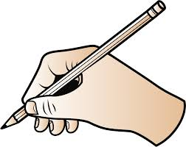
Key Skills for Maths
• Compare and order numbers up to 10,000,000.
• Identify common factors, common multiples and prime
numbers.
• Round any whole number and decimal number to a
required degree of accuracy.
• To read, write and compare numbers with up to 3
decimal places.
• Multiply:
- 4-digits by 1-digit/ 2-digit
• Divide
- 4-digits by 2-digits
• To use BODMAS to calculate (Brackets, Order, Divide,
Multiply, Add, Subtract).
• To cube numbers
• Add and subtract fractions with different denominators
and mixed numbers.
• To write fractions in their simplest form.
• Multiply simple pairs of proper fractions, writing the
answer in the simplest form.
• Divide proper fractions by whole numbers.
• Calculate percentage of a whole number.
• To convert between fractions, decimals and
percentages.

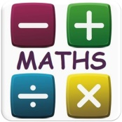
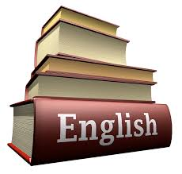

Key Skills for Writing
- Maintain a positive attitude and stamina for writing across a range of text types.
- Use subordinate clauses to write complex sentences.
- Use passive voice where appropriate.
- Use expanded noun phrases to convey complicated information concisely (e.g. The fact that it was raining meant the end of sports day).
- Use a range of sentence structures.
- Use a sentence structure and layout matched to requirements of text type.
- Use semi-colon, colon or dash to mark the boundary between independent clauses.
- Use colon to introduce a list and semi colon within a list.
- Use correct punctuation of bullet points.
- Use hyphens to avoid ambiguity.
- Use full range of punctuation matched to requirements of text type.
- Use wide range of devices to build cohesion within and across paragraphs.
- Use a wide range of figurative language to add detail to creative writing.
- Use paragraphs to signal change in time, scene, action, mood or person.
- Write legibly, fluently and with increasing speed.
- Identify audience and purpose of a piece of writing, selecting appropriate form and using other similar writing as models for their own.
- In narratives, successfully integrate dialogue to convey character and action.
Key Skills for Reading
- Maintain a positive attitude to reading.
- Recognise and discuss how layout and other presentational devices aid structure and comprehension of a text.
- Refer to text to support opinions and predictions.
- Give a view about choice of vocabulary, structure, etc.
- Distinguish between fact and opinion.
- Appreciate how a set of sentences has been arranged to create maximum effect.
- Recognise:
- complex sentences with more than one subordinate clause
- phrases which add detail to sentences
- Explain how a writer has used sentences to create particular effects.
- Skim and scan to aide note-taking.

