Online Learning at St Nicholas Primary
How to login to Letter Join – Handwriting

Go to https://www.letterjoin.co.uk/
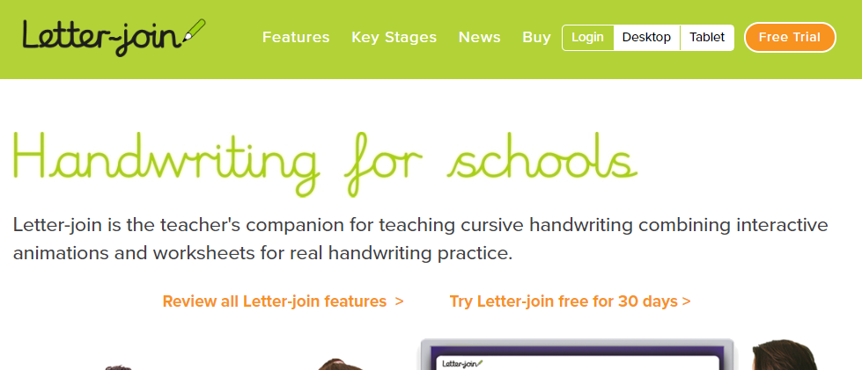
Click the ‘Login’ button at the top of the screen.
Username: nich
Password: olas

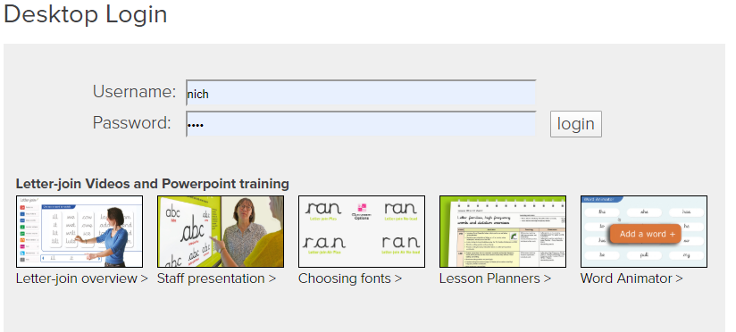
Click on free play, or explore some of the other useful resources within the website. There is also a ‘Home Guide’ available from the website.
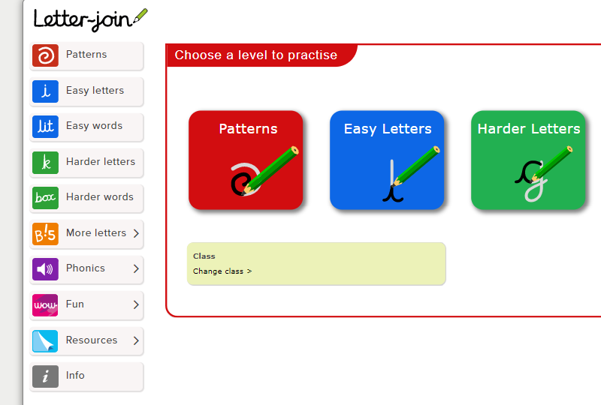

If you have any problems logging in, then please contact Mr Peak/Mr Freeman via the school office: admin3146@welearn365.com
Online Learning at St Nicholas Primary
How to login to Letter Join – Handwriting

Go to https://www.letterjoin.co.uk/
Click the ‘Login’ button at the top of the screen.
Username: nich
Password: olas

Click on free play, or explore some of the other useful resources within the website. There is also a ‘Home Guide’ available from the website.

If you have any problems logging in, then please contact Mr Peak/Mr Freeman via the school office: admin3146@welearn365.com

