Online Learning at St Nicholas Primary
How to login to TTrockstars

Go to www.ttrockstars.com
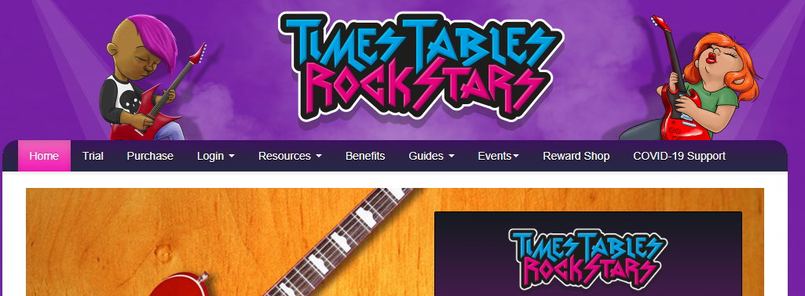
Click on Login at the top and choose School Pupils


Click Login
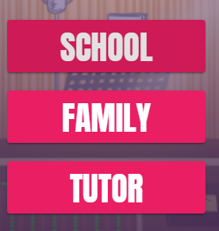
Select School
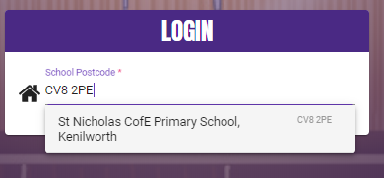
If requested enter school postcode (CV8 2PE) and select our school.
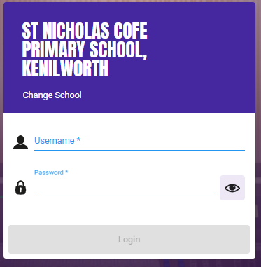
Login in with your TTrockstars account.
If you have lost your TTrockstars account details, please contact Mr Peak/Mr Freeman via the school office: admin3146@welearn365.com

