Online Learning at St Nicholas Primary
How to login to Welearn365 and Purple Mash

Go to www.welearn365.com
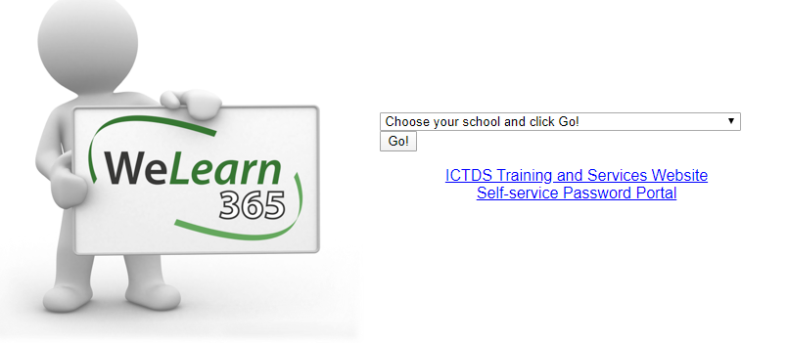
Choose St Nicholas C of E Primary School, Kenilworth and then click Go!
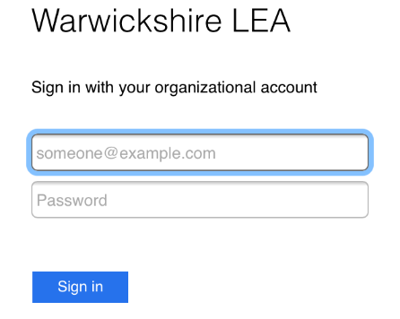
Sign in using the details which you log in at school.
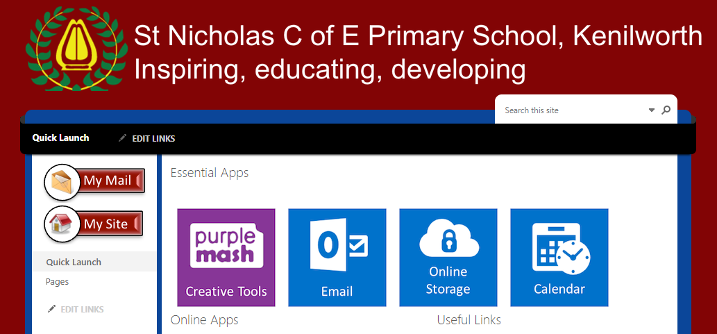
Click on Purple mash
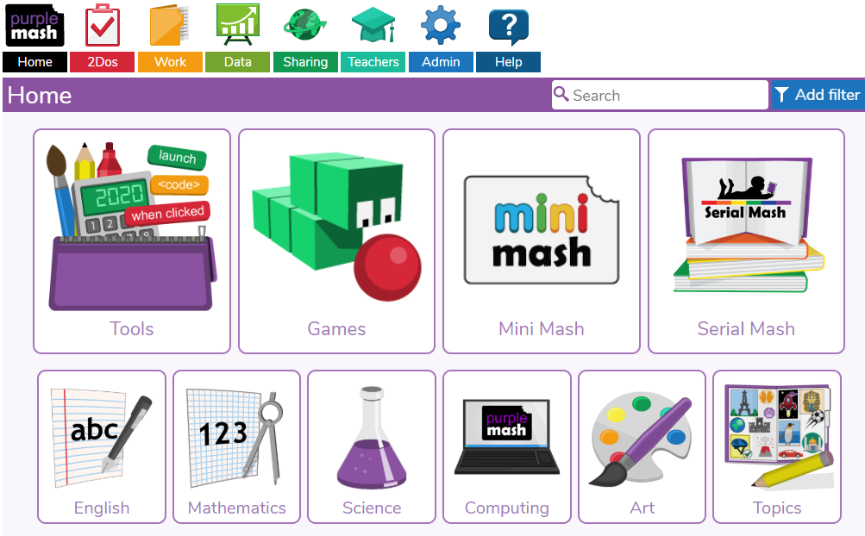
There are lots of games and resources which are available to all ages of children.
Some of our favourites are:
FS-
Art-Paint projects Computing- 2Type English- 2Publish
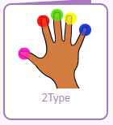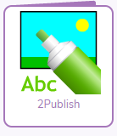
KS1 –
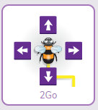
KS2 –
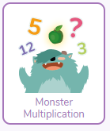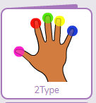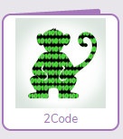
If you have lost your account details, please contact Mr Peak/Mr Freeman via the school office: admin3146@welearn365.com

