EAGLES’ WEEKLY SUGGESTED HOME LEARNING – WB 15.6.20
Good morning Eagles! Here we are again. Sometimes it’s difficult to remember what day it is during lockdown. Put Tuesday in your diary though at 10:30 am, as we’re offering a Zoom session so that we can see your lovely faces. Nobody will be asked to speak if you don’t want to. We’ll just give you a quiz to have a go at for fun. We’re planning some other sessions so let us know if there’s anything you’d like to do or if you’ve got any questions about anything and we’ll try to answer them for you. The transition activities are really useful for you to be doing and will help to get you in the right frame of mind. We hope that you have a good week and we can’t wait to see as many of you as possible on Tuesday.
Take care - #StaySafeStayHomeSaveLives
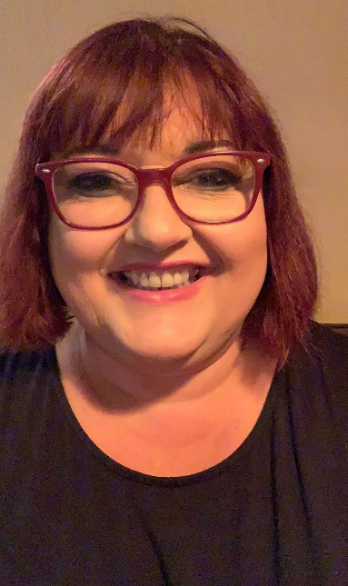
Mrs Colothan, Mrs Hillam, Mrs Jones, Mrs Donlon and Miss Clegg XX
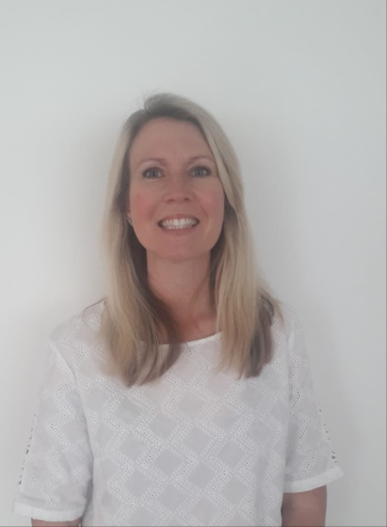
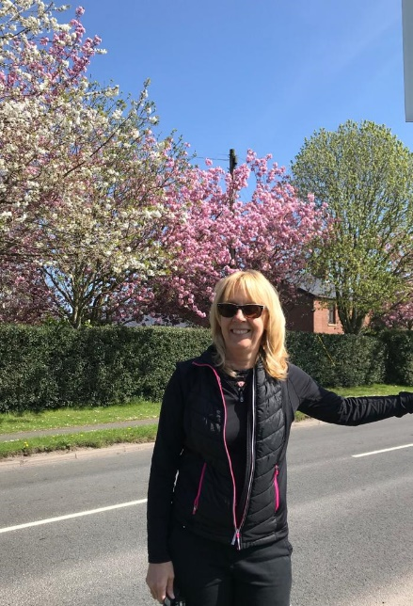

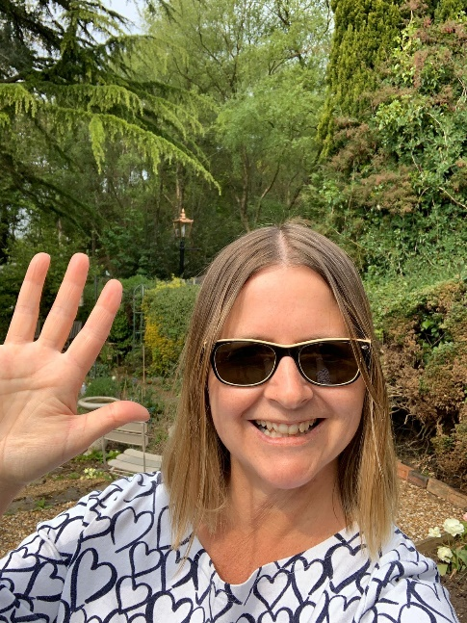
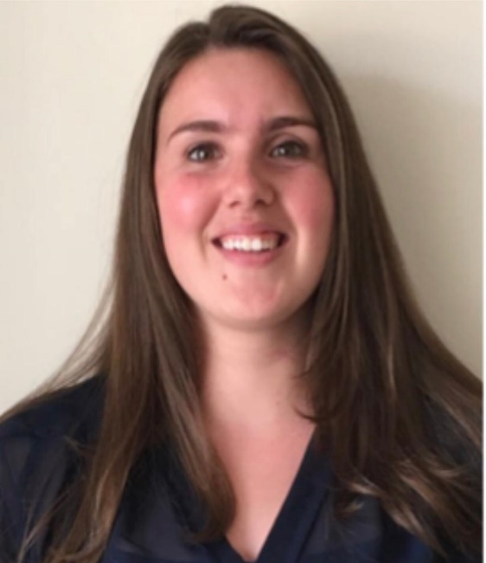
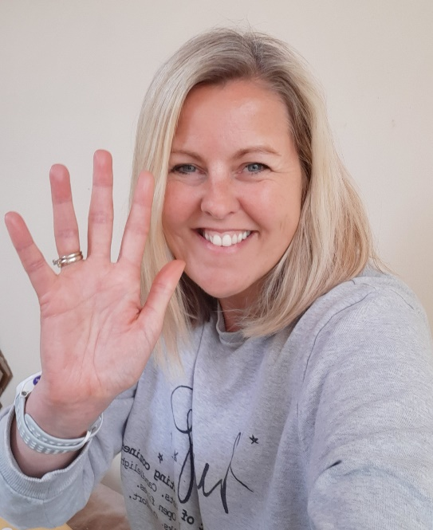

ENGLISH |  | MATHS
Reading – Read every day for pleasure for 30 minutes. You may like to use Epic. This is a great website where you read many online books for free for a month.  This week we are having a weekly focus on the genre of instructions.  https://classroom.thenational.academy/lessons/instructions-lesson-1-reading-focus  Follow this web link and work through the five lessons on instructions. These five lessons contain all the reading and writing work for the week, including a spelling test.  At the end of the week, you will be asked to write some instructions which will require a good imagination. Please ensure that the content of your work, including spelling, punctuation and grammar is your very best!  Spellings – Choose some of the words the Y5/Y6 list that you needed to learn better from last week (or choose any words that you struggle spelling) and complete the ‘Roll and Spell’ task below. |  | 7 and 11 times table – Instant recall.  https://ttrockstars.com/  How many patterns can you spot in the 7 and 11 times tables? What patterns can you spot?  https://classroom.thenational.academy/subjects-by-year/year-6/subjects/maths  Use this web link and scroll down to the Decimals and Measures section. Begin to work through the first 5 lessons on this section.  You can also access the Corbett Maths primary. They have some fantastic videos and 5 a day - questions which will keep different aspects of maths bubbling for you.  https://corbettmathsprimary.com/
R.E. | OTHER
Our new theme is based on Reconciliation.  Please see below for some information about a special place called Lourdes. You may want to carry out some additional research and talk to the grown up who you live with about this. Design a poster for a school or parish trip to Lourdes and explain why it would be good to go, what the experience would be like and how it might shape your life.  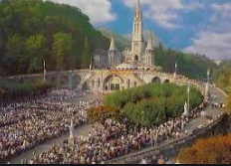  http://www.wednesdayword.org/ | Transition Tasks:  You completed some fantastic work using the Robin Hood MAT last week. We will continue with this.  Follow the link below and then scroll down to Y6/7 transition learning projects. Week beginning 15th June. The theme is about making new friends – something that can be a worry for many of us! Even adults find it really difficult to make friends with new people!  https://www.robinhoodmat.co.uk/Learning-projects/  History  Find out 10 amazing facts about Wigan North Western train station and Wigan Wallgate – create a poster or Powerpoint to let others know about these train stations. It’s really unique to have 2 stations in one town so close to one another. You could even do a video report for the local news.  Music  Have a play about on the app BandLab. You can compose all kinds of music for different reasons. It could be music for a sunny day or a rainy day for example. It could be a piece of music inspired by a person in your life or a happy or sad event that happened. We’ve had loads of fun in my house composing different music by adding different instruments gradually. I’d love to hear how you get on.  Podcasts  I love listening to Podcasts and have been really inspired by them. Have a go at listening to a podcast this week. You can have it on in the background whilst you are drawing. You’ll be amazed at what you can learn. Try: But Why: A Podcast for Curious Kids; brains on; You’re Dead To Me – A history podcast from the makers of Horrible Histories.  There’s even story podcasts and calming ones to help you to relax and go to sleep. Give one a go this week.  Art  https://classroom.thenational.academy/lessons/optical-illusions-and-using-shading-to-show-form-07dac6/activities/1  Have fun creating some optical illusions.

RE Task
Lourdes, a place of healing.

Lourdes is in the south of France. It is an important place of pilgrimage for sick people. It all began when a poor young girl called Bernadette Soubirous, had a vision of Our Lady (her story is in More Friends of Jesus).
Our Lady appeared to Bernadette 18 times, standing on a rock above a dirty old grotto (cave), where pigs used to shelter. At first people thought Bernadette was mad, but she persisted and did as Our Lady asked her. Often, she would pray the Rosary as she gazed at the figure. She did not know it was Our Lady at first. During the thirteenth time Our Lady appeared, she told Bernadette: “Go, tell the priests to come here in procession and build a chapel here.”
Another time, Our Lady told Bernadette to drink at the spring. There was no spring there, but Bernadette scrapped at the earth with her bare hands and, after a few tries, clear, clean water appeared. Later on, other people heard about it and a girl called Catherine, who had a paralysed arm, came and touched the rock and her arm was healed. After that, many people began to visit the grotto and eventually a number of churches were built to accommodate the pilgrims who came to pray.
Today 6 million people come to Lourdes every year from all over the world. Very many sick people come, some wanting a physical cure, but above all, a spiritual healing and to return and face life with an inner peace. There are five special signs at Lourdes:

- The water: many people who go to Lourdes bathe in special baths in the water from the spring.
- The rock of the grotto: pilgrims like to touch the rock of the grotto where Our Lady stood.
- Light: at night, there is a candlelight procession and all day there are candles burning in front of the grotto, reminding people of the light of Christ.
- The crowds are huge, coming from every race and nation, young and old, sick and healthy. Lourdes is a true experience of the Church, a gathering together of all the scattered children of God.
- The sick are given a special blessing every afternoon. It gives them comfort and their helpers also gain from the experience of being with the sick and serving them as Christ cared for the sick when he was on earth.

HCPT - The Pilgrimage Trust is an organisation which enables those who may need help, especially children and adults with disabilities, learning difficulties and social and emotional needs, to experience a pilgrimage to Lourdes. Every year they organise trips to Lourdes for over 7000 people.
SOME KEY QUESTIONS

- What do you think of the way Bernadette acted ?
- Why do you think people go to Lourdes?
- Would you like to go and why?
- What do you think you might do in Lourdes?
- Which of the five signs appeals to you most and why?

SOME SUGGESTED ACTIVITIES

- Research some information about Lourdes and design a poster for a school or parish trip to Lourdes and explain why it would be good to go, what the experience would be like and how it might shape your life.

