OWLETS AND EAGLETS - WEEKLY SUGGESTED HOME LEARNING –
WB 15.06.2020

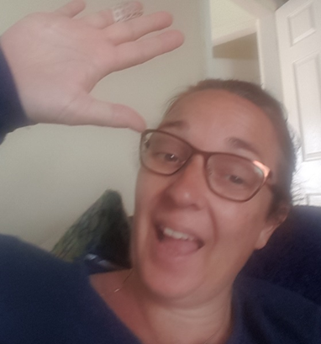

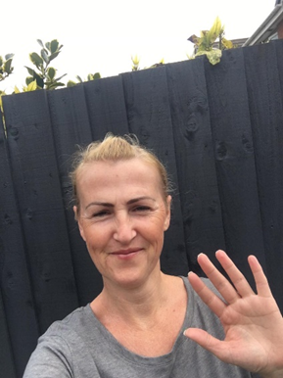
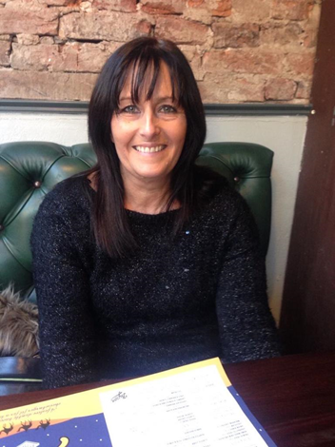

Hello again Owlets and Eaglets, we hope you are all well and still looking after yourselves. These are our suggested activities for you this week. We hope that you enjoy them. This week the focus is on Sport, we know how much you enjoy our PE lessons. Please remember to share some pictures on See-Saw. It is lovely to see what you have been up to, thank you for keeping in contact with us, we miss you so much and it’s lovely to see your happy faces, showing us what you have been up to. Thank you for your ongoing support, enjoy your week of learning. School email – enquiries@saintoswalds.wigan.sch.uk Tweet - @saintoswalds

ENGLISH | MATHS
Reading – Read a variety of books at home. Favourite books can be repeated as it supports the children with their language development as they will hear the patterns of language in the story.  Use Oxford Owl to access books that are related to phase 2 and 3 phonics. Where possible children to read to parents daily.  When you go on click on all ages and click on age 4-5. Then go into levels and click on letters and sounds and choose either phase 2 or 3.(phase 2 will be a little easier and phase 3 more challenging) If you find that these are still not challenging for them then choose age 5-6, go into levels, letters and sounds and click on phase 4. This will then bring books up for you to access with your child.  After reading the book ask the questions on the back cover of the book and complete the play activities linked to the book.  Register here for free access to Oxford owl or you can use our class login  My class name – owlets and eaglets  My Class Password – reception.  Just go to the Oxford Owl login page and click on the My Class login button and use the above details.  Some extra literacy activities this week are taken from Robin Hood Multi Academy Trust. Focus this week is on Sport.  Talk to your child about some words used in sports such as throw, hit, catch, ball. Go on a word hunt around the house to find these words in books, magazines or newspapers.  Listen to stories about sports - Peppa Pig, The Large Family - The sports Day, Maisy's Sports Day.  Reception age children: Can your child practice reading the tricky words: from phase 2 and 3? See end of planning for key words.  Story focus - Sports day in the Jungle Watch this online reading. Sports day in the Jungle.  What is your favourite part of the story?  Who are the characters? Where was the story set?  What happened at the beginning of the story?  What happened in the middle of the story?  What happened at the end of the story  Writing task 1 – Share the story ‘Sports day in the Jungle’ again. Talk for writing – talk with the children about all the different sports that the animals did in the jungle. How were the characters feeling? Write a list of some of the ‘sports’ the animals completed.  Writing task 2:  Ask your child to draw a picture of themselves doing something sporty. i.e. running, jumping, a cartwheel. Can they label the picture or write a simple sentence e.g. I can hop  Remember to use a phase 2 and 3 sound mat to help your child with the sounds in the words.  Writing task 3:  Practice name writing. Can they write their first name? Middle name? Surname?  Writing task 4:  Practise letter formation using this link animated letter formation tool  Inference activity  See end of planning for larger pictures for this activity. Can I infer what is happening in the pictures?  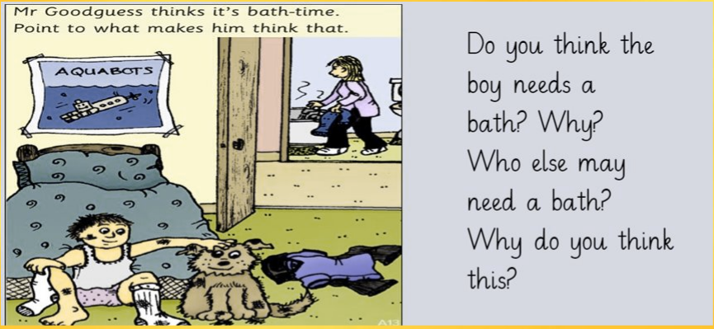  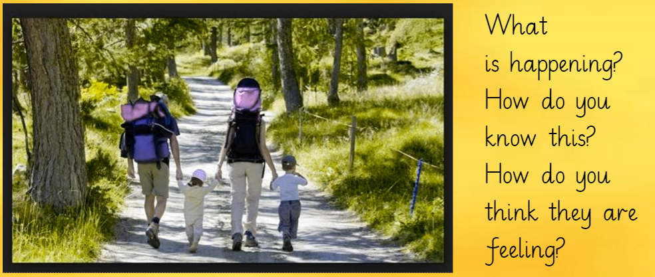  Phonics (Reading and writing)  Please remember to use the free log in -  Use the Username – march20 and the password – home  If you wish to complete a spelling test use a mixture of the key words you have looked at with the children from phase 2 and 3. Only look at up to 8 words choose from these words – the, I no, go, to, into, he, we, me, be, she, they, was, my, all, you, her, are. Or use the words covered in this weeks phase 4 planning.  Phase 4 phonics – Start your phonics session by playing the flashcard games on phonics play for key words and sounds for either phase 2 or phase 3.  Help your children to read the following words – flag, trot, jump, fast, kicker, punch. Once they have practised reading them, can they have a go at writing them? Segment the words slowly so that the children can hear each sound.  These are some of the phase 4 tricky words we would like you to introduce – so, do, some, come - ‘’ Write the tricky words on paper show them your child and help them to read them. Make a bingo game with these words and some from phase 2 and 3 that they need to practise. Who will be the first to fill their bingo board and shout BINGO?  Help your child to read the sentences we have written at the bottom of the planning.  Ask your child to write the following words (please use them over the week and not all on one day) book, look, shook, took, light, night, flight, might. (these are practise words to help keep phase 3 sounds ticking over.) Can your child say these words in a sentence?  Extra challenge – Can your child write the sentences they have said? | Mathematics  Watch number blocks clip each day with your child at  Numberblocks BBCiplayer or Numberblocks Cbeebies  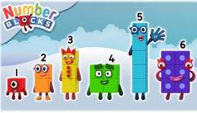  Activity – Practice number formation with you children. Here are the rhymes that we use in the classroom to help your child remember how to write the numbers.  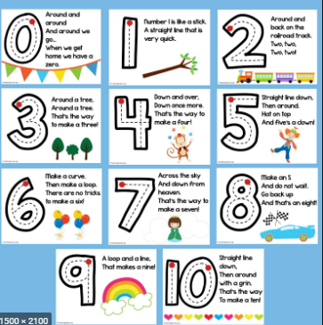  Follow the White Rose Week 7 using the story The Princess and the Wizard – Days of the week, patterns, counting, doubling, halving, and sharing subtraction, symmetrical patterns, positional language.  You may also want to look on Oak National Academy Reception Click on the link below to access 5 lessons on Doubling and Halving. This includes understanding the concept of doubling and then halving, applying and understanding doubling and halving. Click the link to take you to all the maths activities on Oak National Academy Doubling and halving. Please scroll down to the bottom of the link to find the 5 lessons on doubling and halving.  Practise counting up to 20. This can be done through playing hide and seek, singing number songs, chanting, board games etc. Remember to also practise counting back from 20 to 0.  Don’t forget that you have your Numbots username and password that was sent to you on your child’s see-saw learning journal. Look in the parent information file on the app to find it again if you have forgotten it.  Work on positional language if you wish to do some more activities taken from Robin Hood Multi academy trust learning projects..  Listen to this song Where am I now? - position song and then watch this video Describing positon of objects to learn about positional language.  Play positional language Hide and Seek- Choose a selection of items and hide them. Ask your child to count out loud while you’re doing this. Give them clues about the positions of the objects, e.g. it’s under the chair.  Listen to the story We're going on a Bear Hunt. Talk about the positional language used in the story – through, over, under. Create a story in the house using these words-over, under, though, behind, next to, opposite, around.  Encourage your child to jump, hop or skip. Give them directions as they do this e.g. jump forwards 5.  Make a positional language picture- cut out a selection of 2d shapes. Give your child positional instructions to create a picture e.g. put the square in the middle of your page.
R.E. | OTHER
The theme is: Good News  RE –Reveal Jesus’ new rule.  Read Text based on John 13: 34-35  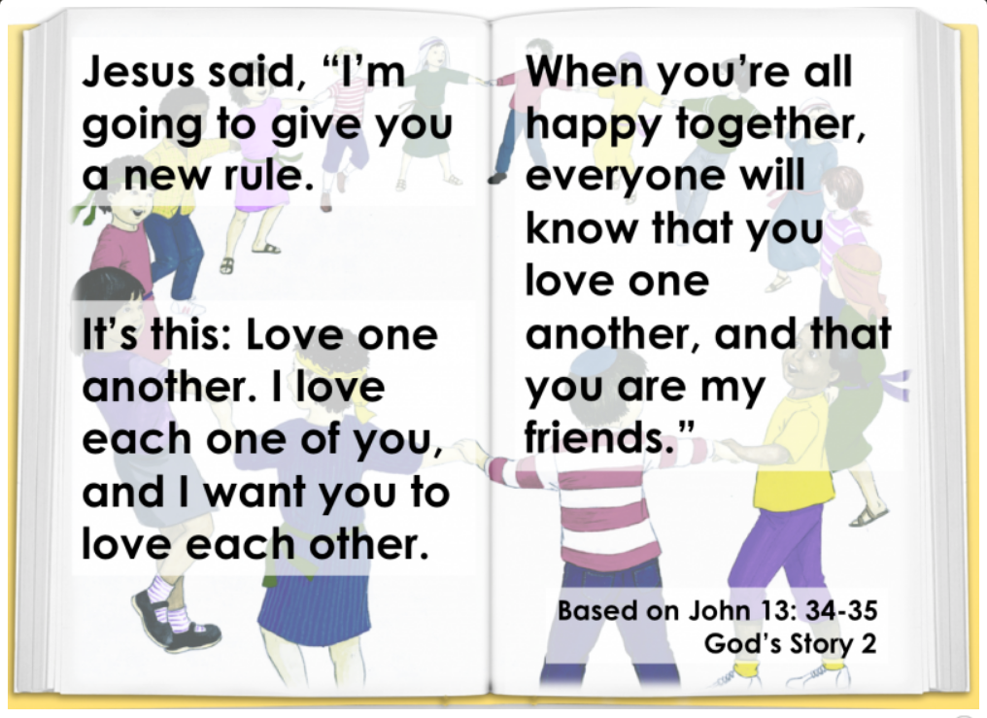  Answer these questions –  - What is Jesus’ rule? What will happen when you are happy together? Why do you like your friends? What makes a good friend? Is there anything which might break the friendship circle? (talk about the things that can make you and others unhappy introduce saying sorry) What will help to mend the circle?  Listen to and learn this song and join in once you know the words Come and join the circle. By Bernadette Farrell.  Task – Make a banner to show Jesus’ rule and decorate it. Display where lots of people will see it. Use the template at end of planning or make your own.  Love one another  Make a paper doll chain and turn each person into one of your friends. Then join them into a circle.How to make a paper doll chain. | PE – Follow the link  Youth sport trust home learning resources for early years.  Ball Games ● Play a game of catch with a ball - when you drop the ball, you lose a point. You could record points using a tally chart and count up who has the most points at the end. CHALLENGE: See if you can catch the ball standing further apart, catch with one hand or use a smaller ball.  Play Skittles ● If you have a set of skittles, you’re ready to go, if not you can make your own skittles using plastic bottles. Take a plastic bottle and partly fill with water/soil/ stones or sand to weigh it down. If you don’t have plastic bottles available you could use tin cans for an alternative version. Ask your child to count how many skittles there are to begin with. Roll the ball at the skittles and ask your child to count how many they have knocked over. Can they work out how many are left? CHALLENGE: You could write this out as a subtraction number sentence e.g. if you start with 5 skittles and knock over 2 your child would write 5 - 2. Ask them to count how many are left to find the answer 5 - 2 = 3  Have a time challenge. Give your child an action to do e.g. hop, skip, jump, clap or star jump. how many can they do in one minute. Keep a record of the scores. Ask everyone in the house to have a go!  Balance activity card - Can you copy the balances? Body challenge cards  Understanding the world –  Parts of the Human Body ● Ask your child which parts of their body they use to run? To do a handstand? Draw around the children and ask them to label the different parts of the body. Remember to use your phonics knowledge. How many can you name?  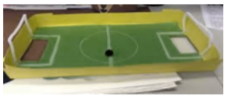  Recycling/ Exploring Materials- Create your own Junk Modelled Football Pitch ● Using a lid of a shoe box or similar container, help your child to cut out two holes on each end as the goals. If you have green card or paper, stick this in the base, if not you can colour in plain paper using a crayon. Draw out the marking on the pitch using crayons or felt tips. When finished, stand your football pitch on a box on the table. Using something ball-like (e.g. a sweet), take turns aiming at your partner’s goal whilst the other tries to save the goal. If you score you get to eat the sweet! CHALLENGE: Write instructions to play your game e.g. 1. Put the ball in. 2. Flick at the goal. 3. Eat the sweet!  Wellbeing - try cosmic kids yoga Click on the link and choose from one of the videos.  Take some time to be quiet and still, listen to some calming music and think about your week. What has gone well? What has not gone so well?  A lesson about feeling worried shared by Oak National Academy.  A lesson about feeling worried during the lesson you will listen to a story and create your own worry jar and happy box.

Your own number rhyme sheet.

RE text
RE Banner Template

Inference activity

Phonics
When revisiting the sounds with the children sing the song.
i.e when revisiting a sound.
An (insert the sound here) together make one sound.
What is it?
An (insert the sound here) together make one sound.
What is it?
It’s in (insert 4 words with the sound in here)
An (insert the sound here) together make one sound.
What is it?

If you need support with the song when recapping sounds with your child, please do not hesitate to get in contact with Mrs Gill via see-saw.

After singing the song ask the children which sound did we hear in each of the words. Repeat the words slowly if you need to. Then repeat the song again but where we sing what is it? The children say the sound the letters make together.

Resources for Phonics
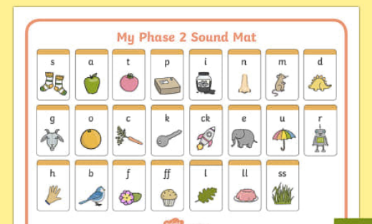
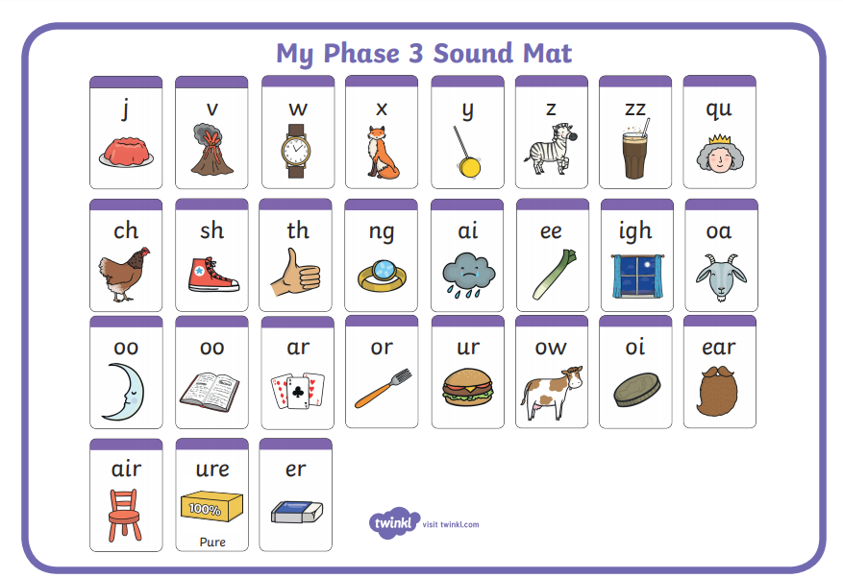

Phase 2, 3 and 4 tricky words for you to practise.
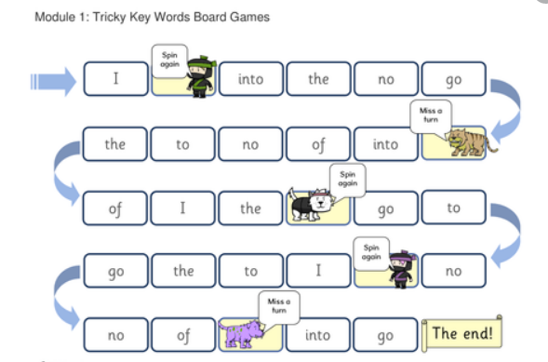

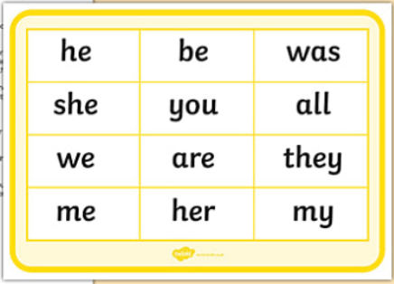
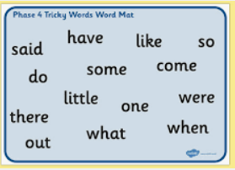

Phonics sentences

- Has it been hot this year?.

- Bow down to the king and queen.

- The frog swam across the pond.

- The dog ran along the track.

- The cat had to jump high over the wall.

