ROBINS’ WEEKLY SUGGESTED HOME LEARNING – WB 15.6.20
Hi Robins, we hope that you enjoyed your tasks last week all about friendship. This week’s tasks are all about Oceans. It was World Oceans’ Day last week and we thought you would love to know more about the oceans of the world and the plants and animals that live there. We hope the weather improves and you can all get outside for some fresh air. Missing you all. Stay Safe!
Mrs Fox, Mrs Davies and Miss Lea xxx
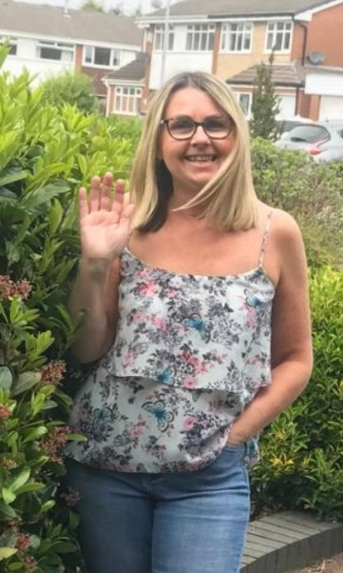
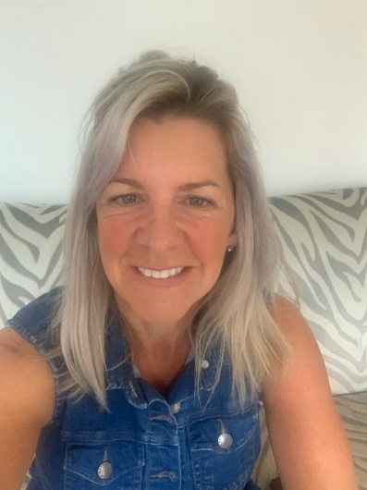
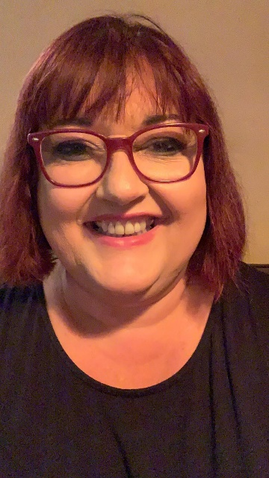
We’d love to see your work, so please Tweet @saintoswalds or send an email to enquiries@saintoswalds.wigan.sch.uk FAO Miss Lea.

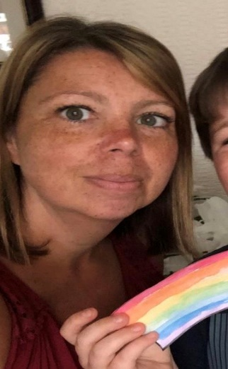

English | Maths
Reading for pleasure – 15mins per day  Have you got any stories or information texts about the seas and oceans?  Here are a few titles to get you started  Commotion in the Ocean  Tiddler  Harry the Fish with Fingers  Snail and The Whale  Rainbow Fish  The Tale of the Toothbrush  Somebody Swallowed Stanley  Reading Comprehension  - End of Plastic Pollution  1* for Year 1  3* for Year 2  Share the story of the Rainbow Fish online version and answer the questions below  Writing – use the writing prompts from previous week don’t forget your verbs, adjectives and adverbs  Listen to the story The Tale of the Toothbrush  - Write your own story about a plastic  bottle, carrier bag using above story as inspiration.  Write an oceans shape poem e.g.  I see the whales, dolphins and turtles swimming busily by.  I hear the roar of the ocean hitting the yellow, sandy beach.  Create an information booklet or write factual sentences informing people about the oceans and the dangers of plastic pollution to the plants and animals that live there  Spelling - Year 2  Help Mr Whoops to correct his sentences linked to the Rainbow Fish (attached below)  Phonics – Year 1  Alternative spelling for the sound ‘ur’  Ur – burn, er – term, ir – girl  Mr Thorne and Geradine the Giraffe  Alphablocks – birthday girl, surf and turf,  Phonics play  Phab Fonics – Turkey Burt, Kirk Bird, Amber the Tiger,  Nessy Spelling Strategy you tube search - Nessy Spelling Strategy | er ir ur Words  Complete the table or ‘ur’ words below and write the words in sentences – sentences as silly and funny as you can. | Basic Skills  Y1 – Continue with your number bonds within 20 – use the numbe rbonds sheet from last week’s learning tasks  Y2 – Rapid recall of number bonds within 20 and 100 – Crack the Code attached below  White Rose Maths – videos alongside BBC Bitesize videos plus sheets below  Y1/Y2 – 2D and 3D shape – Naming, describing, sorting and creating patterns  Properties of shapes  2D – Sides and Vertices  3D – Faces, Edges and Vertices  Go on a shape hunt around your house  Can you find spheres, cuboids, cylinders, triangular prisms, cubes, cones?  Look at the faces on these shapes can you identify the squares, circles, triangles, rectangles?  Once you have found objects around your home put them into a bag and ask someone to put their hand in and describe using the correct mathematical language the shape they care holding in the bag.  Write/say shape riddles  I have 4 straight sides that are all the same length and I have 4 vertices.  What am I?  I have 6 square faces, 8 vertices and 12 edges. What shape am I?  Shape Sheets to complete below
RE | Other subjects
Our focus this week is a man called Zacchaeus.  Zacchaeus’ story is attached for you to read to your grown-ups.  After you have shared the story ask these key questions  - What wrong choices did Zacchaeus make?  - Why do you think he wanted to see Jesus?  - How did Zacchaeus feel when Jesus told him that he was coming to his house?  - What did the people who grumbled think? Why?  - How did Zacchaeus show he was really sorry for his wrong choices?  - Why was it a happy day for Zacchaeus?  Listen to and learn this song all about Zacchaeus.  https://www.youtube.com/watch?v=v_QgANy5U1I  Cut out and sequence the story of Zacchaeus (pictures below)  Y1 – write a caption for 3 of the pictures  Y2 – write captions for all of the pictures  There are lots of pictures of Zacchaeus online for you to print and colour | Geography  Plastic pollution is a very important issue for everyone around the world.  Go on to the Espresso website to find out more about the plastic pollution that is killing many sea creatures and washing up on our beaches harming our environment.  Search for PLASTIC POLLUTION  Share the stories all about plastic pollution  The story The Tale of the Toothbrush and Somebody swallowed Stanley can be found on you tube  - Create a poster encouraging people to recycle their plastic  Or  - Create a poster showing the damage that is happening because of the plastic in the world’s oceans  - Complete the Oceans word search (below)  - Oceans and Continents jigsaw activity (see below)  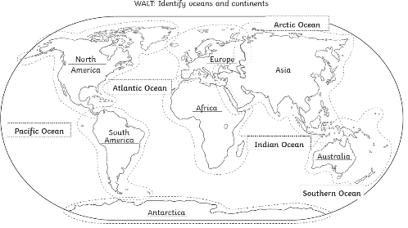  DT/ART – create a sculpture/model using things that are made from plastic  Draw a circle like a submarine’s window then draw and label all of the plant and animal life you would see through the window.  Can you find any artists that used the sea and Ocean as inspiration for their art work?  History –  Reading comprehension of sea explorers  Music – Spend some quiet time listening to the sounds of the ocean. After a busy day/week it is always good to relax and listen to some music and just breathe,  Computing – Discovery Coding – year 1 – making the fish move
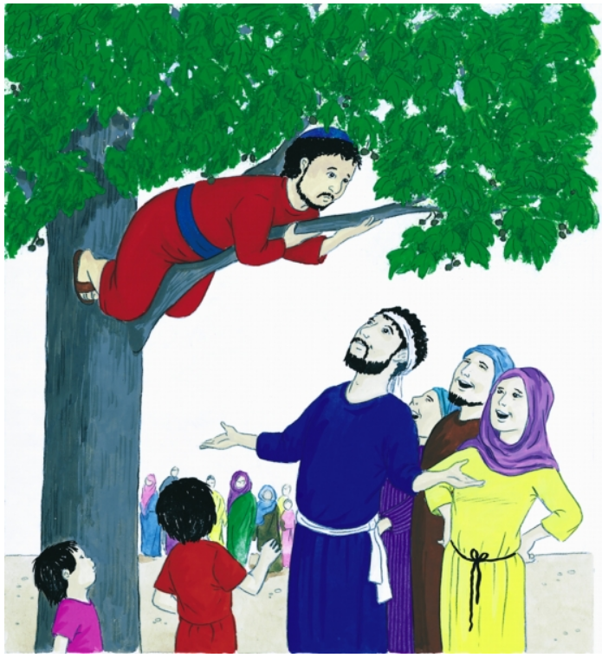
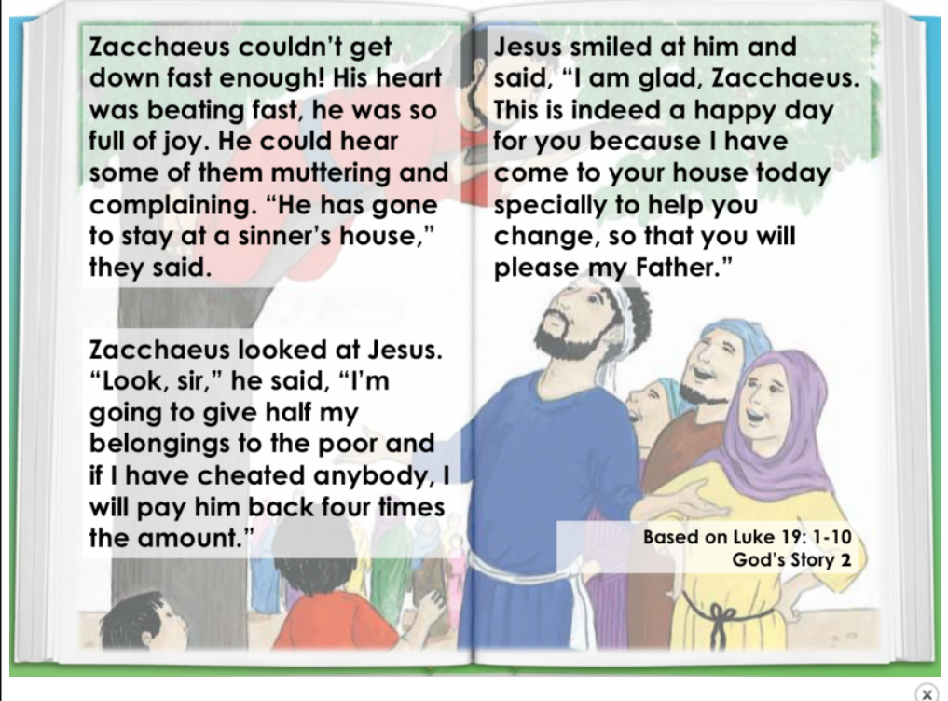

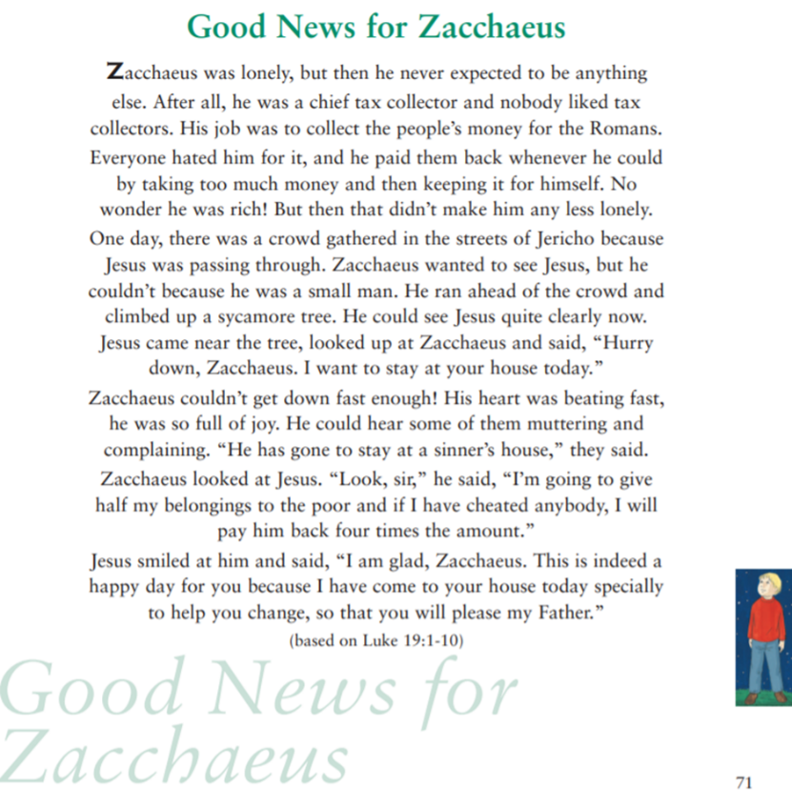

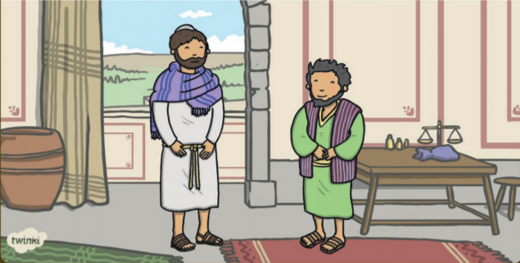
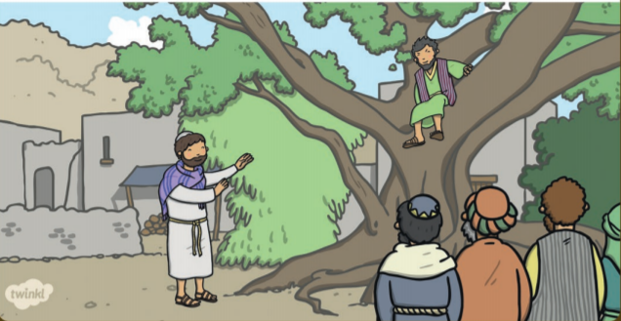
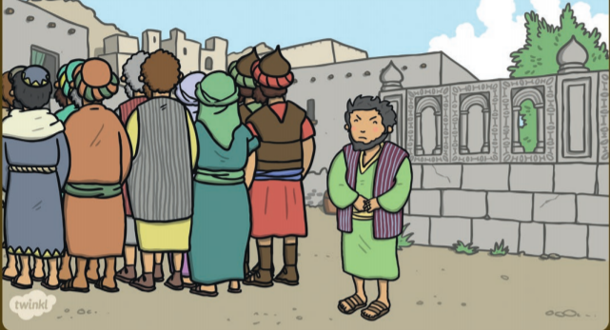
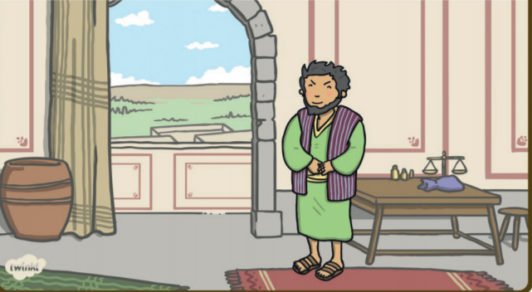
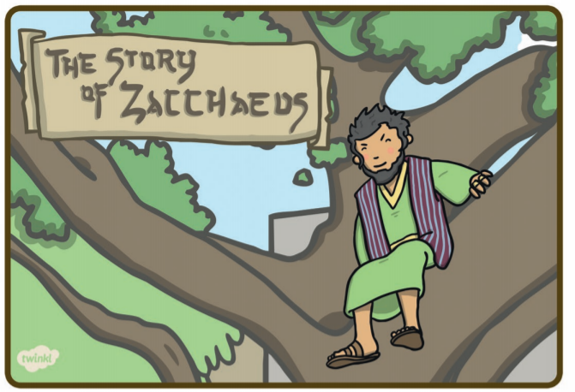
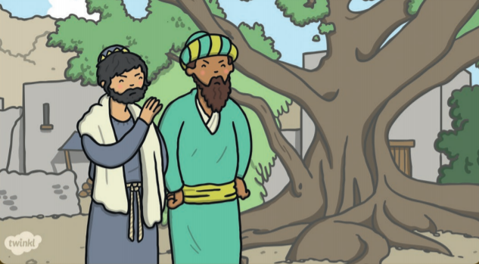

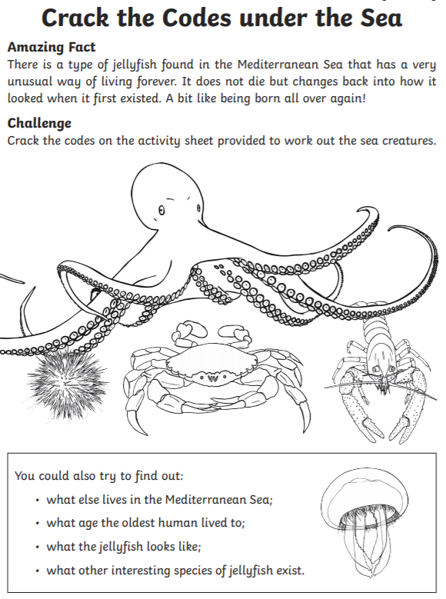
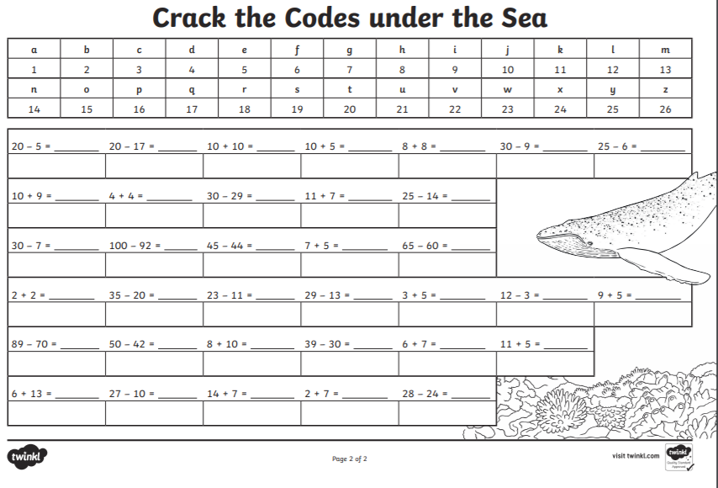
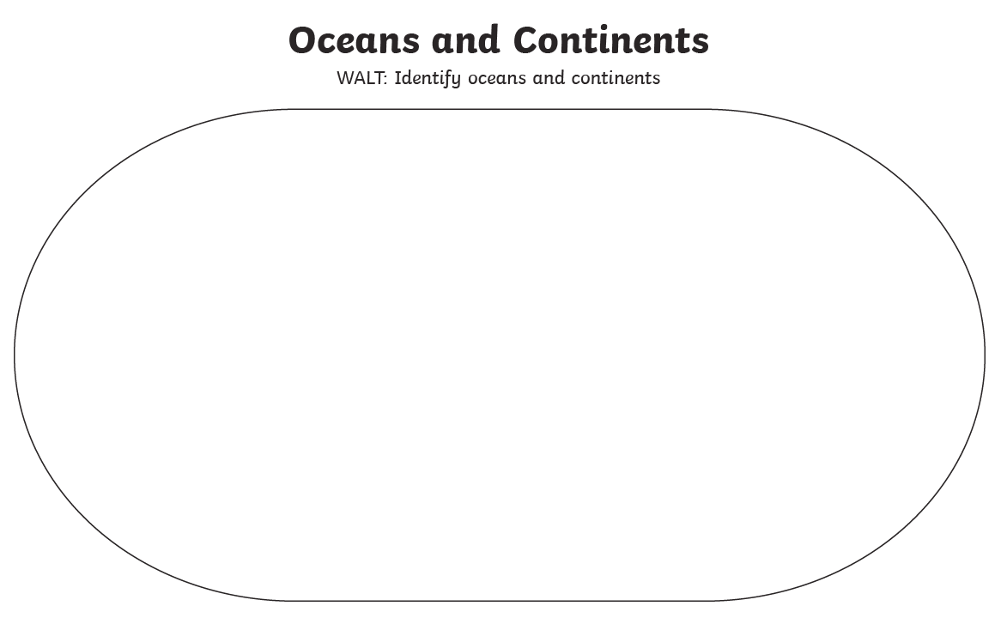
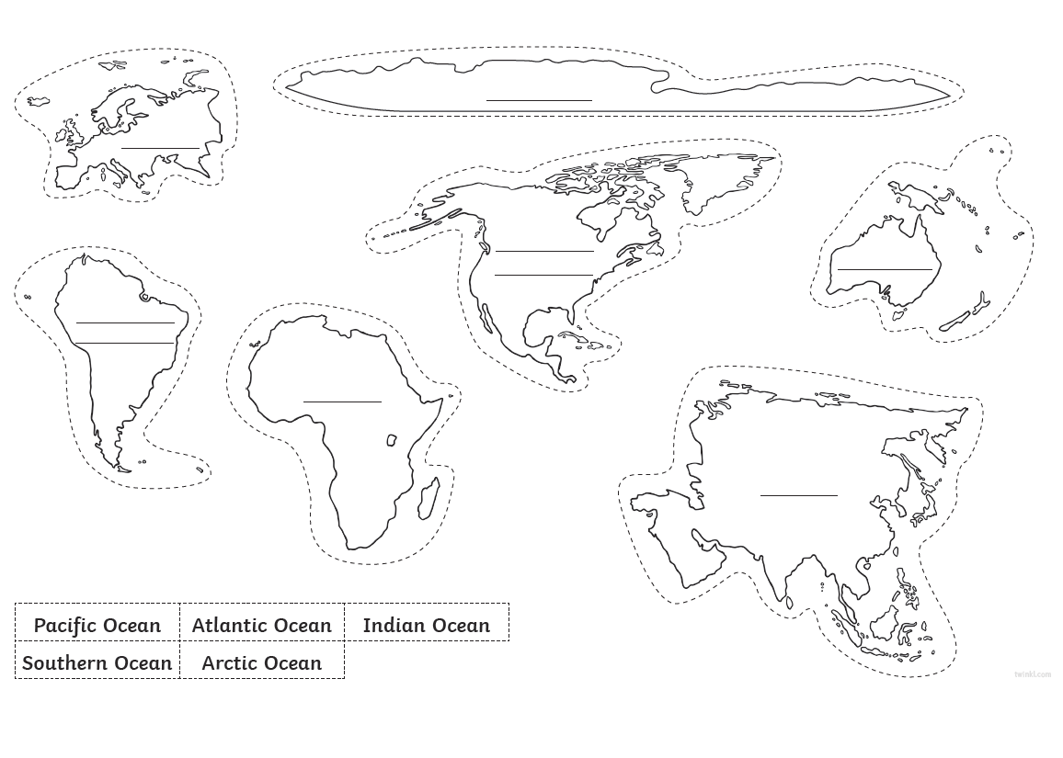
Cut out the continents and Oceans and arrange them in the oval

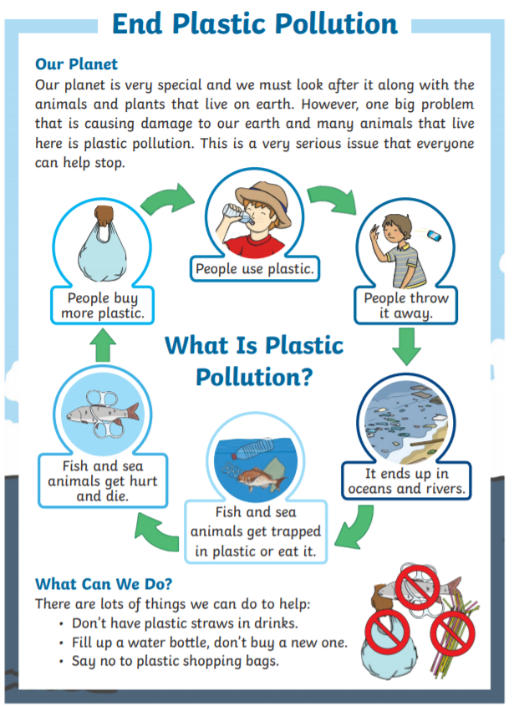
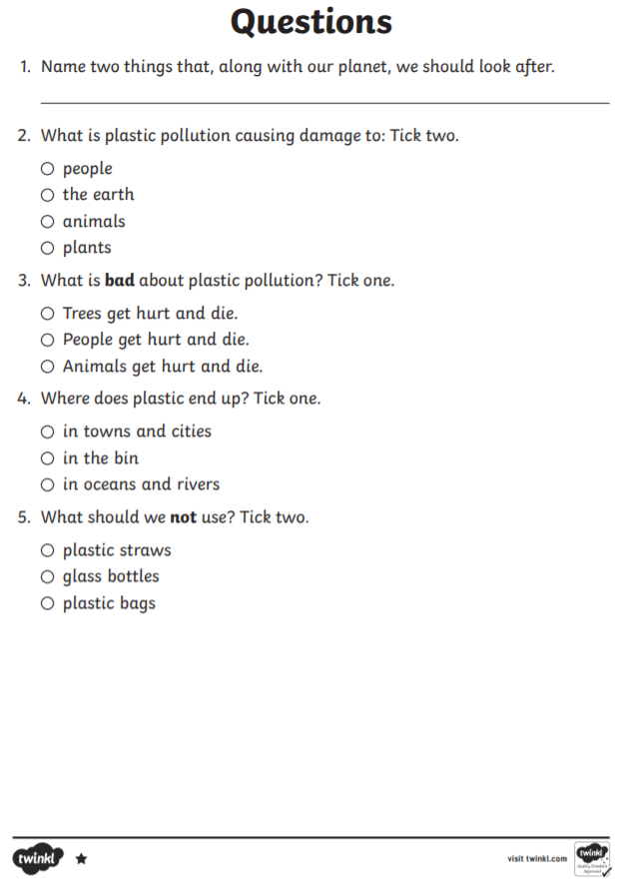
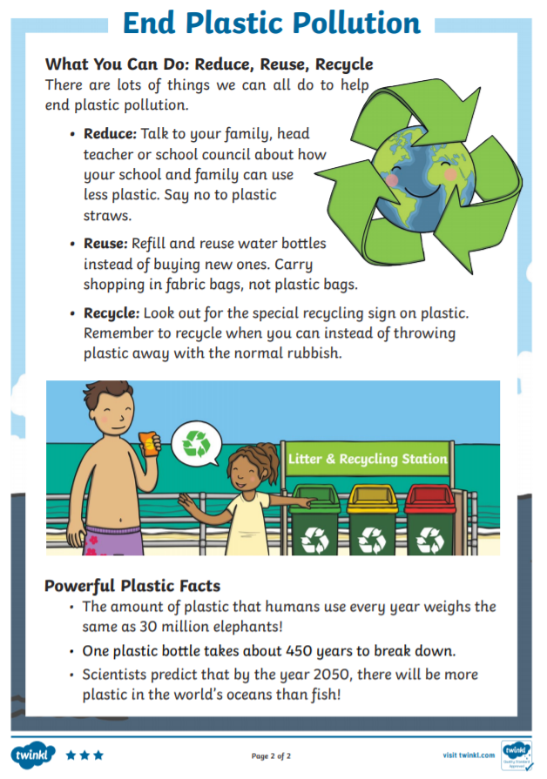
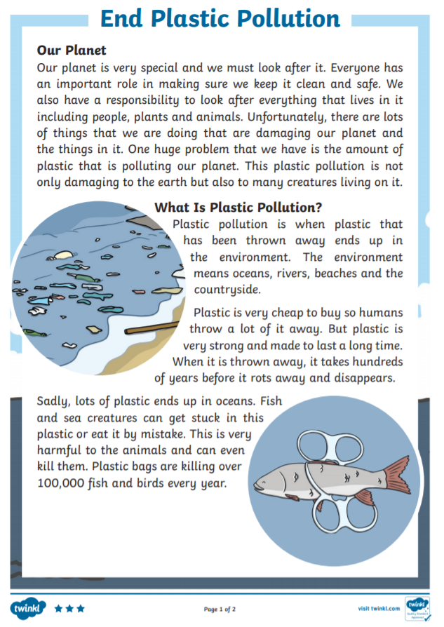
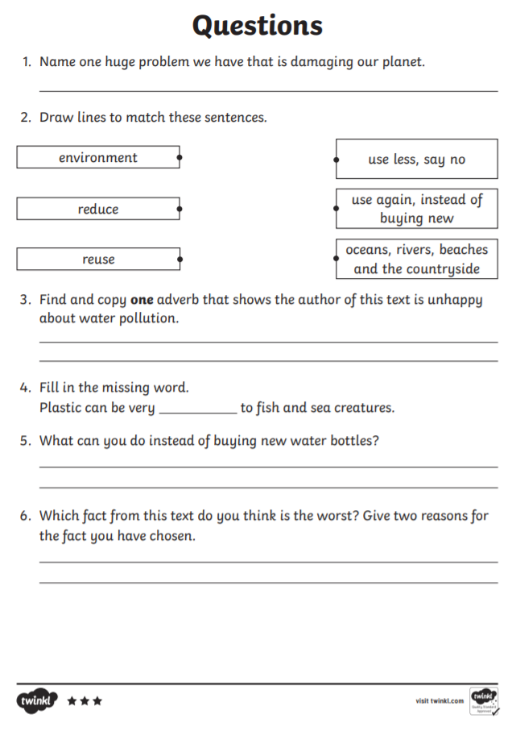
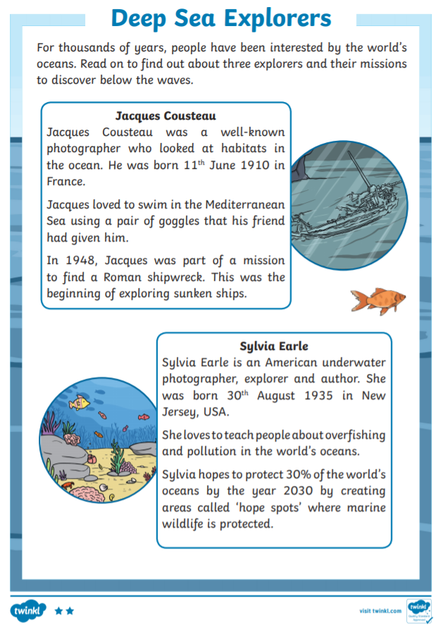
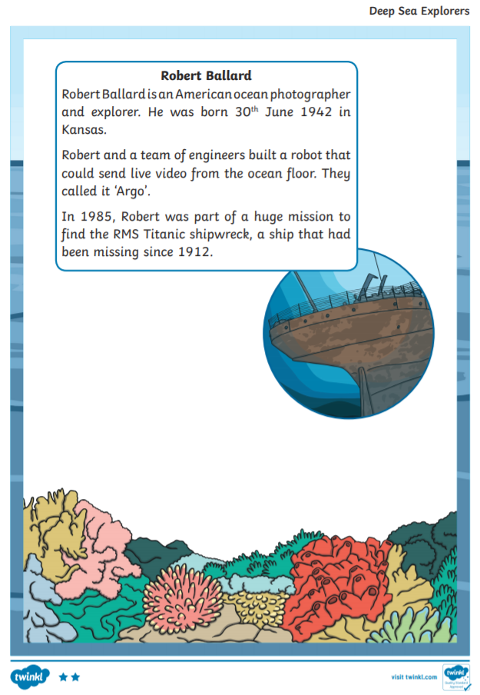
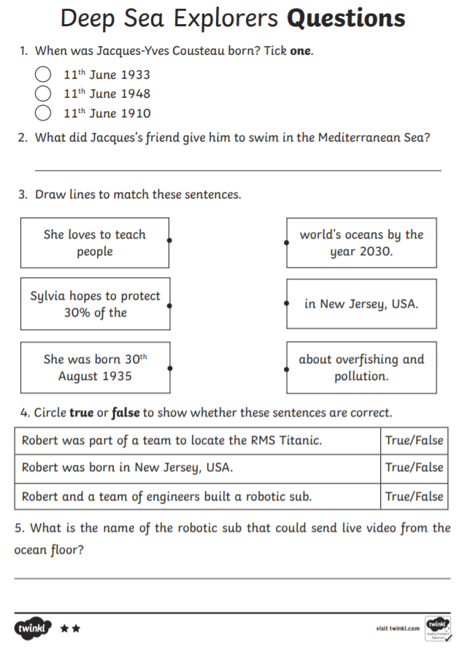
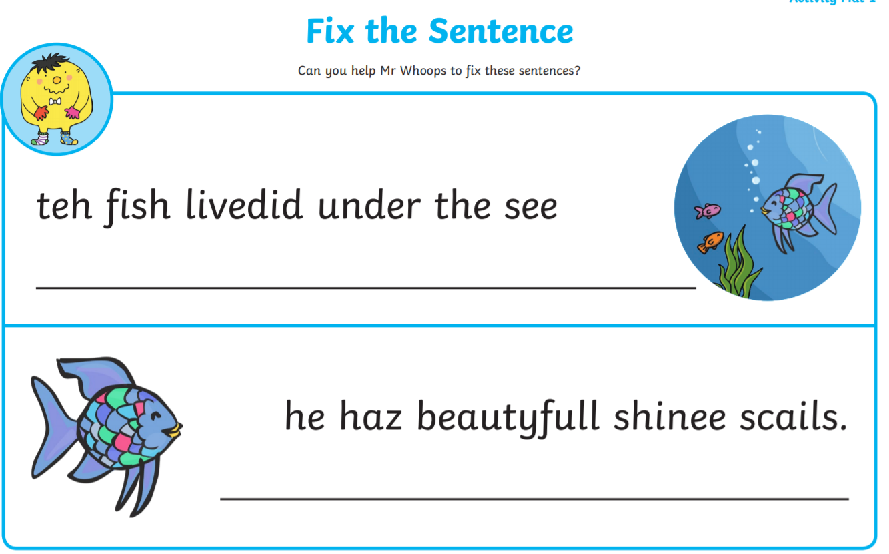
Year 2 – Spelling – Fix Mr Whoop’s Sentences

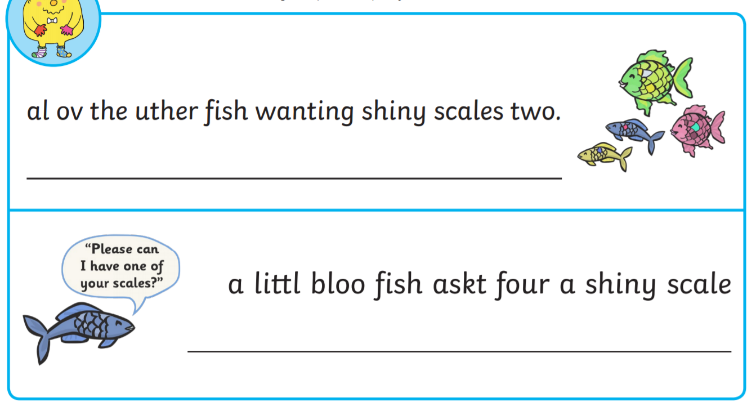

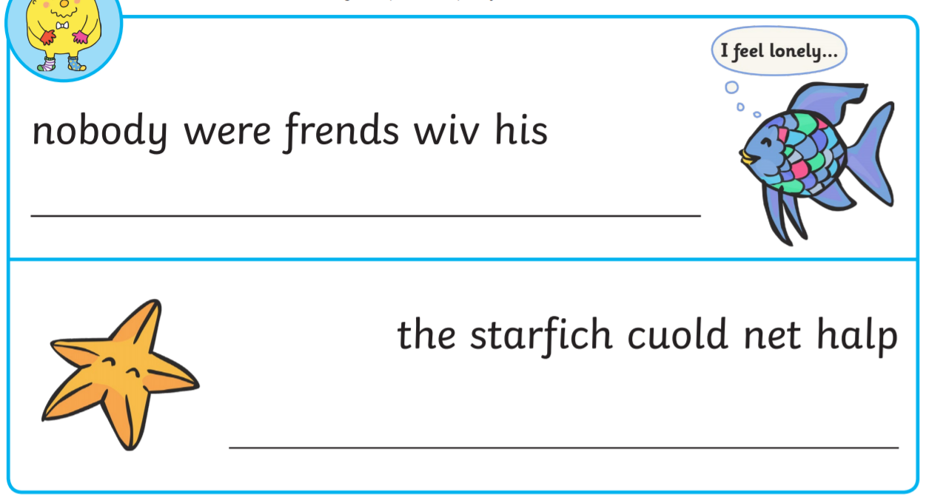

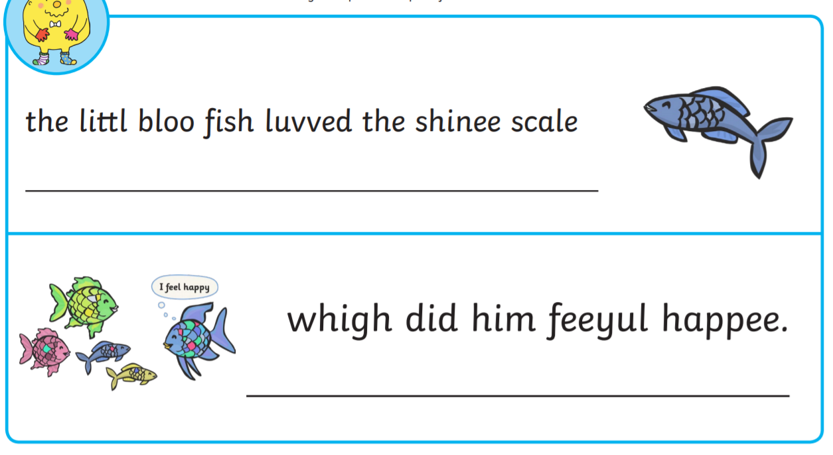
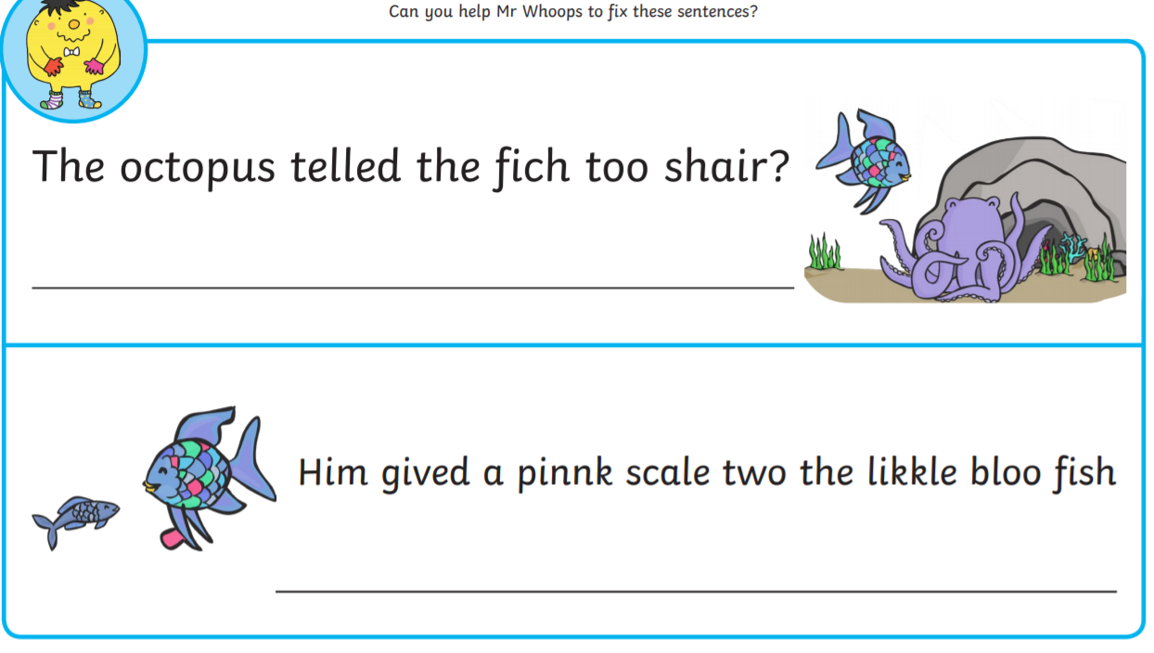

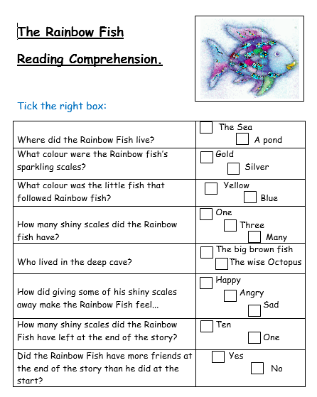

Year 1 phonics alternative spelling for the ‘ur’ sound
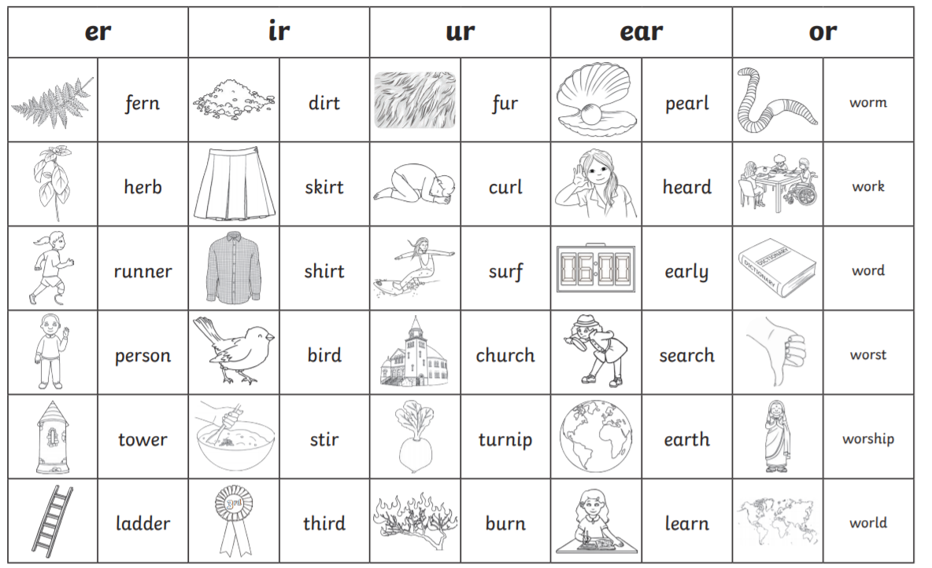
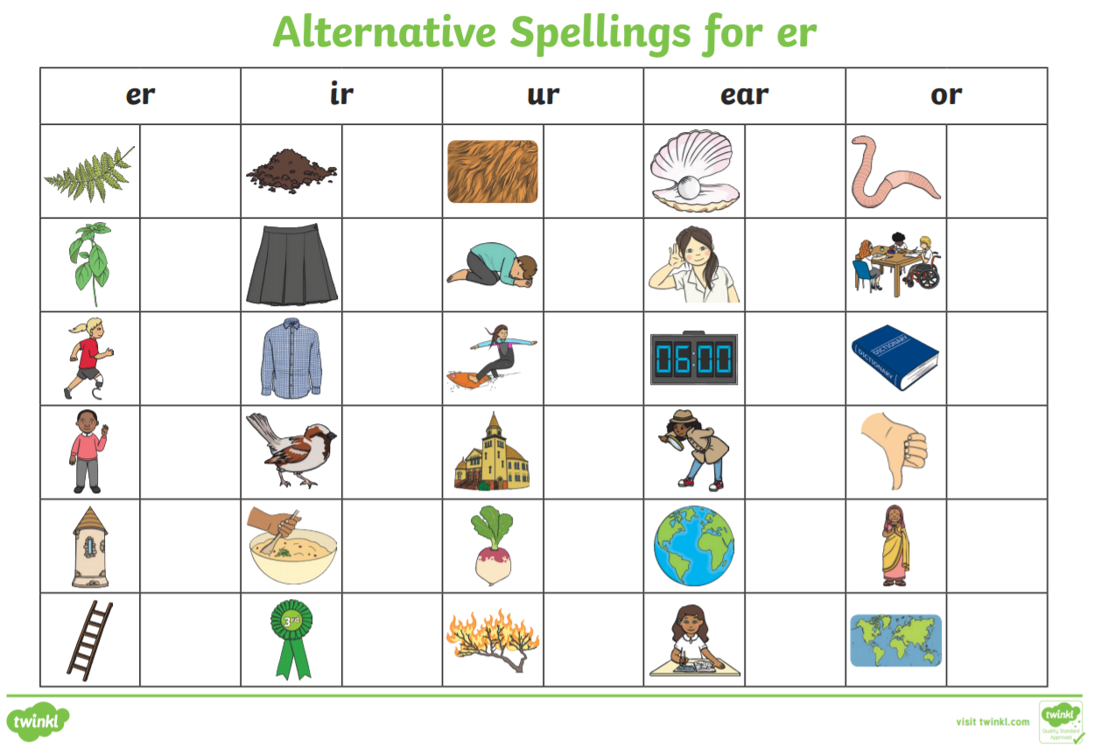
Complete the table below then use the words to write silly, funny sentences. The funnier the better!

