SEAGULLS’ WEEKLY SUGGESTED HOME LEARNING – WB 15.6.20
Hello Seagulls! We hope you’re all well and are not too disappointed that the weather has changed so drastically. Staying at home is much easier when the sun is shining and you can spend some time in the garden. On the positive side, Mr Goulding’s lawn definitely needed some rain!
As time is passing, the school emails have quietened and we would still love to hear from you. Please do let us know what activities you have been up to, even if many of them are now indoors. Fingers crossed for more sunshine soon! Take care everyone.
Mr Goulding, Mrs Barton, Mrs Brearton and Mr Little

ENGLISH | MATHS
Reading – Read every day for pleasure for 30 minutes.  Comprehension and Writing tasks- Story Ending- Lessons 1-5 (Scroll towards the end of the page)  https://www.thenational.academy/online-classroom/year-5/english#subjects  Spellings- Unstressed vowels  Learn and complete sheet below  definite, desperate, literate, secretary, stationary, dictionary, Wednesday, familiar, original, animal  Extra – a good game to practise spellings online http://www.ictgames.com/mobilePage/spookySpellings/index.html | Corresponding Division Facts – Use your knowledge of the 2 and 3 times tables to instantly recall the corresponding division facts. For instance, 2x3=6 therefore 6 divided by 3 is 2. Use ‘Hit the Button’ online to revise facts like those above  Don’t forget about TT Rockstars!  Volume- Lessons 1-5 (Scroll towards the middle of the page)  https://www.thenational.academy/online-classroom/year-5/maths#subjects  https://corbettmaths.com/primary/  This website is also really useful in case you need extra help and support or if you would like to do some more maths
R.E. | OTHER
Reconciliation- Freedom and Responsibility- The Ten Commandments.  Task: Research one person who has lived our the Ten Commandments in their daily lives, for example, Pope Francis or Saint Teresa. Present your findings in any way you like- try to be creative! | Science: Properties of Materials – Describing Materials.  Read the information below and complete the activity; matching the words to the definitions, then look at the materials you have at home and describe them using the words and definitions.  https://www.sciencekids.co.nz/gamesactivities/materialproperties.html  Humanities- Geography: The Alps  https://www.bbc.co.uk/bitesize/articles/z6kts4j  https://kids.kiddle.co/Alps  - Learn all about this mountain range in Europe and create a brochure for The Alps (see below)  Challenge: Research and create an information text about one of the countries that the Alps mountain range runs through.

Science: Properties of Materials – Describing Materials

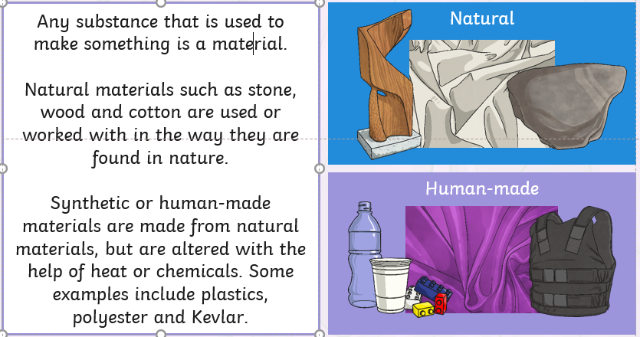
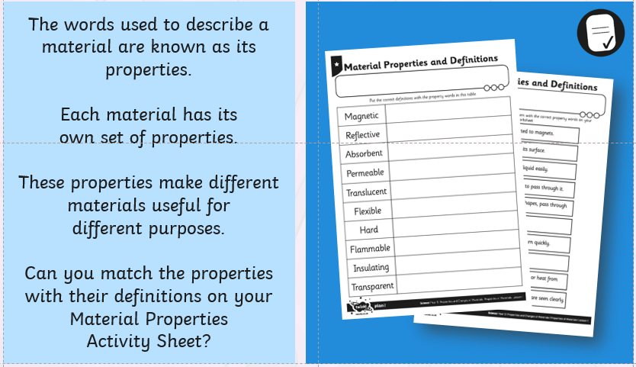

Properties of Materials Definitions – Write next to the correct word on the sheet below.

