SPARROWS WEEKLY SUGGESTED HOME LEARNING – WB 15.6.20
Hello Sparrows! I hope you enjoyed the tasks last week all about your friends. This week your tasks are all about a familiar friend… Elmer the elephant! You can watch the story here https://www.youtube.com/watch?v=ZFrD18XLmlM being read by the author David McKee if you do not have the book at home.
Some Sparrows will be returning to school this week and we look forward to seeing you and working through these tasks with you. If you are not returning, please keep in contact as usual and we will still reply as soon as we can. You can email the office at enquiries@saintoswalds.wigan.sch.uk FAO Sparrows or tweet us @saintoswalds @mrs_wibberley @MrsOsborne73.
Stay safe and keep smiling
Mrs Wibberley, Mrs Osborne and Mrs Dean xx
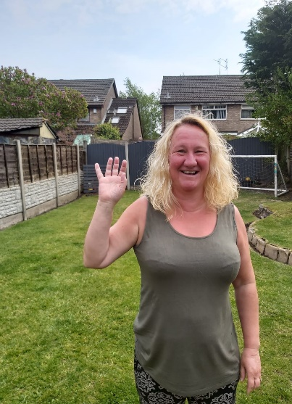
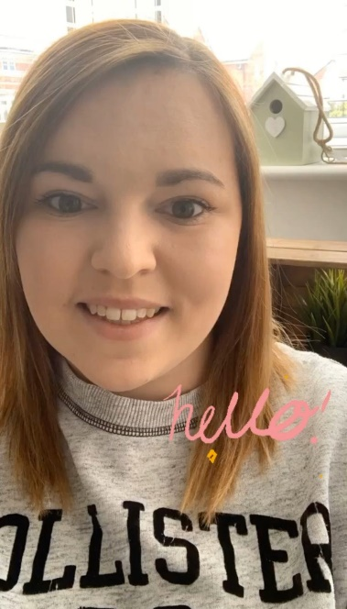

ENGLISH | MATHS
Reading – Read every day for pleasure for 10 minutes.  You can also listen to stories on www.vooks.com. This website is full of stories that come with videos and are a big hit in Sparrows as there are so many to choose from. Maybe your child can share their favourite story with you. You can get a free subscription for 1 month.  Comprehension –  - Use the images below to sequence the story of Elmer by cutting and sticking them in the right order.  - Look at the picture in the video showing the elephants with fancy patterns for Elmer day. Describe some of the elephants for someone in your family to guess which one you are describing.  Writing –  - Look at the first image on the video of the grey elephants – describe how the elephants are the same/different.  - Create your own elephants for Elmer day and write descriptions for them.  - Make an invitation to invite the elephants to celebrate Elmer day.  Phonics – Your child will be able to tell you which phonics group they are in. If they don’t know, please contact school so we can help you.  Mrs Osborne and Mrs Dean’s groups –  1. Go to https://www.phonicsbloom.com/ or https://new.phonicsplay.co.uk/ and play your favourite game to practise all the new sounds you have learnt over the past few weeks.  2. Find objects around the house that have the ‘ar’ sound in them. Write the words and draw pictures to match.  Mrs Wibberley’s group –  1. Go to https://www.phonicsbloom.com/ or https://new.phonicsplay.co.uk/ and play your favourite game to practise all the new sounds you have learnt over the past few weeks.  2. Find objects around the house that have the sound ‘wh’ in them. Put these words into sentences and draw pictures to match.  Miss Lea and Mrs Davies’ groups –  1. Go to https://www.phonicsbloom.com/ or https://new.phonicsplay.co.uk/ and play your favourite game to practise all the new sounds you have learnt over the past few weeks.  2. Play the phase 5 blast off game below. | Basic skill – Read, write and interpret mathematical statements involving addition (+), subtraction (-) and equals (=) signs.  You can use objects to help you work out the statements if you need to and remember the equals sign does not always come at the end!  There are some great games on this website if you would like to use them https://www.topmarks.co.uk/maths-games/5-7-years/addition-and-subtraction  Unfortunately White Rose have started charging for their home learning tasks, however BBC Bitesize have partnered with White Rose and have some great daily tasks including maths for free. Follow this link for a daily maths task https://www.bbc.co.uk/bitesize/tags/zjpqqp3/year-1-and-p2-lessons/1  If your child finds this challenging, please follow this link https://www.hamilton-trust.org.uk/blog/learning-home-packs/ and use the previous year group’s tasks.  I have included some Elmer maths activities if you would like to do them in addition to the above.
R.E. | OTHER
The theme is: Reconciliation – Being sorry.  God helps us to be kind.  Read the stories of Levi and Zacchaeus. Do you think they found it easy to change? It is not easy to do this by ourselves, but God is there to help us, just as Jesus helped Levi and Zacchaeus.  Make a candle using materials and write the words ‘I promise to be the light that shines in the dark’ on it.  Write some sentences about how you can be kind in your everyday lives and show you are living God’s promise. | Music – Sing the song ‘Nellie the elephant’ but change it to ‘Elmer the elephant’.  PE – Ask someone to say different animals and you move around the space like that animal. How many ways can you find to travel?  Art – Using the Elmer template below, ask an adult to say how many squares to colour a certain colour until the whole elephant is colourful e.g colour 2 squares red, 4 squares purple etc. You can use felt tips, crayons, paints, collage materials – I will leave it up to you to decide!  I have included some extra colouring sheets below if you would like to colour them.  PSHE – Elmer teaches us that we are all unique. We are not identical to anyone else and even if you are an identical twin, you don’t even have the same name! Decorate a piece of paper, which shows you are unique. You could have your name in the middle with pictures of all the activities you like to do around it.  Science – Complete the animal sorting activity (farm and jungle animals).

