STARLINGS WEEKLY SUGGESTED HOME LEARNING – WB 15.6.20
Hi Starlings! You were very quiet last week! Make sure you remember to email or tweet school to show me what you are up to. I love seeing the school work that you’re completing but I also really enjoy seeing the other amazing things you are doing too! Show me what your growing in the garden or baking or maybe you’ve learnt a new skill that you would like to share with me! #StaySafeStayHomeSaveLives
Mrs Grindley and Mrs Catterall XX

ENGLISH |  | MATHS
Reading – Read every day for pleasure for 20 minutes.  Comprehension tasks –  https://central.espresso.co.uk/espresso/modules/e2_comprehension_lks2/books/book_happy_endings.html  Read the extract and answer the questions based on The Lost Happy Endings  Writing –  1. Continue the conversation Jub had with the Old Woman making sure  you use inverted commas correctly (speech marks)  2. Write a character profile for Jub  3.Complete the inverted commas activity (speech marks)  https://central.espresso.co.uk/espresso/primary_uk/subject/module/frontscreen/item305326/grade2/index.html  4. Make a list of happy endings from books that you know  5. Write an alternative ending for your favourite fairy tale.  Spellings – words with the s sound spelt sc |  | 15 minutes on TT Rockstars each day  https://ttrockstars.com/  Year 3 –  White Rose – Week 7 – Fractions  Use worksheets below and BBC Bitesize to support the videos  https://whiterosemaths.com/homelearning/year-3/  Create a maths museum to show your understanding of equivalent fractions  Year 4 -  White Rose – Week 7 – Decimals  Use worksheets below and BBC Bitesize to support the videos  https://whiterosemaths.com/homelearning/year-4/  Create a maths museum to show your understanding of decimals
R.E. | OTHER
The theme is: Serving and is linked to  Pentecost.  Reconciliation – Inter-relating  CHOICES  Read the story below ‘The Prodigal Son.  Find some words which describe the father and  write a character sketch of him. Say how he is  like God our loving father.  Draw a story board to retell the story. | Science – Habitats – Sorting and classifying  Watch the video  https://www.bbc.co.uk/teach/class-clips-video/science-ks1-ks2-ivys-plant-workshop-grouping-living-things/zfjxcqt  Use the Venn Diagram below from Twinkl to sort the animal picture – which group of animals do they belong to?  Geography - How could Ashton be improved? Write a letter to the local council giving suggestions on how Ashton could be improved – think about what the leisure facilities are like and what could be added, litter, cleanliness, housing, shops  Music – Time for music Y3/4 Lesson 7  https://www.stoswaldswigan.co.uk/classes/fun-learning-games/music  Art- Make a Fathers’ Day card for your dad or someone who is special to you.

ascend
descend
science
fascinate
scene
scent
muscle
scissors
abscess
crescent
scenery
fluorescent
fascinating

Can you think of any more examples?
Choose 5 of the above words and write a
sentence for each.

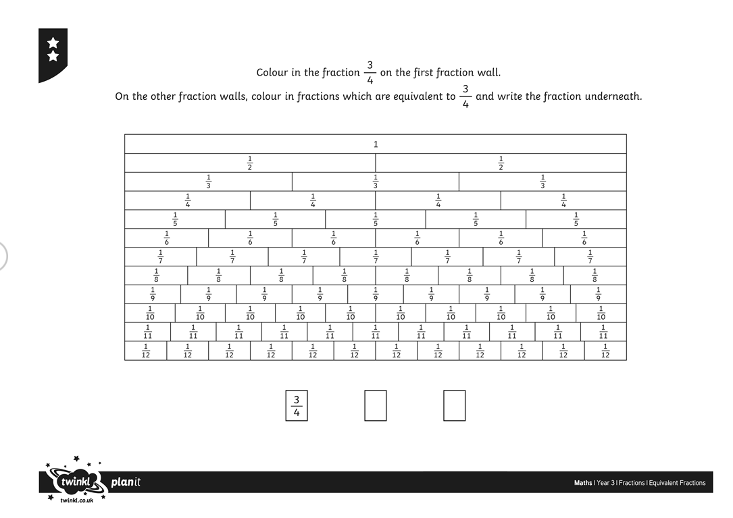

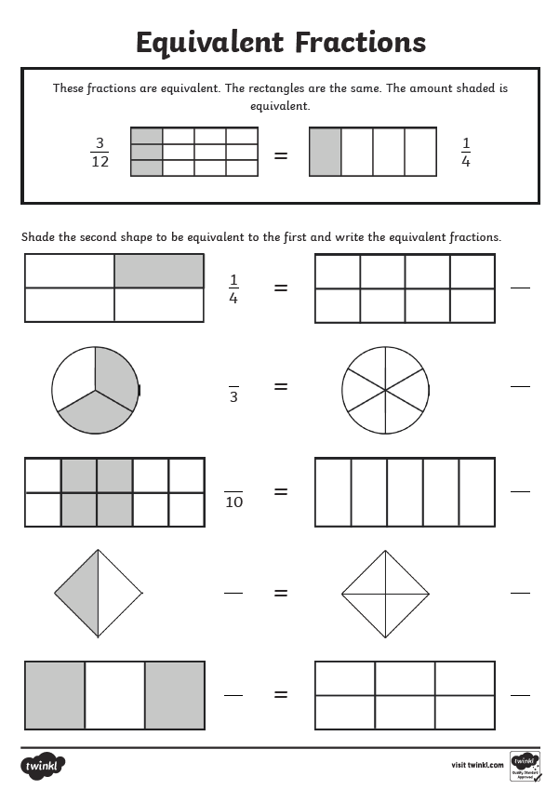

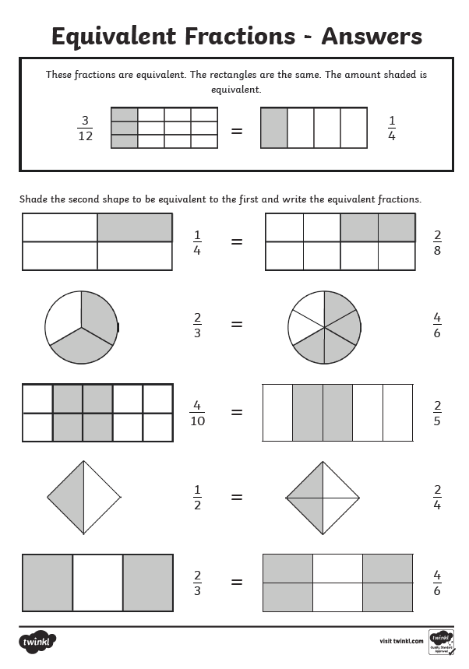

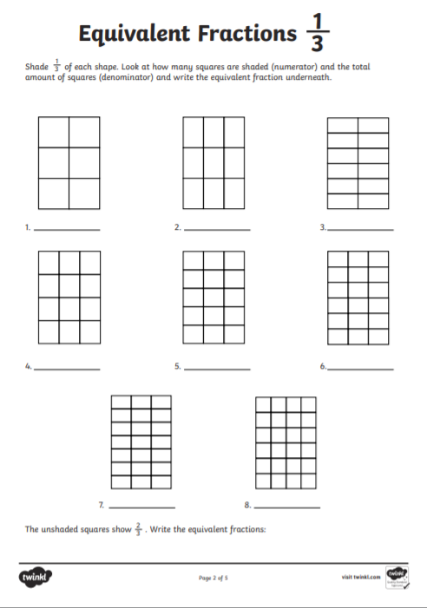
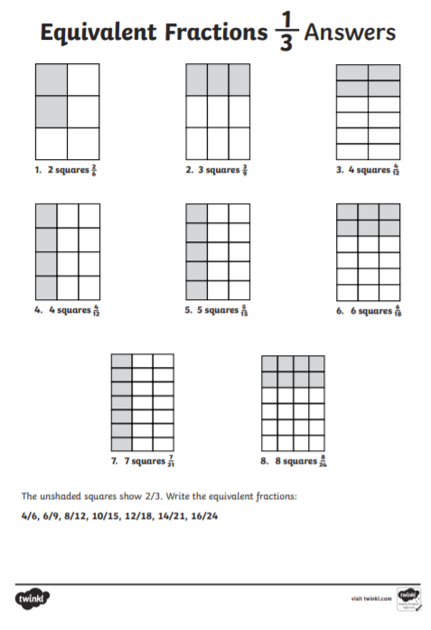

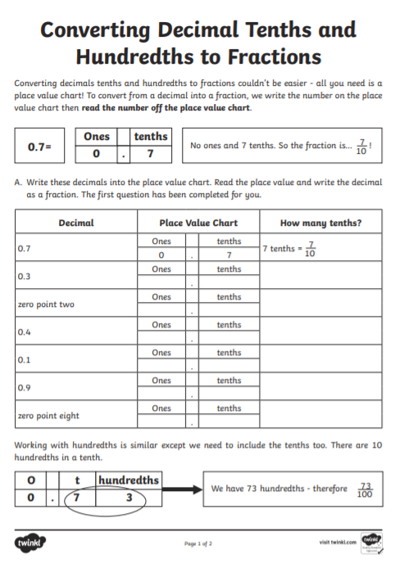

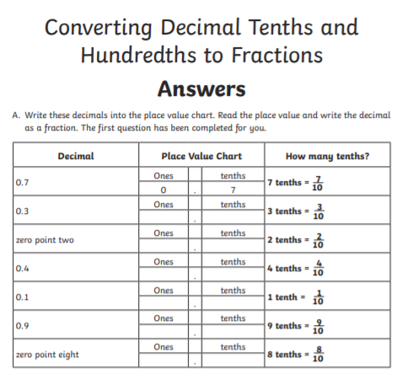

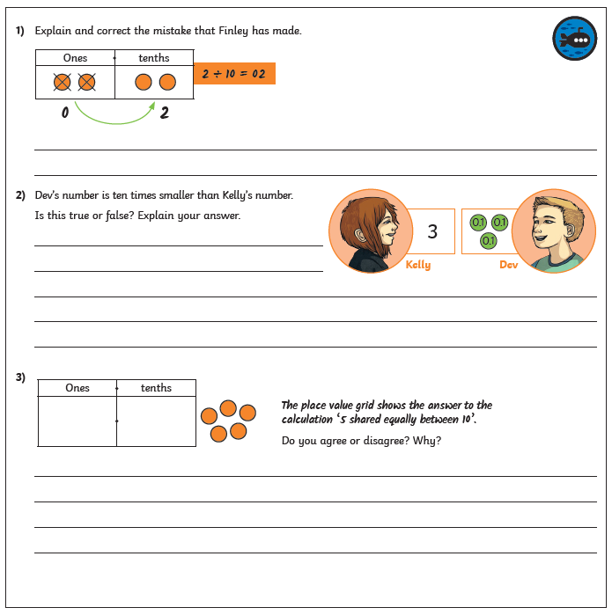

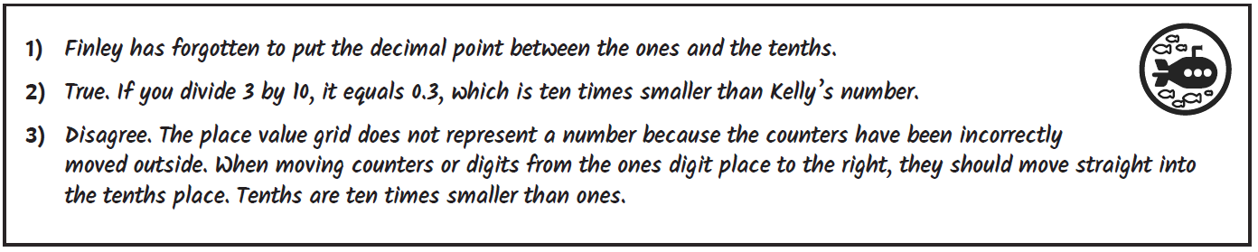

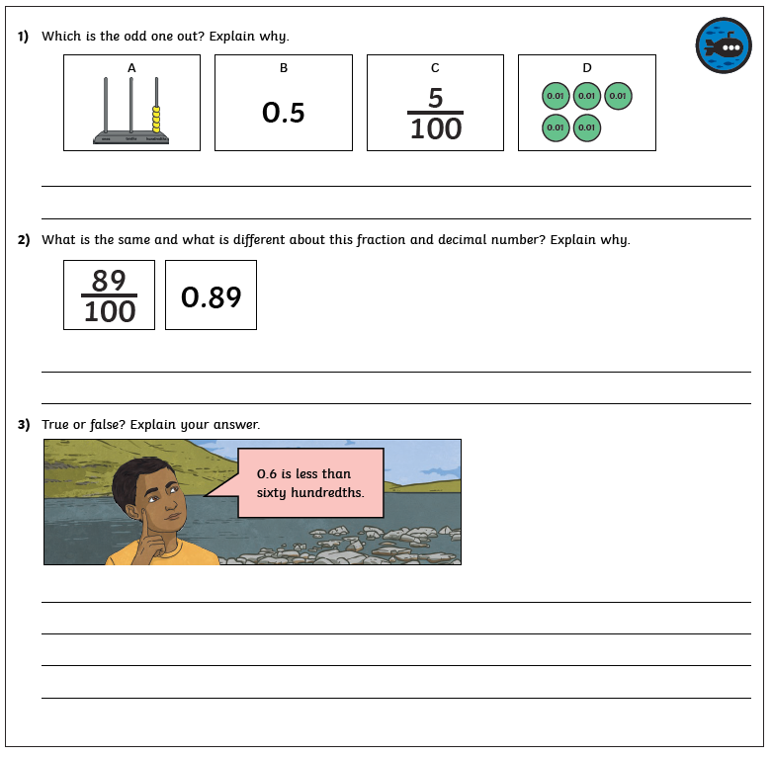

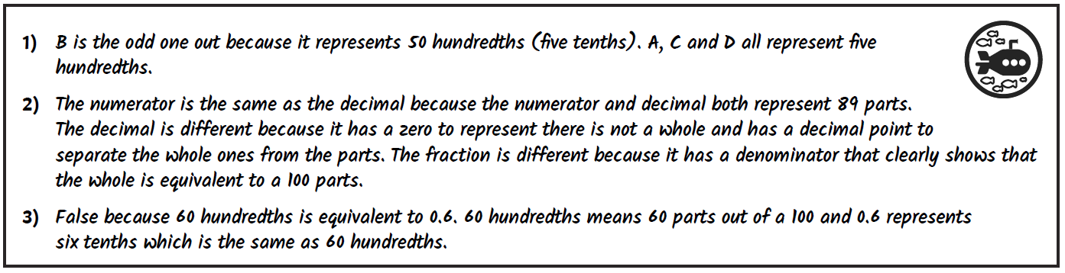

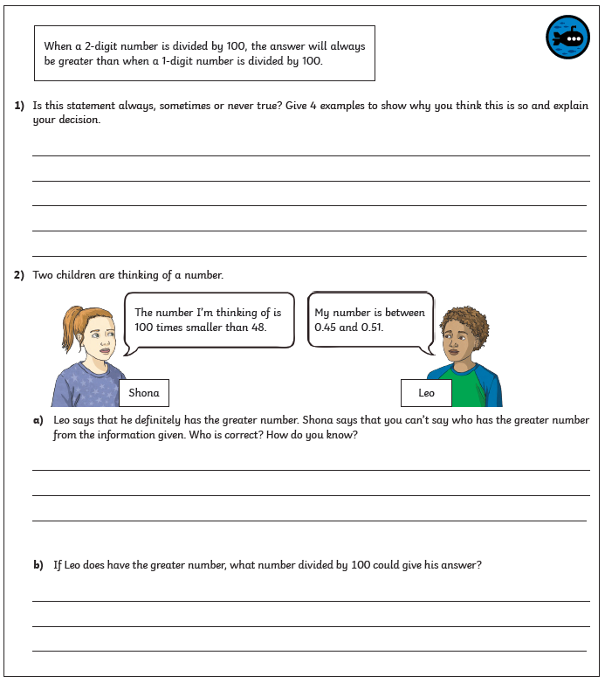

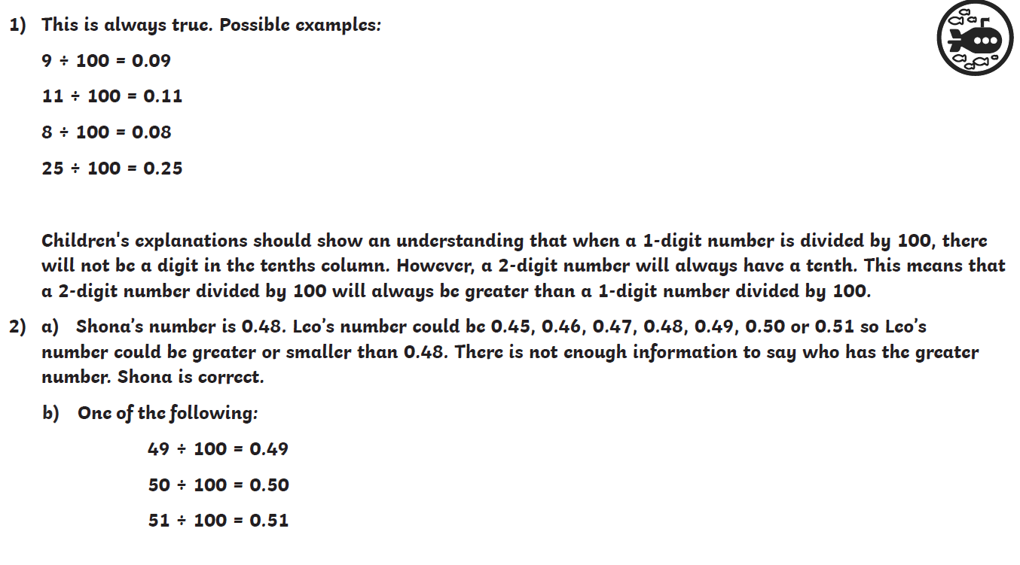

RE

The Parable of the prodigal son (based on Luke 15:11-32)
A man had two sons. The younger became impatient of living at home on the farm. He wanted to set out into the wide world and seek his fortune. He said to his father, “Father, give me my share of the money from the farm that would come to me when you die.” His father was very sad to hear this, but he loved his son, so he sold off half the farm and gave him the money. The older brother was furious, but the younger son was delighted. He had never had so much money in his life! At once he set off for a far country where nobody would know him and his riches would impress everyone. And they were impressed! He soon found friends to help him to spend his money. He really enjoyed himself. He did anything he wanted. There would be plenty of time later to get a job, and come home to his family a very wealthy man. But a famine spread quickly over the country. Crops failed and there was very little work of any sort to be had. His new friends could not even be bothered to offer him a meal. The only job he could find was working on the farm of a Gentile – feeding pigs! He was so hungry that he would have been glad to eat the pigs’ food himself. At last he came to his senses. “Even my father’s servants have more food than they want, and here am I dying of hunger! I will leave this place and go to my father and say: “Father, I have sinned against heaven and against you; I don’t deserve to be called your son; treat me as one of your paid servants.” So he left the place and went back to his father. His father had been watching out, hoping his son would come home. While he was still a long way off, his father saw him, barefoot, ragged and dirty and so very pale and thin. He ran to the boy and hugged and kissed him. The son began his speech, but his father interrupted him, calling to the servants, “Quick! Bring out the best robe and put it on him; put a ring on his finger and sandals on his feet. Bring the calf we have been fattening and prepare a feast. I want to celebrate, because this son of mine was dead and has come back to life; he was lost and is found.”

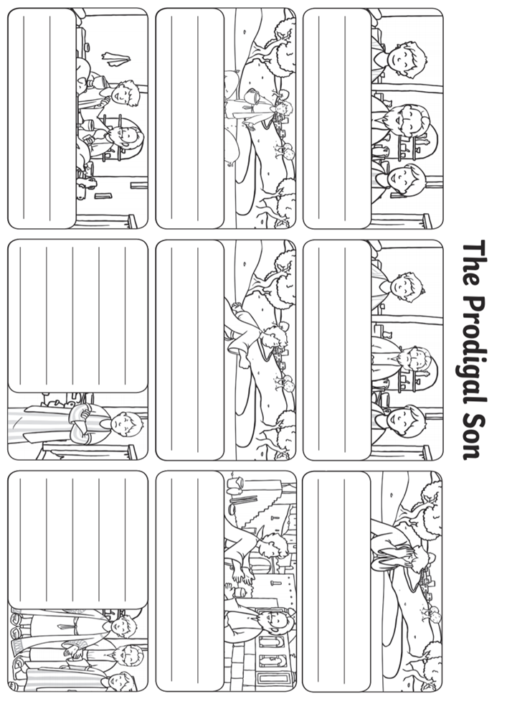

Science
