WAGTAILS’ WEEKLY SUGGESTED HOME LEARNING – WB 15.6.20
Hi there historians! How are you all getting on with your Great Fire of London projects? Do you know 10 interesting facts about the event? Tell a family member your fascinating, new facts! We can’t wait to see your finished work. If we do not return to school before September, I will organise a time for you all to share your projects with each other and I will create a display in school for them to be celebrated.
You are going to continue with your Great Fire of London project this week. We thought it would be a good opportunity to do some fire safety work too so some of your activities have a focus on that.

Have a wonderful week!

Always remember, you are BRAVER than you believe, STRONGER than you seem, SMARTER than you think and LOVED more than you know.

Love from
Miss Silver and Mrs Costello
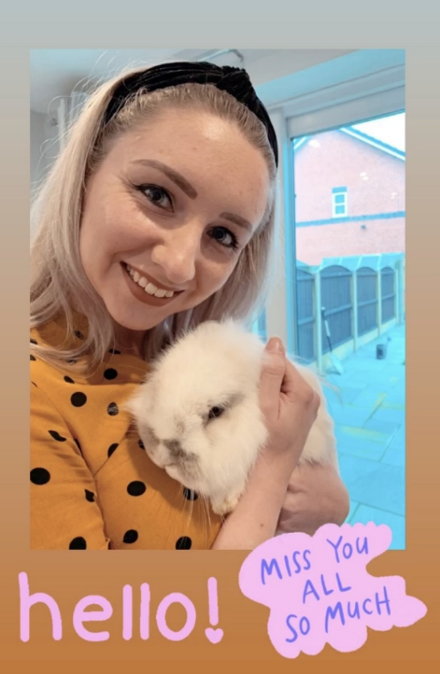
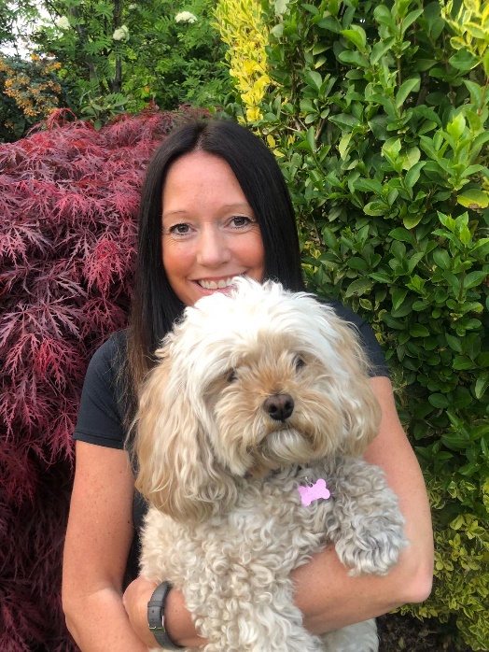

ENGLISH | MATHS
Reading – Read every day for pleasure for 15 minutes.  Comprehension tasks  - Read the diary of Samuel Pepys and answer the questions.  - Complete the fire safety worksheet below. Write your answers on a separate piece of paper, writing in full sentences and in your neatest, joined up handwriting.  - Read the information ‘What do firefighters do?’ and answer the questions.  Writing  - Write five facts about Samuel Pepys. Find out why he was a significant person.  - Complete the ‘Who burnt the buns?’ Mystery SPAG activity below. You need to solve the clues to work out who burnt the buns. I have included the answers too but please do not cheat!  - Imagine you lived in London in 1666. Write a diary (like Samuel Pepys did) describing what it was like to be caught up in the event. Use your senses to help you with this. For example, I can hear people screaming as they run away looking for safety.  I can see thick, black smoke rising high into the sky whilst red and orange flames continue to grow.  Spellings – adding the suffix –ful  Using the word bank below:  - Play the roll and spell game (see below)  - Write a fantasy story using all the words.  - Hunt for all your spelling words in books.  - Can you list any other words that end in the suffix –ful? | Basic Skill – Telling the time on an analogue clock. Continue practising telling the time.  Use these links to help you:  https://www.bbc.co.uk/teach/supermovers/ks1-maths-telling-the-time/zk4t8xs  https://www.bbc.co.uk/bitesize/topics/zhk82hv/articles/zcmdwxs  https://www.topmarks.co.uk/Search.aspx?q=telling+time  Unfortunately, White Rose has started to charge for their worksheets.  Open the link to Hamilton Trust’s home learning packs.  https://www.hamilton-trust.org.uk/blog/learning-home-packs/  Download the Year 2 Week 6 pack.  The activities will download onto your computer. Some activities have PowerPoint presentations that talk you through the maths skill.  Some of the activities are differentiated so please choose the activity that is best suited to you.  If you are finding the Year 2 pack too hard, feel free to download the Year 1 pack.
R.E. | OTHER
The theme is: RECONCILIATION – INTER-RELATING: BEING SORRY  LEARNING FOCUS: Jesus forgives us when we make wrong choices.  Jesus met a chief tax collector, called Zacchaeus. Share his story ‘Good News for Zacchaeus’, based on Luke 19:1-10 (see below). Talk about how when we make wrong choices like Zacchaeus did, we need to show that we are sorry in some way.  Levi gave a big party to say he was sorry. Zacchaeus gave his money to the poor and the people he had cheated to show he was sorry.  SOME KEY QUESTIONS  - What wrong choices did Zacchaeus make?  - Why do you think he wanted to see Jesus?  - How did Zacchaeus feel when Jesus told him that he was coming to his house?  - Why did the people complain?  - How did Zacchaeus show he was sorry for his wrong choices?  - Why was it a happy day for Zacchaeus?  - Dramatise the story in two parts:  - Jesus meets Zacchaeus  - Jesus at Zacchaeus’ house.  Then make a TV interview of the characters in the story and record it using a video camera.  - Make a storyboard of the events (see below for template). | History – Continue working on your Great Fire of London project. This should be completed by the end of the week.  Geography – Create a map of London in 1666 showing the location of the bakery in Pudding Lane, the River Thames and where the fire spread. You could draw this or create a collage.  DT – Make a model of a Tudor house. Using a cereal box is one way you could do this. (Look on Google for some inspiration).  Art - Draw how you would have redesigned the city following the Great Fire. Why would you redesign it this way?  Science – Walk around your house. How many different materials have the builders used to make your house?  Fire safety  - Use this link to access a number of fire safety resources, including an activity booklet, online story and craft tasks: https://www.london-fire.gov.uk/schools/learning-resources/  - Make the biggest pile of leaves you can. Pretend it’s a fire; how will you put it out?  - Design a fire safety poster.  - Use a hose or buckets to clean a car or bike.  - Which is the best route to lead your family out of your house for a fire drill?  - Find out where your nearest fire station is – how long would it take a fire engine to drive to your house?  - Play these online games to help you and your family learn about being safe at home: http://www.familylearning.org.uk/safety_in_the_home.html

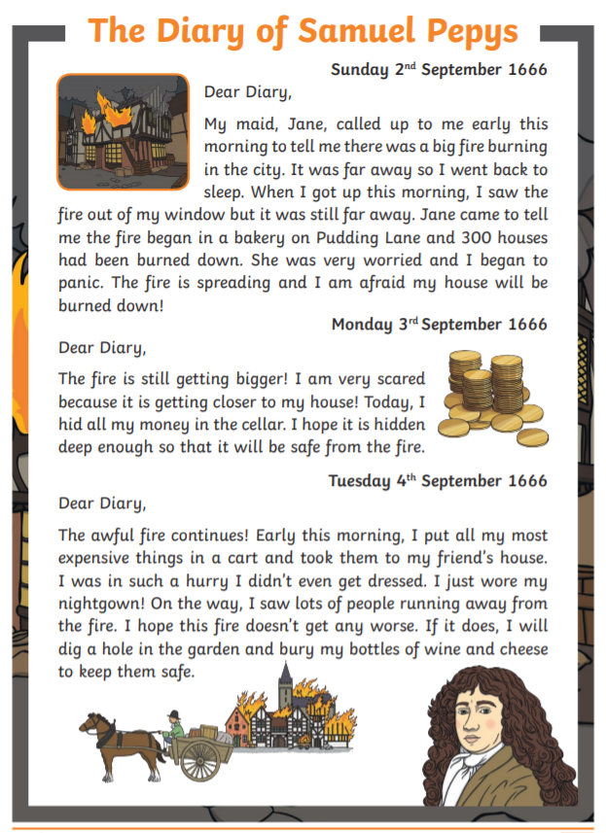
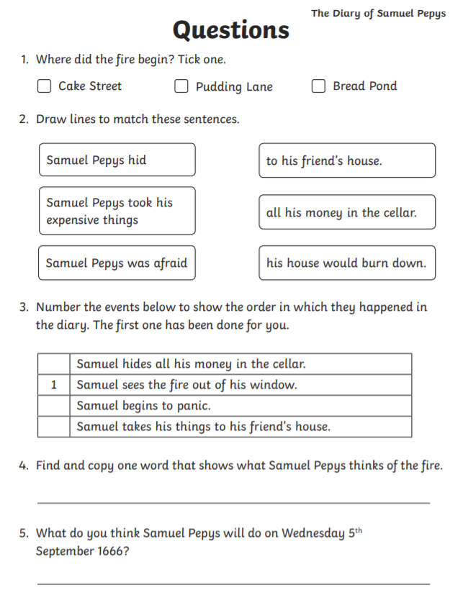

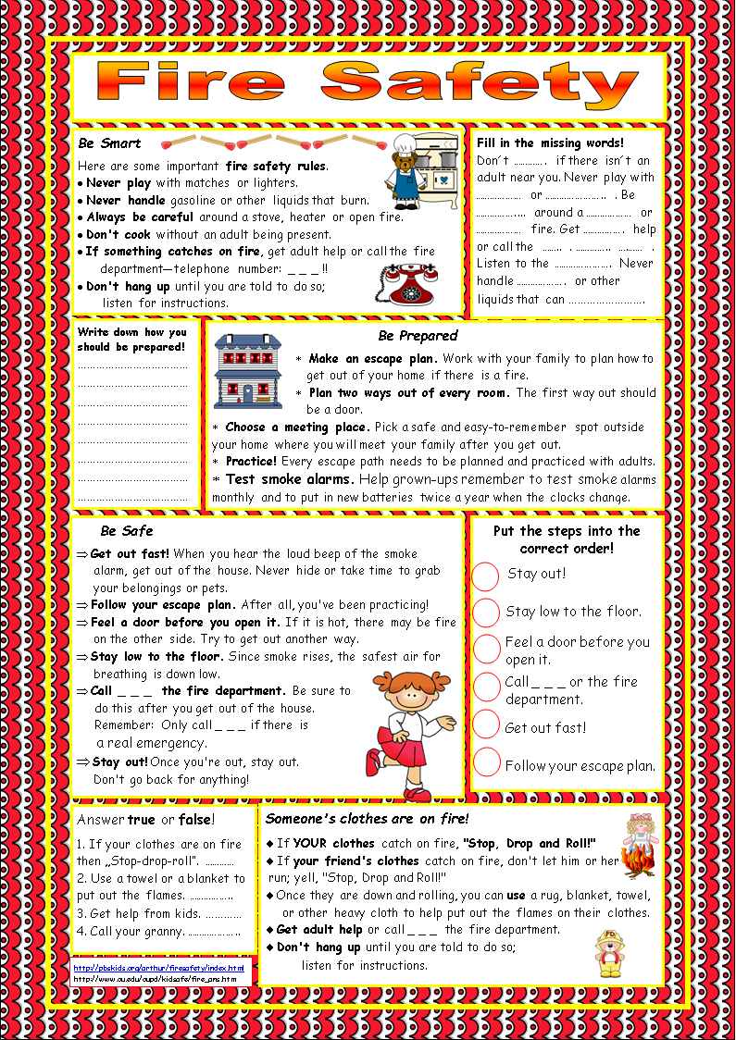
Read the information and then complete the tasks on a separate piece of paper – you will struggle to fit your answers on this page.

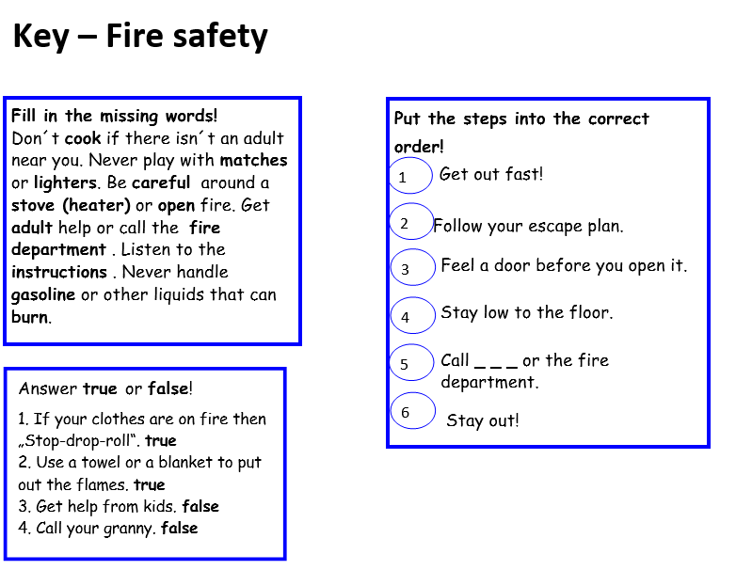

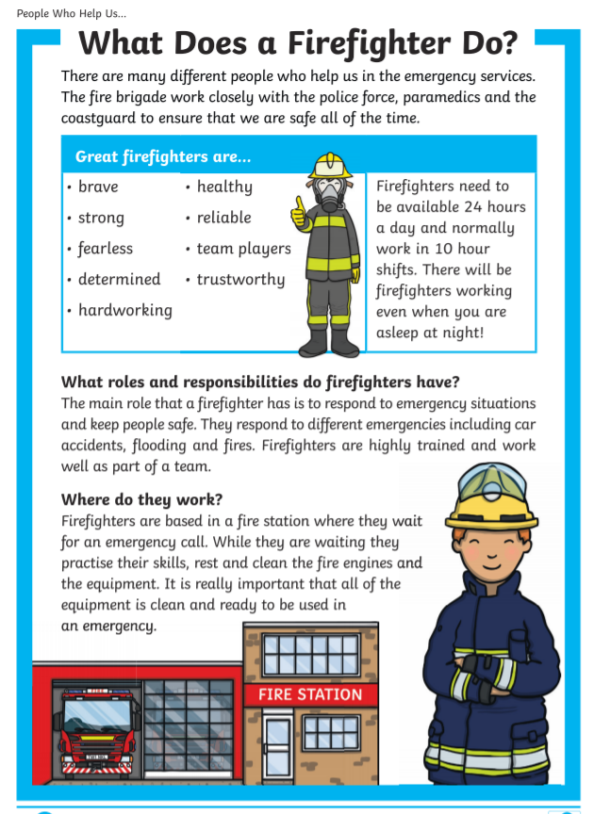
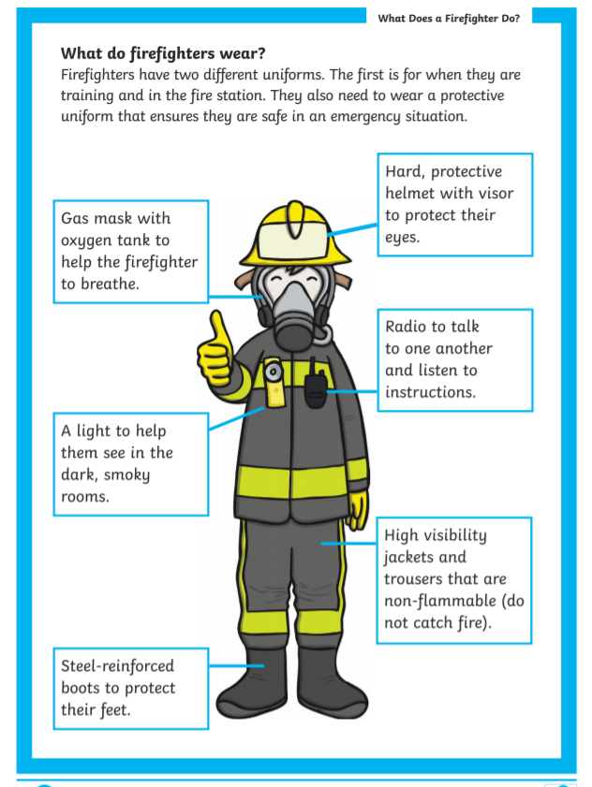
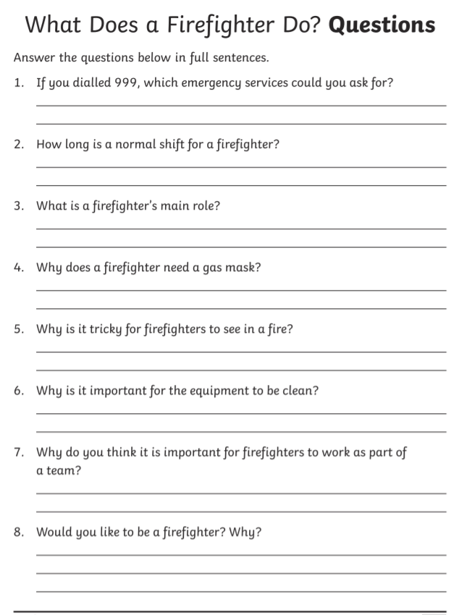
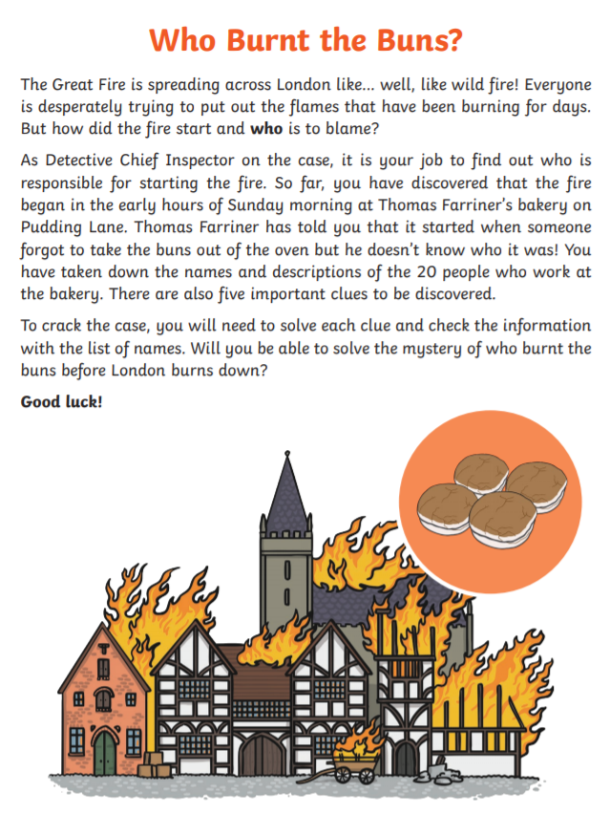
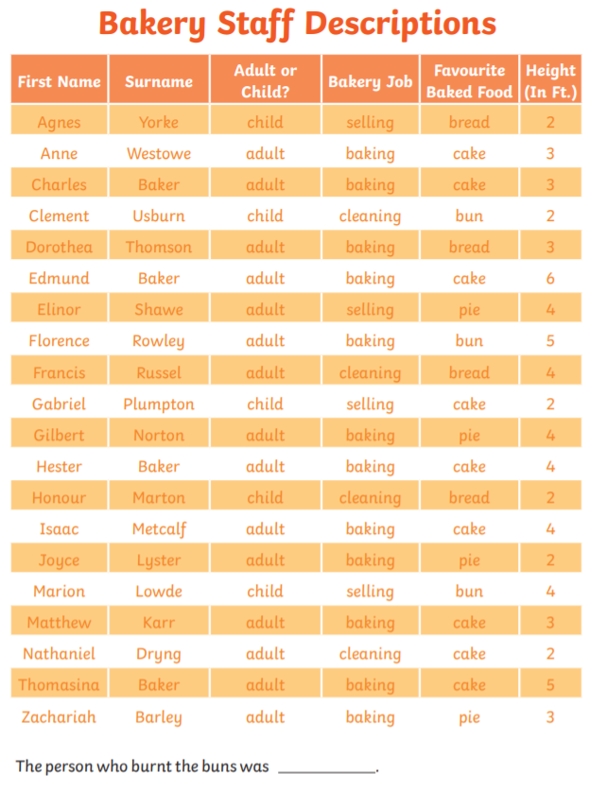

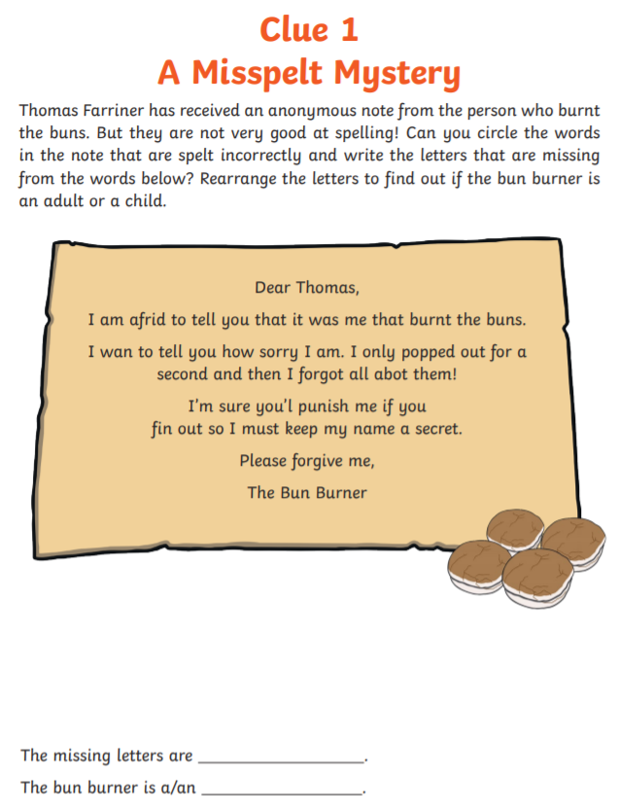
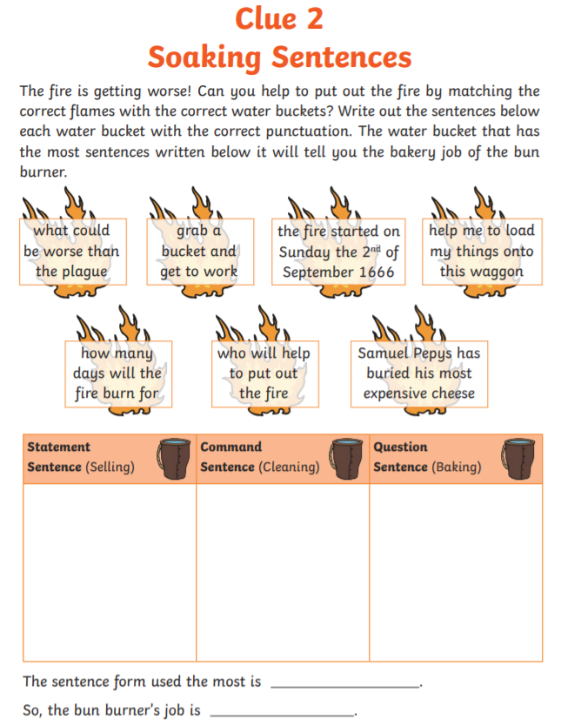
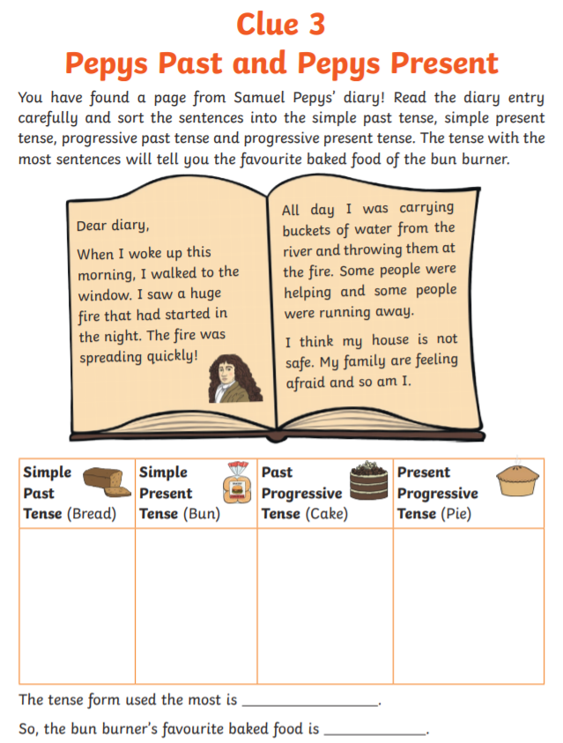

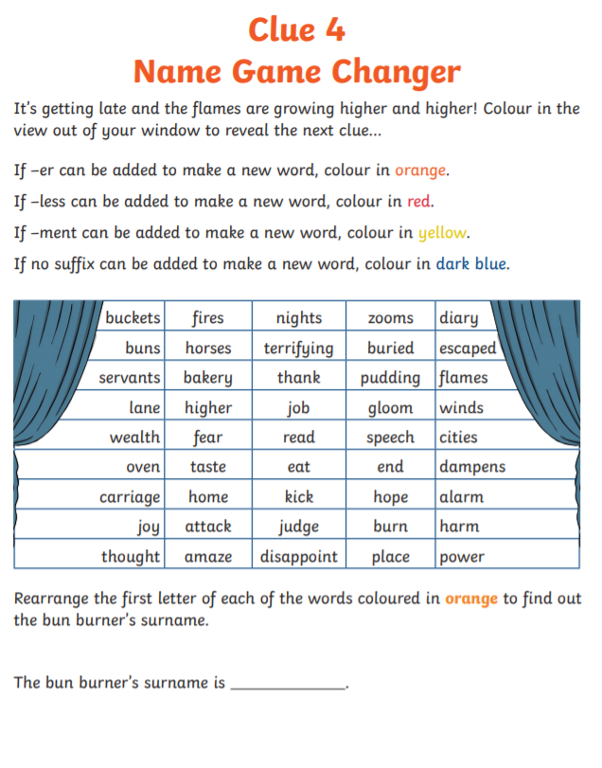
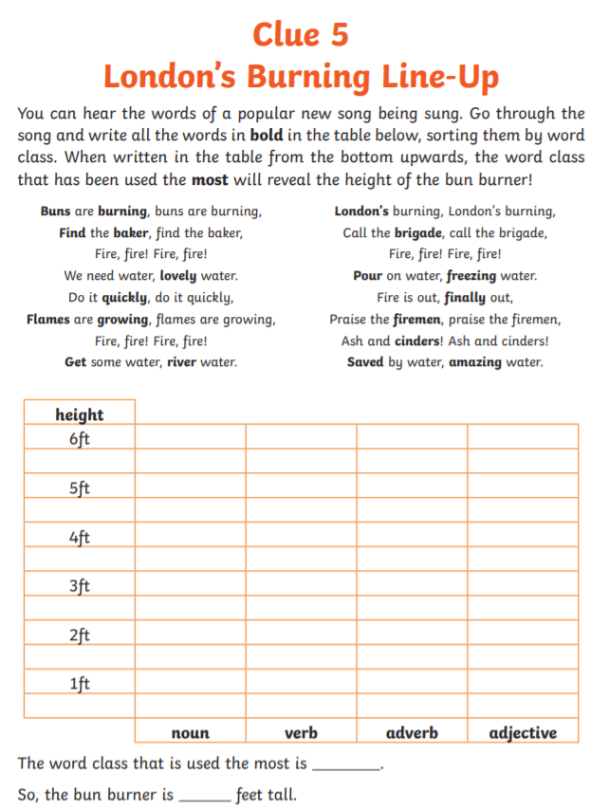
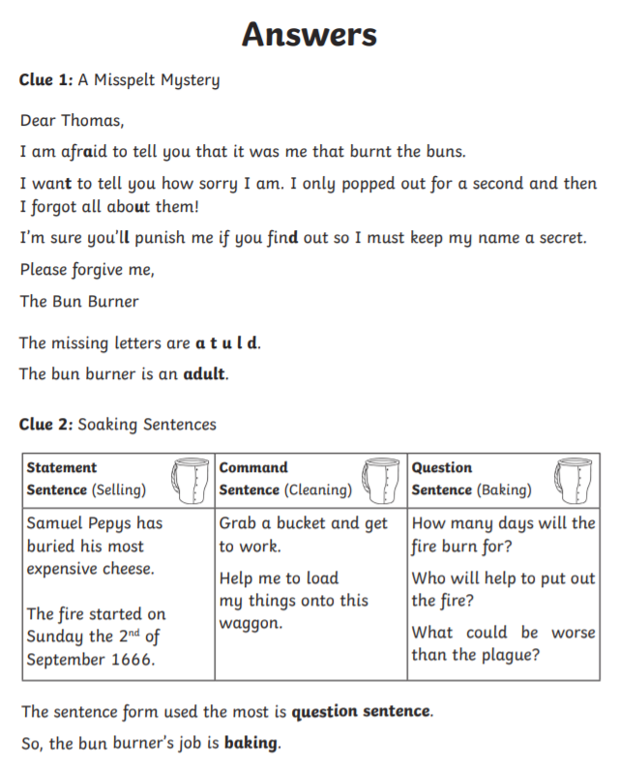

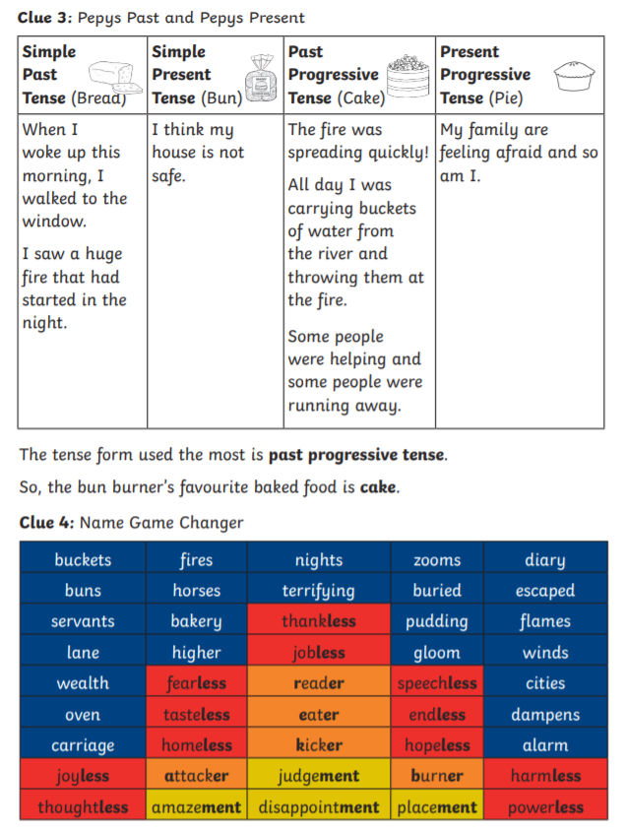

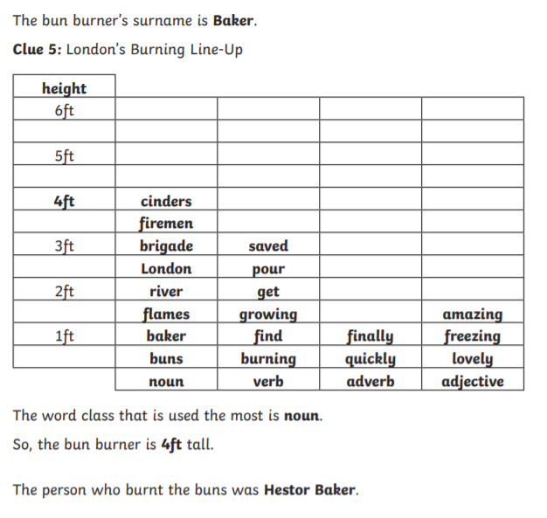

Spelling word bank
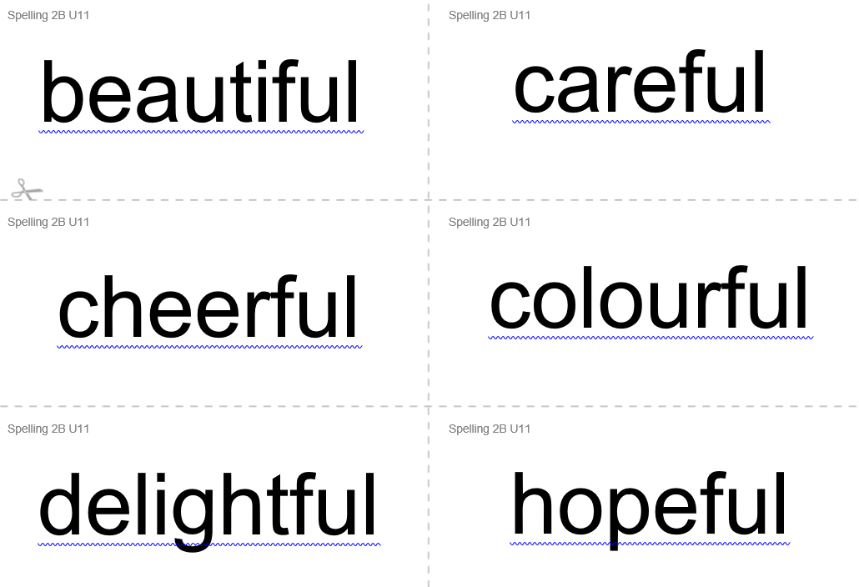

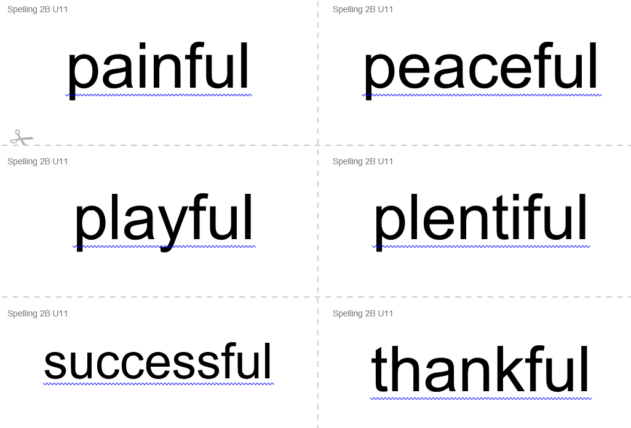

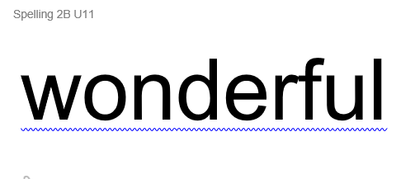

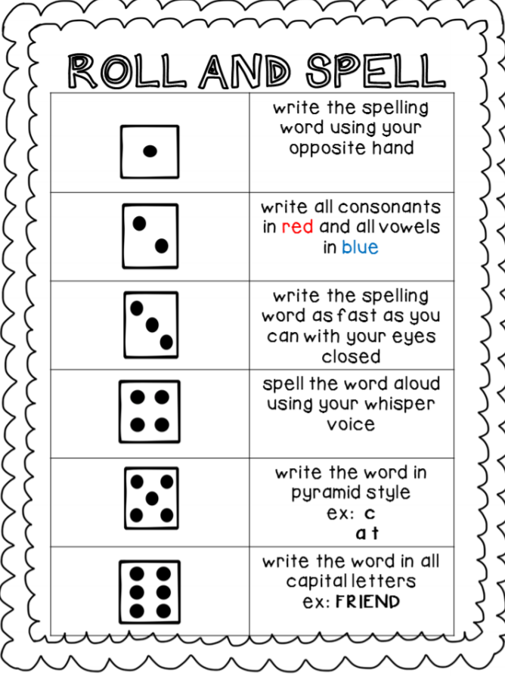

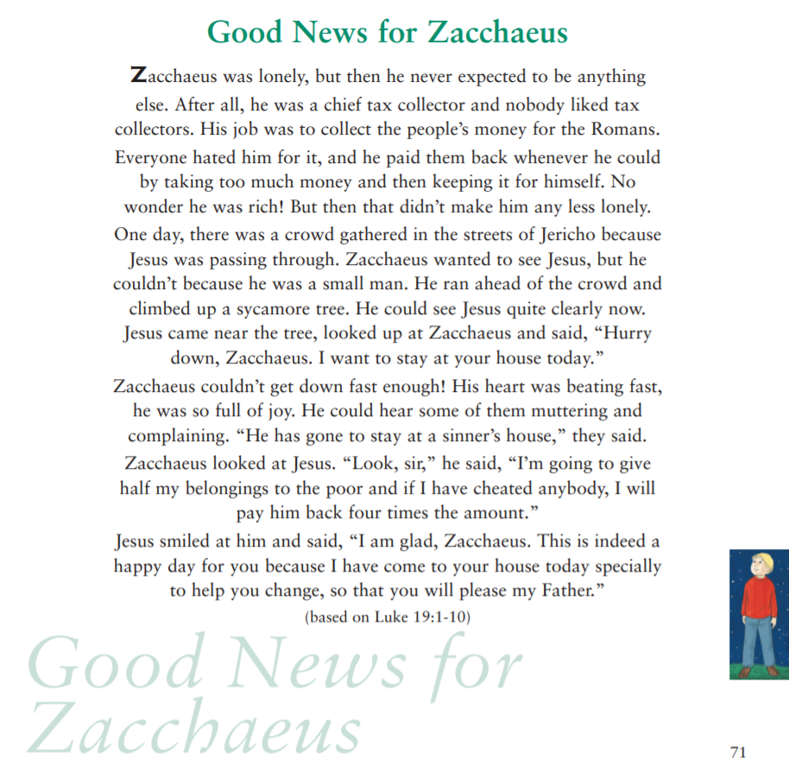
RE

