EAGLES’ WEEKLY SUGGESTED HOME LEARNING – WB 22.6.20
Good morning Eagles! It was so lovely to see you all on the Zoom this week. We have missed seeing your happy faces and hearing your voices. It’s great to hear how many of you enjoyed taking part in the Zoom chat on Tuesday. We look forward to seeing you all on Zoom again soon.
Lastly, it is really important that you are still completing the tasks each week and please email these tasks to us so that we can monitor what you are doing. Thank you!
Take care - #StaySafeStayHomeSaveLives
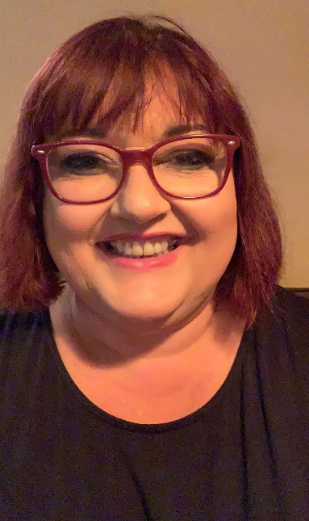
Mrs Colothan, Mrs Hillam, Mrs Jones, Mrs Donlon and Miss Clegg XX
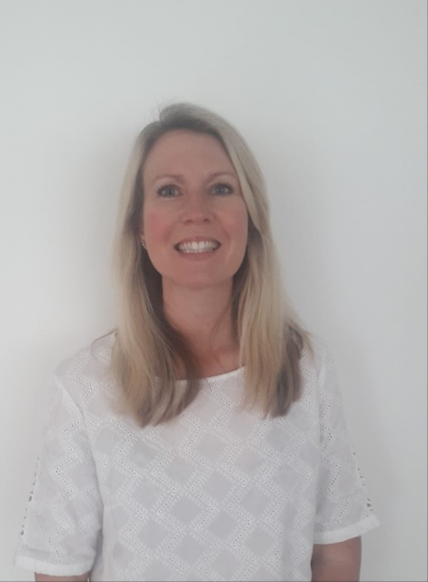
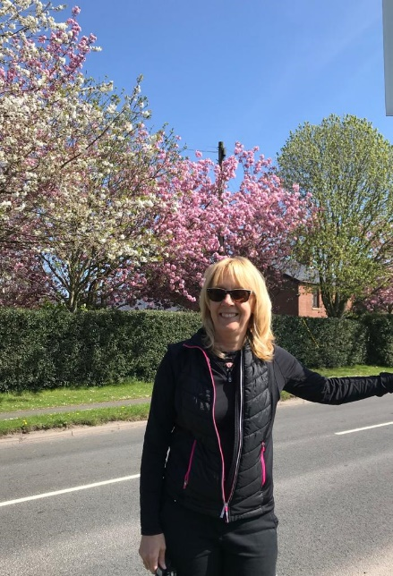

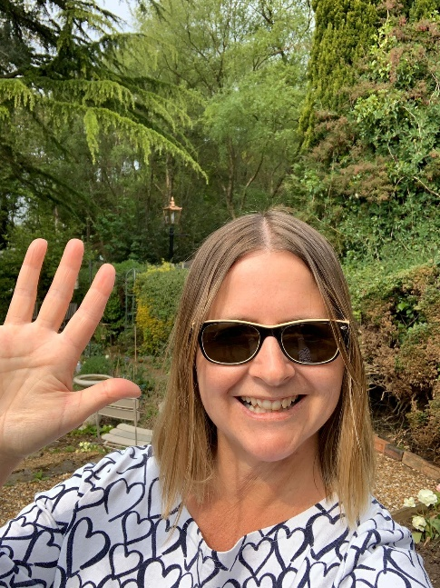
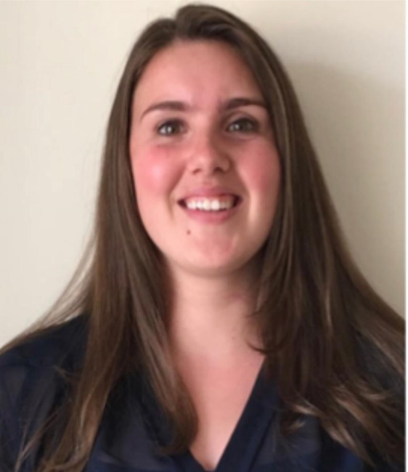
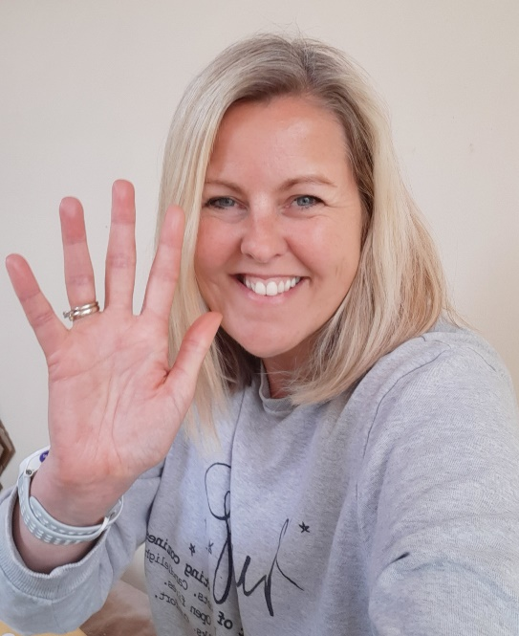

ENGLISH |  | MATHS
Reading – Read every day for pleasure for 30 minutes. You may like to use Epic. This is a great website where you read many online books for free for a month.  Complete ‘Stormbreaker’ reading comprehension using this link. If you have time, complete another comprehension task of your choice.  https://central.espresso.co.uk/espresso/modules/e2_comprehension_uks2/index.html?source=search-all-KS2-all-all&source-keywords=reading%20comprehension%20y6  This week we will continue to focus on the genre of instructions.  https://classroom.thenational.academy/lessons/instructions-lesson-1-reading-focus  This was the web link that you used last week. You might want to refresh yourself on the features of an instruction text.  Your English tasks this week will involve writing and spelling.  Writing and Spellings – Create your own spelling game. Use words that you have struggled to spell from the Y5/Y6 list or you could include homophones, ‘I before e’ words or ‘cian’, ‘tian’, ‘cial’ and ‘tial’ suffix endings.  Make a board game, snap or pairs game. Send in pictures of the game that you have created. Write a set of instructions that explain how to play the spelling game. Remember to include all of the features of an instruction text in your writing. |  | 8 and 12 times table – Instant recall.  https://ttrockstars.com/  How many patterns can you spot in the 7 and 11 times tables? What patterns can you spot?  Follow these weblinks for some quick maths challenges.  https://www.transum.org/software/SW/Starter_of_the_day/starter_June11.asp  https://www.transum.org/software/SW/Starter_of_the_day/starter_June13.asp  https://www.transum.org/software/SW/Starter_of_the_day/starter_June18.asp  The website below has some videos and activities linked to algebra.  https://central.espresso.co.uk/espresso/primary_uk/subject/module/frontscreen/item317416/grade2/index.html?source=subject-Maths-KS2-Maths-Resource%20types  Complete the tabs on the right-hand side of the page.  Create a poster based on what you have learnt after the ‘Learning Review’.
R.E. | OTHER
Next Monday, on the 29th June, is the feast day of St Peter and St Paul. We traditionally would celebrate this day across the whole school so we would like to try and join across our homes in celebration instead.  It would be fantastic if you use the key and fish images (see attached) and create a mobile or a poster and add in key words that sum up what Jesus wants us to do e.g. love. You can use colours, paint or glitter- it’s up to you!  Fish are often symbolic with St Peter because he was a fisherman. Keys are symbolic too because in the Gospel of Matthew 16:13-19, it tells us that Jesus gave Peter the keys to the kingdom of heaven. St Paul was a great missionary of Christianity and the author of most of the Letters of the New Testament. What else can you find out about these two important people from the Early Church?  PLEASE SEND IN YOUR CREATIONS TO SHARE WITH US ON TWITTER OR VIA EMAIL. Below are a couple of starting ideas.  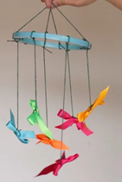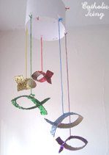  http://www.wednesdayword.org/ | Transition Tasks:  We are continuing with Robinhood Mat work.  Follow the link below and then scroll down to Y6/7 transition learning projects. Week beginning 22nd June. The theme is about growing your independence – this is very important during the transition to high school!  https://www.robinhoodmat.co.uk/Learning-projects/  Science  Create a mindmap of your understanding of the ‘Properties of Materials’. Include as much scientific vocabulary as you can. Then use this website to revise this topic.  https://www.bbc.co.uk/bitesize/topics/zryycdm  Add any information that you have found out to your mindmap in another colour.  Complete this quiz.  https://www.educationquizzes.com/ks2/science/materials-vocabulary/  If there is any vocabulary that you are unsure of, research it and add it to your mindmap. Use a different colour when adding this new information.  Art  https://www.youtube.com/channel/UCBpgrJijMpk_pyp9uTbxLdg  This website is called ‘Draw with Rob’. Pick a few characters, copy and adapt these fun characters. . Experiment using pencil, crayon, watercolours or even collage to add colour to your drawings. Email your finished drawings.  Mindfulness  Listen to this meditation video. Find a quiet space and enjoy a calming moment.  https://www.youtube.com/watch?v=HtYIQiXyrsE  French  Don’t forget the good progress that you have made with your French knowledge. Follow this link to refresh your understanding of French vocabulary to describe school and hobbies.  https://www.bbc.co.uk/bitesize/articles/z93n7yc

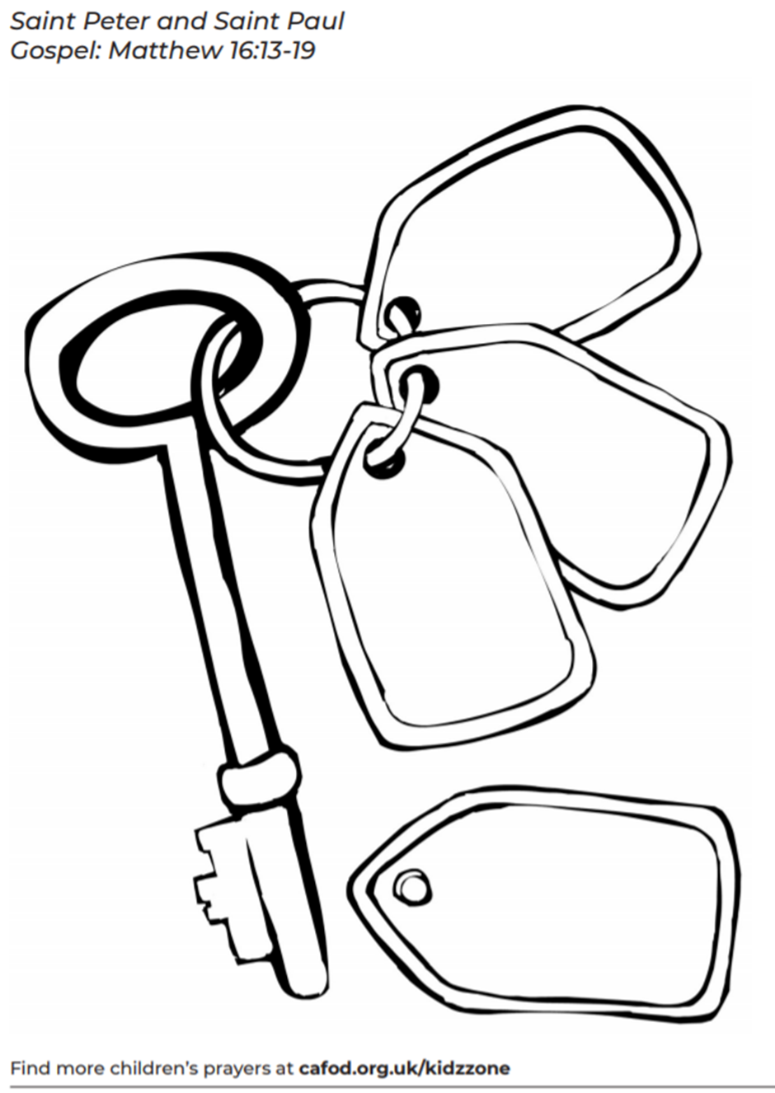RE Task

