OWLETS AND EAGLETS - WEEKLY SUGGESTED HOME LEARNING –
WB 22.06.2020

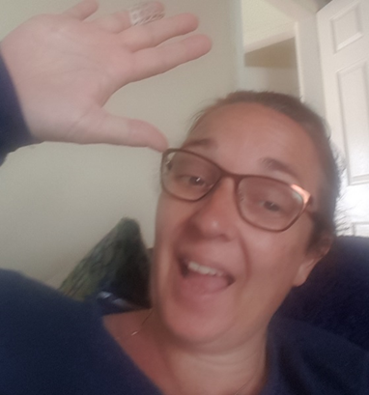

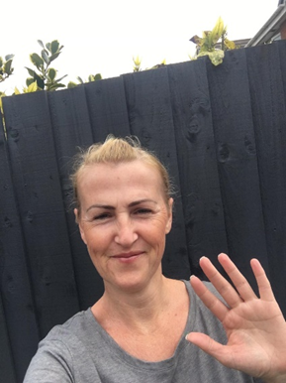
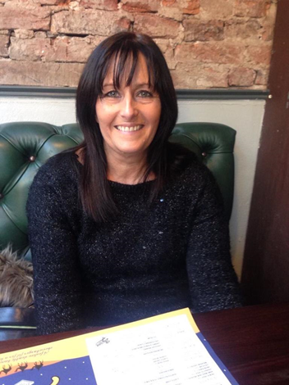

Hello again Owlets and Eaglets, we hope you are all well and still looking after yourselves. These are our suggested activities for you this week. We hope that you enjoy them. This week the focus is on the Rainforest, what interesting animals or plants do you think you would find in a rainforest? Please remember to share some pictures on See-Saw. It is lovely to see what you have been up to, thank you for keeping in contact with us, we miss you so much and it’s lovely to see your happy faces, showing us what you have been up to. Thank you for your ongoing support, enjoy your week of learning. School email – enquiries@saintoswalds.wigan.sch.uk Tweet - @saintoswalds

ENGLISH | MATHS
Reading – Read a variety of books at home. Favourite books can be repeated as it supports the children with their language development as they will hear the patterns of language in the story.  Use Oxford Owl to access books that are related to phase 2 and 3 phonics. Where possible children to read to parents daily.  When you go on click on all ages and click on age 4-5. Then go into levels and click on letters and sounds and choose either phase 2 or 3.(phase 2 will be a little easier and phase 3 more challenging) If you find that these are still not challenging for them then choose age 5-6, go into levels, letters and sounds and click on phase 4. This will then bring books up for you to access with your child.  After reading the book ask the questions on the back cover of the book and complete the play activities linked to the book.  Register here for free access to Oxford owl or you can use our class login  My class name – owlets and eaglets  My Class Password – reception.  Just go to the Oxford Owl login page and click on the My Class login button and use the above details.  Some extra literacy activities this week are taken from Robin Hood Multi Academy Trust. Focus this week is on the Rainforest.  Ask your child if they know of any plants, animals or insects that may live in the rainforest. What do they think the weather would be like in the rainforest? What different foods would you find in the rainforest?  Listen to stories about rainforests - Go Jetters-Amazon Rainforest Slowly Slowly Said the Sloth The Tiger Who To Tea  Reception age children: Can your child find and practice reading the tricky words: from phase 2 and 3? See end of planning for key words.  Story focus – Go Jetters- Amazon Rainforest Watch this online reading. Go Jetters- Amazon Rainforest  Can your child tell you where the tree frog was found?  What sound did it make?  Which rainforest insect steals the picnic?  What happens when the tree frogs aren’t there to eat the ants?  Ask your child to use pictures from a familiar story book to make up their own story or to retell their favourite story.  Writing task 1 -  Write a list of all the animals you would find in the rainforest.  Can your child think of an animal for each letter of the alphabet e.g. a=alligator, b=bird.  Writing task 2-  Talk for writing- talk about the rainforest with your child and ask: What can you see? What can you hear? Ask your child to draw a picture of the rainforest and write a sentence about what they can see or hear.  Remember to use a phase 2 and 3 sound mat to help your child with the sounds in the words.  Writing task 3 –  Using the story The Tiger Who Came To Tea, draw a picture of the tiger and label the picture using words to describe him e.g. stripy fur, sharp teeth.  Writing task 4 –  Ask your child to create a rainforest animal mask then talk about the sounds that different animals make. Can they write a sentence to describe the animal e.g. I like the monkey. He is cheeky. He jumps in the trees  Inference activity  See end of planning for larger pictures for this activity. Can I infer what is happening in the pictures?  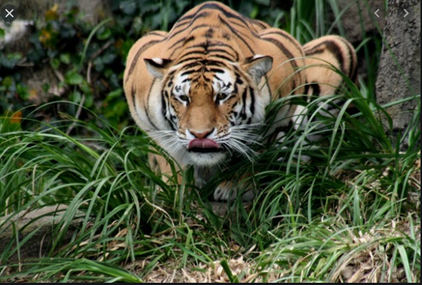  What can you see in the picture?  What do you think the tiger is ready to do?  Will the tiger move fast or slow? Why?  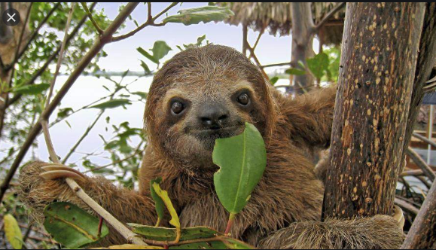  What animal is in the picture?  What is the sloth doing?  Do you think the sloth is hungry? Why?  Phonics (Reading and writing)  Phase 4 phonics –  Please remember to use the free log in - Use the Username – march20 and the password – home If you wish to complete a spelling test use a mixture of the key words you have looked at with the children from phase 2 and 3. Only look at up to 8 words choose from these words – the, I no, go, to, into, he, we, me, be, she, they, was, my, all, you, her, are. Or use the words covered in this weeks phase 4 planning. Phase 4 phonics – Start your phonics session by playing the flashcard games on phonics play for key words and sounds for either phase 2 or phase 3. Help your children to read the following words – tent, damp, lump, bend, mend, fump, hent, yend, sent, bump, jump .. Once they have practised reading them, can they have a go at writing them? Segment the words slowly so that the children can hear each sound. These are some of the phase 4 tricky words we would like you to introduce – recap so, do, some, come and introduce said - ‘’ Write the tricky words on paper show them your child and help them to read them. Write out two lots of each word and play a pairs game. Who will find the most pairs? Help your child to read the sentences we have written at the bottom of the planning which are appropriate for phase 4. Ask your child to write the following words (please use them over the week and not all on one day) toad, roam, load, road, tree, feel, seen, peel. (These are practise words to help keep phase 3 sounds ticking over.) Can your child say these words in a sentence? Extra challenge – Can your child write the sentences they have said? | Mathematics  Watch number blocks clip each day with your child at  Numberblocks BBCiplayer or Numberblocks Cbeebies  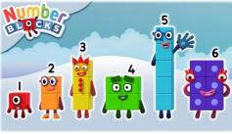  Activity – Practice number formation with you children. Here are the rhymes that we use in the classroom to help your child remember how to write the numbers.  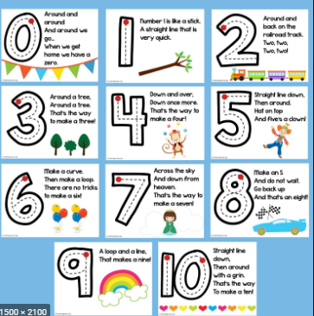  Follow the White Rose Week 8 using the story Princess Mirror-Belle – 3 D shapes, counting, addition, counting, doubling, halving, and sharing subtraction.  You may also want to look on Oak National Academy Reception Click on the link below to access 5 lessons on addition and subtraction. This includes combining 2 quantities to find a total, exploring addition by adding on, exploring subtraction as partitioning, exploring subtraction as take away and comparing 2 sets of objects using ‘more’ or ‘fewer.’ Click the link to take you to all the maths activities on Oak National Academy Addition and Subtraction. Please scroll down to the bottom of the link to find the 5 lessons on addition and subtraction.  Practise counting up to 20. This can be done through playing hide and seek, singing number songs, chanting, board games etc. Remember to also practise counting back from 20 to 0.  Don’t forget that you have your Numbots username and password that was sent to you on your child’s see-saw learning journal. Look in the parent information file on the app to find it again if you have forgotten it.  Work on counting and number recognition if you wish to do some more activities taken from Robin Hood Multi academy trust learning projects.  Use this tens frame to practise making different amounts. Or, your child can practice making amounts to 10 using different objects from the garden e.g. leaves.  Practice writing the numerals to 10 and then up to 20 if your child is able. You could do this in chalk in the garden, using felt tips, crayons or anything that will engage your child.  Play this Ladybird Spots- Counting, Matching and Ordering Game You can tailor the difficulty to your child’s level.  Make a garden trail using arrows made from sticks. Ask your child to follow the trail and identify the direction. This could be done on your walk.  Use a teddy and count forwards and backwards making deliberate mistakes. Can your child spot the mistakes? Mistakes can include omitted numbers, repeated numbers or a number in the wrong place. Ask your child to spot the mistake when the numbers are written down.
R.E. | OTHER
The theme is: Good News  This is the final week on the Good News topic it is a time to remember, celebrate and respond to to how we can make good friends, that Jesus had good friends and what Jesus tells us about friendship  Ask your child if there is anything they wonder about:  How friends make us feel happy, comfortable and glad.  What breaks and mends friendships.  How Jesus is our friend.  Task 1 – Ask your child to write or draw a picture of how they can show friendship to someone today. (See below for an enlarged version of this activity sheet.  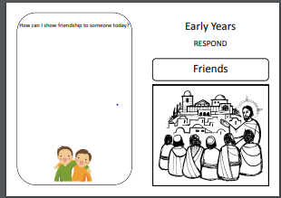  Task 2- Play some quiet music and ask your child to think about these questions:  How do friends make us feel happy, comfortable and glad?  What makes a friendship?  What breaks a friendship?  How is Jesus our friend?  Then ask them to respond to the big question  Our Big Question - Is it good to have friends  Ask your child to draw or write what they will remember and hold onto from this topic.  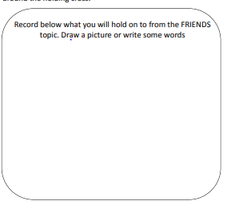  Text for the task..  Next Monday on the 29th June, is the feast day of St Peter and St Paul. We traditionally would celebrate this day across the whole school so we would like you try and join across our homes in celebration instead.  It would be fantastic if you use the key and fish images (see bottom of the planning) and create a mobile or a poster and add in key words that sum up what Jesus wants us to do e.g. be kind, love. You can use colours, paints, glitter – its up to you.  Fish are often symbolic with St Peter because he was a fisherman. Keys are symbolic too because in the Gospel of Matthew 16: 13-19, it tells us that Jesus gave Peter the keys to the Kingdom of heaven. St Paul was a great missionary of Christianity and the author of most of the letters of the New Testament. What else can you find out about these two important people from the early church. PLEASE SEND IN YOUR CREATIONS TO SHARE WITH US ON TWITTER OR VIA EMAIL. Below are a couple of starting ideas.  Next Monday, on the 29^{t}  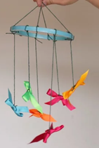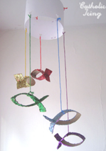 | Understanding the World  Ask your child to make their own explorers outfit (e.g. binoculars, sunhat, backpack) and head out to the garden or on your daily walk. What creatures can your child find? Are they similar to any you might see in the rainforest? Take photographs.  Expressive Arts and Design  Draw a Picture of a Rainforest Animal on the Computer  Ask your child to draw a picture of a rainforest animal. Can they use computing software to recreate their picture? Try Paint.  Make a Collage of a Rainforest Animal Use collage to create your own rainforest animal using recycled materials from around the house.  PE- Moving like animals  Follow the link to- Rainforest Animals  Can you think of different ways animals move? Remember some animals move very fast and some very slow!  You might also like to make your own rainforest out of a plastic jar and some outdoor items  Follow the link  My Rainforest  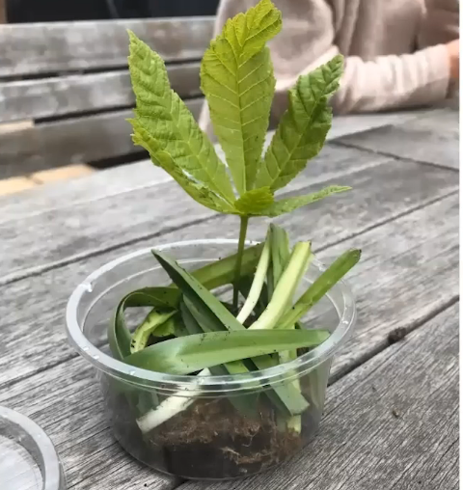  Wellbeing - try cosmic kids yoga Click on the link and choose from one of the videos.  Take some time to be quiet and still, listen to some calming music and think about your week. What has gone well? What has not gone so well?  .

Your own number rhyme sheet.

RE
Task 1
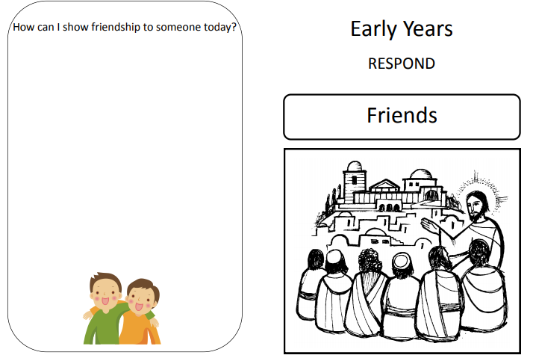
Task 2
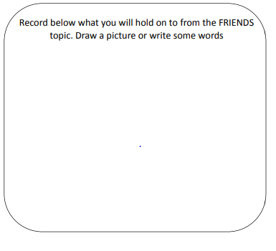

St Peter and St Paul Activity
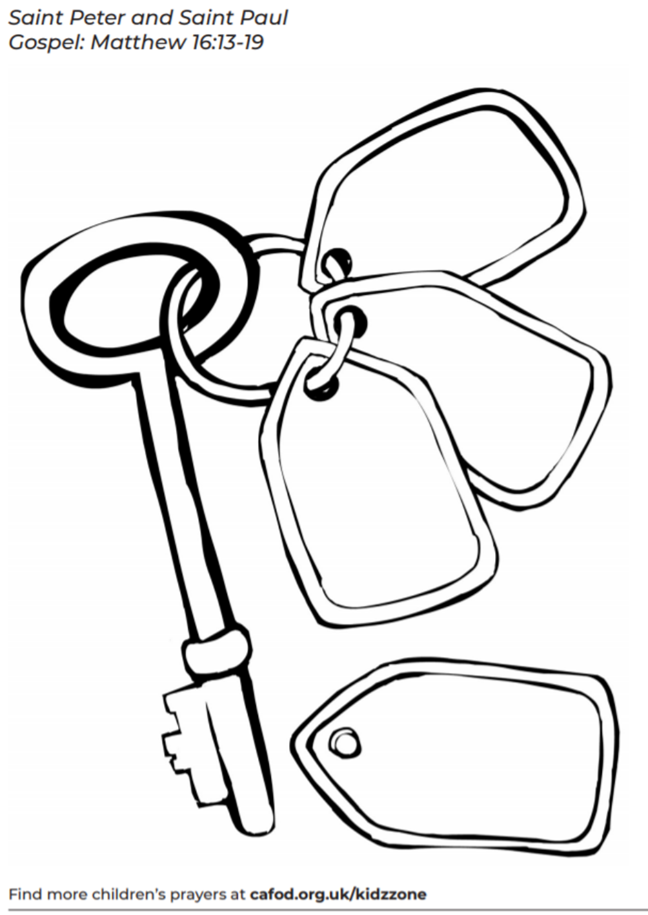

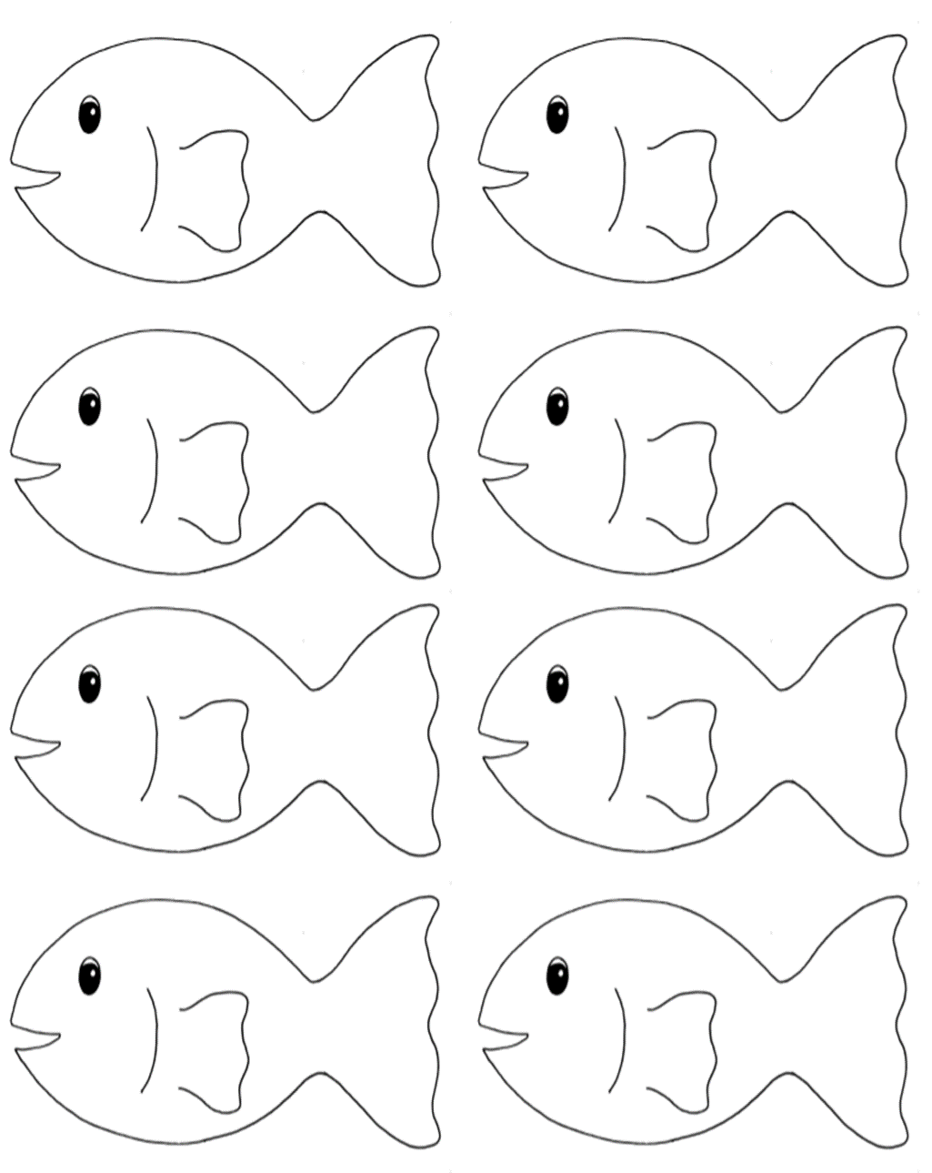

Inference Activity
What can you see in the picture?
What do you think the tiger is ready to do?
Will the tiger move fast or slow? Why?
What animal is in the picture?
What is the sloth doing?
Do you think the sloth is hungry? Why?

Phonics
When revisiting the sounds with the children sing the song.
i.e when revisiting a sound.
An (insert the sound here) together make one sound.
What is it?
An (insert the sound here) together make one sound.
What is it?
It’s in (insert 4 words with the sound in here)
An (insert the sound here) together make one sound.
What is it?

If you need support with the song when recapping sounds with your child, please do not hesitate to get in contact with Mrs Gill via see-saw.

After singing the song ask the children which sound did we hear in each of the words. Repeat the words slowly if you need to. Then repeat the song again but where we sing what is it? The children say the sound the letters make together.

Resources for Phonics
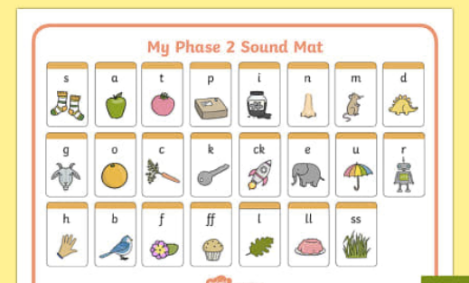
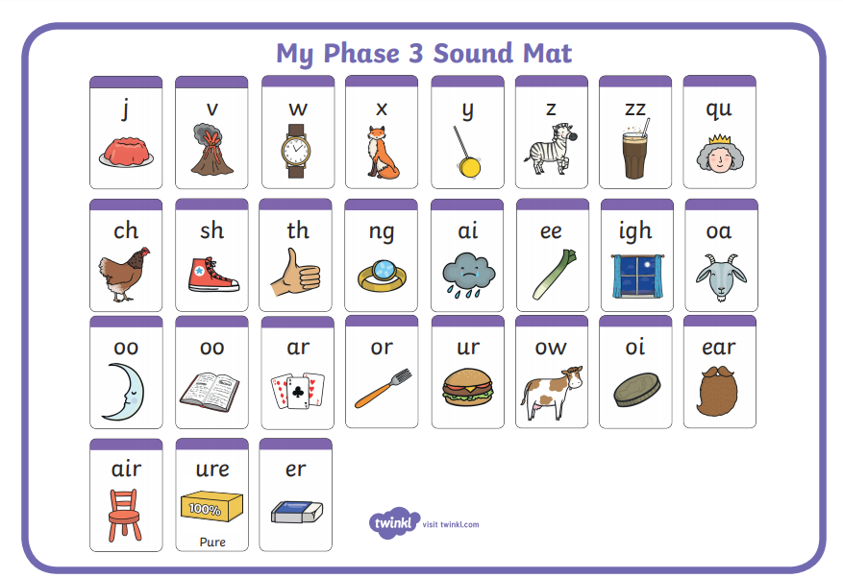

Phase 2, 3 and 4 tricky words for you to practise.
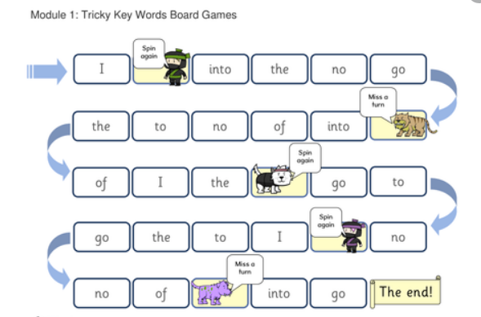

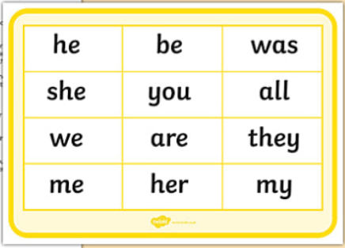
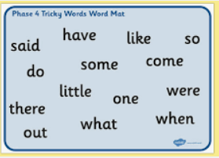

Phonics sentences

- Help! I got a bump on the leg.

- A tent will get damp in the rain.

- Milk is good for teeth and gums.

- Mum said, “It is best not to jump on the bed.”

- A lost chimp felt so sad he wept.

- This belt is so tight, it hurts my waist.

- I can boast that I had toast for my lunch.

- I think that pink socks might be the best.

- If you feel down in the dumps then jump and sing.

- The chimp sings a song as he jumps up and down.

- We put the tent next to the pond.

- He put the milk in the sink.

