Magpies’ WEEKLY SUGGESTED HOME LEARNING – WB 22.6.20
Hi Magpies! I Hope that you are all well. I miss you all lots and really do enjoy seeing the work that you’re doing. Keep getting in touch! Don’t forget that this week is the National School Sport Week at Home, supercharged by Sky Sports! Head to the Youth Sport Trust website to find out more information and to sign up! #StaySafeStayHomeSaveLive
Mrs Knott and Mrs Harris XX
ENGLISH | MATHS
Reading – Read every day for pleasure for 20 minutes.  This week your English task is a little different. You are going to plan a family movie night! You can organise it to suit your own family. You will need to decide on which film you are going to be showing at your cinema, when it is going to be shown, what snacks and drinks will be available and who you are going to invite.  Writing –  - Design invitations that can be sent to the people who you are inviting. Remember to include all the relevant details – time, date etc. An example can be found below but I’m sure you can design a better one.  - Write a letter to the people you will be inviting to persuade them to attend. An example of a persuasive letter can be found below as well as a checklist.  - Write a price list for the snacks and drinks that you will be serving.  - Design tickets to be given out once your invitation is accepted.  - Write a film review once the film has been watched. There is a template below to help you.  Spellings – Year 3/4 Common Exception Words – learn the spellings below and put them into your own wordsearch.  Try the spelling activities below. | 15 minutes on TT Rockstars each day  https://ttrockstars.com/  Contact school if you need a password reminder Year 4 -  White Rose – Week – 9 -Money  Use worksheets below and BBC Bitesize to support the white Rose videos  https://whiterosemaths.com/homelearning/year-4/  https://www.bbc.co.uk/bitesize  Try the free to use money pack from Classroom Secrets  https://classroomsecrets.co.uk/pounds-and-pence-year-4-money-free-resource-pack/  If you find these activities too challenging you can create your own money activities.  - Make a café or shop and work with real money to sell items to your family.  - Count all the money in your money box/jar.  - Use your toys to set up a toy shop. Price all the toys and play shop with your family.  - Link to your English task- Movie night. How much will your night cost? Include the cost of the film and the cost of the snacks and drinks that you will serve.
R.E. | OTHER
Next Monday, on the 29th June, is the feast day of St Peter and St Paul. We traditionally would celebrate this day across the whole school so we would like to try and join across our homes in celebration instead.  It would be fantastic if you use the key and fish images (see attached) and create a mobile or a poster and add in key words that sum up what Jesus wants us to do e.g. love. You can use colours, paint or glitter- it’s up to you!  Fish are often symbolic with St Peter because he was a fisherman. Keys are symbolic too because in the Gospel of Matthew 16:13-19, it tells us that Jesus gave Peter the keys to the kingdom of heaven. St Paul was a great missionary of Christianity and the author of most of the Letters of the New Testament. What else can you find out about these two important people from the Early Church?  PLEASE SEND IN YOUR CREATIONS TO SHARE WITH US ON TWITTER OR VIA EMAIL. Below are a couple of starting ideas. | Science – Habitats –  https://central.espresso.co.uk/espresso/modules/s2_habitats/video_pages/multivideo_pond.html  Watch the video about the habitats of a pond and complete the activities.  Geography - Research an area/city of a European country e.g. Barcelona in Spain or Paris in France. It could be somewhere you have visited or somewhere you would like to go to in the future. Create a poster all about this place – include activities you can do there, what the landscape is like, where it is located, jobs that local people do, information about the tourist industry in that area etc.  You could use the information about The Alps- follow the link below  https://www.bbc.co.uk/bitesize/topics/z3fycdm/articles/zb3ywty  or try  https://www.kids-world-travel-guide.com/france-facts.html  Music – Time for music Y3/4 Lesson 8  https://www.stoswaldswigan.co.uk/classes/fun-learning-games/music  Art- Design your own animal that could live in the habitat of a pond. Label the features, it could be a mix of a few of the animals that you would find in that habitat.

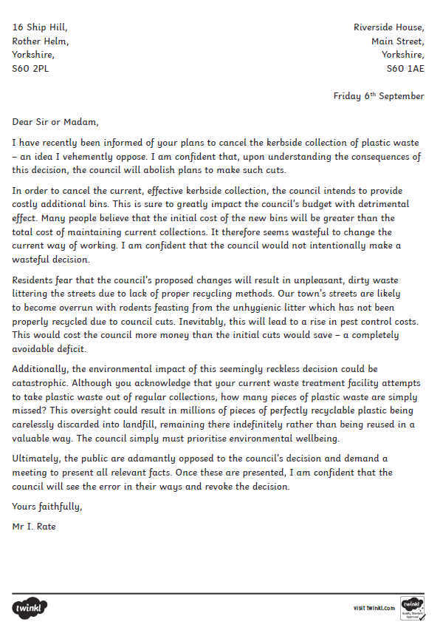

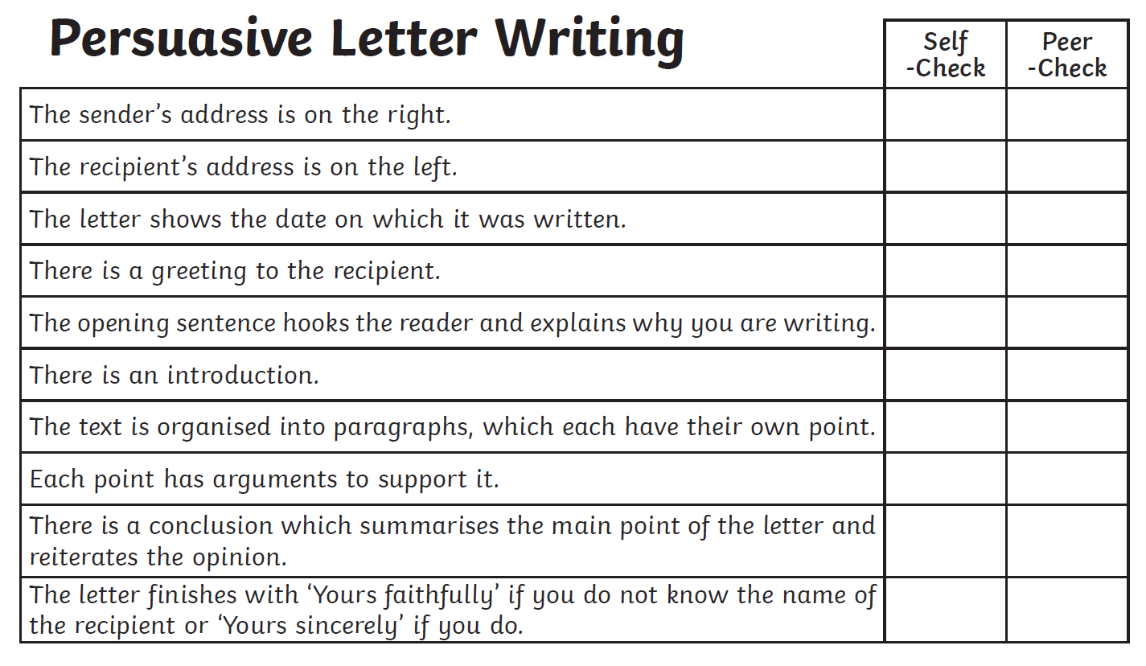
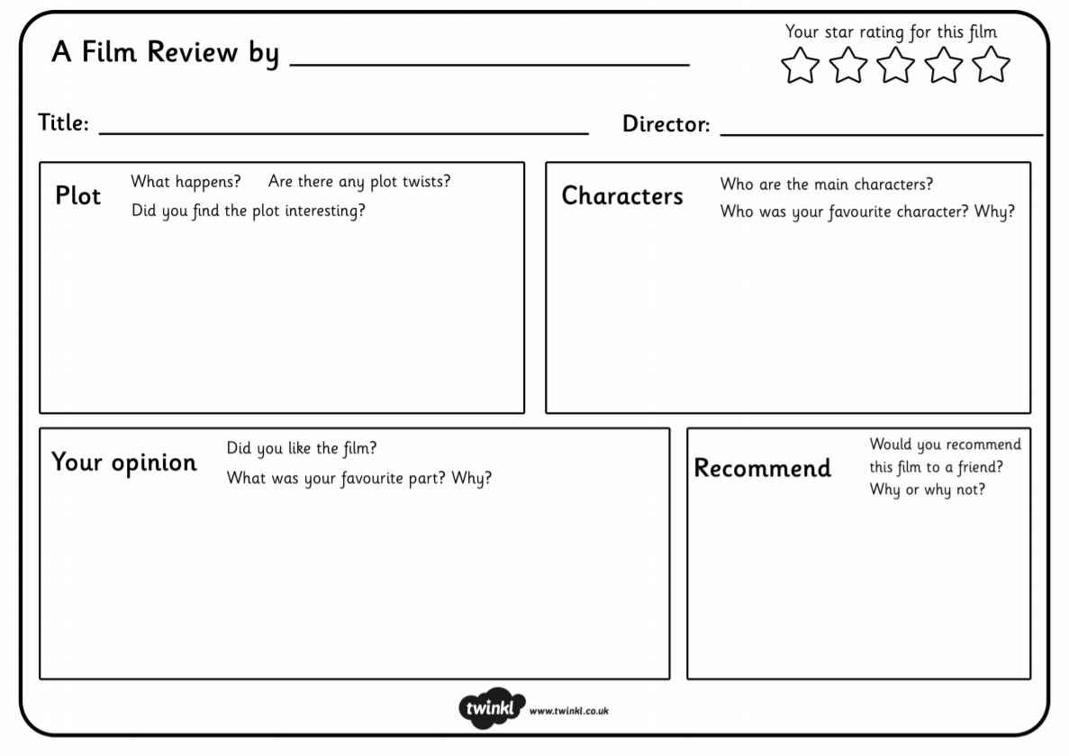
Spellings
Focus – Year 3/4 spelling words
 | Attempt 1 | Attempt 2 | Attempt 3
various
weight
woman
women
accident
believe
calendar
decide
early
famous
grammar
heard
imagine
knowledge
learn
material
natural
occasion
particular
quarter

