ROBINS’ WEEKLY SUGGESTED HOME LEARNING – WB 22.6.20
Hi Robins, we hope that you are all well and enjoyed your learning tasks from last week. This week’s focus is ‘Feelings and Emotions.’ Looking after your mind and body is very important. Talking and expressing how you are feeling helps us to have a healthy mind. This week’s tasks will help you to share your thoughts and feelings. If there is an activity you have done, you tube clip or online games that you can share with us we can share it with the rest of our Robin friends. Missing you all. Stay Safe!
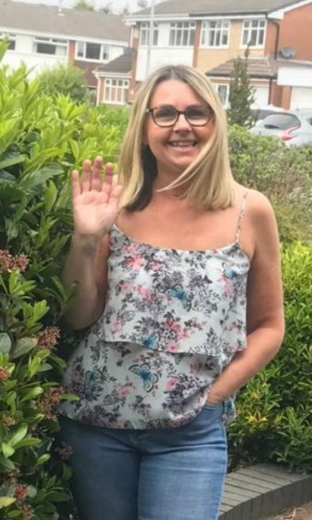
We’d love to see your work, so please Tweet @saintoswalds or send an email to enquiries@saintoswalds.wigan.sch.uk FAO Miss Lea
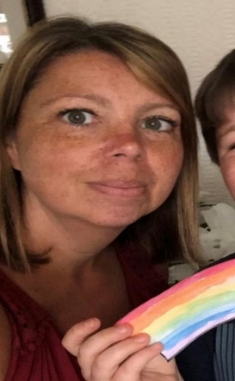
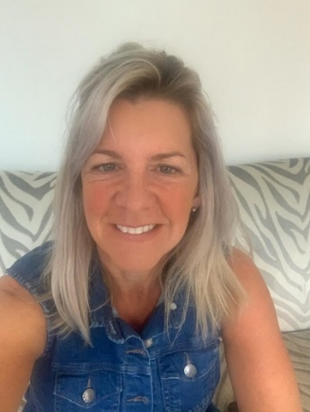
Mrs Fox, Mrs Davies and Miss Lea xxx

ENGLISH | MATHS
READING FOR PLEASURE – 15 mins per day  Reading is an excellent way of relaxing and drifting away into your very own imagination. This week read books that help you to relax and be calm.  Texts about feelings and emotions  Colour Monster goes to School  The Day the Crayons Quit  The Monster’s Monster  READING TASKS  Share the online story – Colour Monster.  Draw and write sentences about the story.  Think about the different colours and how they make you feel. Maybe you could write your own story with you as the main character, like the Colour Monster, thinking about colours and your feelings and emotions. There is a workbook attached to help you.  Feelings poem – colour the words that rhyme. Write a new verse for the poem about a different feeling from those that are in the poem.  Read and label the monsters.  Create your own monster character (Monsterpedia attached)  WRITING TASKS  Write your own story linked to the Colour Monster story using your own monster character that you created on your Monsterpedia sheet.  Write about your feelings using the ‘Feelings Booklet’ below  Phonics – Year 1 – alternative spelling for the ‘n’ and ‘r’ sound  n – nose, gn – gnome, kn – knot  r – red, wr - wrote  Activities attached  Remember also the online videos that you can watch to support learning  Spelling – Year 2 – correct Mr Whoop’s  Sheets attached below  CHALLENGE – write the words you have corrected in a sentence.  Remember sentences are…  Statements (full stop)  Questions (question mark)  Exclamations (starting how/what, ending with an exclamation mark)  Commands (short and bossy sentences) | Basic Skills –  Quick recall of addition and subtraction facts within 10 and 20  Quick count forwards and backwards in 2’s, 5’s, 10’s  Y2 – counting in 3’s  Y2 – recall 2. 3. 5. 10 times tables  This week we are focusing on 2D and 3D shapes again  Sheets attached  Challenge – create your own –  2D shape monster  3D shape monster using tubes, boxes etc  Name and describe the shapes that you have used.
RE | OTHER SUBJECTS
Next Monday, on the 29th June, is the feast day of St Peter and St Paul. We traditionally would celebrate this day across the whole school so we would like to try and join across our homes in celebration instead.  It would be fantastic if you use the key and fish images (see attached) and create a mobile or a poster and add in key words that sum up what Jesus wants us to do e.g. love. You can use colours, paint or glitter- it’s up to you!  Fish are often symbolic with St Peter because he was a fisherman. Keys are symbolic too because in the Gospel of Matthew 16:13-19, it tells us that Jesus gave Peter the keys to the kingdom of heaven. St Paul was a great missionary of Christianity and the author of most of the Letters of the New Testament.  What else can you find out about these two important people from the Early Church?  PLEASE SEND IN YOUR CREATIONS TO SHARE WITH US ON TWITTER OR VIA EMAIL. Below are a couple of starting ideas. There are also some fish outlines attached.  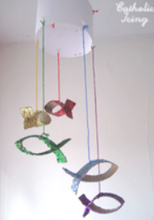  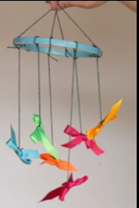 | PSHE  Complete yoga/mindfulness videos from you tube as a family e.g. Cosmic Yoga  Play the emotions board game below  It’s ok to feel sad (sheet attached)  Talk about times when you have felt sad and think of what can make you feel happy again.  Mindfulness Colour My Feelings (sheet attached) instructions on the sheet  Bake something yummy to share with your family  ART  Look in the mirror and draw your face showing different emotions  Happy, sad, scared, worried, exciting, nervous,  Draw marks, lines to show your different emotions  Mix colours to create different feeling paintings – what colours would your use in a happy picture, sad picture etc.  Music – lots of resources on our school website in our music folder. These are updated regularly.  Listening to music is a great way to unwind and relax if we are feeling anxious, sad  Listen to different types of music – talk about how they make you feel… some music makes you feel happy, some music makes you feel sad. Listen carefully to the pieces of music  PE – having a healthy body helps to have a healthy mind  You can set up your own obstacle course in your garden (we would be having our school sports day around this time)  Hold your own family sports day!  Use Supermovers, Joe Wickes, family walks and bike rides etc to keep your body, mind and brain active and healthy  Science/DT  Using recycled boxes, tubes etc make a model of a worry monster. This is something you can share your worries with.  Identify and describe the materials that you have used. Give reasons for why you have chosen the different materials  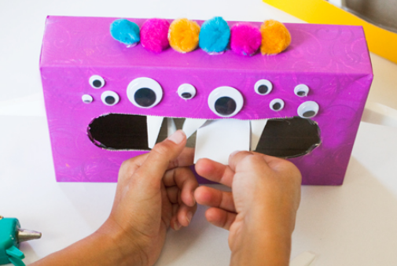
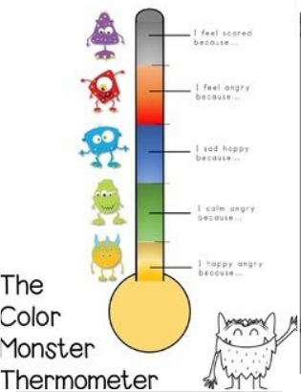

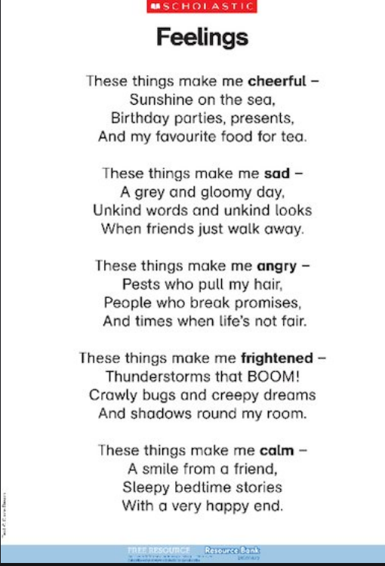

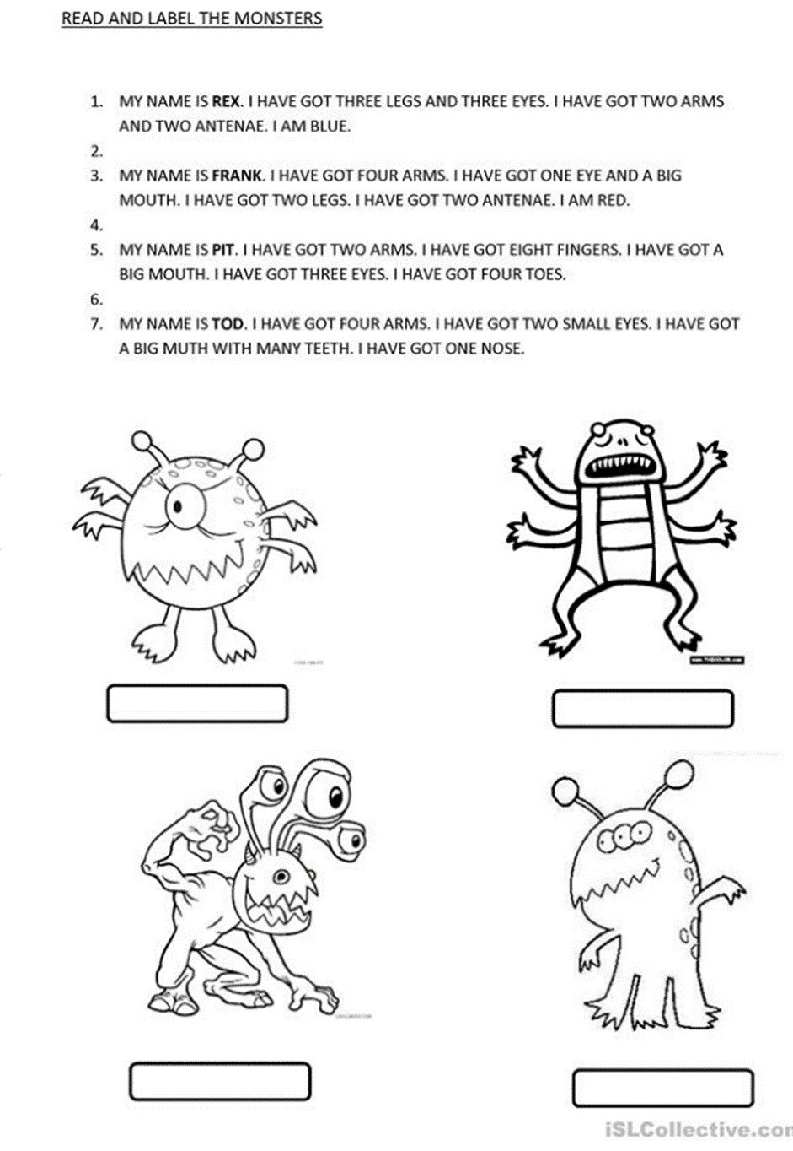

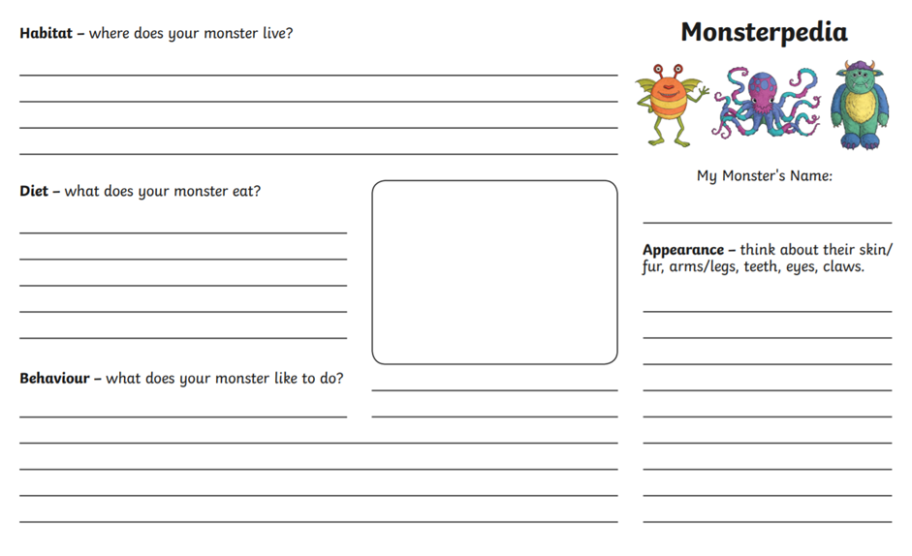

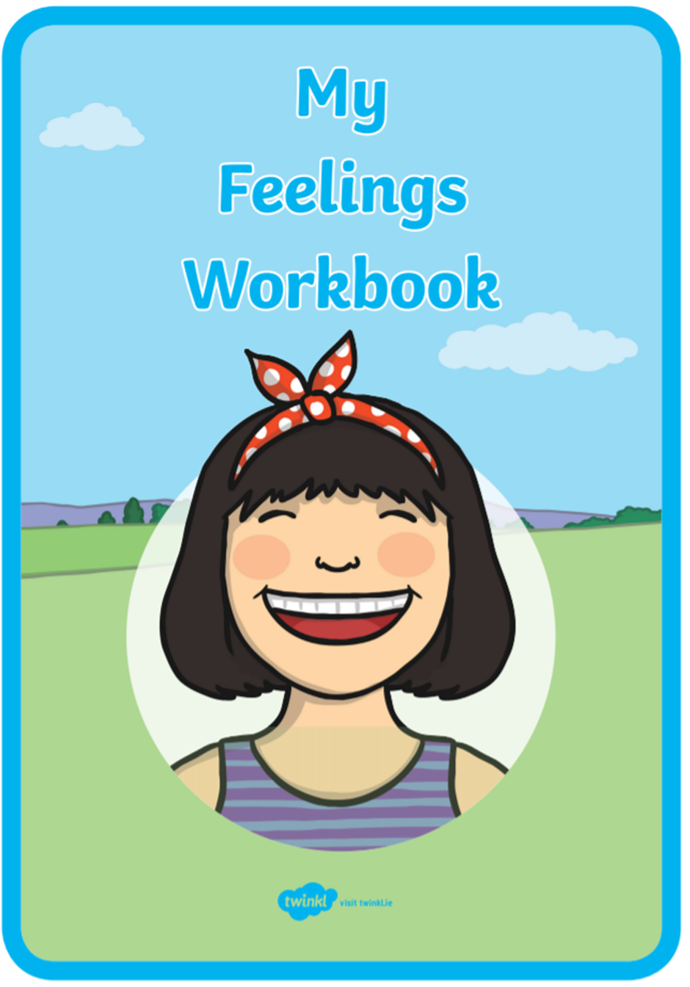
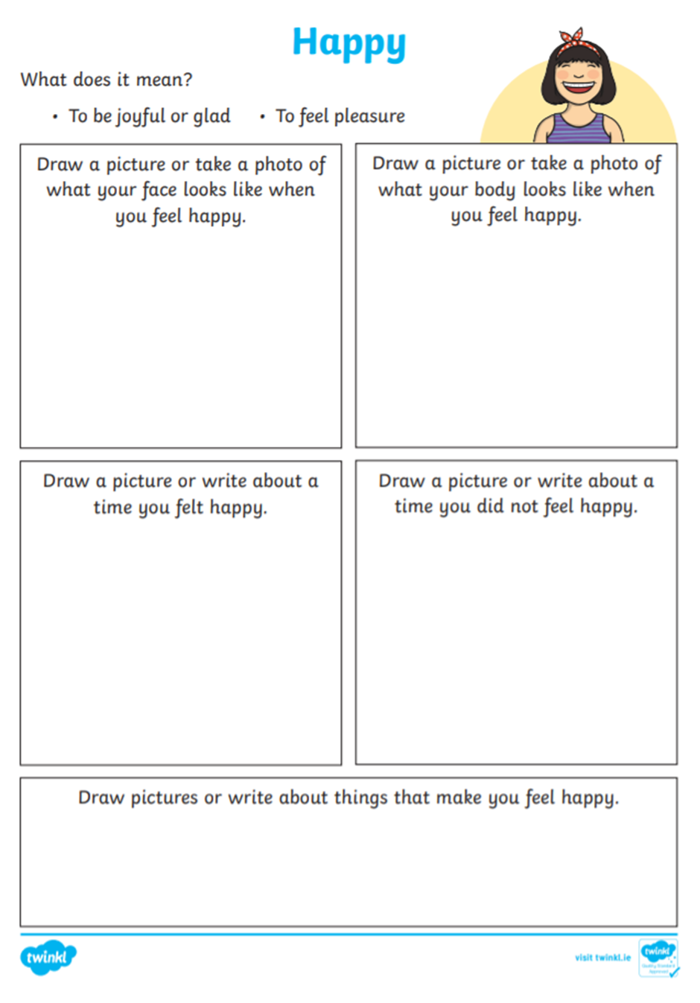

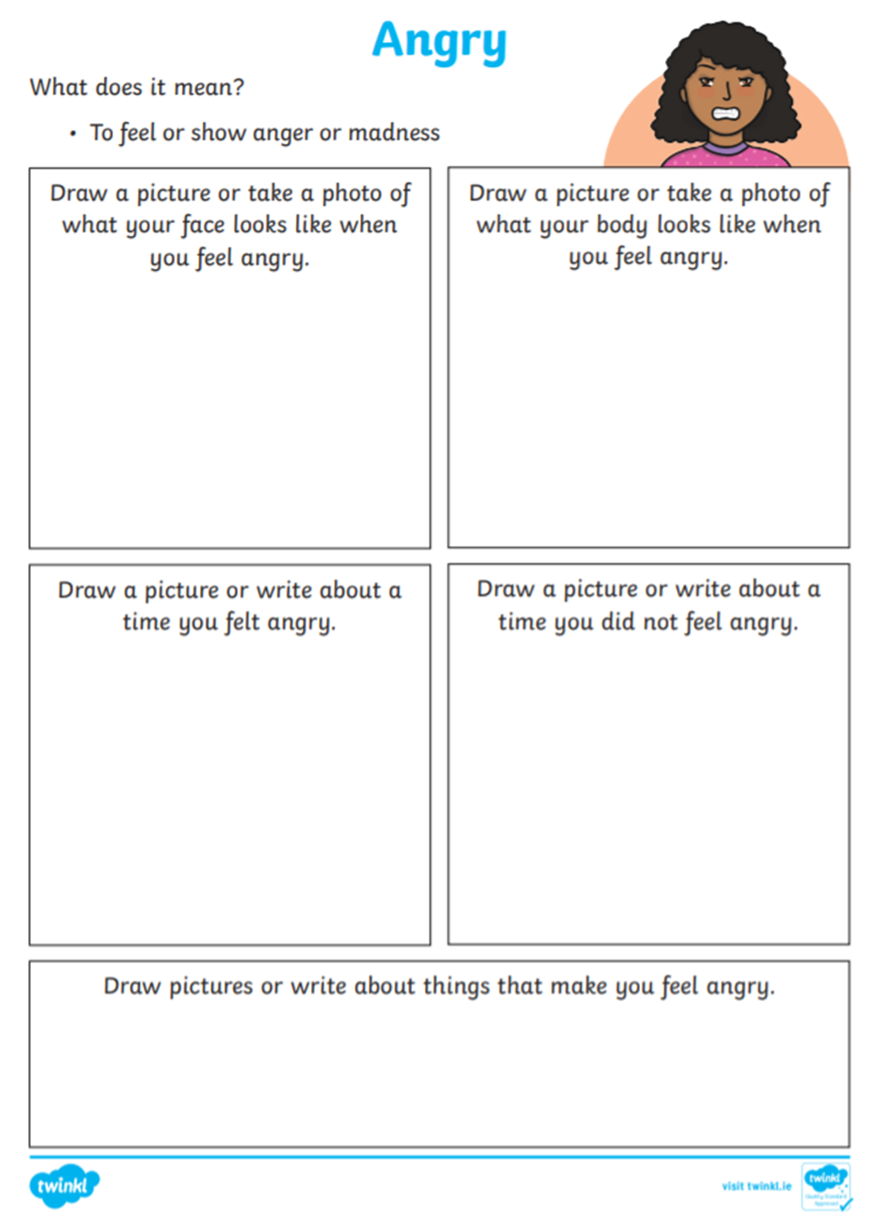
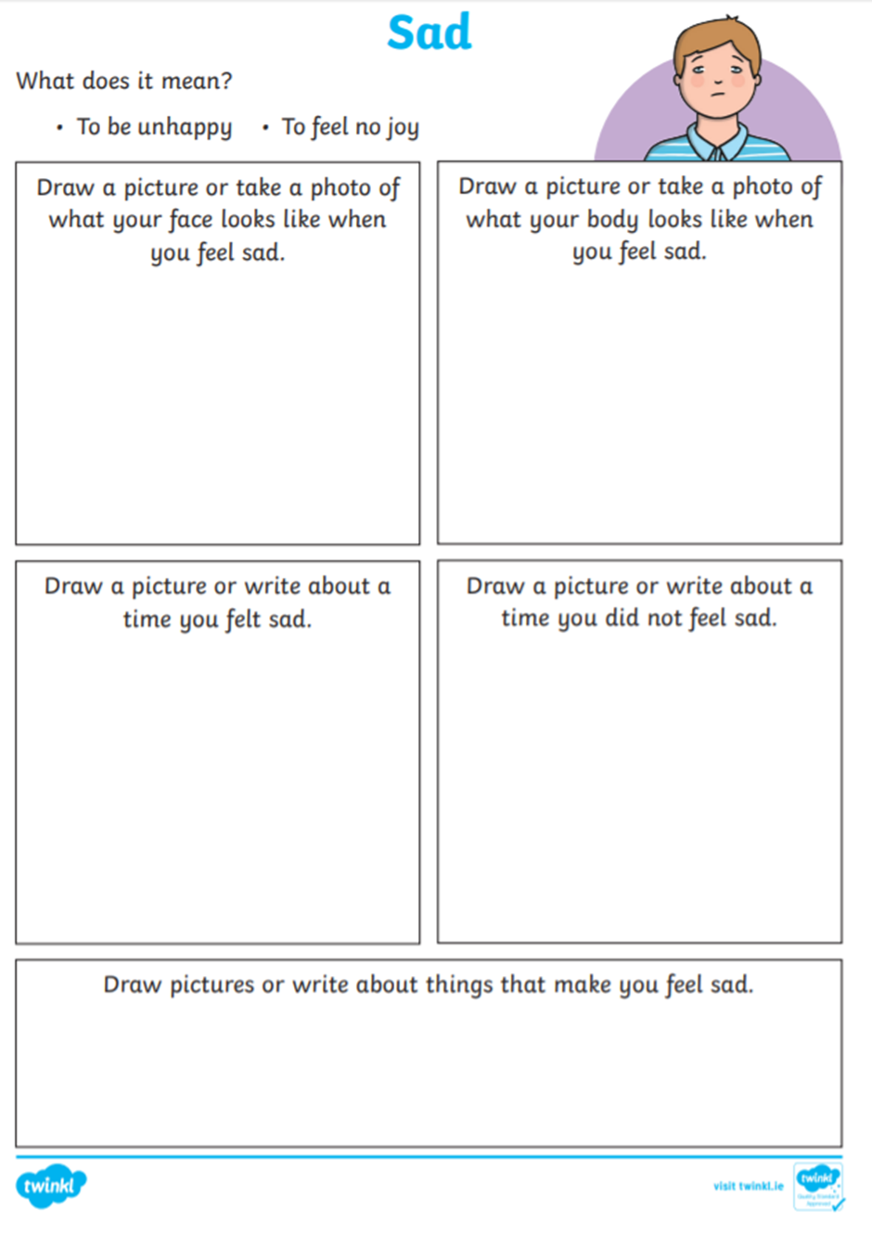
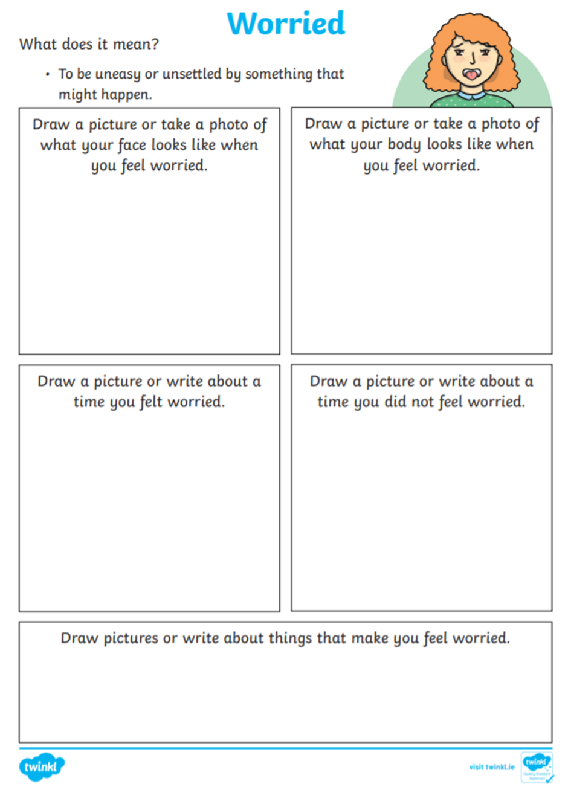
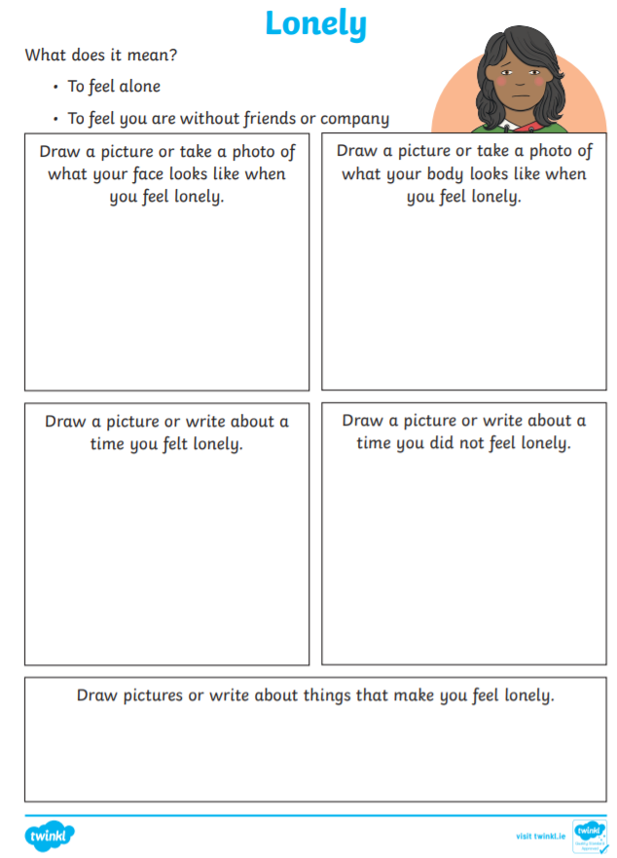
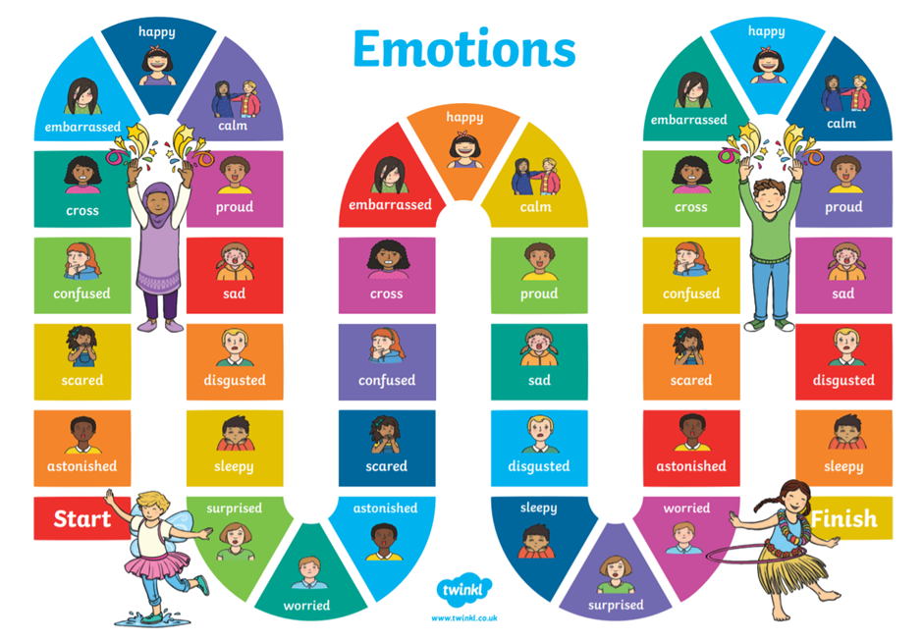
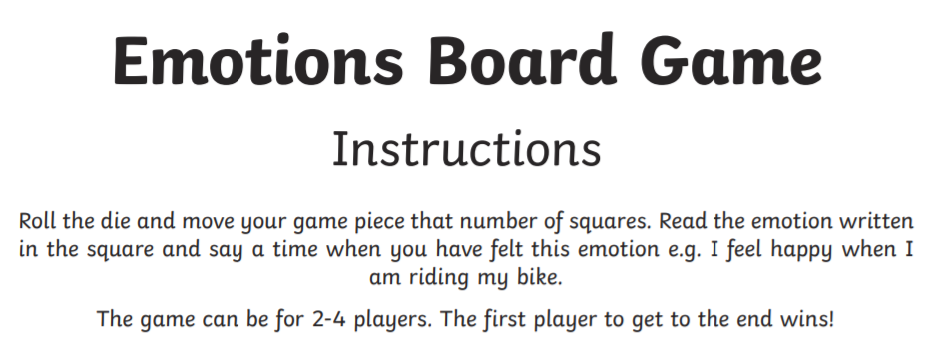
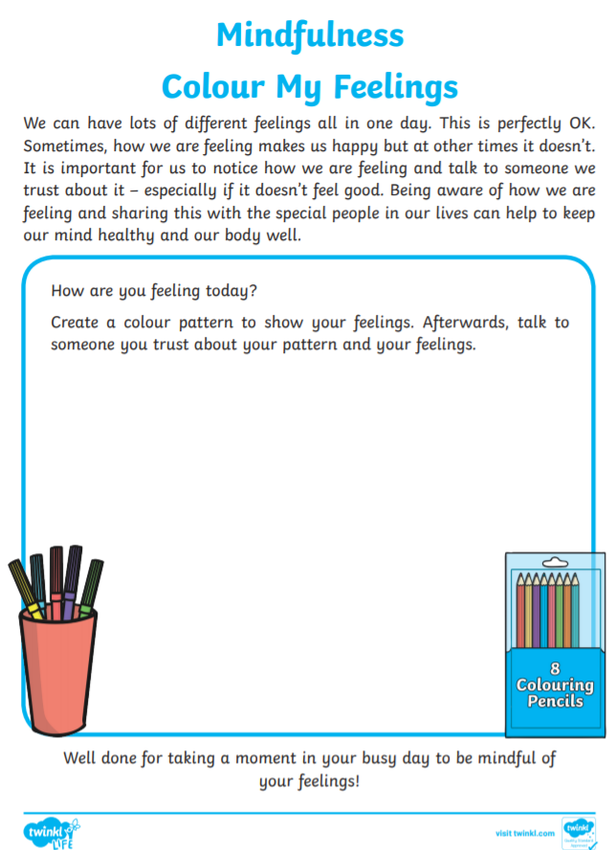
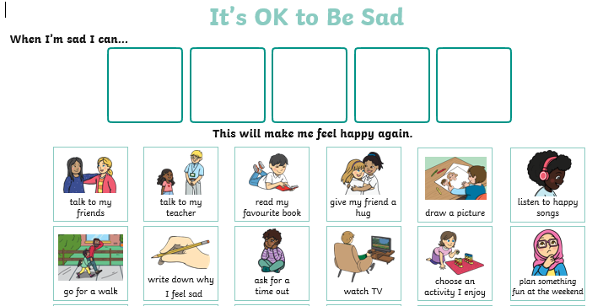
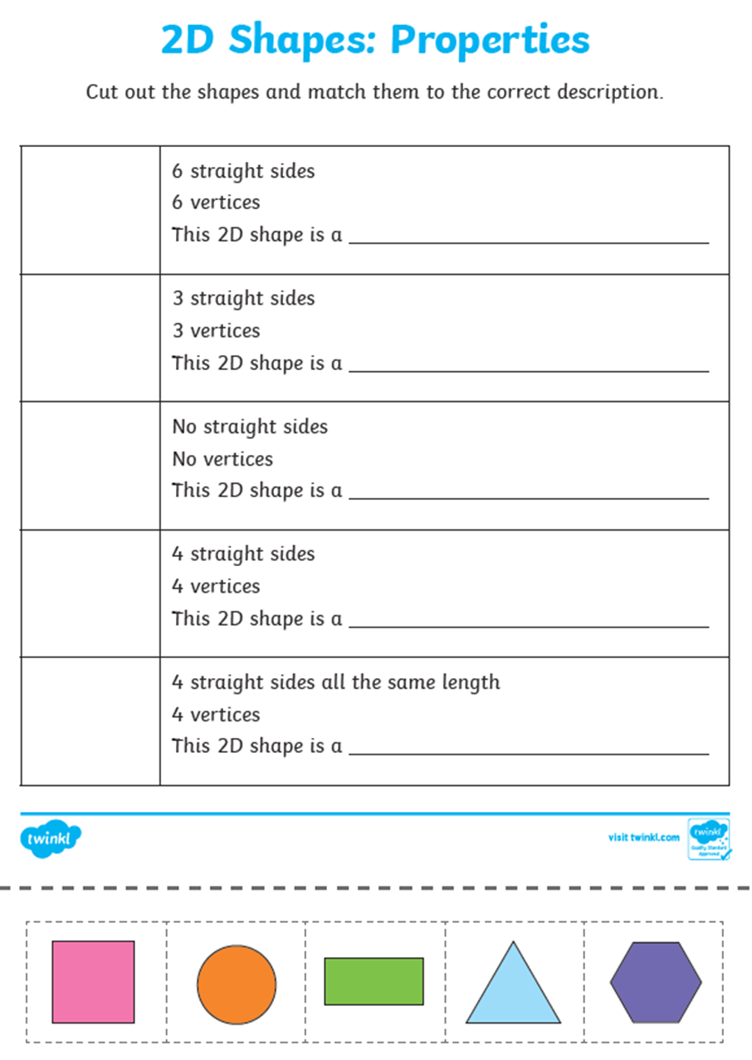
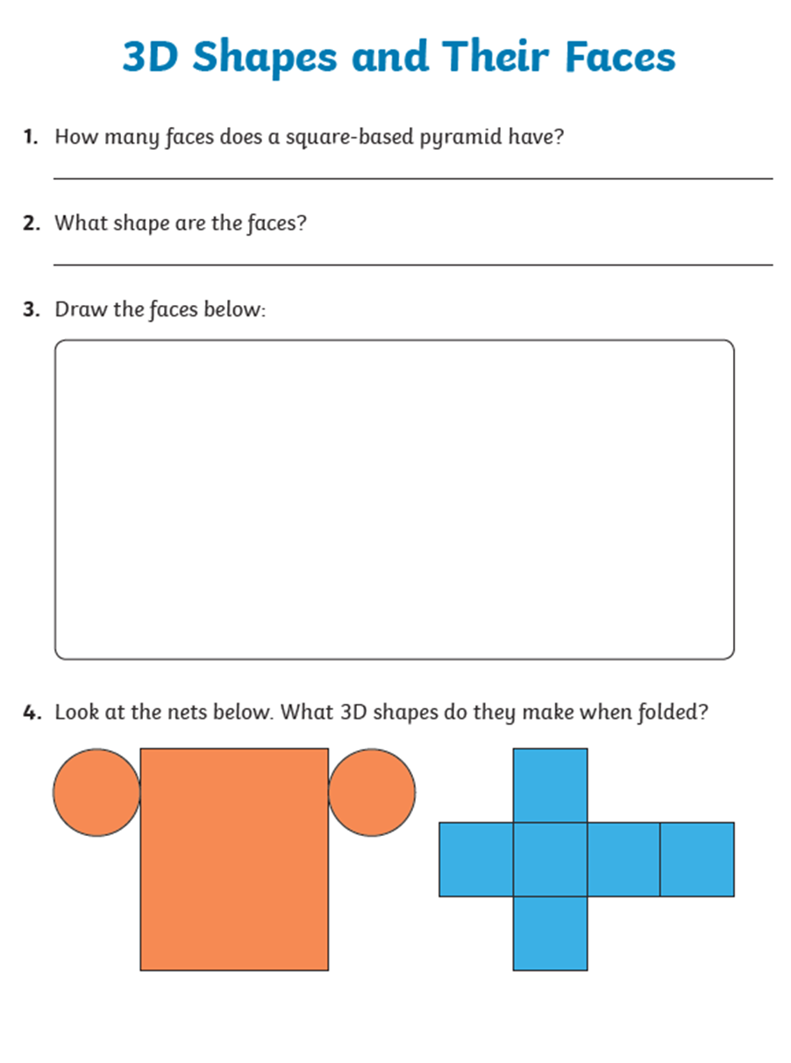
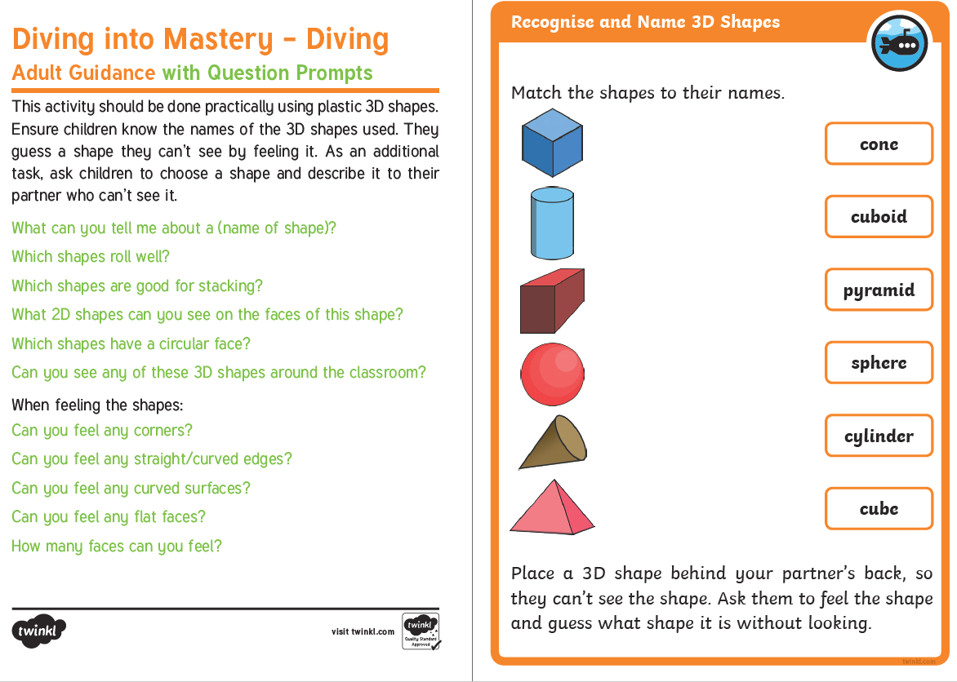
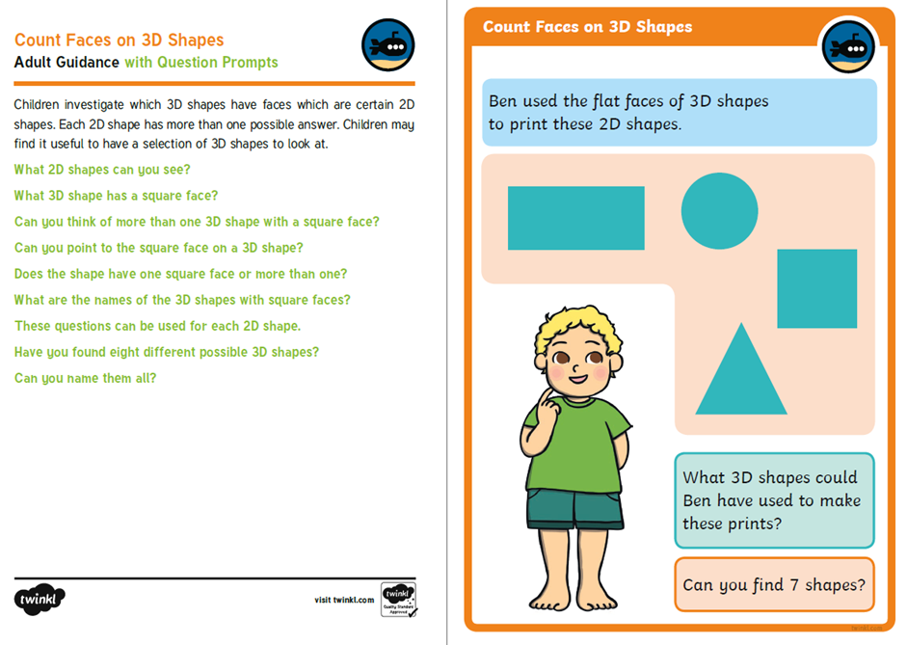

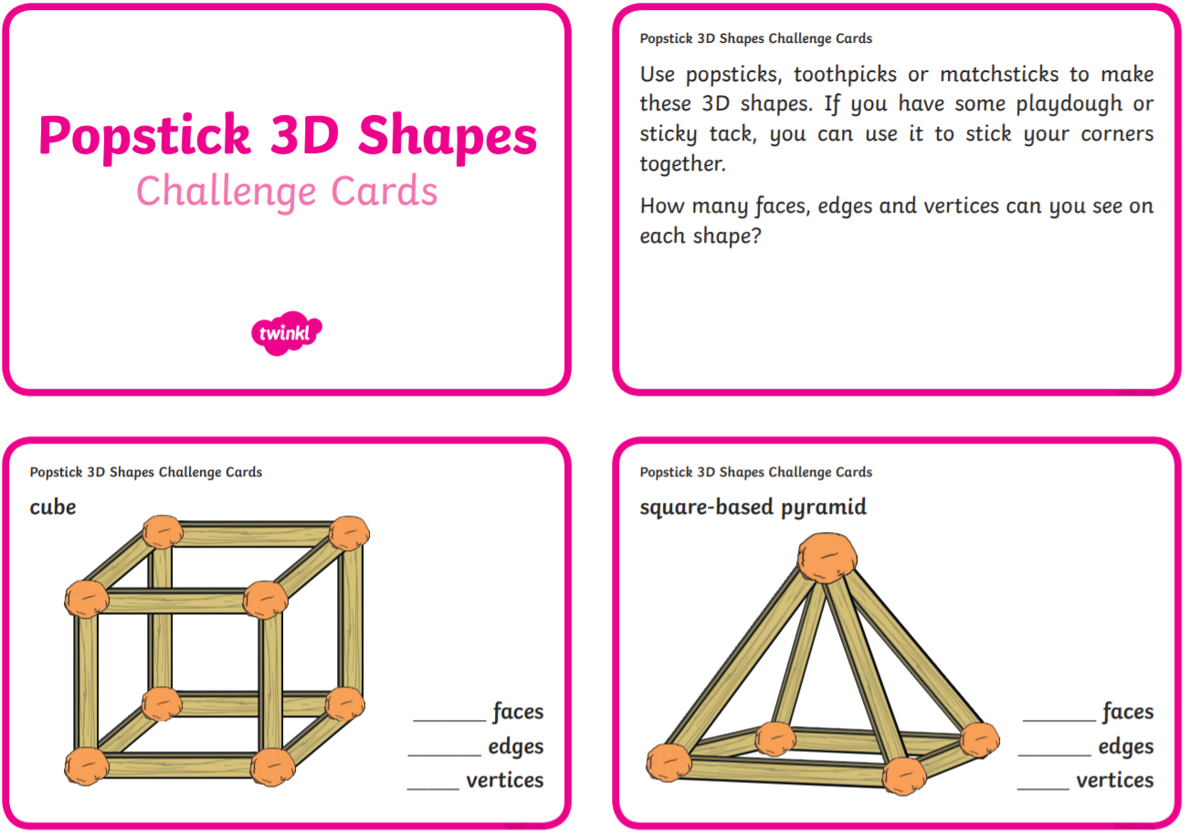
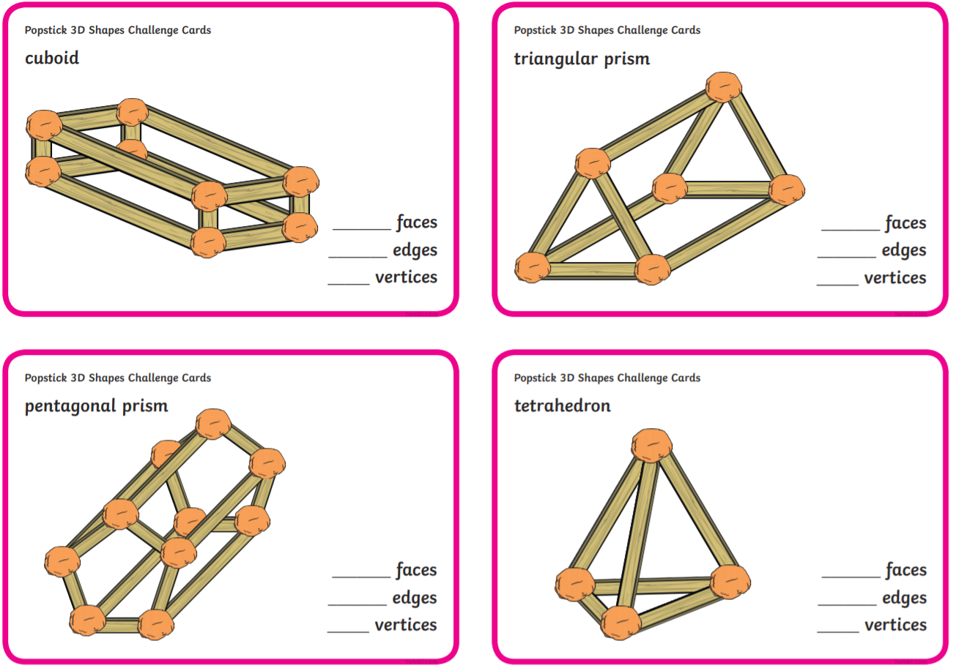
St Peter and Paul – Creative Task
