SEAGULLS’ WEEKLY SUGGESTED HOME LEARNING – WB 22.6.20
Hello Seagulls! We hope you are all staying safe and keeping alert! We are so pleased that we have received a few more emails from you this week- thank you! It really is so nice to hear from you and to see how you are finding the tasks that we have set for you. Please remember we really would love to hear about any activities that you are completing at the moment!
There are lots of good news stories online and in the media at the moment about people who have gone ‘above and beyond’ to make a difference and help others during the lockdown or people who have thought of good ways to keep our spirits up. We enjoyed this poem called ‘Stand Together’ by Marcie – aged 10. https://www.bbc.co.uk/cbbc/joinin/bp-post-topical-poem
Do you know anybody like that or have you heard any inspirational stories? If so, we’d love to hear them via the school email or on our school Twitter page @saintoswalds.
We miss you all! Take care & stay safe xxx
Mr Goulding, Mrs Barton, Mrs Brearton and Mr Little

ENGLISH | MATHS
Reading – Read every day for pleasure for 30 minutes.  Comprehension and Writing tasks- Balanced Argument- Lessons 1-5 (Scroll to the end of the page)  https://www.thenational.academy/online-classroom/year-5/english#subjects  Spellings- Adding verb prefixes de- and re-  Deflate, deform, decode, decompose, defuse, recycle, rebuild, rewrite, replace, revisit  Complete separate activity below.  Extra – a good game to practise spellings online http://www.ictgames.com/mobilePage/spookySpellings/index.html | Corresponding Division Facts – Use your knowledge of the 4 and 5 times tables to instantly recall the corresponding division facts. For instance, 5x4= 20. Therefore, 20 divided four equals five.  Don’t forget about TT Rockstars!  Decimals - Lessons 1-5 (Scroll towards the middle of the page)  https://www.thenational.academy/online-classroom/year-5/maths#subjects  https://corbettmaths.com/primary/  This website is also really useful in case you need extra help and support or if you would like to do some more maths
R.E. | OTHER
Come and See RE –  Please see description of activity below: | Science – Properties and Changes of Materials  Learn about thermal conductors and insulators (see below)  https://www.bbc.co.uk/bitesize/clips/zkntsbk  Can you find examples of thermal conductors and insulators around the house?  Then complete the quiz to test your knowledge:  https://www.educationquizzes.com/ks2/science/thermal-insulators-and-conductors/  Challenge below – research the best materials to make a new packed lunch box that can keep food cool inside. Draw a diagram using labels and captions to show what materials you would use to make it and why  Humanities- Last week we set you the task of learning about The Alps mountain range in Europe and this week we would like you to look at the lesson about The Lake District which is a National Park and World Heritage Site in the Northwest of England – just up the M6 from us!  https://www.bbc.co.uk/bitesize/articles/z6jqcmn  https://school.eb.co.uk/levels/foundation/article/Lake-District/442261#  Compare what you learnt last week and consider the similarities and differences between The Alps and The Lake District. Write a few sentences with reasons why you think areas such as The Alps and The Lake District should be protected.
Come and See RE
Next Monday, on the 29th June, is the feast day of St Peter and St Paul. We traditionally would celebrate this day across the whole school so we would like to try and join across our homes in celebration instead.
It would be fantastic if you use the key and fish images (see attached) and create a mobile or a poster and add in key words that sum up what Jesus wants us to do e.g. love. You can use colours, paint or glitter- it’s up to you!
Fish are often symbolic with St Peter because he was a fisherman. Keys are symbolic too because in the Gospel of Matthew 16:13-19, it tells us that Jesus gave Peter the keys to the kingdom of heaven. St Paul was a great missionary of Christianity and the author of most of the Letters of the New Testament. What else can you find out about these two important people from the Early Church?
PLEASE SEND IN YOUR CREATIONS TO SHARE WITH US ON TWITTER OR VIA EMAIL. Below are a couple of starting ideas.

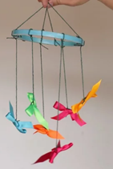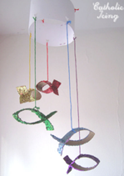

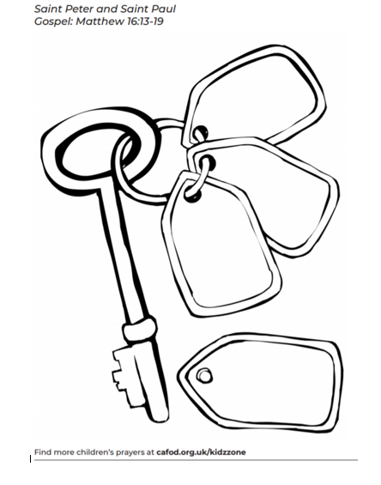

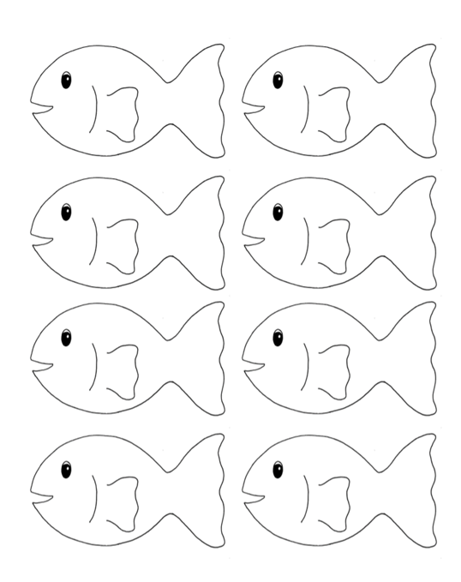

  - Science – Properties of Materials and Changes

Mason has sorted materials into 2 groups.
  - 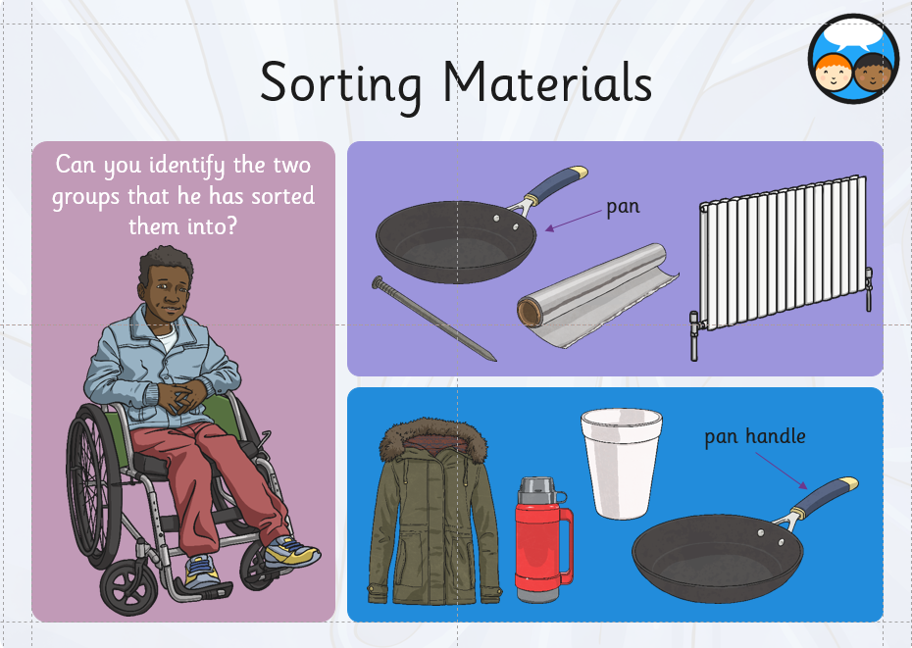
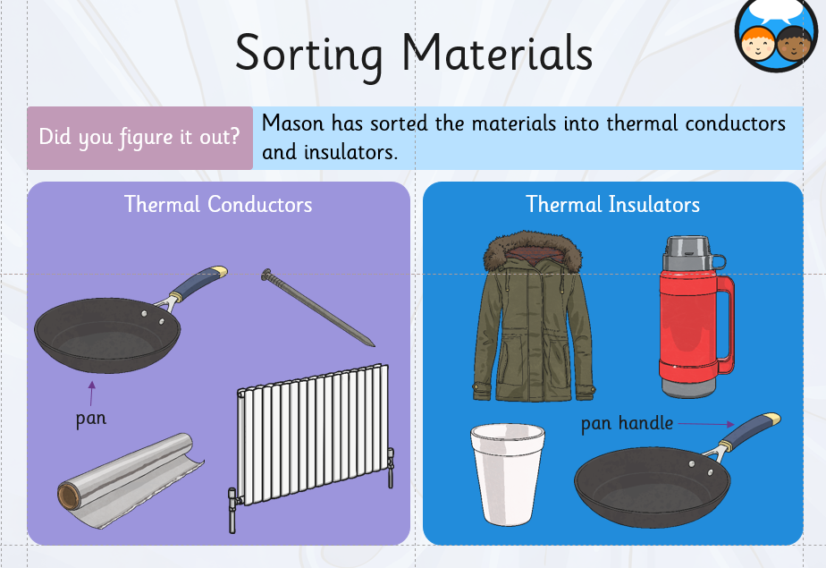
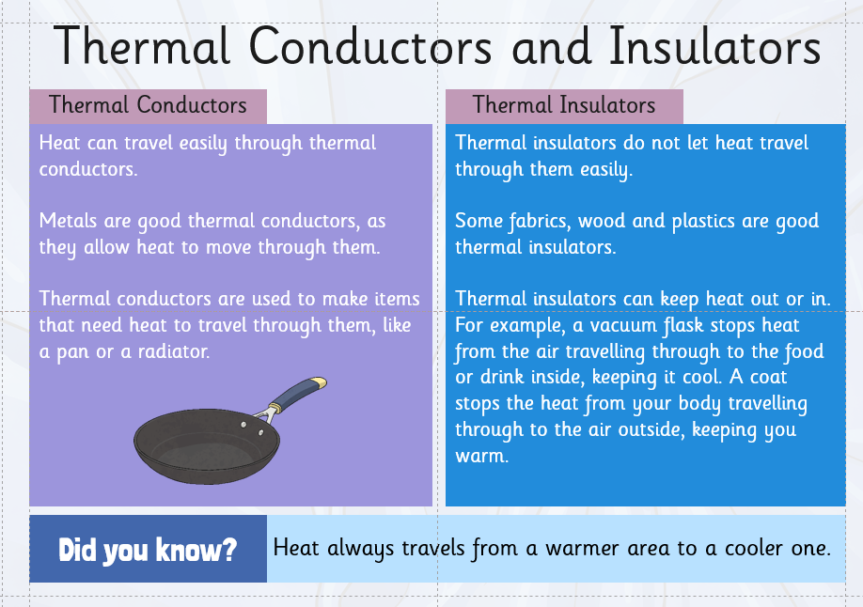

LI: I can design a lunch box that will use thermal insulators to keep food cool
Draw a diagram below, including labels and captions describig materials used and why

