SPARROWS WEEKLY SUGGESTED HOME LEARNING – WB 22.6.20
Hello Sparrows! I loved the Elmer tasks last week and I hope you did too. This week your tasks are all about The Great Fire of London and I am looking forward to seeing pictures and messages of you having fun with the tasks.
Please keep in contact as usual. You can email the office at enquiries@saintoswalds.wigan.sch.uk FAO Sparrows or tweet us @saintoswalds @mrs_wibberley @MrsOsborne73.
Stay safe and keep smiling
Mrs Wibberley, Mrs Osborne and Mrs Dean xx
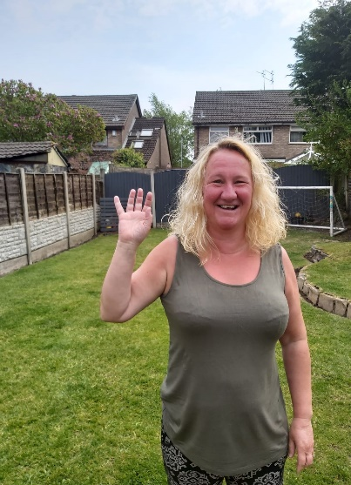

ENGLISH | MATHS
Reading – Read every day for pleasure for 10 minutes.  You can also listen to stories on www.vooks.com. This website is full of stories that come with videos and are a big hit in Sparrows as there are so many to choose from. Maybe your child can share their favourite story with you. You can get a free subscription for 1 month.  Comprehension –  - Read the story of the Great Fire of London below. Sequence the picture cards (use your knowledge of the days of the week to help you).  - Complete the Great Fire of London comprehension below.  Writing –  - Use the common exception words list below. Write some of the words you find tricky to remember to read and write on pieces of paper. Put them in your garden or use chalk to write the words on your patio. Use a sponge or water pistol to soak the words like a firefighter. Read the word as you soak it and then write a sentence using that word.  - Write some instructions on how to make some bread (this links with your DT work below).  - Write a diary entry as if you were someone who lived in London at the time of the fire. What did you do? Where did you go? What did you take with you? Who were you with? What did you see?  Phonics – Your child will be able to tell you which phonics group they are in. If they don’t know, please contact school so we can help you.  Mrs Osborne and Mrs Dean’s groups –  1. Go to https://www.phonicsbloom.com/ or https://new.phonicsplay.co.uk/ and play your favourite game to practise all the new sounds you have learnt over the past few weeks.  2. Find objects around the house that have the ‘or’ sound in them. Write the words and draw pictures to match.  Mrs Wibberley’s group –  1. Go to https://www.phonicsbloom.com/ or https://new.phonicsplay.co.uk/ and play your favourite game to practise all the new sounds you have learnt over the past few weeks.  2. Find objects around the house that have the sound ‘ph’ in them. Put these words into sentences and draw pictures to match.  Miss Lea and Mrs Davies’ groups –  1. Go to https://www.phonicsbloom.com/ or https://new.phonicsplay.co.uk/ and play your favourite game to practise all the new sounds you have learnt over the past few weeks.  2. Complete the animal mosaic below. | Basic skill – Ask your adult to teach you how to tell the time to o’clock and half past.  Unfortunately White Rose have started charging for their home learning tasks, however BBC Bitesize have partnered with White Rose and have some great daily tasks including maths for free. Follow this link for a daily maths task https://www.bbc.co.uk/bitesize/tags/zjpqqp3/year-1-and-p2-lessons/1  If your child finds this challenging, please follow this link https://www.hamilton-trust.org.uk/blog/learning-home-packs/ and use the previous year group’s tasks.
R.E. | OTHER
Next Monday, on the 29th June, is the feast day of St Peter and St Paul. We traditionally would celebrate this day across the whole school so we would like to try and join across our homes in celebration instead.  It would be fantastic if you use the key and fish images (see attached) and create a mobile or a poster and add in key words that sum up what Jesus wants us to do e.g. love. You can use colours, paint or glitter- it’s up to you!  Fish are often symbolic with St Peter because he was a fisherman. Keys are symbolic too because in the Gospel of Matthew 16:13-19, it tells us that Jesus gave Peter the keys to the kingdom of heaven. St Paul was a great missionary of Christianity and the author of most of the Letters of the New Testament. What else can you find out about these two important people from the Early Church?  PLEASE SEND IN YOUR CREATIONS TO SHARE WITH US ON TWITTER OR VIA EMAIL. Below are a couple of starting ideas.  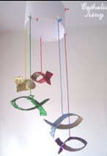 | DT – Bake a loaf of bread following the instructions from your writing task.  Art – Make a fire collage.  STEM – Use the template below to make a 3D Tudor house.  Music – Learn the song London’s burning and perform to your family.  History – Walk around your neighbourhood and find the oldest building. Can you research any interesting facts about it?  Science – Collect different materials from around the house and measure how much water each one can hold.  Outdoor – Wash the car whilst pretending to be a firefighter.

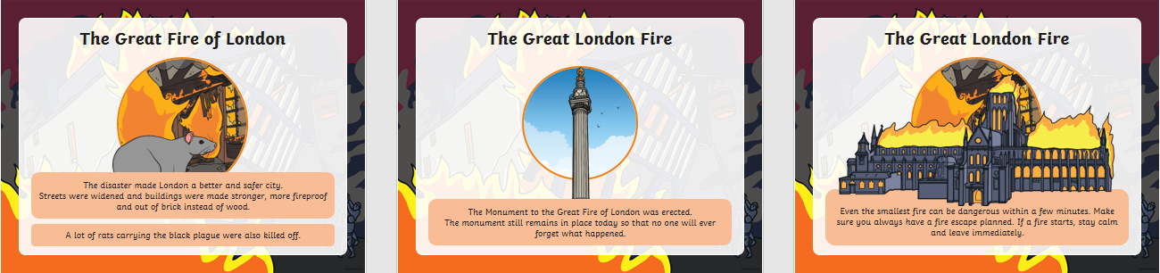
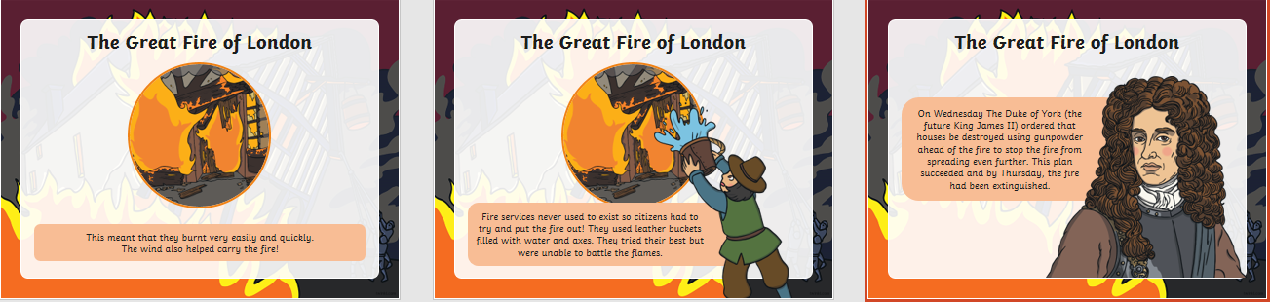
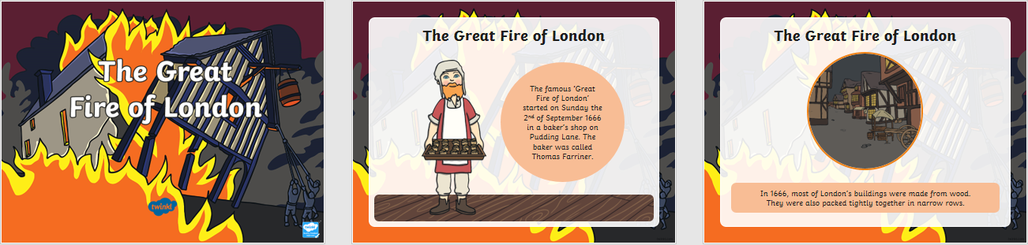
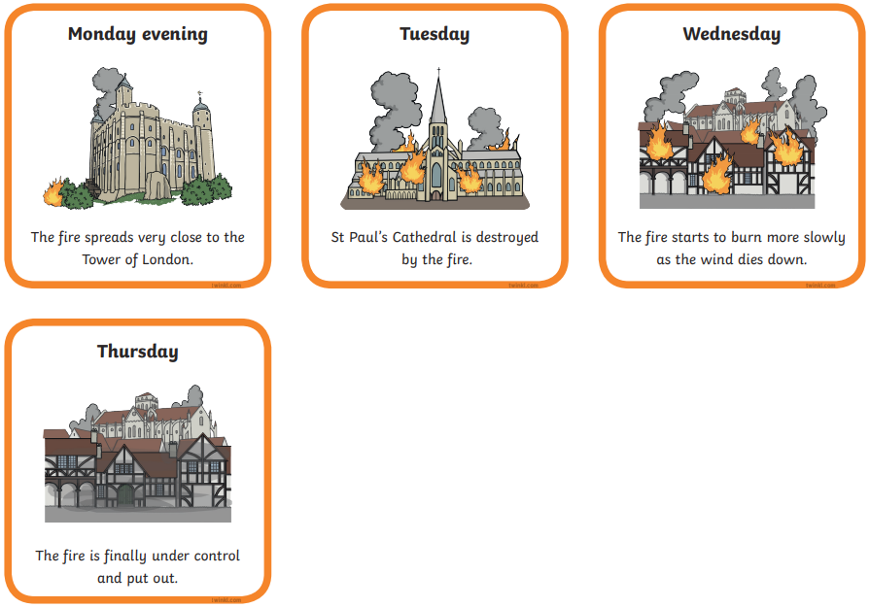
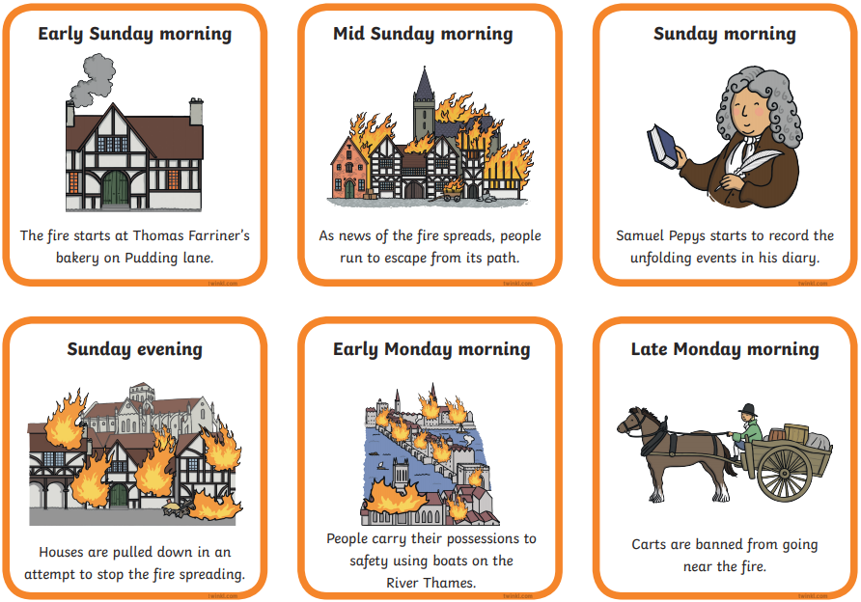
The Great Fire of London
The Great Fire of L___________________ started on S________________.
It began in a b________________.
The fire had ended by T______________________.
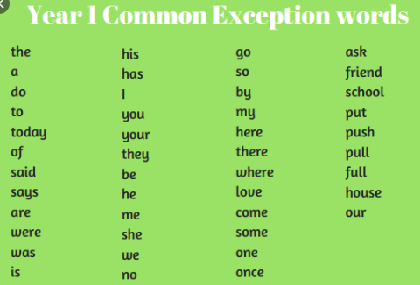
Lots of h_________________ were made from w______________ so the fire spread q_________________.
London | quickly | wood | Houses
Thursday | Sunday | bakery

