WAGTAILS’ WEEKLY SUGGESTED HOME LEARNING – WB 22.6.20
What a wonderful week we have had receiving emails and tweets of your incredible Great Fire of London work. We are super impressed with the amount of effort you have put into learning about the significant event and how well you have presented your learning to us. We would like to thank you for all the hard work you have done – we wish you could see our huge grins!

This week, we are all going to get our sports gear out and take part in National School Sport Week 2020. This year, the Youth Sport Trust has collaborated with Sky Sports to run a national campaign which aims to unite the country – families, schools, sport and businesses – in celebration of the power of sport to bring people together, even during isolation. Right now, you must be missing your friends and missing the sense of connection you get from enjoying sport and play. You will be deprived of sports day this summer, so this week, you are going to engage in a series of sporting challenges which will help you capture the enjoyment, competition and camaraderie you are missing out on.

Start by reading the information and plan out your week (comprehension task), stick to your plan throughout the week, have fun moving and enjoy the PE curriculum while at home.

We look forward to hearing all about your week via either email or Twitter.

Love from
Miss Silver and Mrs Costello
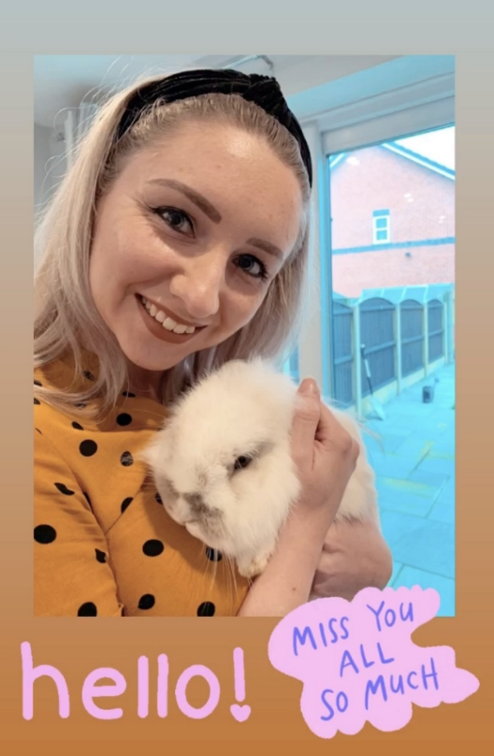
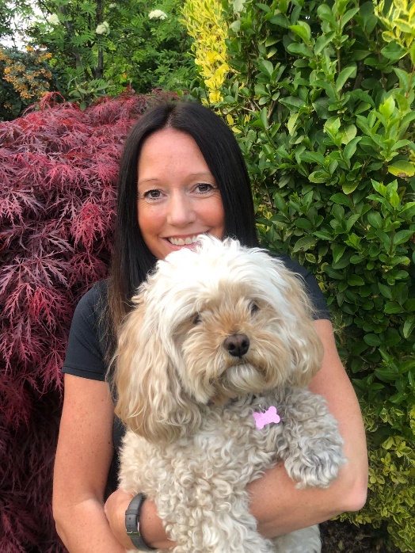

ENGLISH | MATHS
Reading – Read every day for pleasure for 15 minutes.  How many books can you read based on sport? You might find a fiction book telling you a story about sports day or about your favourite sport. Have a look for a non-fiction book that tells you about different sports around the world. Maybe you could find a book about the Olympics or sporting world records. Write a list of the books about sport you read and share them with me.  Comprehension tasks  - Read the 5 activity cards below (athletics, aiming sports, team sports, adventure sports and artistic sports) and decide which activities you are going to take part in this week. Use the planning sheet provided to map out your week. I would love to see your plan of action – please send me a picture of your timetable.  - Read the information about staying safe whilst having fun (see below) and retell these guidelines to your family members.  - Read the information about wellbeing. Make sure you ask a family member if you are unsure what some of the words mean. Challenge - Can you recall the Five Ways of Wellbeing to a family member without looking?  Writing  - Create your own informative but eye-catching poster about the Five Ways of Wellbeing. Display your poster somewhere in the house so all your family members know how to keep their mind and body healthy.  - Write a set of instructions explaining how to stay safe whilst having fun, using the information you read earlier. Share the instructions with the people who are taking part in the activities with you throughout the week.  - At the end of the week, write up about your fun, active 5 days. Describe the activities you completed, explain who you completed them with, where you carried them out, how you challenged yourself, how you felt after each activity and which activities were your favourite and least favourite.  Spellings – adding the suffix –less  See word bank below.  Use the ‘Active Alphabet’ below to create your own workout routine by spelling out the words from the word bank.  Feel free to create your own Active Alphabet. | Basic Skill – Fractions  Espresso provides a brilliant unit to help you understand fractions. Here is the link: https://central.espresso.co.uk/espresso/primary_uk/subject/module/frontscreen/item883167/grade1/index.html  Open this link and work your way through the small steps to achieve the Year 2 national curriculum objectives for fractions: https://whiterosemaths.com/wp-content/uploads/2019/SoLs/Primary/SOL-Year-2-2018-19-Spring-Term-Block-4-FINAL.pdf  You may choose to follow these two learning guides off BBC Bitesize to help you too: https://www.bbc.co.uk/bitesize/topics/z3rbg82  If you wish to continue working through the Hamilton Trust’s home learning packs, click on the following link and download the Year 2 Week 7 pack.  https://www.hamilton-trust.org.uk/blog/learning-home-packs/
R.E. | OTHER
Next Monday, on the 29th June, is the feast day of St Peter and St Paul. We traditionally would celebrate this day across the whole school so we would like to try and join across our homes in celebration instead.  It would be fantastic if you use the key and fish images (see below) and create a mobile or a poster and add in key words that sum up what Jesus wants us to do e.g. love. You can use colours, paint or glitter- it’s up to you!  Fish are often symbolic with St Peter because he was a fisherman. Keys are symbolic too because in the Gospel of Matthew 16:13-19, it tells us that Jesus gave Peter the keys to the kingdom of heaven. St Paul was a great missionary of Christianity and the author of most of the Letters of the New Testament. What else can you find out about these two important people from the Early Church?  PLEASE SEND IN YOUR CREATIONS TO SHARE WITH US ON TWITTER OR VIA EMAIL. Below are a couple of starting ideas.  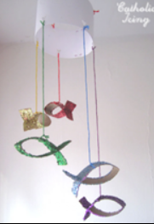  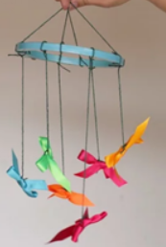 | PE – Follow the plan you created at the beginning of the week with the ideas for activities and challenges provided below. Challenge yourself to complete:  • An activity a day for the week  • As many activities as you can in one day  • Activities with as many people as you can at the same time  Mindfulness – Enjoy some time out with the sports day themed mindfulness colouring sheets below.  History – Find out about and compare the ancient and modern Olympic games. Record your findings in some way and share them with me.  PSHE – Discuss with your family what you need to do to keep healthy. Write a list about what you do to keep healthy and what you could change to be healthier. Think about what athletes might eat and do to keep healthy and create a training schedule for an athlete including what they need to eat and drink, what exercise they need to do and how much sleep they need.

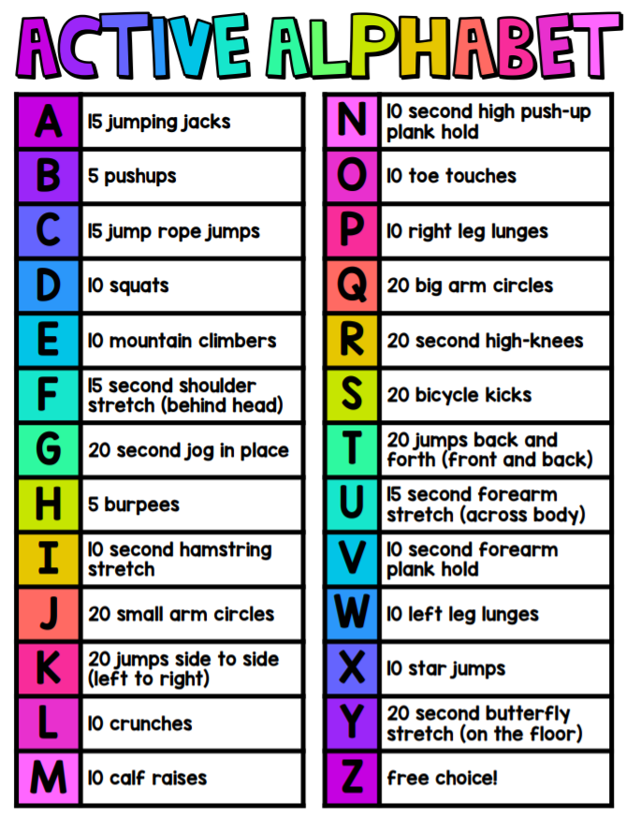
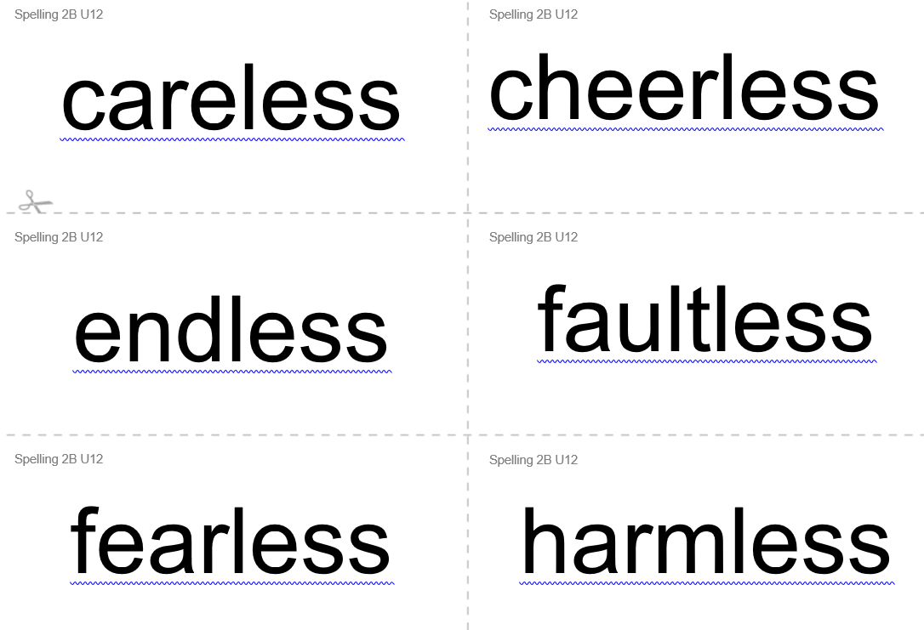
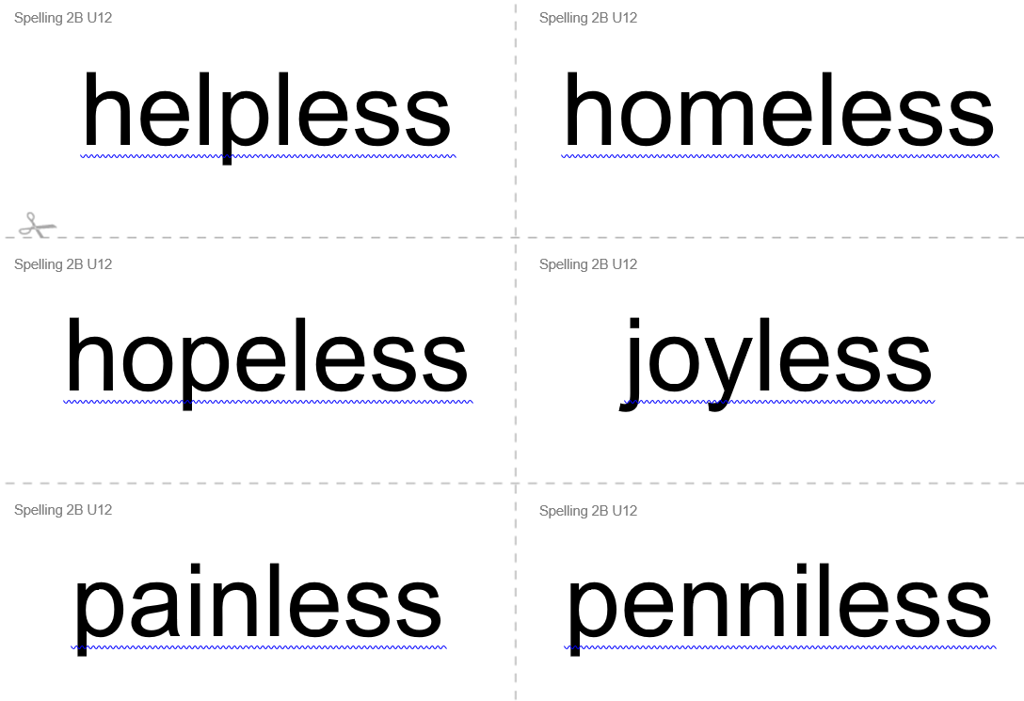
Spelling word bank

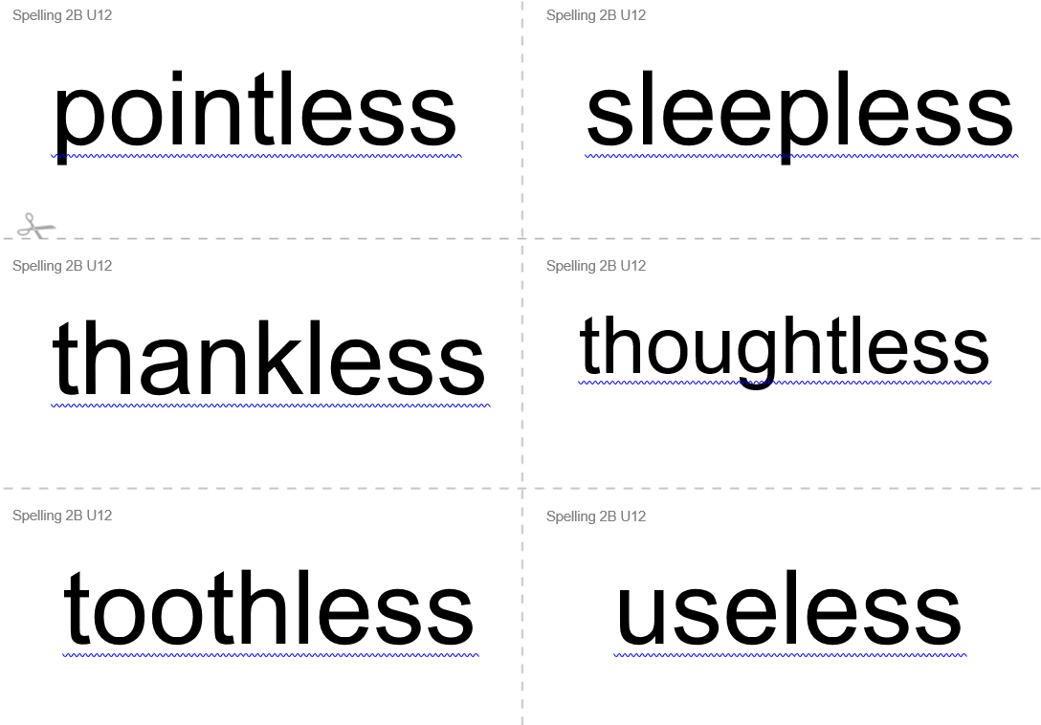

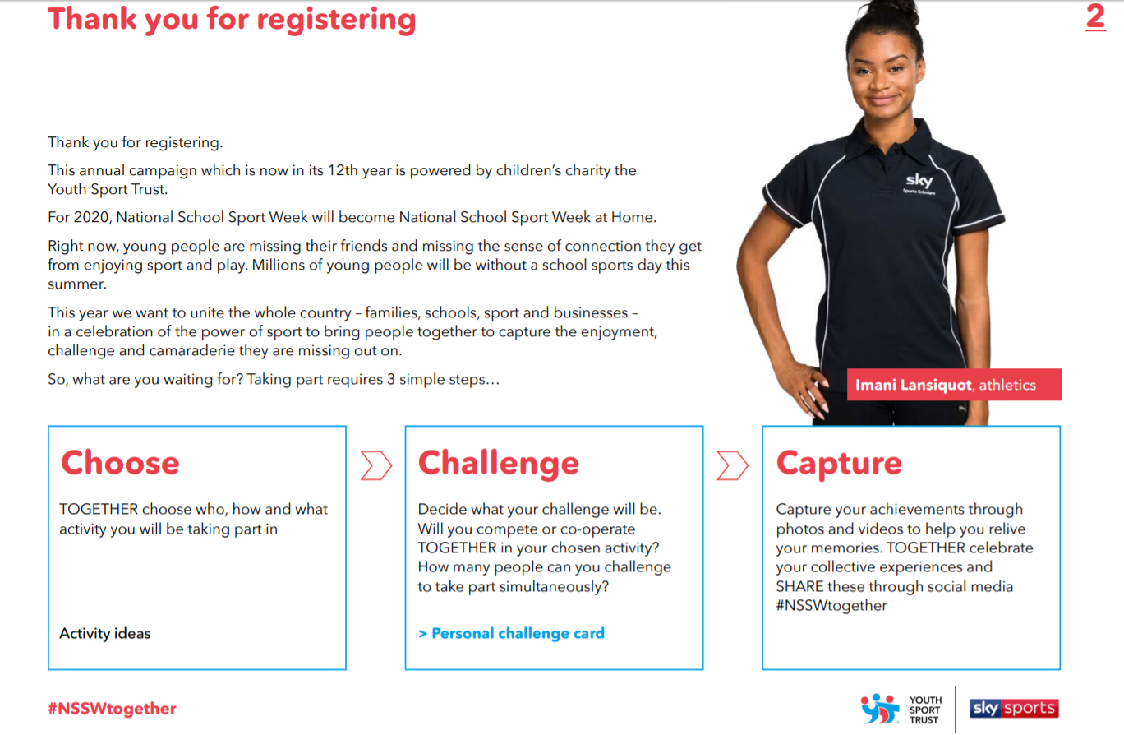
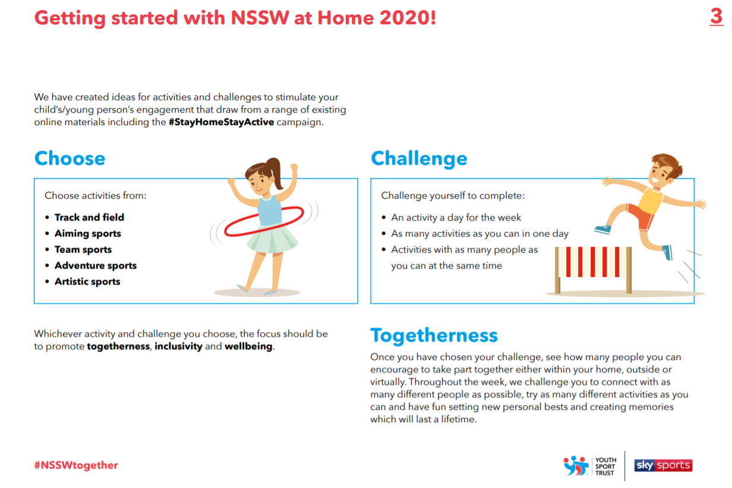
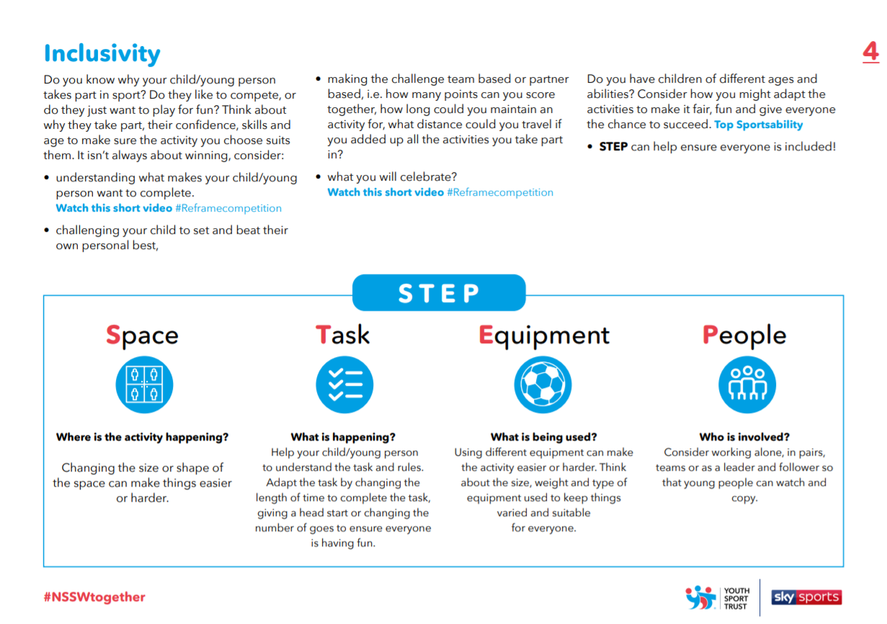
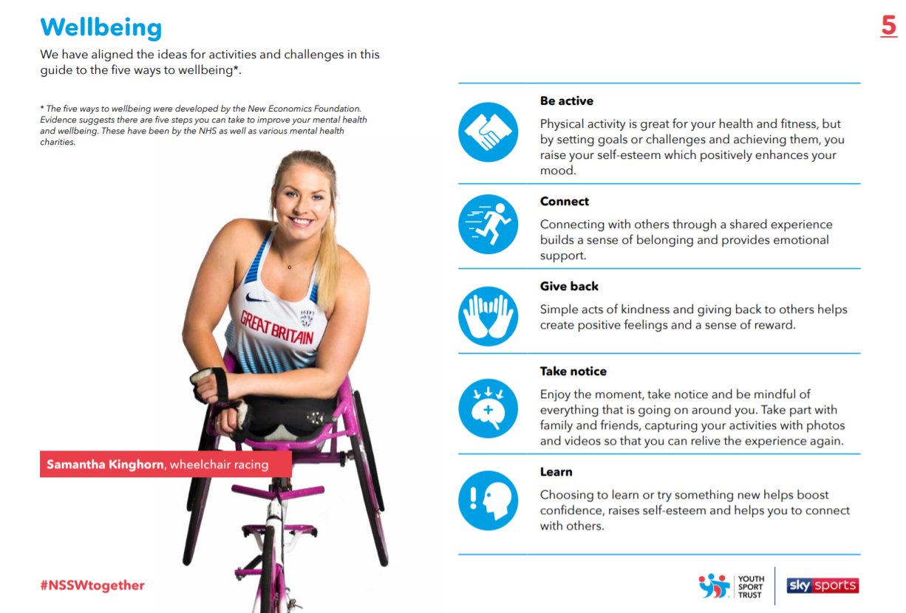
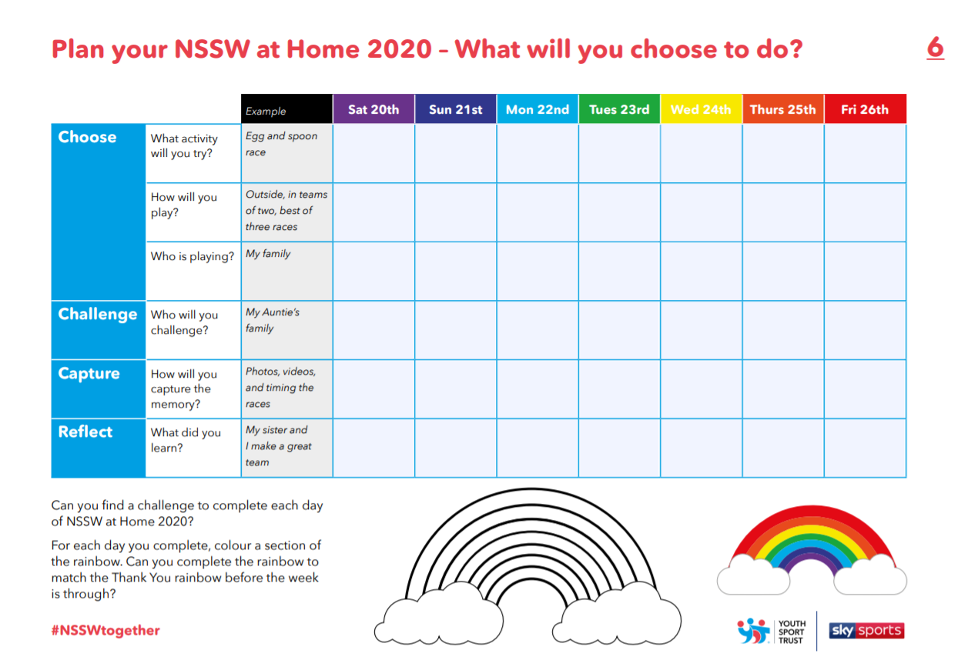
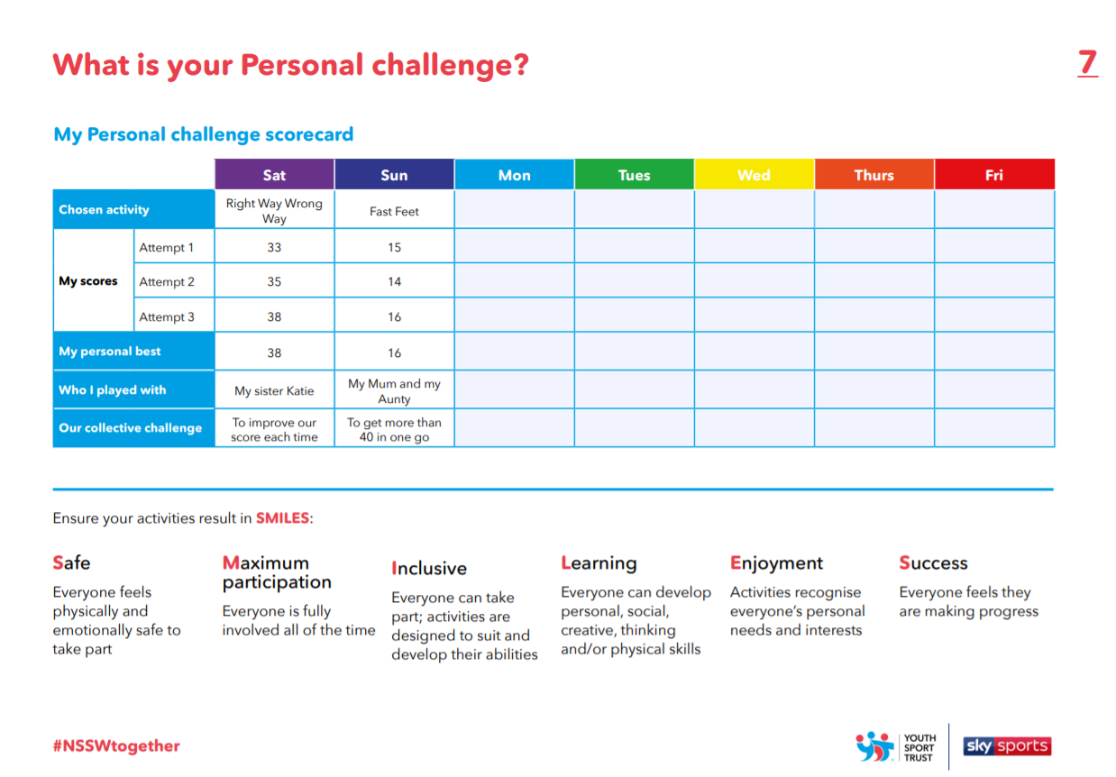
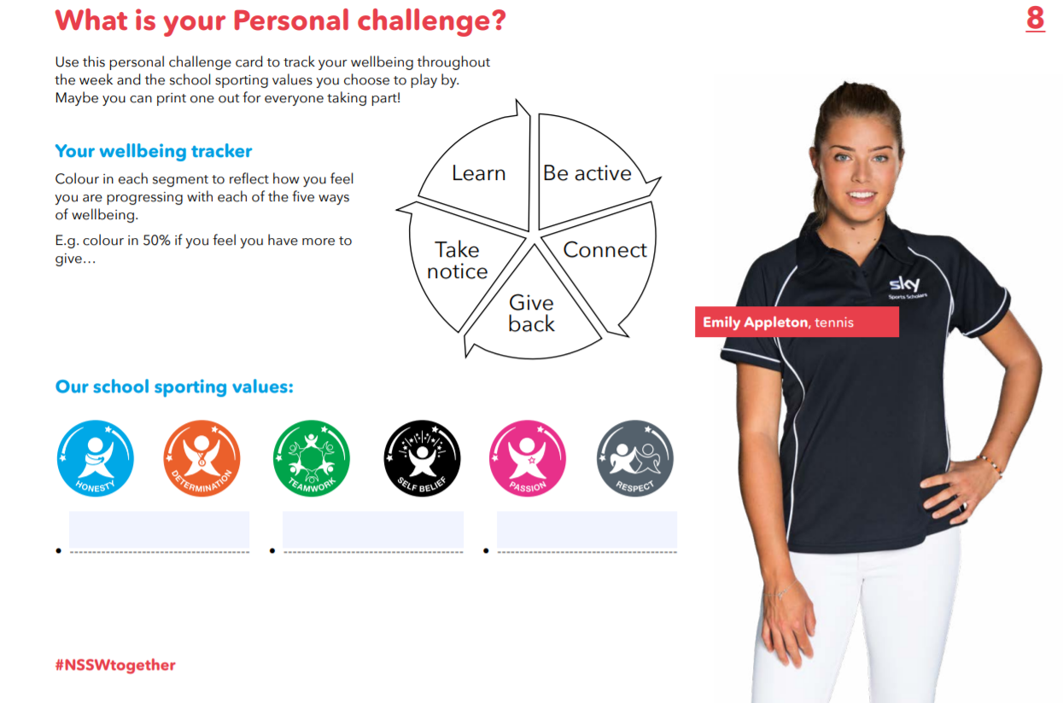
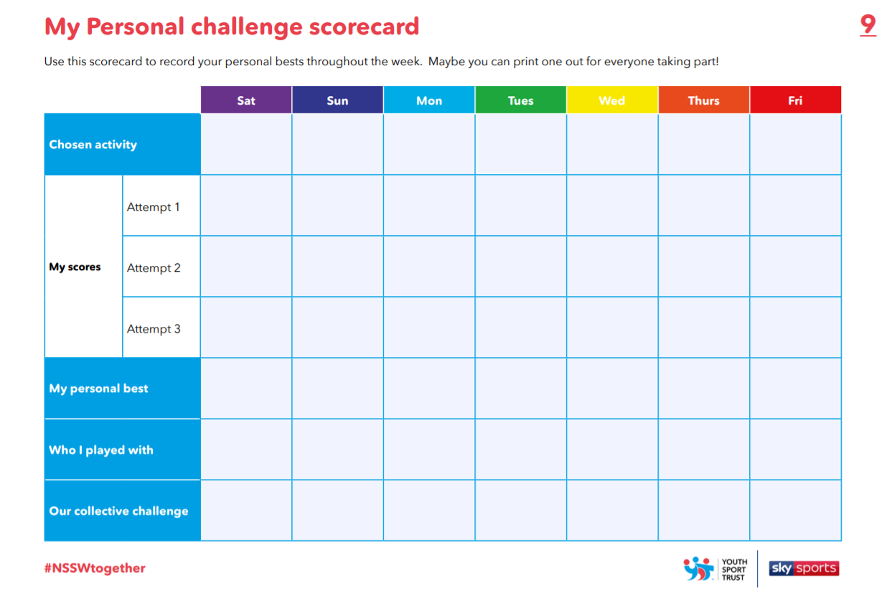
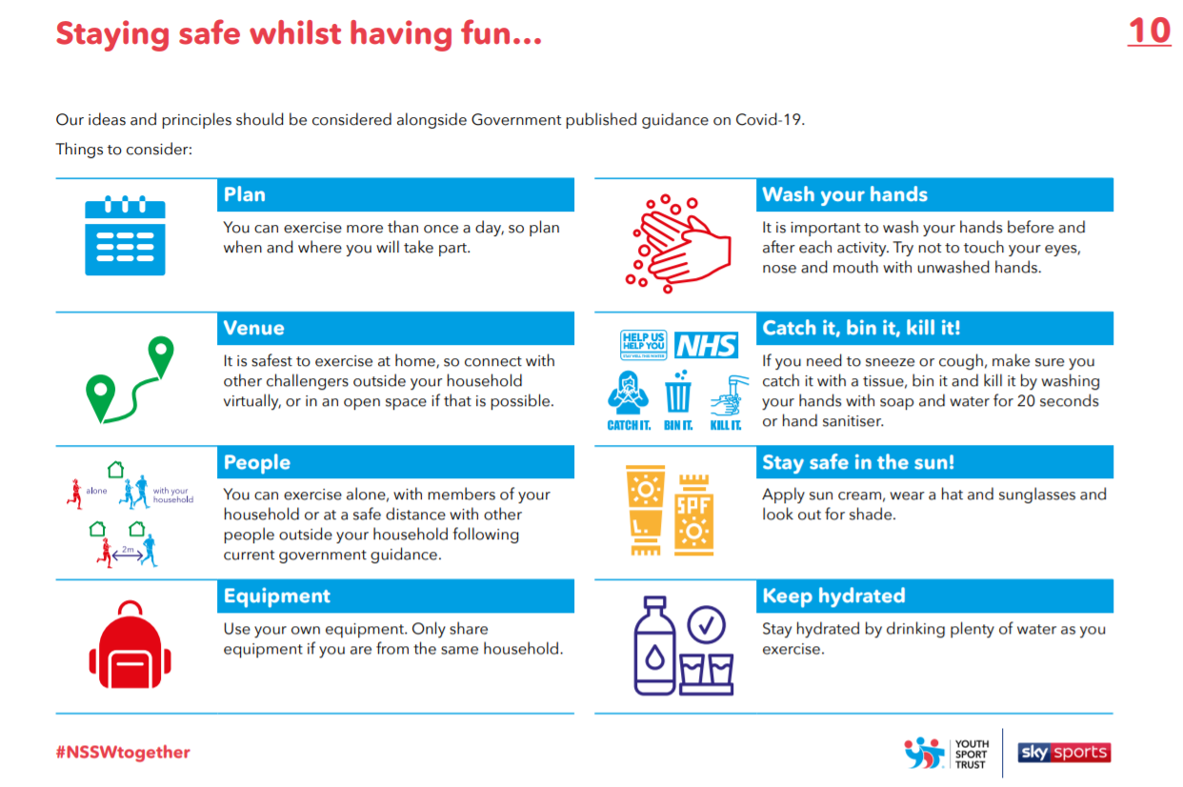
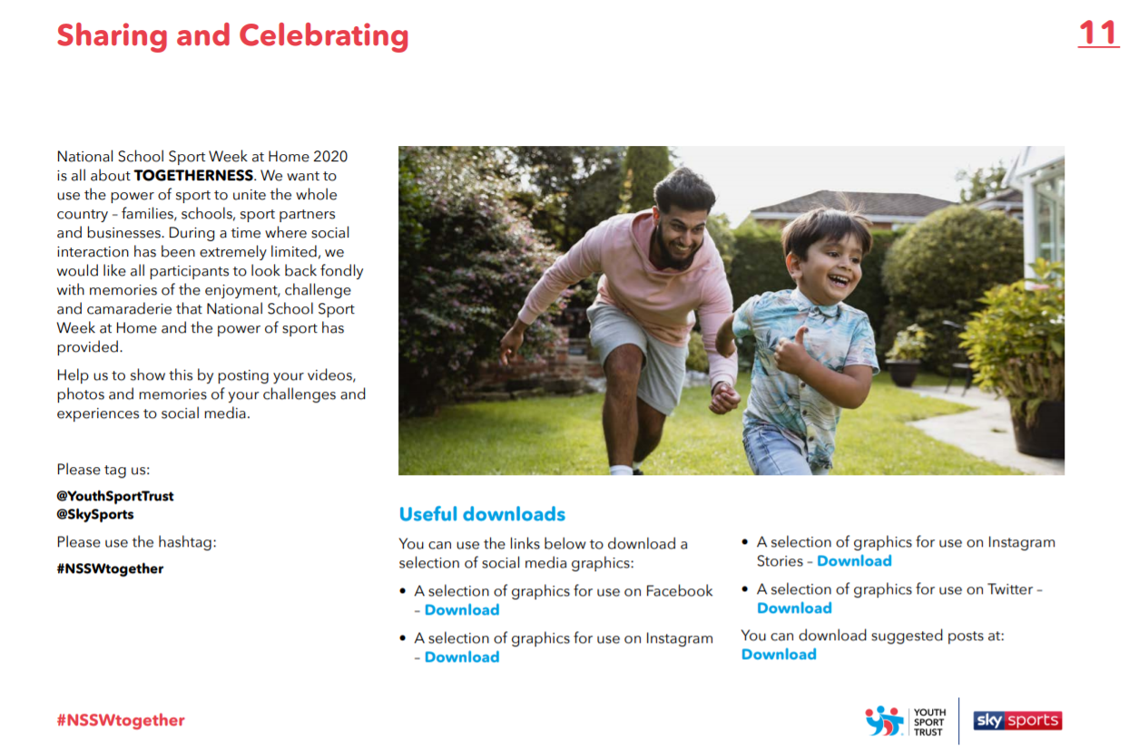
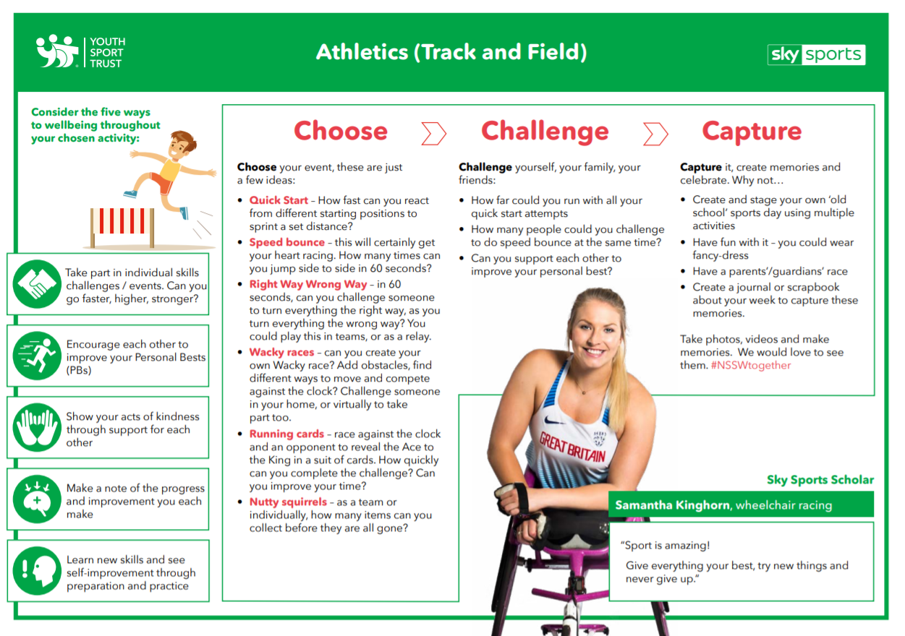
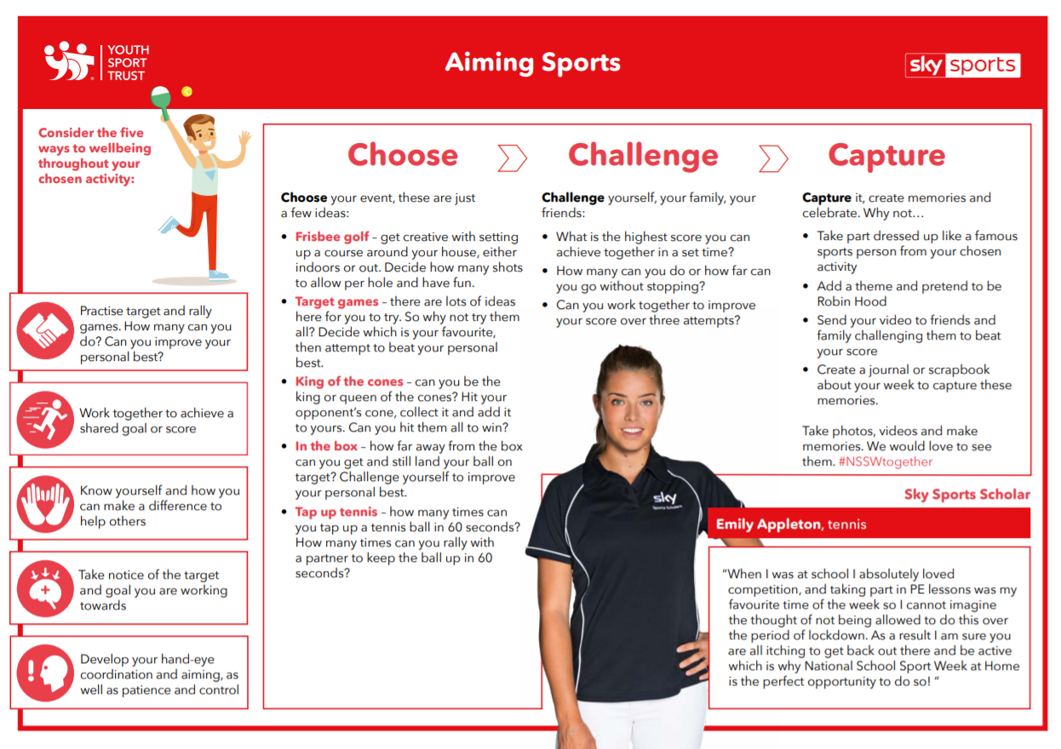
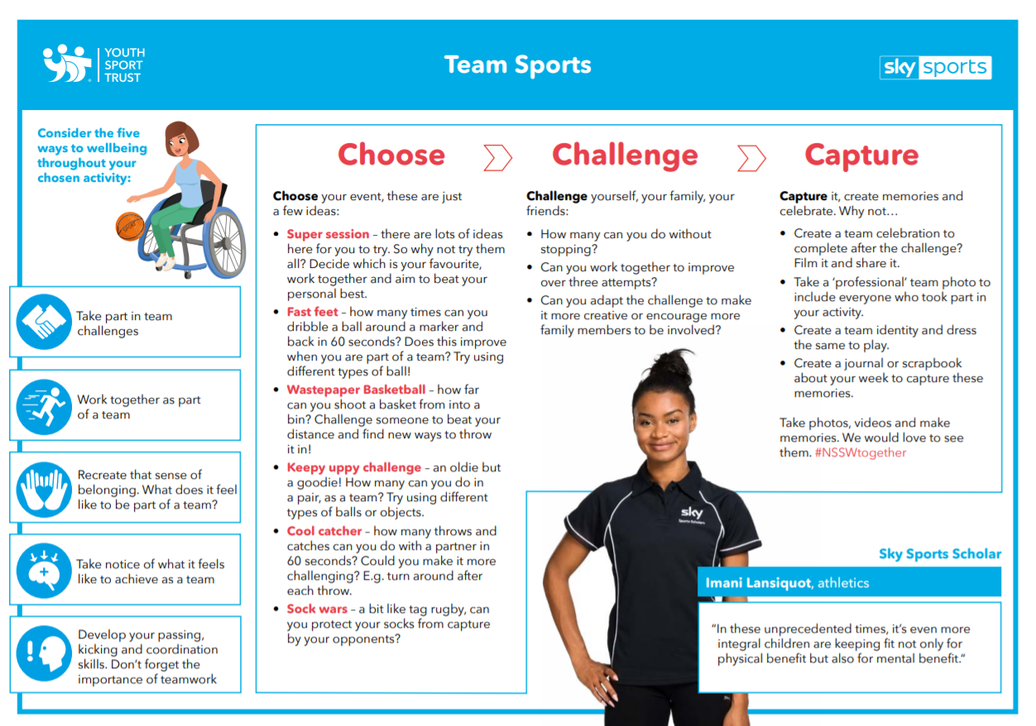
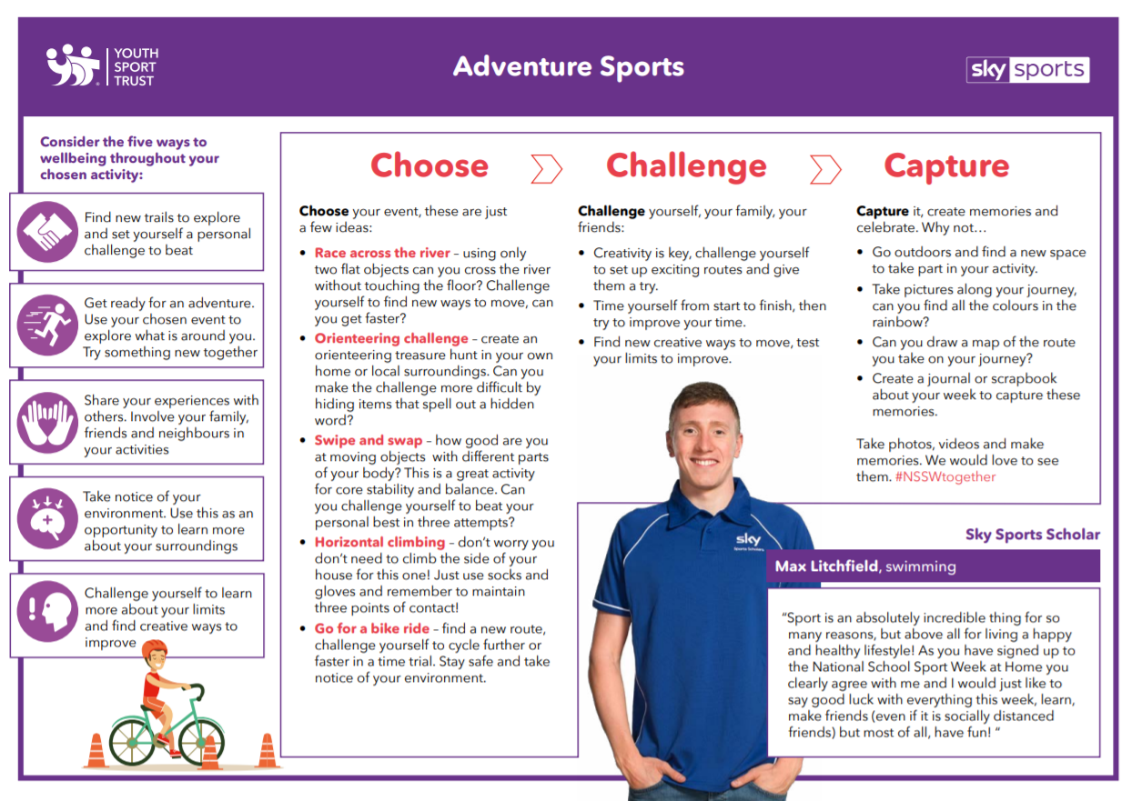
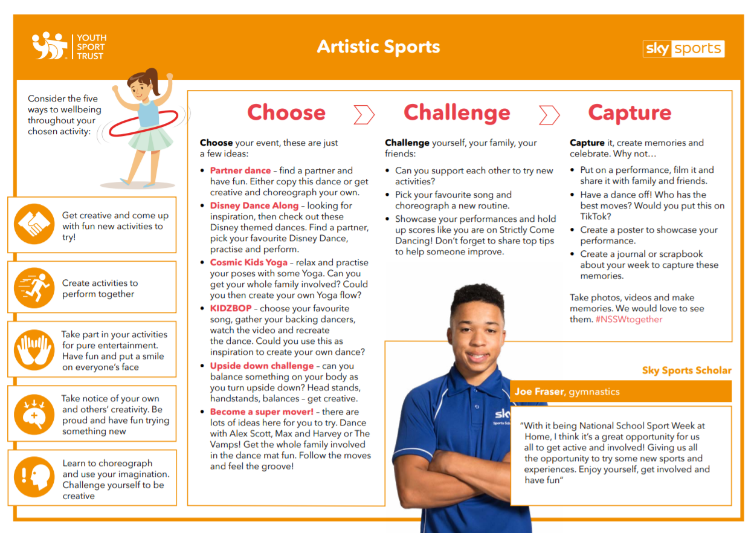
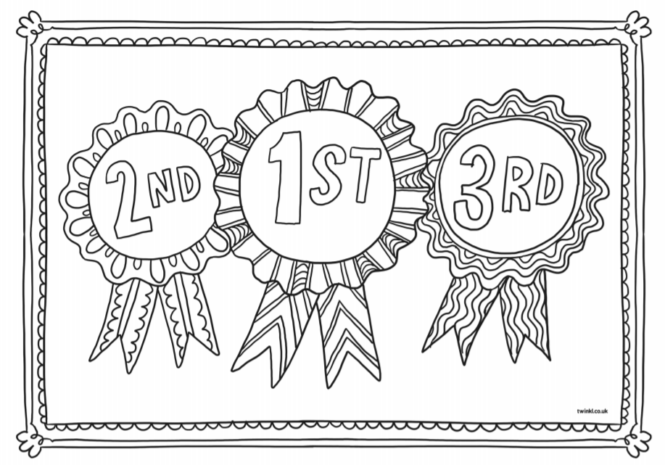
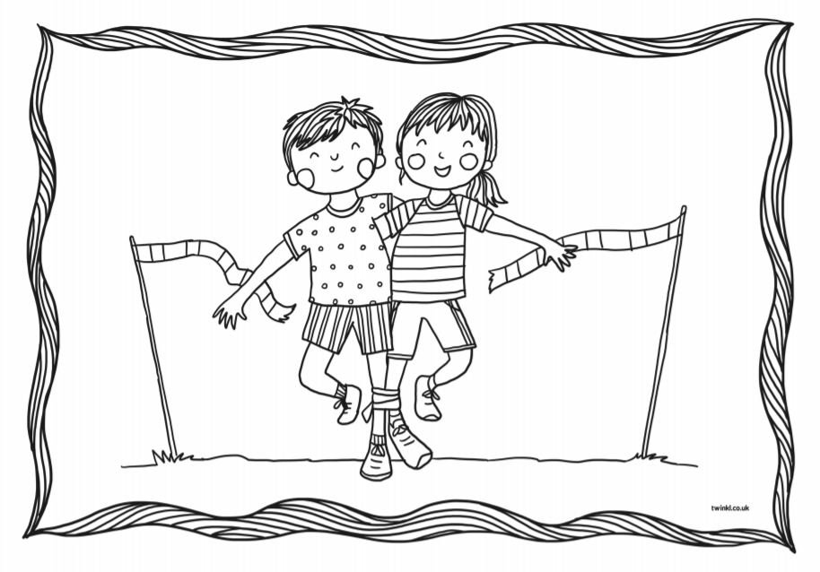
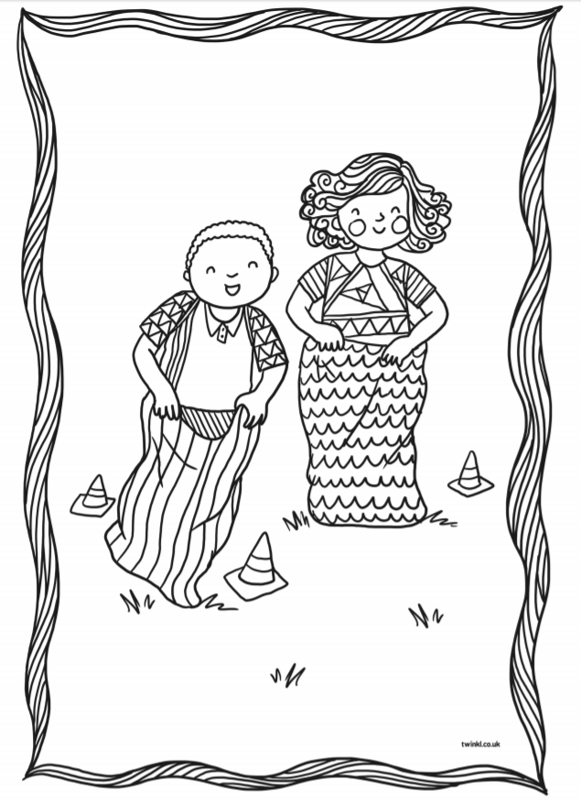
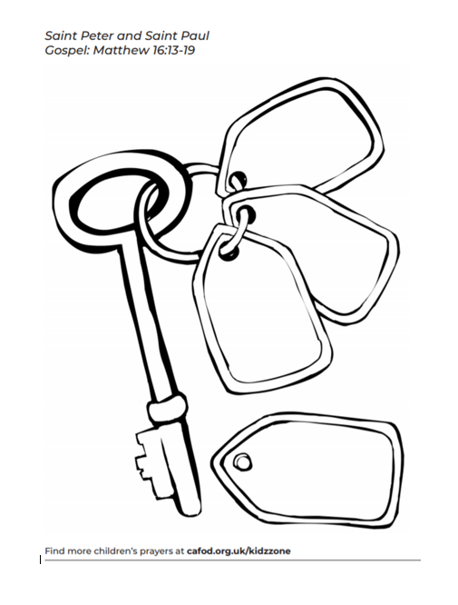
RE
