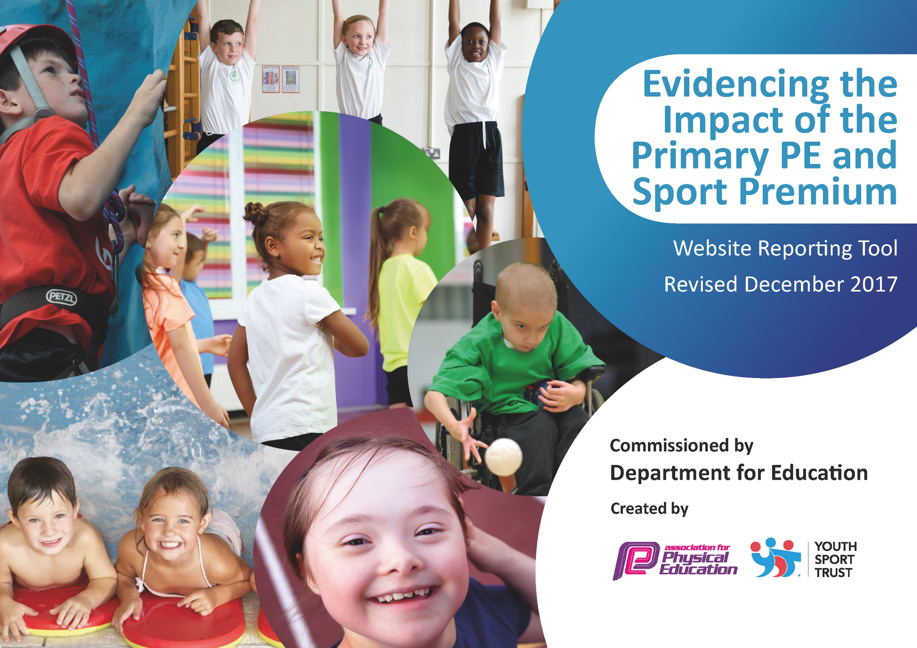
Evidencing the impact of the Primary PE and Sport Premium at
St Oswald’s Catholic Primary School
2025 2026

Schools must use the funding to make additional and sustainable improvements to the quality of PE and sport they offer. This means that you should use the Primary PE and Sport Premium to:

- develop or add to the PE and sport activities that your school already offers
- build capacity and capability within the school to ensure that improvements made now will benefit pupils joining the school in future years

Please visit gov.uk for the revised DfE guidance including the 5 key indicators across which schools should demonstrate an improvement. This document will help you to review your provision and to report your spend. DfE encourages schools to use this template as an effective way of meeting the reporting requirements of the Primary PE and Sport Premium.

We recommend you start by reflecting on the impact of current provision and reviewing the previous spend.
Under the Ofsted Schools Inspection Framework, inspectors will assess how effectively leaders use
the Primary PE and Sport Premium and measure its impact on outcomes for pupils, and how effectively governors hold them to account
for this.

Schools are required to publish details of how they spend this funding as well as on the impact it has on pupils’ PE
and sport participation and attainment.
We recommend regularly updating the table and
publishing it on your website as evidence
of your ongoing review into how you are using the money
to secure maximum, sustainable impact.

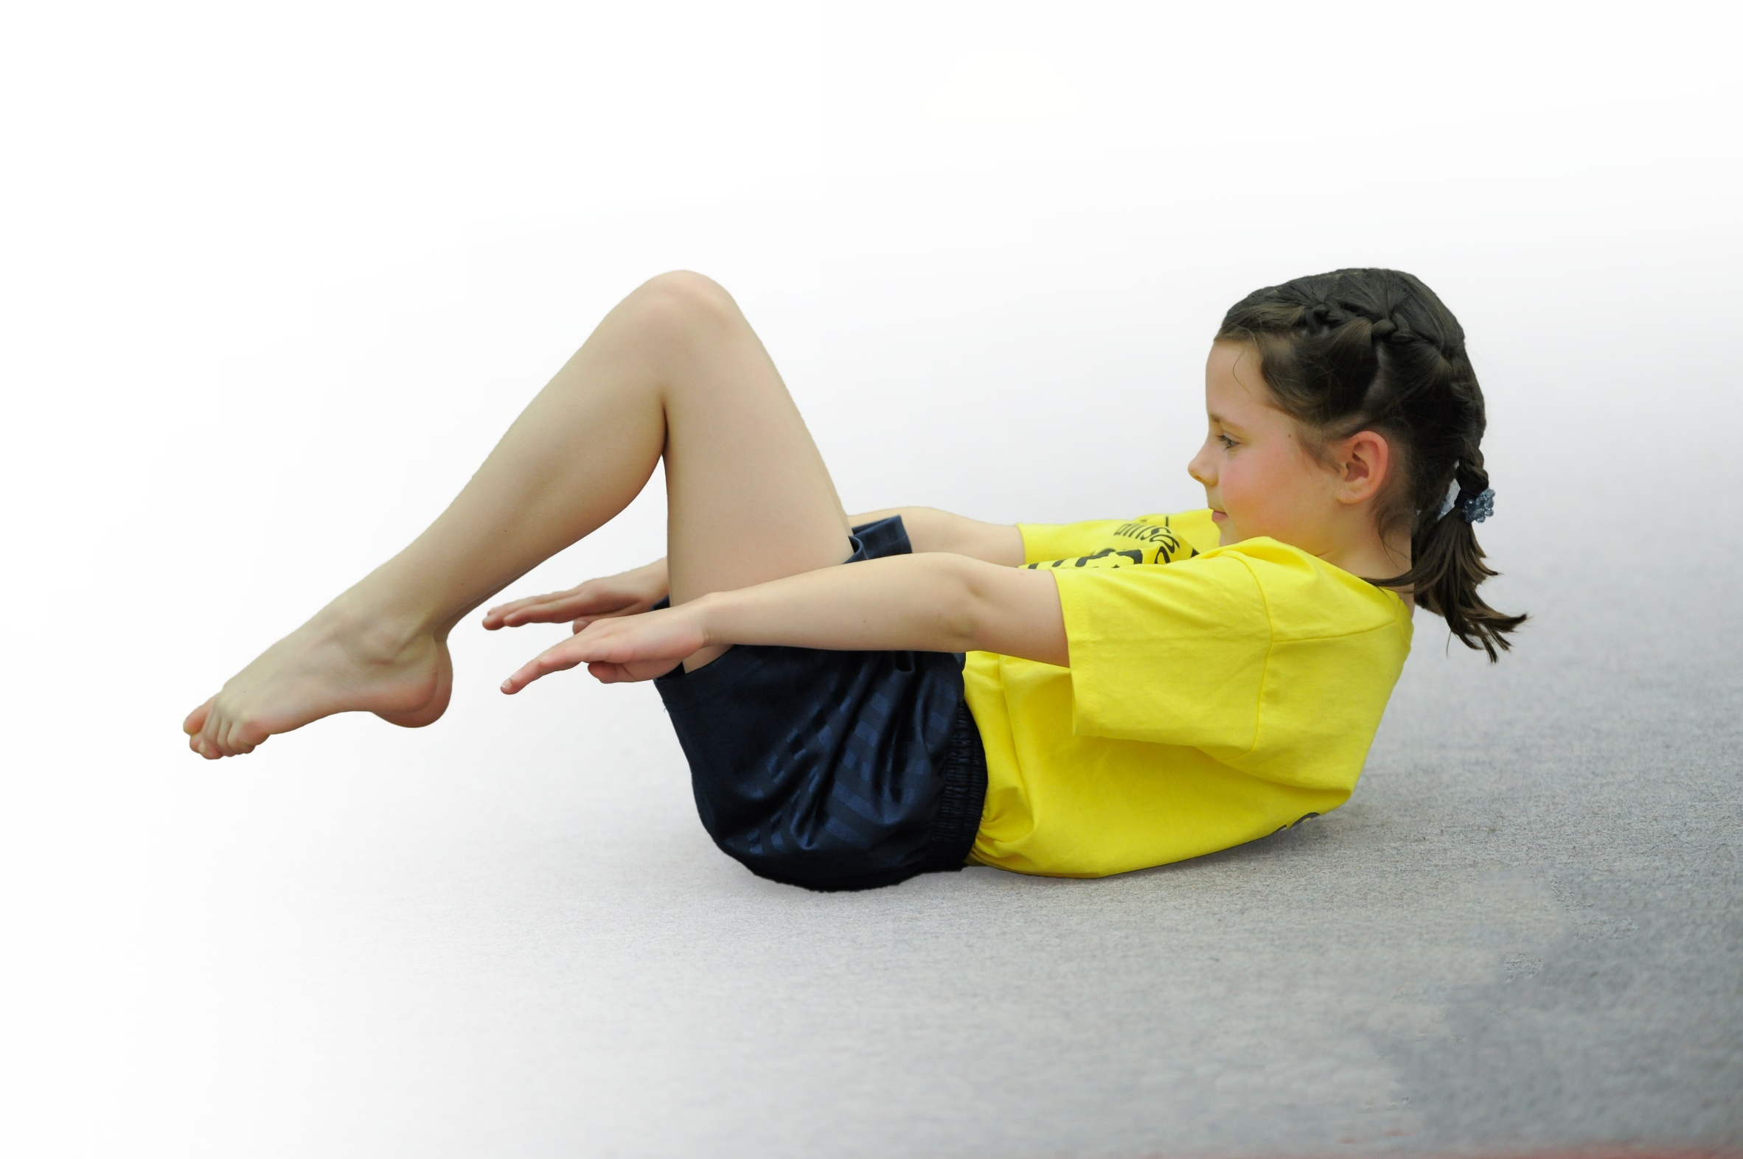
Support for review and reflection - considering the 5 key indicators from DfE, what development needs are a priority for your setting and your students now and why? Use the space below to reflect on previous spend, identify current need and priorities for the future.

Key achievements up until July 2026: | Areas for further improvement and baseline evidence of need:
• We are beginning to enter more competitions, buy different equipment, make Sports Week bigger and better, collaborate with more outside agencies and improve the opportunities. This will be further enhanced with Mr Little, historically a coach from Wigan Athletic and has worked with our school for many years, begins to be a full time member of staff in September 2026 to deliver P.E. We have had specialist coaches from Wigan Athletic and Wigan Warriors to deliver PE lessons, however one of their coaches Tom Little, will be a member of our staff to deliver PE across school from September 2026.  • Children love PE at school all know when it is a ‘P.E Day’ due to being able to come into school on that particular day in their P.E kit.  • Children are active and happy. Children’s happiness and well-being is improving by including more physical activity into their daily routine at school.  • Children access a wide range of sport and activities. This includes new equipment bought from our PFTA at playtimes. | • To ensure we have an active Sports Crew/ Sports Councilors allowing the Student Voice to promote sport and PE across the School.  • A full time sports coach to deliver PE within school for 2026 2027. Due to this, extend the number, and array, of after-school clubs for the children and during lunchtimes.

Meeting national curriculum requirements for swimming and water safety | Please complete all of the below*:
What percentage of your current Year 6 cohort swim competently, confidently and proficiently over a distance of at least 25 metres? | 88%
What percentage of your current Year 6 cohort use a range of strokes effectively [for example, front crawl, backstroke and breaststroke]? | 88%
What percentage of your current Year 6 cohort perform safe self-rescue in different water-based situations? | 88%
Schools can choose to use the Primary PE and Sport Premium to provide additional provision for swimming but this must be for activity over and above the national curriculum requirements. Have you used it in this way? | Yes/No
*Schools may wish to provide this information in April, just before the publication deadline.

Action Plan and Budget Tracking
Capture your intended annual spend against the 5 key indicators. Clarify the success criteria and evidence of impact that you intend to measure to evaluate for students today and for the future.

Academic Year: 2025 2026  Action Plan for 2026 2027 | Total fund allocated: £18, 2010  Wigan Warriors £10,000- delivery of PE lessons  Wigan Athletic £8,478- delivery of PE lessons  Sports Equipment £165 in addition to PFTA buying of equipment  Swimming for LKS2 children £5, 550 (income into school from parents £4226.90 | Date Updated: July 2026
Key indicator 1: The engagement of all pupils in regular physical activity – Chief Medical Officer guidelines recommend that primary school children undertake at least 30 minutes of physical activity a day in school
School focus with clarity on intended impact on pupils: | Actions to achieve: | Funding allocated: | Evidence and impact: | Sustainability and suggested next steps:
Delivery of high quality PE lesson 2 hours per week from specialist PE staff.  Active lunch times – targeted groups to target daily 60 minutes.  Develop a whole school sporting calendar with focused activities each term  Ensure competitive opportunities are fully accessed with a consideration for all year groups and abilities  Increase in targeted bikeability for all children before leaving school. | Timetables hall and disseminated  Encourage all classes to engage with this at lunch time  Timetable created and accessed each term  All Y6 pupils to take part in training by the end of the academic year. | Externally funded | Range of sporting activities, competitive and festival-based are evident with a range of year groups.  Decrease in the number of children travelling to school by car. Increase in children walking, scooting, cycling or parking and striding.  Active lunch times. All children receiving 60 minutes of exercise each day. Children targeted to be more active through lunch time groups and sports.  100% attendance, with case study on those not attending.  Increase % of children attending school on bikes. | Ensure training and support for staff delivering the activities  Senior Prefects and playleaders used to ensure focused activities  Consider need to up-skill those children not able to take part
Key indicator 2: The profile of PE and sport being raised across the school as a tool for whole school improvement
School focus with clarity on intended impact on pupils: | Actions to achieve: | Funding allocated: | Evidence and impact: | Sustainability and suggested next steps:
To develop the School Sports Crew through inclusion of pupil leadership to promote the participation and enjoyment of sport.  To continue to develop the profile of PE across the school for all children, including a section on PE in monthly school newsletter. Use of Bluesky/newsletters to promote and celebrate out of school sporting success. | Profile of Sports crew and sports leaders raised  Celebrate achievements in weekly assemblies  Regular updates on newsletters  Update the school Bluesky to share information and achievements  Positive Growth Mindset promoted across school  Children taking part in representative sport at town / national level to be recognised  Release time to complete  Continue to build upon Sport’s Day activities such as inflatable assault course, boot camp sessions, timed competitions, tournaments, sports days and much more! |  | Pupils appreciate the recognition  Positive and appreciative parental feedback  Evidenced in relevant communication documentation  Evidenced in relevant communication documentation | Consider developing further and including a separate ‘Sports Assembly’ at the end of the year  Consider staffing with ratios for competitions.

Key indicator 3: Increased confidence, knowledge and skills of all staff in teaching PE and sport
School focus with clarity on intended  impact on pupils: | Actions to achieve: | Funding  allocated: | Evidence and impact: | Sustainability and suggested  next steps:
Increase staff confidence and competence.  Ensure the curriculum matched to the Inspection Framework  Employment of high quality Specialist PE teacher  Improve confidence of teaching staff to deliver quality PE lessons | Ensure curriculum coverage, progression of skills and planning is effective  Subject Leader to provide evidence, via video and photos for curriculum needs  Annual timetable for quality curriculum lessons and extracurricular clubs (including lunchtime)  Identified staff to attend training  Access to internal CPD opportunities (in line with social distancing restrictions)  Use TL to offer a range of opportunities across school. |  | Curriculum Intent, Implementation and Impact are clear (and displayed on the school website)  Curriculum is monitored effectively by the Subject Leader  Increased quality provision in lessons, lunchtimes and extracurricular time  Curriculum is monitored effectively by the Subject Leader / HT  Good practice is shared amongst staff  Improved staff confidence and knowledge  Increased confidence and knowledge of pupils | Further development of curriculum through needs arising within academic year  Consider how this can be used to effectively develop CPD
Key indicator 4: Broader experience of a range of sports and activities offered to all pupils
School focus with clarity on intended  impact on pupils: | Actions to achieve: | Funding  allocated: | Evidence and impact: | Sustainability and suggested  next steps:
Continue to offer a wide range of activities both within and outside the curriculum in order to get more pupils involved in extracurricular activities.  Ensure extracurricular opportunities are given to ‘less interested’ children | Timetable lunch activities including cross country, tennis etc.  Target children to attend lunchtime / after school clubs  Use of sports coach to target particular groups  Enable all children across school to access a variety of sports. |  | Increase in those playing rugby / new to rugby, also signposted to local clubs  Children trying out new sports in the hope to take something further.  More enjoyable experiences in a variety of sprots for all children.  Exposing children to a range of sports – especially away from the more traditional ones to broaden experiences and enjoyment. | For all sports listed, school staff to have the relevant local knowledge to signpost children to clubs and groups  Consider where further financial investment is required
Key indicator 5: Increased participation in competitive sport
School focus with clarity on intended  impact on pupils: | Actions to achieve: | Funding  allocated: | Evidence and impact: | Sustainability and suggested  next steps:
Increase the number of competitions and competitive sport opportunities.  Ensure competitive opportunities are fully accessed with a consideration for all year groups and abilities – done through entering ‘development’ events aimed at less active and less confident children.  Use of parental support and Sports Premium to assist with increased transport costs to interschool competitions | We continue to participate in competitions organised by three different groups |  | A wide range of competitive opportunities accessed  Resources purchased if necessary  Additional teams have accessed competitive sports, with a measurable % increase  Trackers show more and more children invited to compete – especially in Y5/Y6 where each child represents school at least once an academic year. | Continued entrance into a competitive wide range of events  Staging of own events where restrictions in numbers

