


OZZIE’S NEWS – 28.02.25

The Ozzie’s Way Champions
These children have all contributed towards making our school HAPPY this week. A big “well done” and “thank you “ to them.

Eaglets/Owlets- Lucas V
Sparrows – Libby G
Robins – Joseph R
Starlings – Francis C
Magpies – Oliver T
Seagulls – Louie W
Owls- Guy C
Eagles – Patrick F

MASS AT ST OSWALD’S
Sunday 11 am
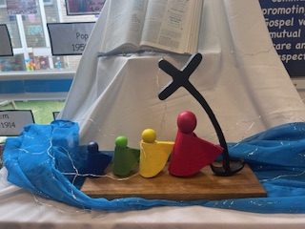

  - Wednesday’s Word “ ACTION ” LOVE JESUS, LOVE LEARNING, LOVE EACH OTHER.

BOOKFAIR
We have been able to purchase £278.58 worth of books for our school library thanks to the sales taken.
MALAWI
Well done to Callum and Alex who ran a ‘design your own burger’ competition and raised £17.05 for Malawi.
VALLEY BRASS BAND HONOUR
Patrick in Y6 plays in this band. They have been awarded the King’s Voluntary Service Honour which is the equivalent of an MBE and is given to volunteers that make a significant contribution to their local community. Well done Patrick !
FIRST AID
Starlings, Magpies, Seagulls and Owls have all completed their First Aid training this week. Eagles will do theirs next week. They’ve been learning how to put people in the recovery position , bandage wounds , deal with shock and hypothermia and know how to keep warm in survival situations.
ASH WEDNESDAY
Seagulls, Owls and Eagles will be attending Mass. The rest of our classes will receive ashes in school. If you want to take your child to Mass please let school know so that we can arrange for them to have lunch early.
WORLD BOOK DAY
For World Book Day on Thursday 6th March we will be asking children to dress as a number and bring any books that have a number reference in them. There is further information and some ideas on Seesaw.
OWN CLOTHES FRIDAY 7TH MARCH
In return for a chocolate or Easter themed donation for our raffle children can wear their own clothes next Friday.

Have a lovely weekend.

