EAGLES’ WEEKLY SUGGESTED HOME LEARNING – WB 29.6.20
Good morning Eagles! We’ve got another Zoom session this week and we’re going to send the details out later today. Thank you for your work last week. We’d like you to keep sending your work into us and remember to check what is on the St. Edmund Arrowsmith website and work through some of those tasks too. 29th June is the feast day of St. Peter and St. Paul and we usually have a celebration at school by having a picnic. Try and have your own mini celebration and find out a bit more about who St. Peter and St. Paul were. We set you some tasks last week. Remember to email us if you want to ask anything or let us know how you are doing. We’re here to help. Have a good week and thank you for the photos – you’re all incredibly cute!
Mrs Colothan, Mrs Hillam, Mrs Jones, Mrs Donlon and Miss Clegg XX
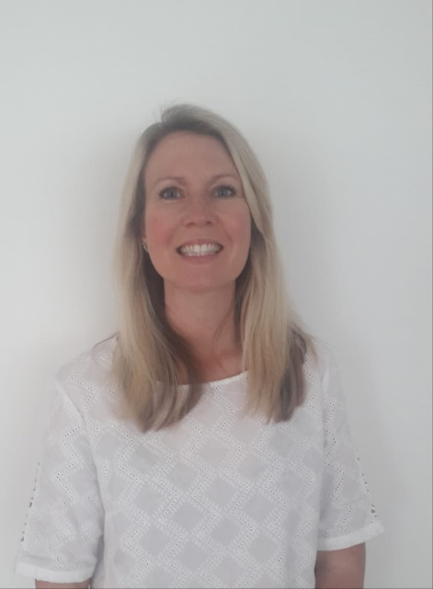
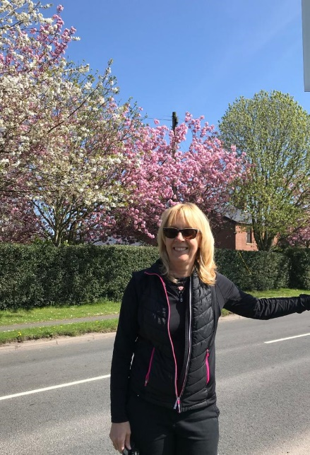

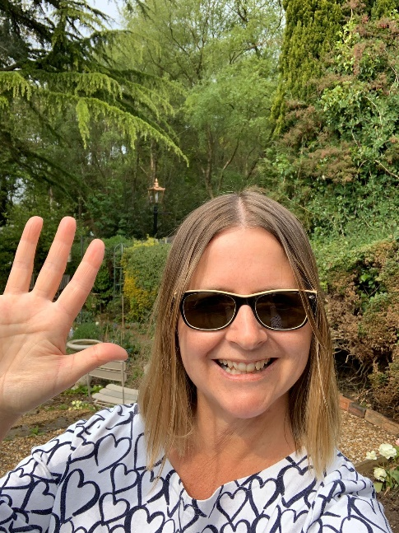
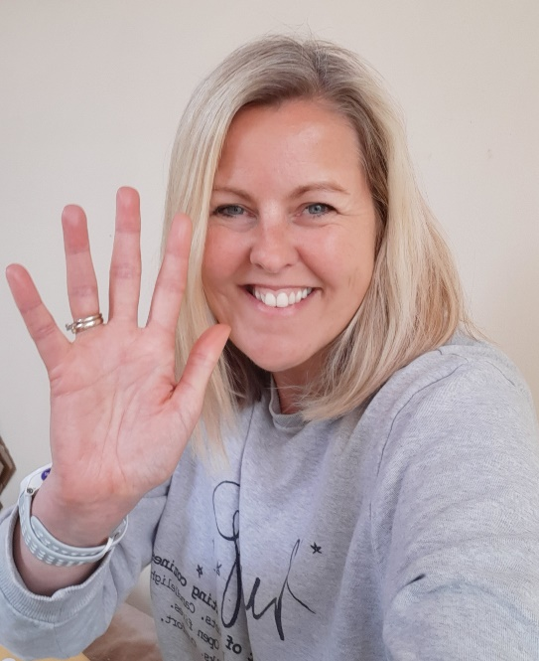

ENGLISH |  | MATHS
Reading – Read every day for pleasure for 30 minutes. You may like to use Epic. This is a great website where you read many online books for free for a month.  Complete ‘Titanic’ reading comprehension using this link. If you have time, complete another comprehension task of your choice.  https://cdn.oxfordowl.co.uk/2017/03/30/09/42/41/727/2749604_Reading_Comp_A.pdf  Answers  https://cdn.oxfordowl.co.uk/2017/03/30/09/44/53/749/2749604_Reading_Comp_A_Answers.pdf  This week we will focus on INFORMATION LEAFLETS  https://classroom.thenational.academy/lessons/information-leaflet-lesson-1-reading-focus  Information leaflets are so useful to be able to do and can be applied across lots of different subjects. Work through the daily activities.  Create an information leaflet about St. Oswald’s for new families who want to come to our school.  Spellings – Look below for some ideas that you could do to help you to learn your spellings. If you are confident with the Y5/Y6 words, go through your reading books and find some interesting words to learn how to spell carefully. |  | 6 and 7 times table – Instant recall.  https://ttrockstars.com/  https://corbettmathsprimary.com/wp-content/uploads/2018/06/times-tables-pdf.pdf  How many patterns can you spot in the 6 and 7 times tables? What patterns can you spot?  This week’s focus is Decimals and Measures – scroll down the link and complete lessons 1 – 5 on this theme.  https://classroom.thenational.academy/subjects-by-year/year-6/subjects/maths  Use the link below for 5-a-day challenges and also for specific worksheets, videos and tasks on decimals and measures.  https://corbettmathsprimary.com/  After each session, write a sentence or two to summarise what you have learned.
R.E. | OTHER
This week we are beginning a new unit of work based on the topic of The Universal Church- Our World. Please see resources which have been attached below  Please feel free to access Cafod’s site for lots more engaging and free resources.  https://cafod.org.uk/Education/Primary-teaching-resources/Home-learning-primary  Could you help with this year’s Summer of Hope fundraiser? Details are on Cafod’s website.  http://www.wednesdayword.org/ | Transition Tasks:  We are continuing with Robinhood Mat work.  Follow the link below and then scroll down to Y6/7 transition learning projects. Week beginning 29th June. The theme is about being a problem solver – the scenarios are really realistic and address some of the usual worries children have.  https://www.robinhoodmat.co.uk/Learning-projects/  Science  Physical and Chemical Changes  Scroll down to the Science and find out about how materials change. This is really useful for high school especially and sometimes can be tricky to remember.  https://classroom.thenational.academy/subjects-by-year/year-6/subjects/foundation  Mindfulness  Follow this link to Peace Out and have a go at taking some time to complete this guided session. Perhaps as a family, you could try this together.  https://www.youtube.com/watch?v=pVKIZNCL5Ms  ST. EDMUND ARROWSMITH TRANSITION TASKS  Try to complete three of these this week.  https://www.arrowsmith.wigan.sch.uk/parents/Y7-Intake

