OWLS’ WEEKLY SUGGESTED HOME LEARNING – WB 29.6.20
Hello Owls!
Here we are in the very last week of June! Today, June 29th, is the day when we usually celebrate the Feast of St Peter and St Paul by having our picnics out on the field. Why not find time today, or this week, to have your own mini celebration at home. You could hang up the mobiles that you made as part of last week’s home learning. Enjoy your celebrations and let me know what you got up to!
It was great to hear from so many of you last week and I was I was one proud class teacher as I read your emails and looked at your work. I was treated to some raps about dogs and rhinos, an eerie story about an abandoned house, a fun story about a surfing bookmark and a fact file about the Titanic! I read PowerPoints about canals, and saw some of your fabulous pets on zoom! I even heard that we have children who have applied for Blue Peter badges. I loved seeing your William Morris collages and your creative worlds for your mini figures were just brilliant! Wow. I wonder what my Inbox will bring me this week!
Take care, Mrs Higgens and Mrs Smith xx
How to get in touch… enquiries@saintoswalds.wigan.sch.uk or you can Tweet @saintoswalds or @Mrs_higgens.

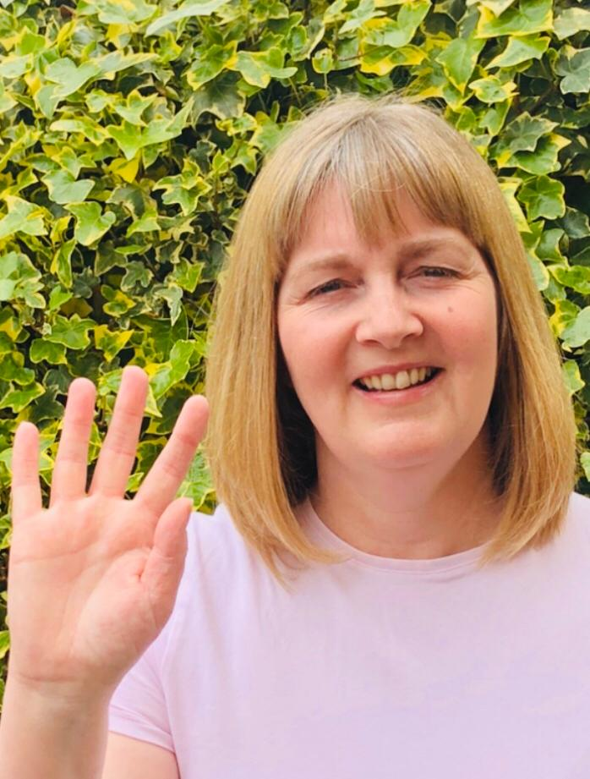
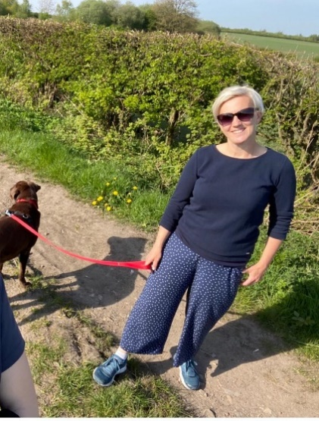

ENGLISH | MATHS
Year 6 Transition  We would like you to continue with the transition tasks on the Robinhood MAT website. The focus this week is about building independence ready for high school. Follow the link below and then scroll down to Y6/7 transition learning projects. Week beginning 29nd June  https://www.robinhoodmat.co.uk/Learning-projects/  Spelling  1. Practise spellings using this link. There are lots of games to choose. https://spellingframe.co.uk/  2. Each day, choose 5 words from the Year 5/6 spelling list. Write a synonym, antonym, the meaning and an example of how to use the word in a sentence.  Comprehension/Reading  1. Listen to or read along to the poem Cosmic Disco. What do you think is the main idea in the poem? Cosmic Disco poem  2. Complete this reading activity based on space tourism. space comprehension  Writing  1.Create a poster which will help younger children to learn about where the continents, particular countries and oceans of the world are. It must provide key facts and an imaginative layout/design to get children to learn where key places are around the world.  2. The Literacy Shed lesson packs are proving very popular so we have another one this week. Before you watch the film clip, have a look at the questions first! A Cloudy Lesson | Hamilton Maths Packs  Please use the home learning packs from Hamilton at Home.  https://www.hamilton-trust.org.uk/blog/learning-home-packs/  Click on this link and scroll down to go to either Y5 or Y6.  We are up to week 9 but feel free to go back if you feel like you need to. These have some PowerPoints to help and also come with answer sheets. The download includes a file for each day of work.  The structured daily lessons on BBC Bitesize are another good option https://www.bbc.co.uk/bitesize/dailylessons as is picking and choosing from Corbett Maths https://corbettmathsprimary.com/content/  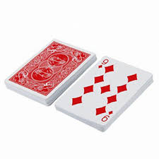  Game Challenge! Why not play multiplication war with another person and a deck of cards. Flip two cards over and multiply. Whoever has the highest product keeps the cards. Use 3 cards as a challenge.  Ongoing Times Table Rockstars- try for 15 minutes a day  https://ttrockstars.com/.  We are getting much better! Keep up your hard work!

R.E. | OTHER
This week we are beginning a new unit of work based on the topic of The Universal Church- Our World. Please see resources which have been attached.  Please feel free to access Cafod’s site for lots more engaging and free resources.  https://cafod.org.uk/Education/Primary-teaching-resources/Home-learning-primary  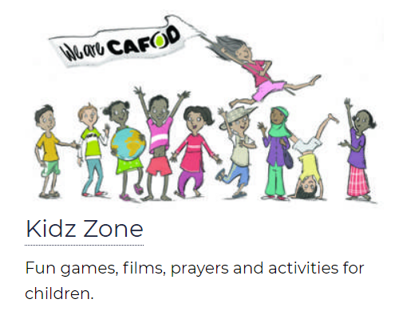  Could you help with this year’s Summer of Hope fundraiser? Detail are on Cafod’s website. | Science – Electricity  Lesson 1 https://classroom.thenational.academy/lessons/what-is-static-electricity  Lesson 2 https://classroom.thenational.academy/lessons/what-are-the-different-components-in-an-electrical-circuit  Lesson 3 https://classroom.thenational.academy/lessons/what-are-circuit-diagrams  Art and DT Lesson 6  Using the skills and techniques that we’ve been practising, please see below for this week’s William Morris task. I’m looking forward to seeing these  History  This week we continue with our topic based on railways which we would have been learning about in school. Find out 10 amazing facts about Wigan North Western train station and Wigan Wallgate – create a poster or Powerpoint to let others know about these train stations. It’s really unique to have 2 stations in one town so close to one another. You could even do a video report for the local news.  PE This PE link is to lots of fun You Tube videos produced by the Yorkshire Sport Foundation which give some practical learning activities to do PE at home using things from around the home. We are up to lesson 20 https://www.youtube.com/watch?v=NDZhgfrmogA  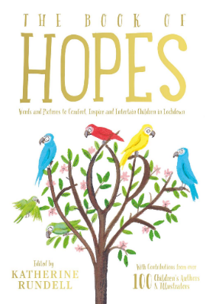  Wellbeing  Reading or being read to offers hope and positivity. The Book of Hopes aims to comfort and encourage children during these unusual times and is free to download here. There are contributions from many well-known authors such as Michael Morpurgo, Axel Scheffler and Lauren Child.

