ROBINS’ WEEKLY SUGGESTED HOME LEARNING – WB 29.6.20
Hi Robins, we hope that you enjoyed your tasks last week all about feelings and emotions. This week’s tasks are all about Sports Day. In the summer term we would have our annual sports day as we are not in school we thought that you would enjoying taking part in sports day themed activities at home. We hope the weather improves and you can all get outside for some fresh air to set up your own family sports day. Missing you all. Stay Safe!
Mrs Fox, Mrs Davies and Miss Lea xxx
We’d love to see your work, so please Tweet @saintoswalds or send an email to enquiries@saintoswalds.wigan.sch.uk FAO Miss Lea
English | Maths
Reading for pleasure – 15mins per day  There are lots of stories that you can read about sports day. Here are a few. You can share them on you tube.  Life with the Large Family Sports Day  Sports Day in the Jungle  Cbeebies story time – Nadiya’s Sports Day  Maisie’s Sports Day  Topsy and Tim – The Big Race  Reading Comprehension  1* Sports Day, 2** The Terrible Trip Up  3*** Sports Day,  Spelling Task (Y1/2)  Rearrange the letters to find the different sports day themed words (answers are attached)  Writing Tasks (Y1/2)  Have a look back at the photographs that your parents took on previous sports day that you have taken part in. Recalling these memories will help you with your writing tasks.  Sports Day Senses’ Poem (attached)  Sports Day Recount  Y1 – remember to use the different spellings for the sounds that you have been learning and the conjunction ‘and’ to join your ideas together.  Y2 – Remember to use adjectives and adverbs.  Can you use the conjunctions – when, then, if, or, but, so in your writing?  Use adverbs in your writing to add more information to your verbs – e.g. I ran quickly to the finish line.  Phonics – Year 1 phoneme spotter and comprehension questions (attached)  Split digraph – a_e, e_e, i_e, o_e, u_e  Alternative spelling for or/aw  Spelling – Year 2 – changing adjectives to adverbs  Wanda the Witch attached | Basic Skills  Y1 – Quick recall of doubling and halving facts within 20  Top Marks Website has games to play linked to doubling and halving  Y2 – Rapid recall of 2’s, 3’s, 5’s, 10’s time tables – play TT Rockstars and Top Marks to develop quick recall.  White Rose Maths – videos alongside BBC Bitesize videos  Year 1 – Ordering Numbers  Challenge – Order numbers in steps of 2, 5, 10 and Money – recognising coins and notes, making different totals finding different ways of making amounts within 20p e.g.  17p – 10p, 5p, 2p, or 5p, 5p, 5p, 2p or 17 1p’s etc  Year 2 – measures in grams, kilograms, millilitres.  Attached:  Longthorne Primary School Sports Day Trophy Thief Mystery  Year 1 and Year 2 Maths Challenge Cards
RE | Other Subjects
This week we start our new topic about the Universal Church.  Neighbours  - See attached sheets  Challenge – write a diary entry for a day in the life of Marie-Dorriane and her family. | Science – Escape the Second Hand Show Shop (attached)  Challenge – think about the equipment that we would use in an obstacle race:  Bench, hula hoop, bean bag, sack, egg and spoon, ball, hurdles.  What are the different pieces of equipment and why are they used?  e.g. What is the bench made from? Why is the bench used to jump on and off in our obstacle race?  ART/DT  Design a sports day medal and use different materials to make you design come to life.  Music – see our school website for this week’s music links.  PE – design a sports day for you and your family  What tasks will you ask your family to do?  History – speak to your parents and grandparents about their experiences of sports day when they were at school. How does their sports day experiences compare to your sports day experiences?  Geography – Research Sports Days around the world  How are sports days different or similar to Sports Days in England?
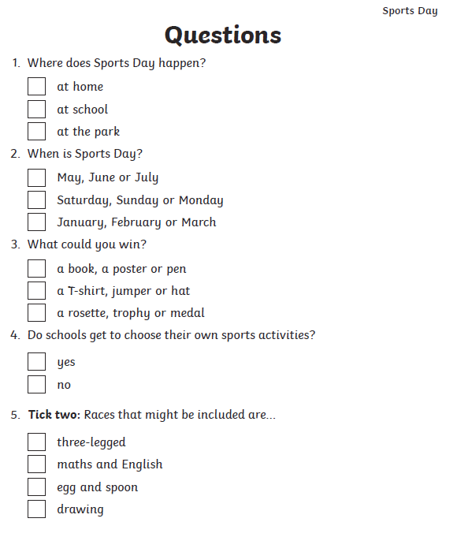
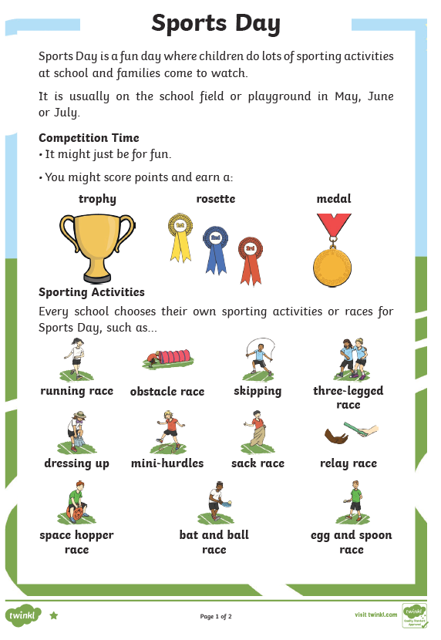
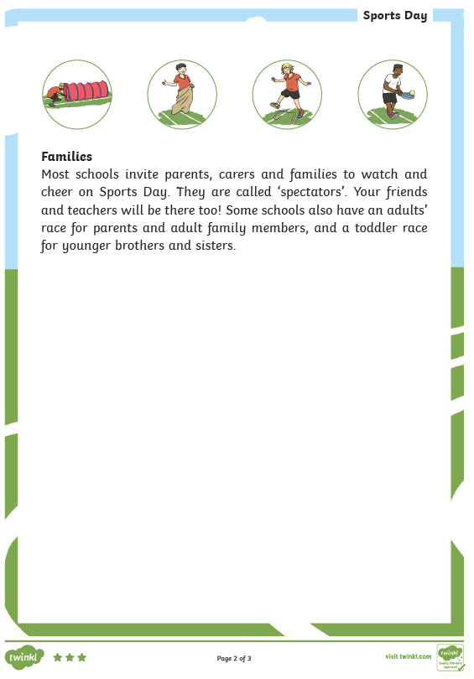
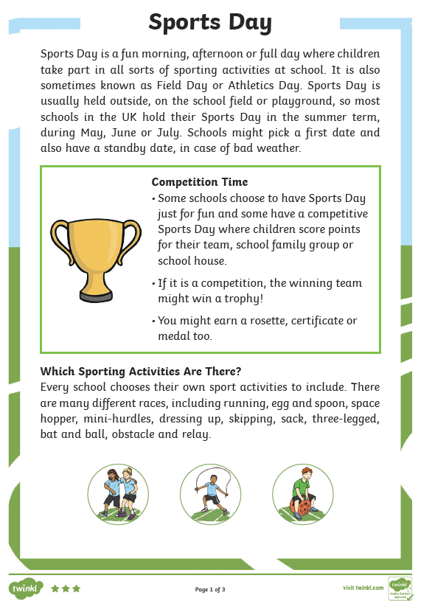
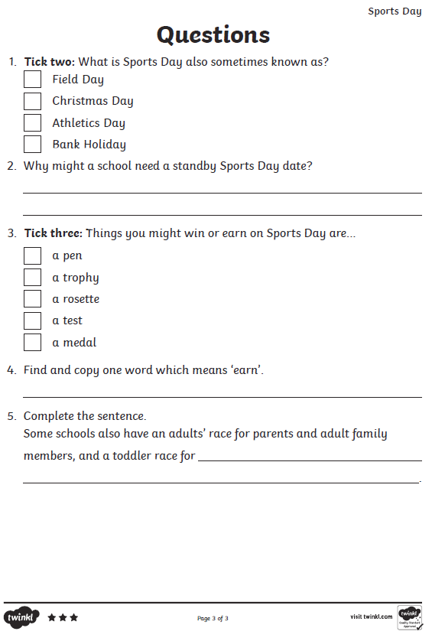
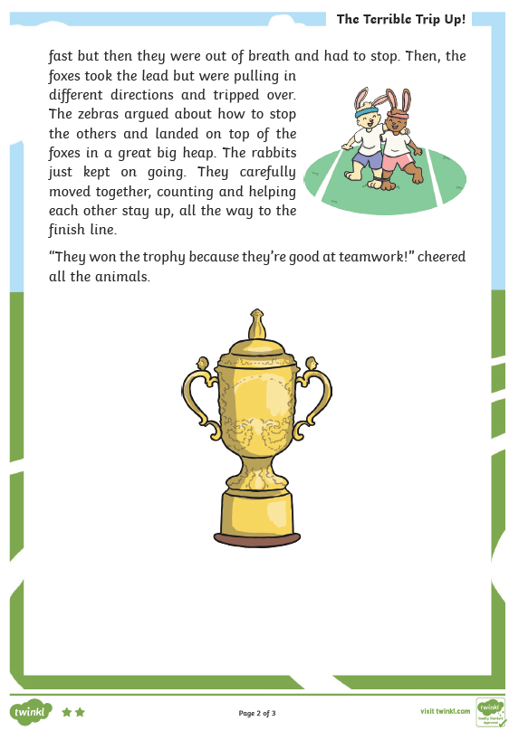
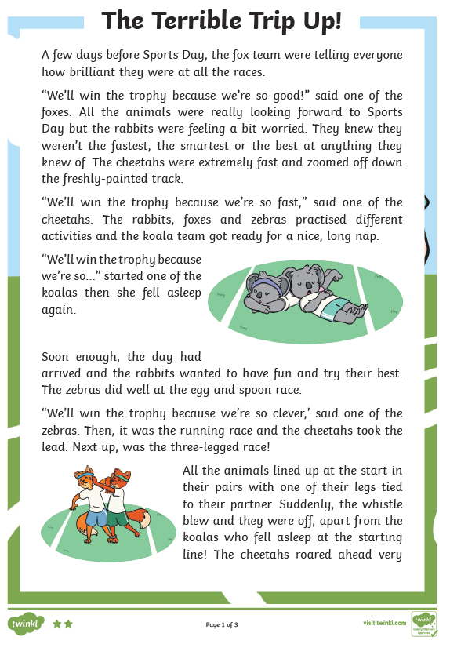
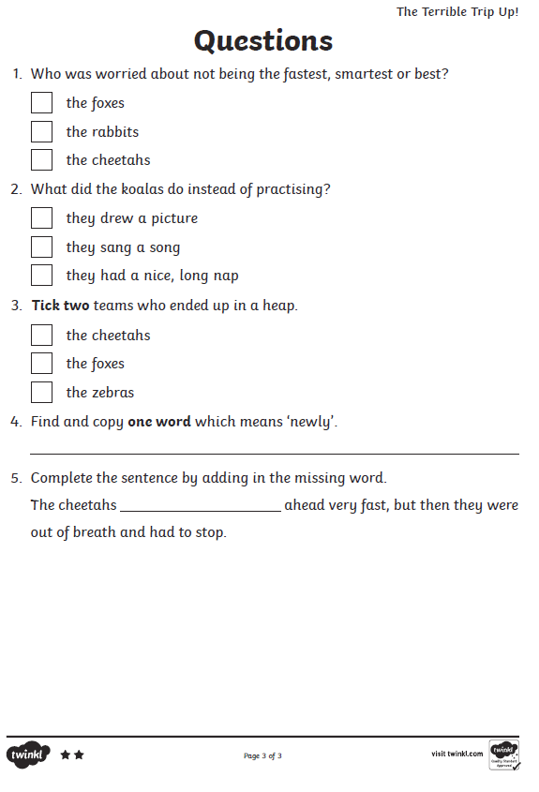
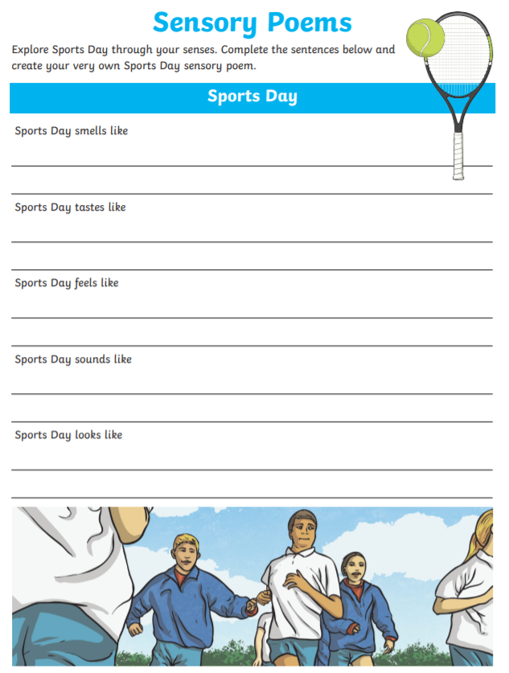
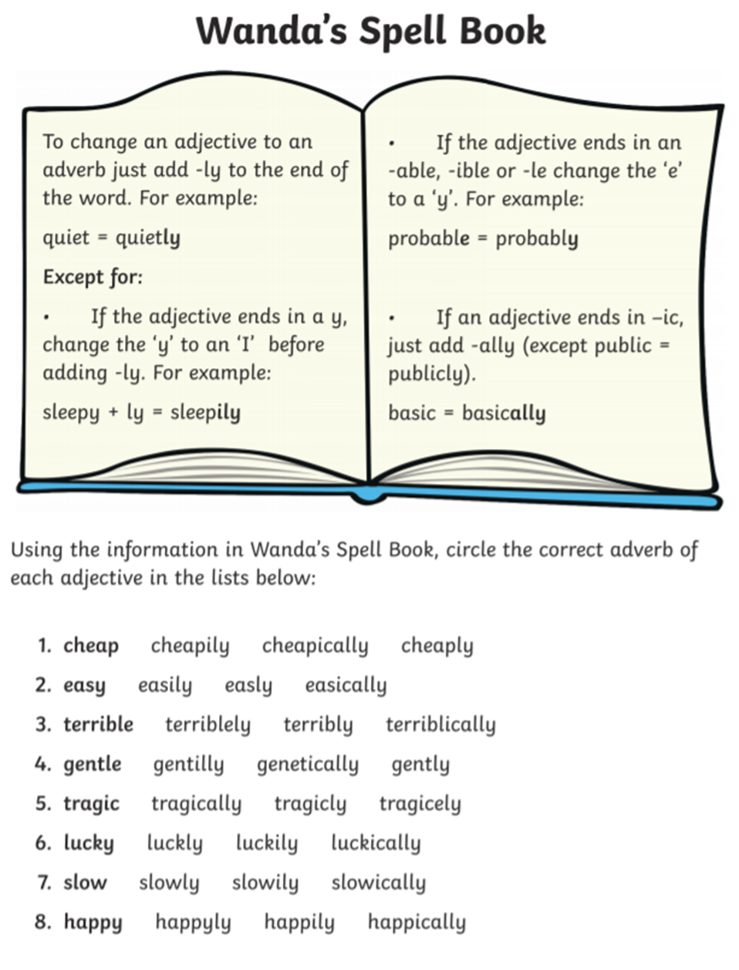
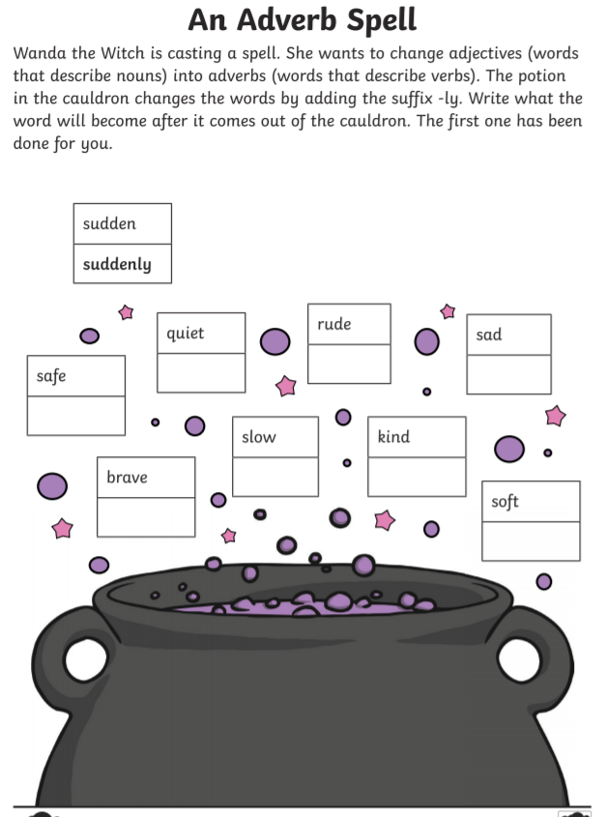
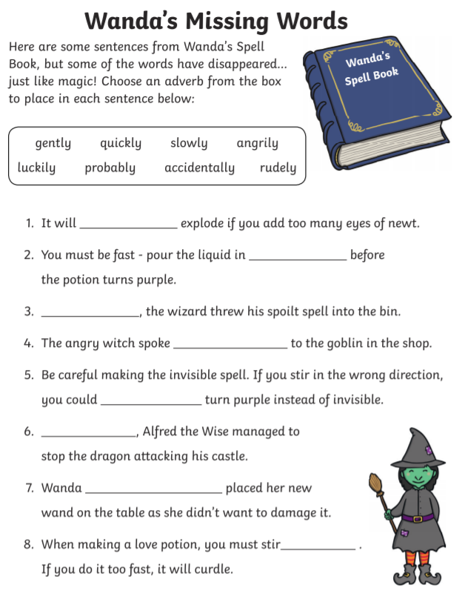
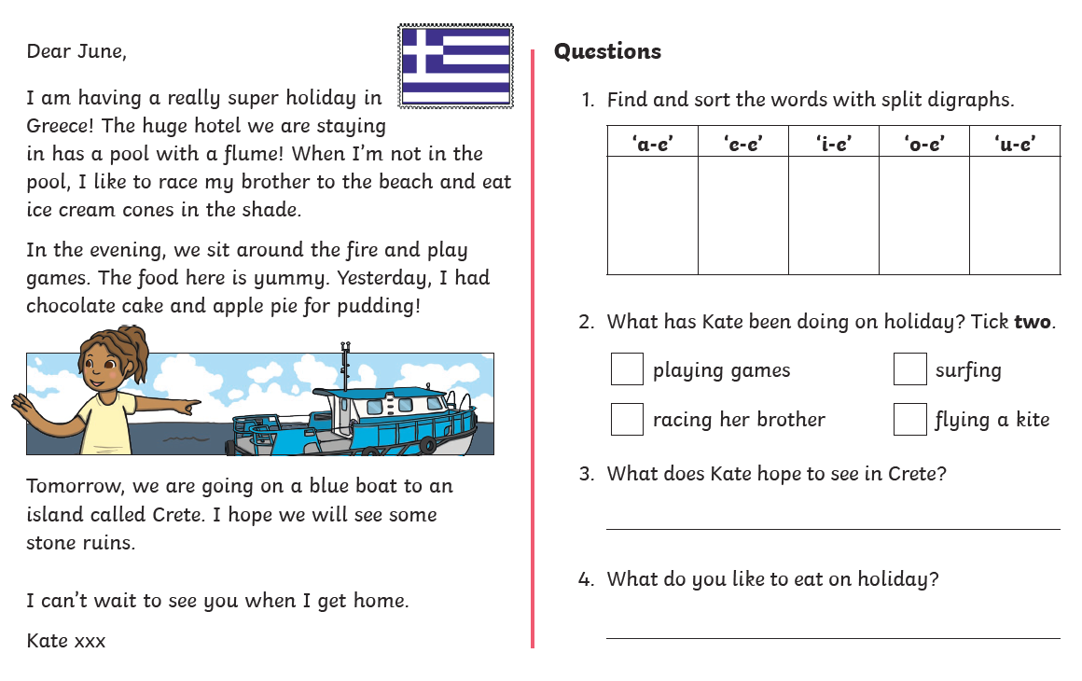
Year 1 – Phonics
