SPARROWS WEEKLY SUGGESTED HOME LEARNING – WB 29.6.20
Hello Sparrows! I hope you enjoyed being firefighters last week and learnt some new facts all about the Great Fire of London. This week we are looking at the story Jack and the Beanstalk. There is a short version of the story below or there are plenty of videos on YouTube if you don’t have the story at home.
Please keep in contact as usual. You can email the office at enquiries@saintoswalds.wigan.sch.uk FAO Sparrows or tweet us @saintoswalds @mrs_wibberley @MrsOsborne73.
Stay safe and keep smiling
Mrs Wibberley, Mrs Osborne and Mrs Dean xx
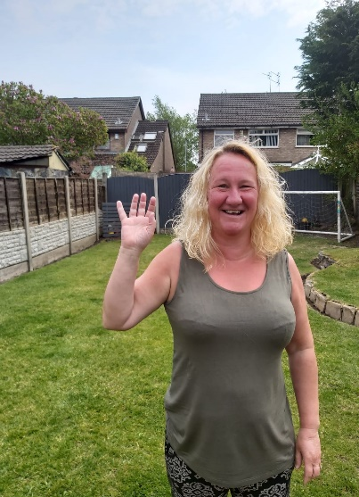
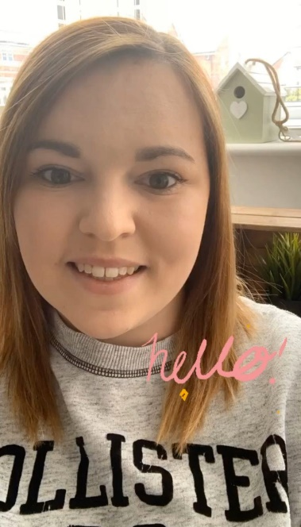

ENGLISH | MATHS
Reading – Read every day for pleasure for 10 minutes.  You can also listen to stories on www.vooks.com. This website is full of stories that come with videos and are a big hit in Sparrows as there are so many to choose from. Maybe your child can share their favourite story with you. You can get a free subscription for 1 month.  Comprehension –  - Read the story and answer the questions below. You might need an adult to help you read it but have a go at the words where you know the sounds.  - Sequence the story using the matching activity below.  Writing –  - A day in the life of a giant – Think about what it might be like to be a giant for a day. What would you do? What do you think would be different?  - What would happen if you had a magic bean? You can start your writing with ‘If I had a magic bean…’  Phonics – Your child will be able to tell you which phonics group they are in. If they don’t know, please contact school so we can help you.  Mrs Osborne and Mrs Dean’s groups –  1. Go to https://www.phonicsbloom.com/ or https://new.phonicsplay.co.uk/ and play your favourite game to practise all the new sounds you have learnt over the past few weeks.  2. Find objects around the house that have the ‘ur’ sound in them. Write the words and draw pictures to match.  Mrs Wibberley’s group –  1. Go to https://www.phonicsbloom.com/ or https://new.phonicsplay.co.uk/ and play your favourite game to practise all the new sounds you have learnt over the past few weeks.  2. Find objects around the house that have the sound ‘a-e’ in them. Put these words into sentences and draw pictures to match.  Miss Lea and Mrs Davies’ groups –  1. Go to https://www.phonicsbloom.com/ or https://new.phonicsplay.co.uk/ and play your favourite game to practise all the new sounds you have learnt over the past few weeks.  2. Complete the phase 5 task below. | Basic skill – Ask your adult to teach you how to tell the time to o’clock and half past.  Unfortunately White Rose have started charging for their home learning tasks, however BBC Bitesize have partnered with White Rose and have some great daily tasks including maths for free. Follow this link for a daily maths task https://www.bbc.co.uk/bitesize/tags/zjpqqp3/year-1-and-p2-lessons/1  If your child finds this challenging, please follow this link https://www.hamilton-trust.org.uk/blog/learning-home-packs/ and use the previous year group’s tasks.
R.E. | OTHER
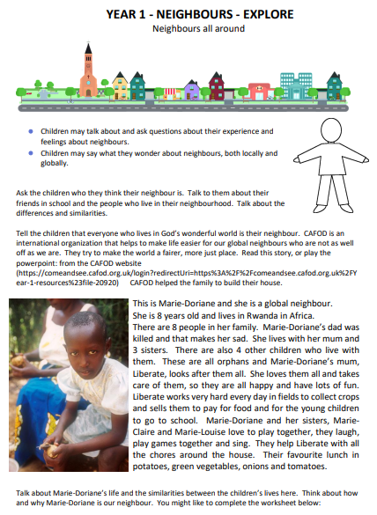  You will find your activities below. | Art – Create your own beanstalk using kitchen roll tubes/wrapping paper tubes etc. How tall can you make your beanstalk?  Create a beanstalk using finger prints for the leaves.  Science – Complete the life cycle of a bean activity below. You could even buy your own beans to plant and watch the life cycle happen over the next few weeks.  Science/DT – Look in your kitchen and research where the different foods come from. A lot of food is made in a factory but you might be surprised where some of it came from before it turned up at the factory!  Music – Think about the sounds you might hear in the story. Can you create these sounds with items from around your house?  Extra activities have been included below if you wish to complete them.

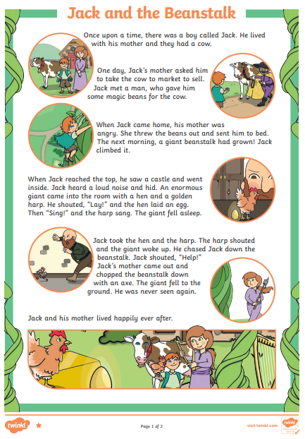
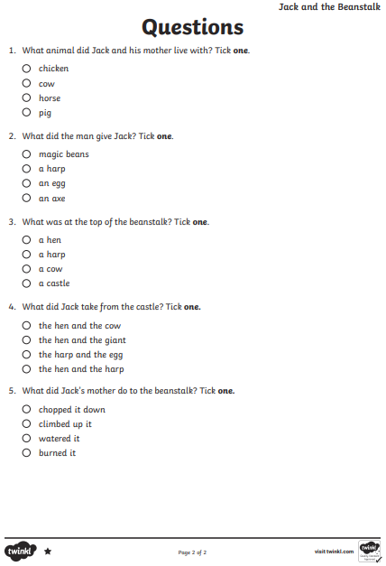
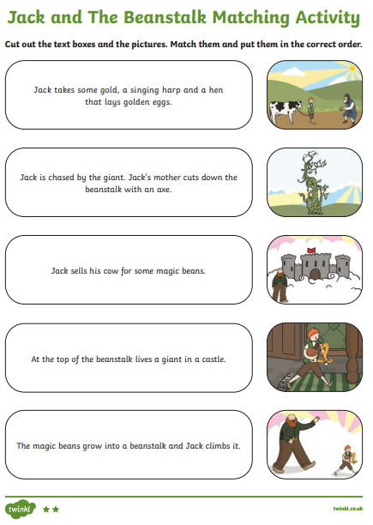
Phase 5 - Can you write 2 words with the same sound?

ay stray ………………………………… ………………………………..
ou cloud ………………………………… ……………………………….
ie tie …………………………………. ………………………………..
ea sea ………………………………… …………………………………
oy enjoy …………………………………. ………………………………….
ir twirl …………………………………. …………………………………….
ue glue …………………………………. …………………………………….
ue queue …………………………………. …………………………………….
aw saw ………………………………… ……………………………………..
wh which ………………………………… …………………………………….
ph elephant ………………………………….. ……………………………………..
ew screw …………………………………. ……………………………………..
oe toe …………………………………. ……………………………………..
au dinosaur …………………………………… ……………………………………..
ey key ………………………………….. ……………………………………….
a-e snake ………………………………….. ……………………………………..
i-e strike ………………………………….. ……………………………………….
e-e cheese ………………………………….. ……………………………………….
o-e stroke …………………………………. ……………………………………….
u-e tube …………………………………. ……………………………………………

