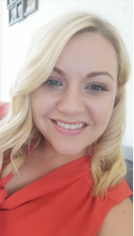
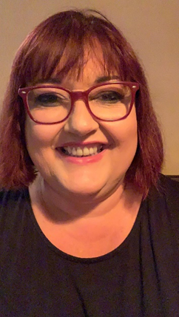
OWLETS AND EAGLETS - WEEKLY SUGGESTED HOME LEARNING –
WB 29.06.2020

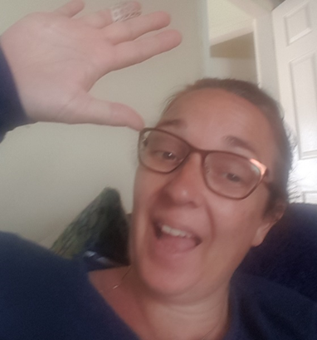

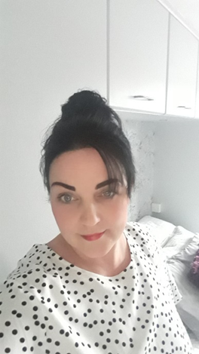
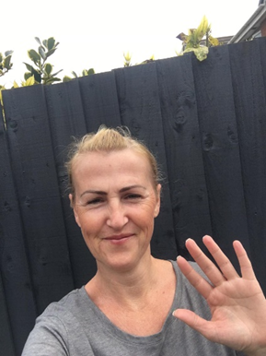
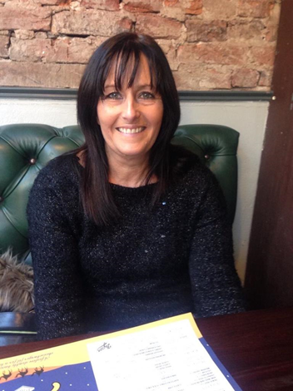

Hello again Owlets and Eaglets, we hope you are all well and still looking after yourselves. These are our suggested activities for you this week. We hope that you enjoy them. This week the focus is on the Famous and Significant People, past or present inventors, explorers or scientists and how they influence society today. Please remember to share some pictures on See-Saw. It is lovely to see what you have been up to, thank you for keeping in contact with us, we miss you so much and it’s lovely to see your happy faces, showing us what you have been up to. Thank you for your ongoing support, enjoy your week of learning. School email – enquiries@saintoswalds.wigan.sch.uk Tweet - @saintoswalds

ENGLISH | MATHS
Reading – Read a variety of books at home. Favourite books can be repeated as it supports the children with their language development as they will hear the patterns of language in the story.  Use Oxford Owl to access books that are related to phase 2 and 3 phonics. Where possible children to read to parents daily.  When you go on click on all ages and click on age 4-5. Then go into levels and click on letters and sounds and choose either phase 2 or 3.(phase 2 will be a little easier and phase 3 more challenging) If you find that these are still not challenging for them then choose age 5-6, go into levels, letters and sounds and click on phase 4. This will then bring books up for you to access with your child.  After reading the book ask the questions on the back cover of the book and complete the play activities linked to the book.  Register here for free access to Oxford owl or you can use our class login  My class name – owlets and eaglets  My Class Password – reception.  Just go to the Oxford Owl login page and click on the My Class login button and use the above details.  Some extra literacy activities this week are taken from Robin Hood Multi Academy Trust. Focus this week is on the Famous and significant People.  Ask your child to think about their favourite books and read one of them together. Find out about the famous authors and encourage your child to think  about why they like these books?  Read stories written by the famous author, Julia Donaldson. You can also listen to them if you click on the following links: Room on the Broom/ Gruffalo  Reception age children: Can your child find and practice reading the tricky words: from phase 2 and 3? See end of planning for key words.  Story focus – Room on the Broom/ Gruffalo  Ask your child to draw pictures showing what happened at the beginning, middle and the end of Room on the Broom or The Gruffalo. Or choose  a different story.  Ask your child questions about the books that you have shared- Who are the main characters?  How are the characters feeling?  Who is your favourite character? Why?  What did you like/dislike about this story?  Ask your child to use pictures from a familiar story book to make up their own story or to retell their favourite story.  Writing task 1 –  Watch The Gruffalo then choose your favourite character. Can you draw a picture of your favourite character. Can you write words/sentences to describe your character, i.e. furry body, knobbly knees and black teeth.  Writing task 2-  Can you make a wanted poster for the Gruffalo?  Can you draw a picture of the Gruffalo? Can you describe him?  Writing task 3 –  Talk for Writing- Who do you think is an important person an example may be the Queen. How would you describe the queen?  Why do they think they are important?  See if you can write a list of other important people.  Writing task 4 –  Can you think of someone that is important to you? Can you draw them? Can you say or write a simple sentence describing why this person is so important?  Inference activity  See end of planning for larger pictures for this activity. Can I infer what is happening in the pictures?  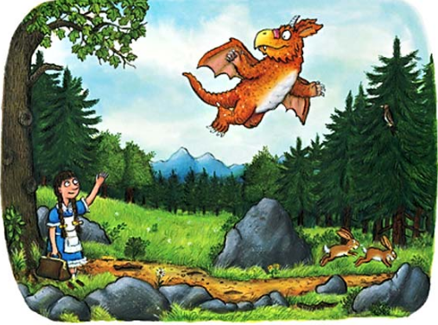  What can you see in the picture?  Why is Zog waving to the little girl?  Do you think the little girl has helped Zog?  How do you think Zog is feeling? Why?  How is the little girl feeling? Why?  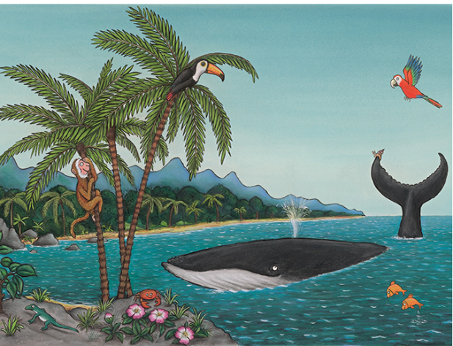  What animals and birds can you see in the picture?  Where is the snail going now?  How do you think the snail is feeling? Why?  Do you think the whale likes the snail hitching a ride?  Phonics (Reading and writing)  Phase 4 phonics –  Please remember to use the free log in - Use the Username – march20 and the password – home If you wish to complete a spelling test use a mixture of the key words you have looked at with the children from phase 2 and 3. Only look at up to 8 words choose from these words – the, I no, go, to, into, he, we, me, be, she, they, was, my, all, you, her, are. Or use the words covered in this weeks phase 4 planning. Phase 4 phonics – Start your phonics session by playing the flashcard games on phonics play for key words and sounds for either phase 2 or phase 3. Help your children to read the following words – step, stop, slin, trip, glan, plan, from, frog, twin, swim, ri, spem, skip  Once they have practised reading them, can they have a go at writing them? Segment the words slowly so that the children can hear each sound. These are some of the phase 4 tricky words we would like you to introduce – recap so, do, some, come, said and said introduce Was- ‘’ Write the tricky words on paper show them your child and help them to read them. Write out two lots of each word and play a pairs game. Who will find the most pairs? Help your child to read the sentences we have written at the bottom of the planning which are appropriate for phase 4. | Mathematics  Watch number blocks clip each day with your child at  Numberblocks BBCiplayer or Numberblocks Cbeebies  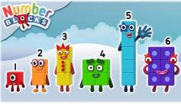  Activity – Practice number formation with you children. Here are the rhymes that we use in the classroom to help your child remember how to write the numbers.  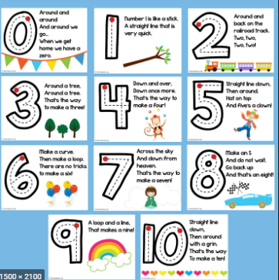  Follow the White Rose Week 8 using the story Zog – patterns, positional language, addition and subtraction- adding more, taking away, counting and measure.  You may also want to look on Oak National Academy. This is a continuation of last week as it had 10 lessons. Reception Click on the link below to access 10 lessons on addition and subtraction. This includes combining 2 quantities to find a total, exploring addition by adding on, exploring subtraction as partitioning, exploring subtraction as take away and comparing 2 sets of objects using ‘more’ or ‘fewer.’ Click the link to take you to all the maths activities on Oak National Academy Addition and Subtraction. Please scroll down to the bottom of the link to find the 10 lessons on addition and subtraction continue with the next 5 lessons.  Practise counting up to 20. This can be done through playing hide and seek, singing number songs, chanting, board games etc. Remember to also practise counting back from 20 to 0.  Don’t forget that you have your Numbots username and password that was sent to you on your child’s see-saw learning journal. Look in the parent information file on the app to find it again if you have forgotten it.  Work on counting and number recognition if you wish to do some more activities taken from Robin Hood Multi academy trust learning projects.  Practice counting on from any given number. Try to create rhythmic patterns: 1,2 3,4, 5,6 2,3,4, 5,6,7 8,9, 10. Then play this online adding machine game add up the animals and objects.  Use this tens frame to practise making different amounts. Or, your child can practice making amounts to 10 using different objects from the house/garden e.g. dried pasta.  Adding numbers: Watch Numberblocks (clip 1) to support with adding. You can also click on clip 2 or clip 3.  Generate your own addition number stories: First, there are 3 people on the bus. Then, 2 more people get on the bus. How many people are on the bus? Now there are 5 people on the bus.
R.E. | OTHER
The theme is: Reconciliation -Friends  This is the first week on the Friends topic it is a time for your child to think about their experiences and feelings about what a friend is, making friends and when friendships go wrong and begin to wonder about what makes people friends.  Start by sharing one of these stories that explore what it means to be a friend;  - The Selfish Crocodile by Faustin Charles  - The Snow Child by Freya Littledale  - The Pain and the Great One by Judy Blume  - Let’s be Friends Again by Hans Wilhelm  If you don’t have copied of these stories here are the links for the stories on YouTube:  The Selfish Crocodile  The Snow Child  The Pain and the Great One  Let's be Friends Again  Ask your child these questions:  How do we make friends?  Why is it important to have a friend?  What do friends do together?  Task 1 – Listen to and join in with these songs about friendships:  The More We Get Together and Be My Friend  Task 2- Make paper chains of friendship. These could be people or teddy bears. The images are enlarged further down the page.  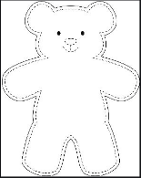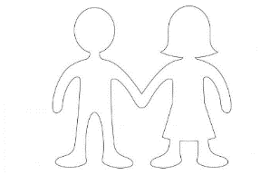  Task 3 –Make a friendship bracelet  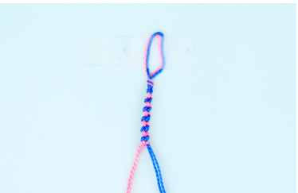  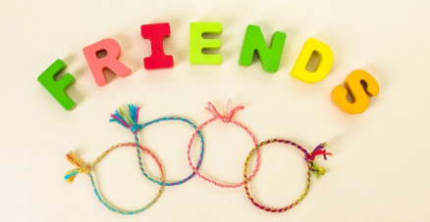 | Expressive Arts and Design  Make your Favourite Characters- Make a puppet of a famous story character. Use a toilet roll and draw, colour and stick other bits of material onto the tube to make your own character puppet. This can be a character from the Gruffalo or a character from another story written by a different famous author or you make like to paint your hand and make handprints and decorate to make your very own Gruffalo.  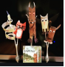  Understanding the World- Technology  Physical Development- Fine Motor Control  Play Snake -The Gruffalo features a snake. Click here to play snake - Use the arrows on the keyboard to move the snake around - count how many apples you can collect. Or, play a family game of Snakes and Ladders.  Expressive arts and Design- Music  Visit ‘The Gruffalo’ website. Listen to the Gruffalo song learn the ‘Monkey Puzzle’ song in makaton and dance along to the ‘Gruffalo’s Child’ song. There are also some great interactive games in the play and explore area. Colour your own Gruffalo using the paint game, create your own monster on monster maker and much more.  Understanding the World  Rose Mitchtom and Margarette Steife - Over 120 years ago two women came up with the idea to make a teddy bear. Collect all your teddy bears.  Are they all the same?  What do you think makes a good teddy bear?  If you were going to invent a new teddy bear what would it look like?  Can you find about any other significant or famous people? Did they invent something? What would you like to invent?  Wellbeing - try cosmic kids yoga Click on the link and choose from one of the videos.  Take some time to be quiet and still, listen to some calming music and think about your week. What has gone well? What has not gone so well?  .

Your own number rhyme sheet.

RE
Task 2
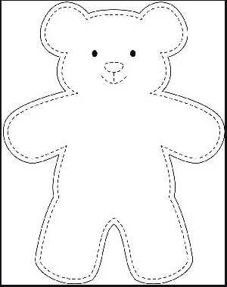

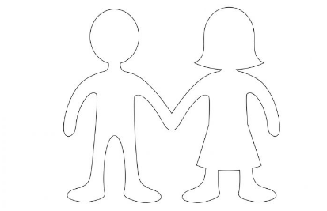

Inference Activity
What can you see in the picture?
Why is Zog waving to the little girl?
Do you think the little girl has helped Zog?
How do you think Zog is feeling? Why?
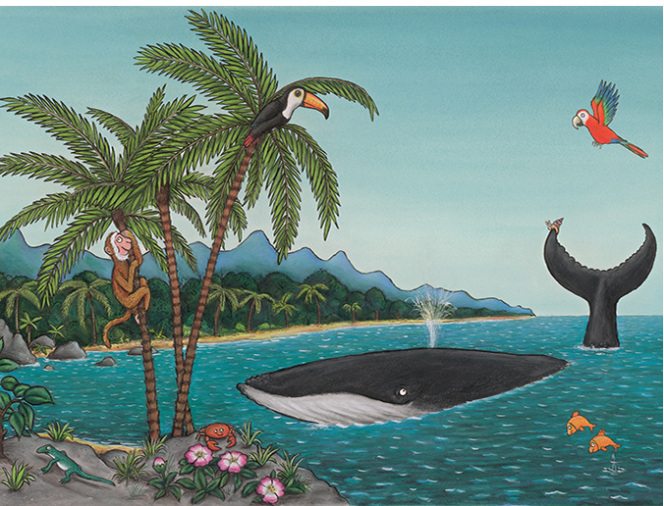
How is the little girl feeling? Why?
What animals and birds can you see in the picture?
Where is the snail going now?
How do you think the snail is feeling? Why?
Do you think the whale likes the snail hitching a ride?

Phonics
When revisiting the sounds with the children sing the song.
i.e when revisiting a sound.
An (insert the sound here) together make one sound.
What is it?
An (insert the sound here) together make one sound.
What is it?
It’s in (insert 4 words with the sound in here)
An (insert the sound here) together make one sound.
What is it?

If you need support with the song when recapping sounds with your child, please do not hesitate to get in contact with Mrs Gill via see-saw.

After singing the song ask the children which sound did we hear in each of the words. Repeat the words slowly if you need to. Then repeat the song again but where we sing what is it? The children say the sound the letters make together.

Resources for Phonics
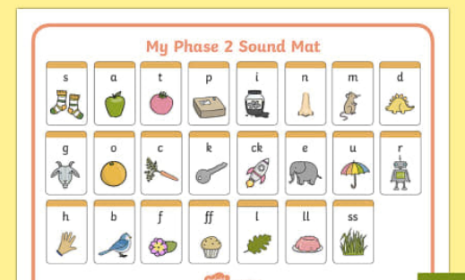
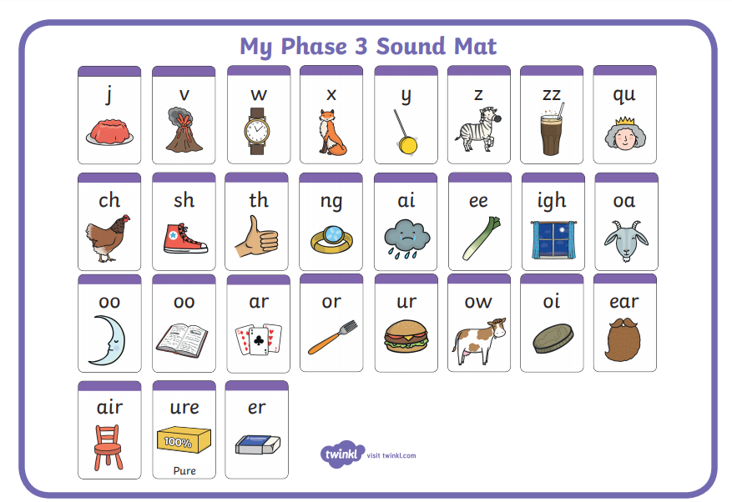

Phase 2, 3 and 4 tricky words for you to practise.
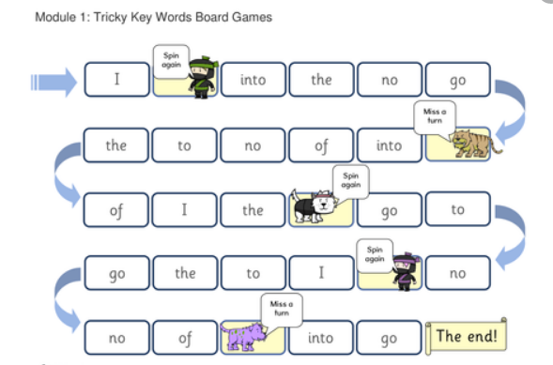

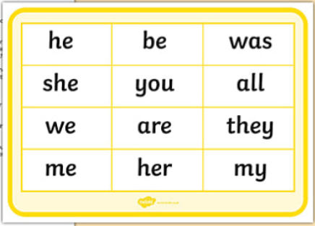
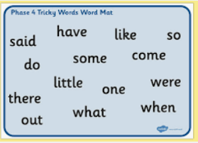
Phonics sentences
- Can I plan a trip to the moon?

- Help! Can you grab that green frog for me?

- Will a clown put on a green wig or stick with his brown hair?

- It smells like we might have some roast chicken tonight.

- Can we train a dragon to come and cook food for us?

- Will you come and have some roast bugs on toast for dinner?

