BLACKBIRDS WEEKLY SUGGESTED HOME LEARNING – WB 6.7.20
Hi Blackbirds! This week would have been the second week of the Wimbledon tennis tournament. Some of this week’s tasks this week are based on this. If you have any problems, please don’t hesitate to email or tweet school, I’m here to help!
Miss Cartwright, Mrs Jackson and Mrs Harrison XX
ENGLISH | MATHS
Reading – Read every day for pleasure for 20 minutes.  Your work this week is all based around Wimbledon as this was due to take place this week before Covid-19 postponed it.  Comprehension - The Wimbledon Championships Comprehension – see sheets below  Writing –  - Complete the Wimbledon News Report below (you may need to research tennis players to complete this)  - Choose a tennis player to research and create a biography all about them  - Complete the Wimbledon themed word search  - Write a list of questions that you would ask your favourite tennis player if you had the opportunity  Spellings – Year 3/4 Common Exception Words – learn the spellings below and put them into sentences. | Times tables 2,3,4,5,6,8,10  https://ttrockstars.com/  https://www.bbc.co.uk/teach/supermovers/  White Rose Home Learning – Year 3 – Summer Term - Week 9 - Angles and Lines  https://whiterosemaths.com/homelearning/year-3/  Use worksheets below and BBC Bitesize to support the videos  Watch lesson 1 then complete sheet 1.  Watch lesson 2 then complete sheet 2.  Watch lesson 3 then complete sheet 3.  Watch lesson 4 then complete sheet 4.
R.E. | OTHER
SPECIAL PLACES  RELATE.  On the map below(See sheet) are some places that were special to Jesus. It is possible today to visit many of these places in what Christians call the Holy Land. They can go there on a pilgrimage to find out more about what happened there and to experience that special place. Ask the children to find out what they can about the places on the map and what happened in the life of Jesus in each special place. When they have done this, they can play the matching activity(see sheet below). These are the scripture references that you can look up to find stories about Jesus’ special places:  Luke 2: 11 (Bethlehem)  Matthew 2: 23 (Nazareth)  Luke 2: 41, 46 (Jerusalem)  Mark 1: 9 (Baptism in the Jordan)  Matthew 5: 1−2 (Sermon on the mount) | Science – Habitats –  https://central.espresso.co.uk/espresso/modules/s2_habitats/video_pages/multivideo_hedgerow.html  Watch the video about the habitats of a pond and complete the activities.  Geography - Compare the place that you researched last week to Ashton. Make a list of all the similarities and differences that you can think of.  Music – Time for music Y3/4 Lesson 10  https://www.stoswaldswigan.co.uk/classes/fun-learning-games/music  Art- Complete the Wimbledon craft activities below

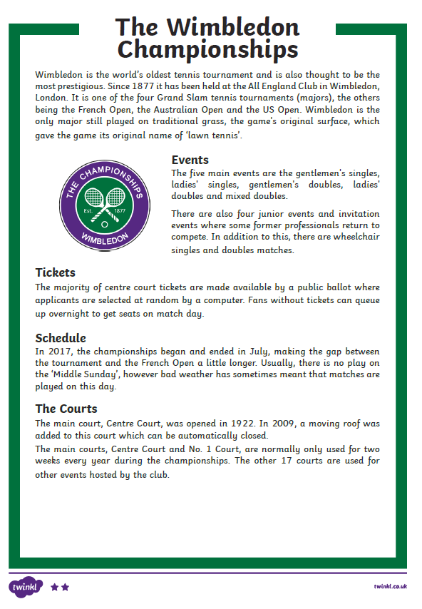
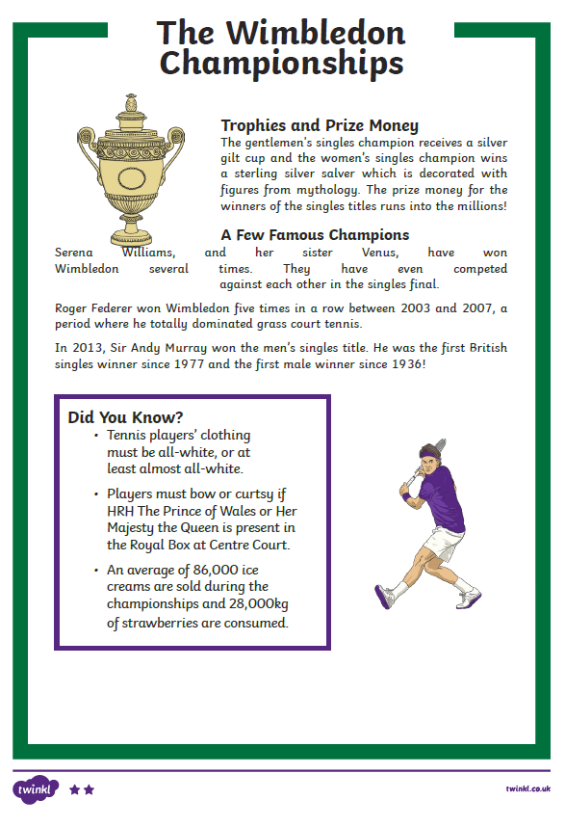
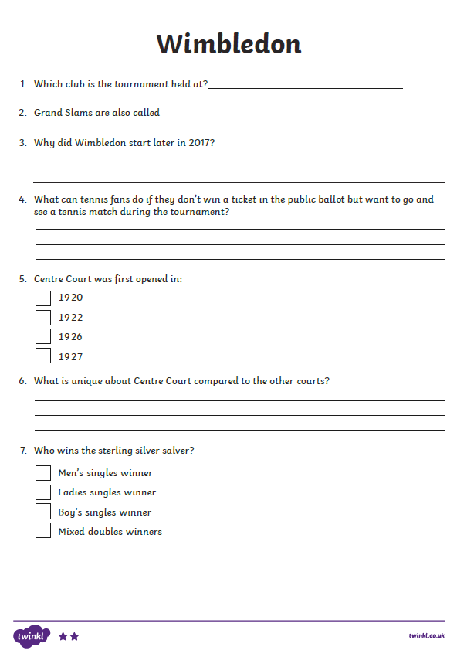
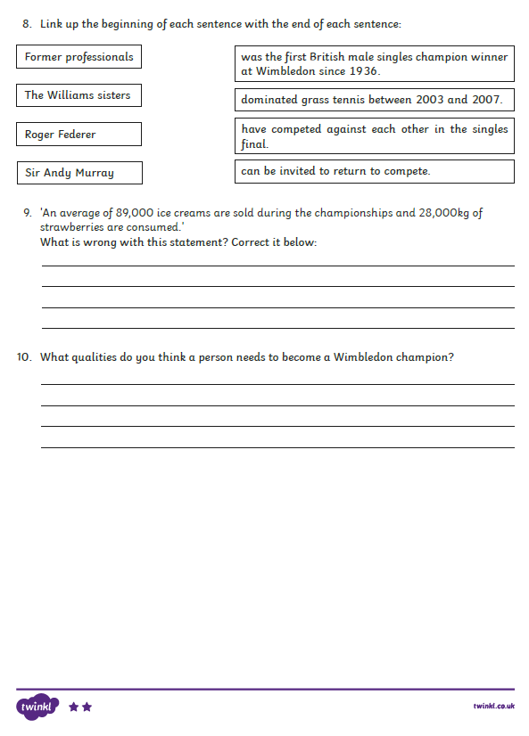
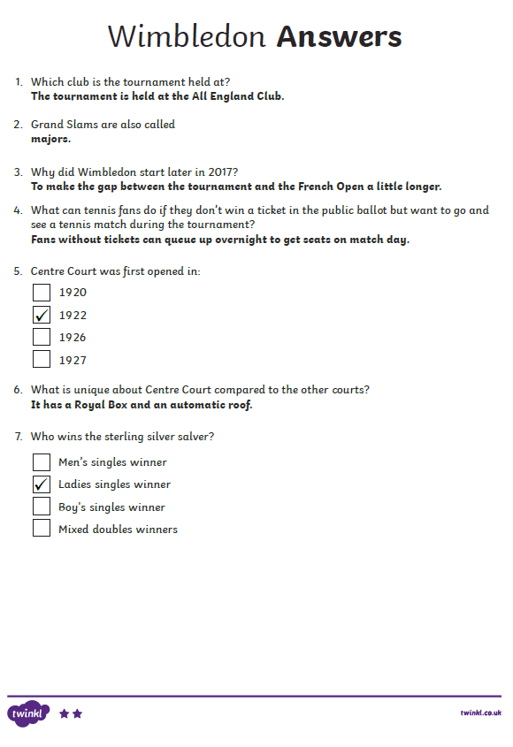
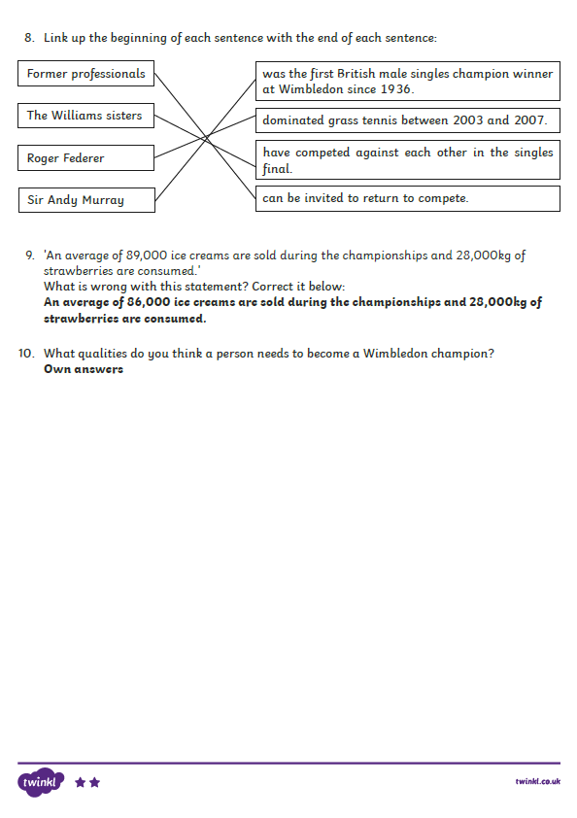
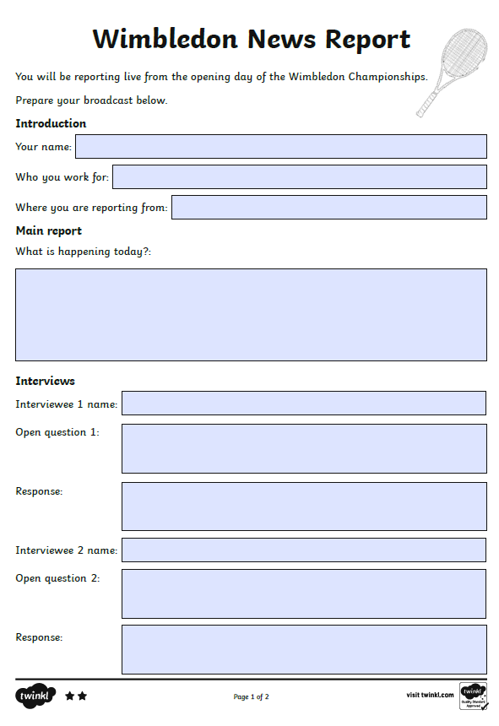
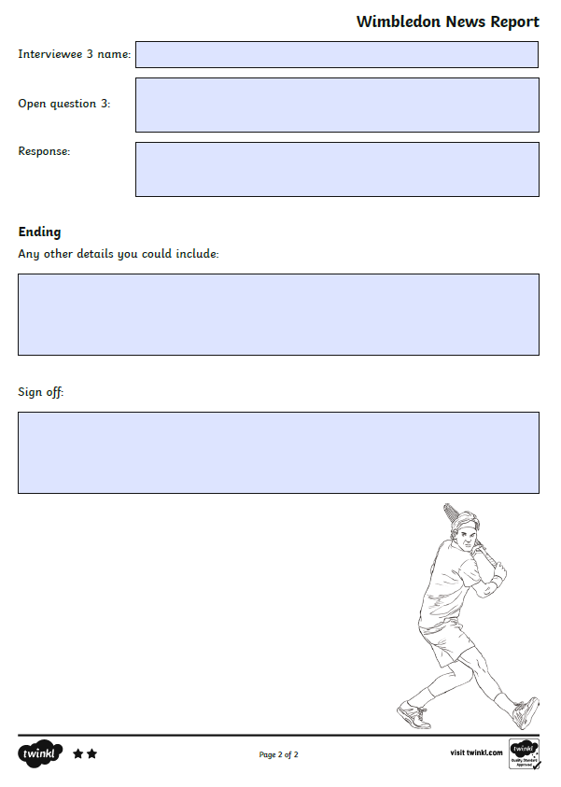
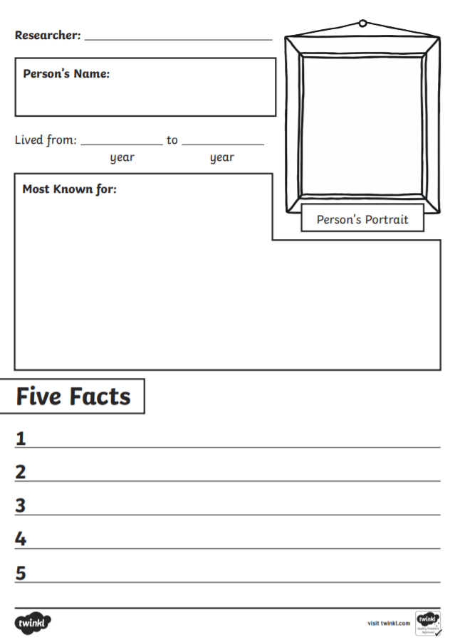
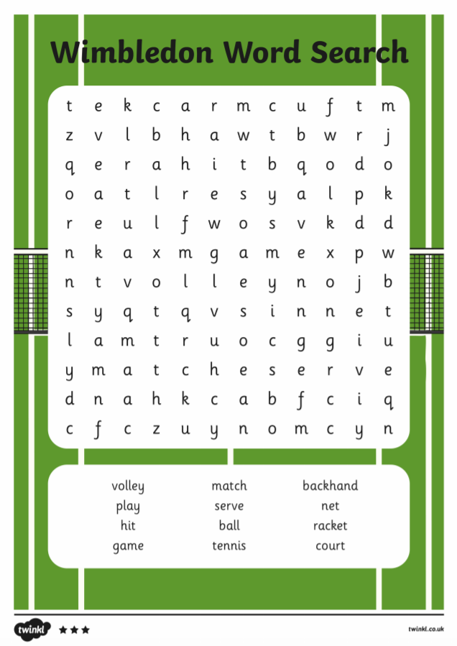
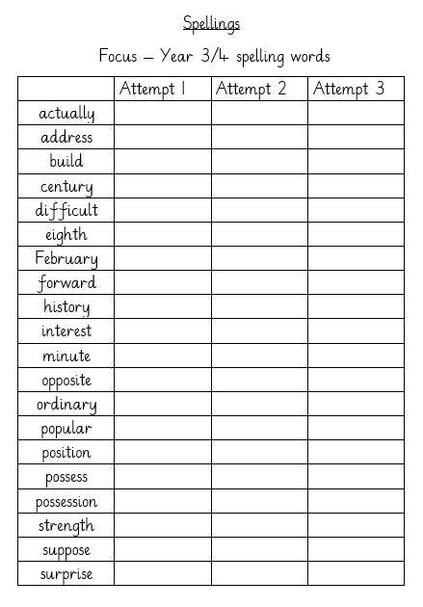
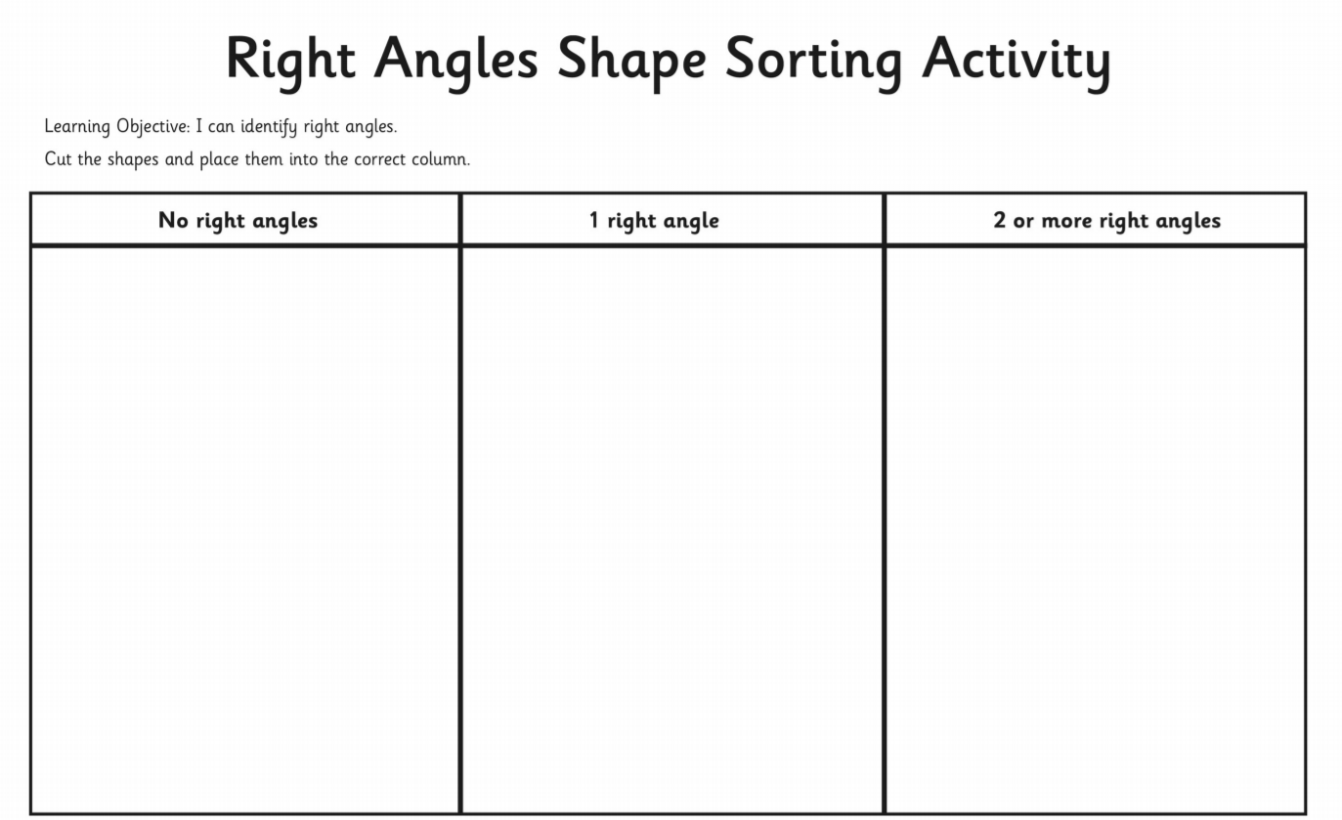
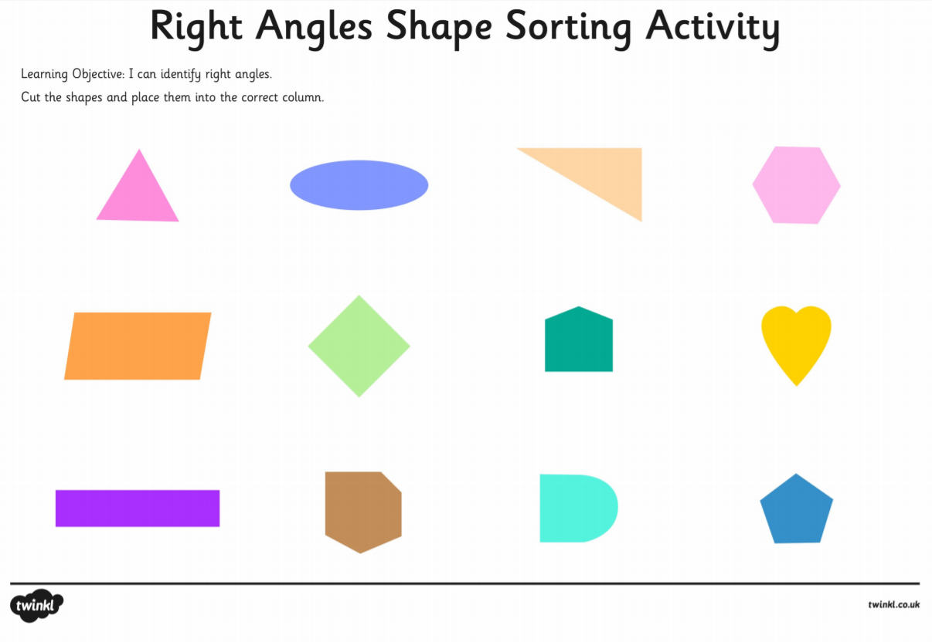
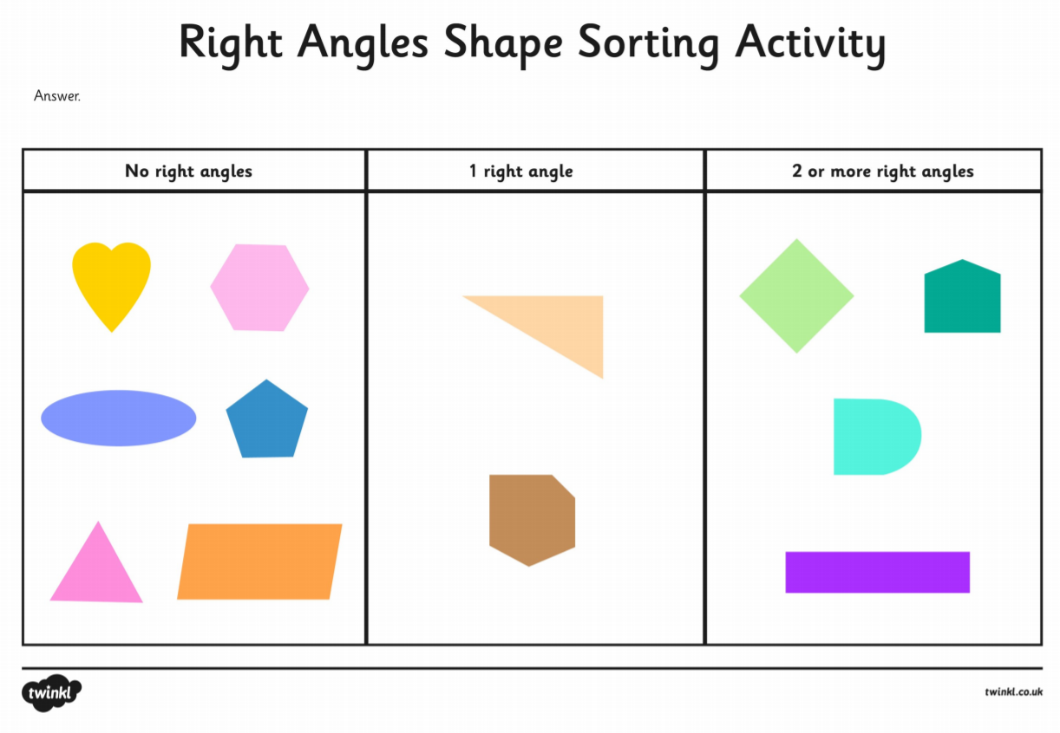

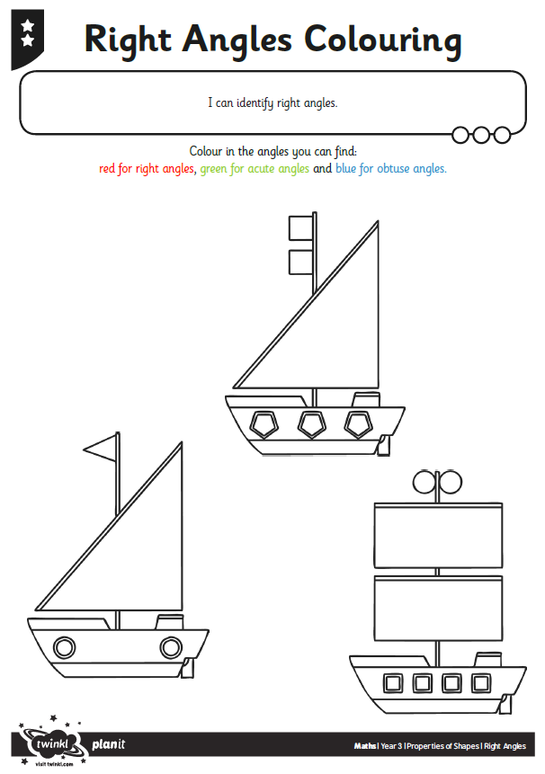
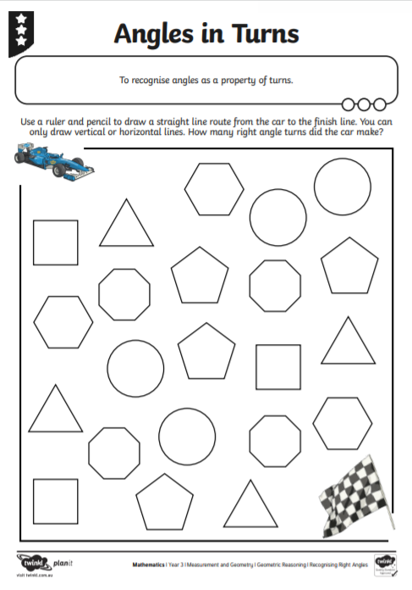
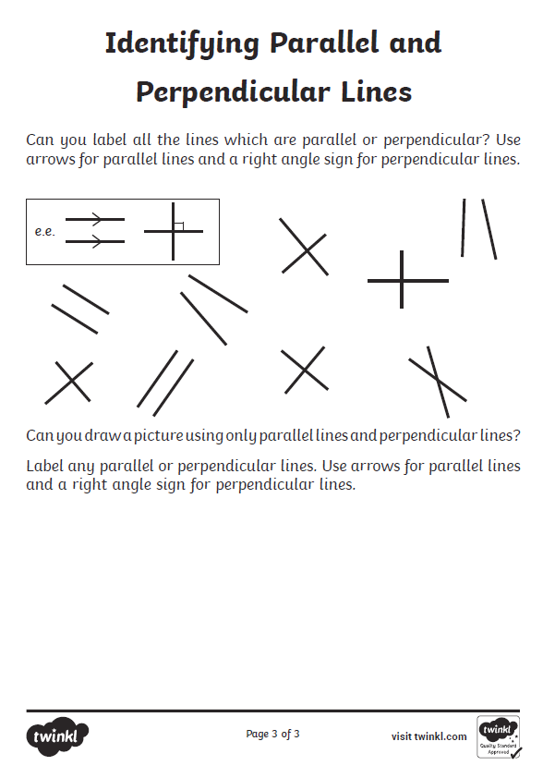

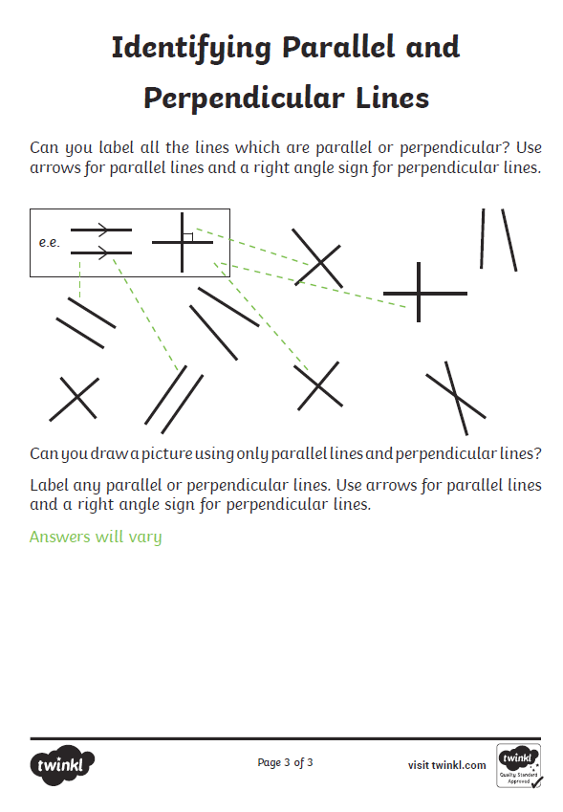

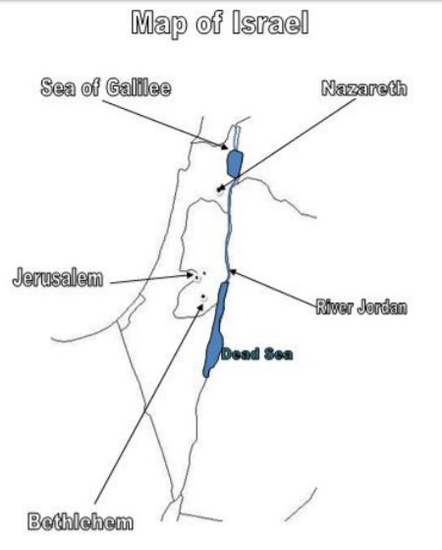

The children might write about which event happened at what place on the map and say why that place is so special to Jesus. They could then relate that to special places for them (e.g. the River Jordan is special to Jesus as he was baptised there. St. Mary’s Church is special to me because this is where I was baptised).
