OWLETS AND EAGLETS - WEEKLY SUGGESTED HOME LEARNING –
WB 06.07.2020

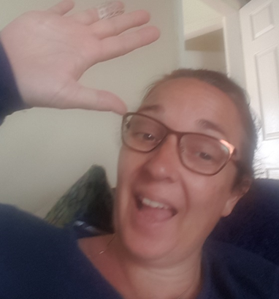

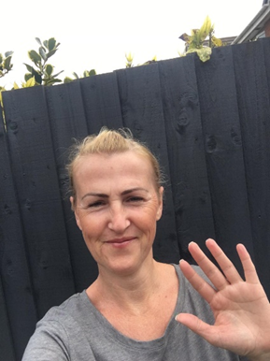
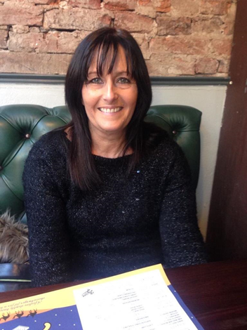

Hello again Owlets and Eaglets, we hope you are all well and still looking after yourselves. These are our suggested activities for you this week. We hope that you enjoy them. This week the focus is on Around the World. What can you find out about countries and cities around the world? What different cultures and traditions do they have? Can you find out about any famous landmarks, food or clothing? Please remember to share some pictures on See-Saw. It is lovely to see what you have been up to, thank you for keeping in contact with us, we miss you so much and it’s lovely to see your happy faces, showing us what you have been up to. Thank you for your ongoing support, enjoy your week of learning. School email – enquiries@saintoswalds.wigan.sch.uk Tweet - @saintoswalds

ENGLISH | MATHS
Reading – Read a variety of books at home. Favourite books can be repeated as it supports the children with their language development as they will hear the patterns of language in the story.  Use Oxford Owl to access books that are related to phase 2 and 3 phonics. Where possible children to read to parents daily.  When you go on click on all ages and click on age 4-5. Then go into levels and click on letters and sounds and choose either phase 2 or 3.(phase 2 will be a little easier and phase 3 more challenging) If you find that these are still not challenging for them then choose age 5-6, go into levels, letters and sounds and click on phase 4. This will then bring books up for you to access with your child.  After reading the book ask the questions on the back cover of the book and complete the play activities linked to the book.  Register here for free access to Oxford owl or you can use our class login  My class name – owlets and eaglets  My Class Password – reception.  Just go to the Oxford Owl login page and click on the My Class login button and use the above details.  Some extra literacy activities this week are taken from Robin Hood Multi Academy Trust. Focus this week is on Around the World.  Listen to stories from around the world - including: Handa's Surprise, and The Tiger’s Child  Choose one of the above stories to share again. Ask your child to retell the story in their own words once they are familiar.  Follow the story All Are Welcome Here with your child. Discuss how your child’ school makes everybody feel welcome.  Play memory games, ‘I went to the market, I bought… The next person repeats the above sentence remembering the items bought already and adding a new one to the list each time. Use fruits like in Handa’s Surprise.  Reception age children: Can your child find and practice reading the tricky words: from phase 2 and 3? See end of planning for key words.  Ask your child questions about the books that you have shared- Who are the main characters?  How are the characters feeling?  Who is your favourite character? Why?  What did you like/dislike about this story?  Ask your child to use pictures from a familiar story book to make up their own story or to retell their favourite story.  Writing task 1 –  Encourage your child to look at the food in your kitchen and find out what countries some of it comes from. Search on a map for those countries. Help your child to trace the letter with which the name of those countries start.  Writing task 2-  After listening to the story Handa’s Surprise, ask your child to name and draw different fruits that they know. Label them using describing words.  Writing task 3 –  Ask your child to play in role as Handa from Handa’s Surprise. Ask them questions and they must answer as Handa e.g. ‘Handa, what is your favourite fruit?’ They might answer by saying ‘My favourite fruit is tangerines. I was very excited to find lots of them’.  Writing task 4 –  Your child can draw a picture of a suitcase and all the things they might take on holiday. CHALLENGE: Ask your child to label the items.  Inference activity  See end of planning for larger pictures for this activity. Can I infer what is happening in the pictures?  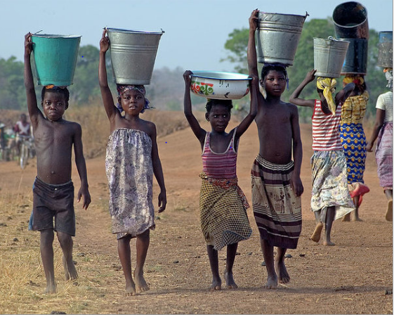  What can you see in the picture?  What are the children carrying?  Do you think it is hot or cold?  What can you see in the picture?  Who do you think has left it there?  What would you build with the toys?  Do you think the weather is hot or cold?  Phonics (Reading and writing)  Phase 4 phonics –  Please remember to use the free log in - Use the Username – march20 and the password – home If you wish to complete a spelling test use a mixture of the key words you have looked at with the children from phase 2, 3 and 4. Only look at up to 8 words choose from these words – the, I no, go, to, into, he, we, me, be, she, they, was, my, all, you, her, are, . Or use the words covered in this weeks phase 4 planning. Phase 4 phonics – Start your phonics session by playing the flashcard games on phonics play for key words and sounds for either phase 2 or phase 3. Help your children to read the following words – steep, tree, trail, train, smeep, gree, prail, frain. Once they have practised reading them, can they have a go at writing them? Segment the words slowly so that the children can hear each sound.  Write a two syllable word for your child making a slash between the two syllables e.g. lunch/box. Sound talk the first syllable and blend it l-u-n-ch lunch. Sound talk the second syllable b-o-x box. Say both syllables lunchbox. Repeat and ask the children to join in. Repeat with the words: helpdesk, windmill, treetop, starlight, lunchbox, desktop, sandwich, sandpit. You could also use these words to for a spelling test if you wish to.  These are some of the phase 4 tricky words we would like you to introduce – recap so, do, some, come, said and said introduce they- ‘’ Write the tricky words on paper show them your child and help them to read them. Write out two lots of each word and play a pairs game. Who will find the most pairs? Help your child to read the sentences we have written at the bottom of the planning which are appropriate for phase 4. | Mathematics  Watch number blocks clip each day with your child at  Numberblocks BBCiplayer or Numberblocks Cbeebies  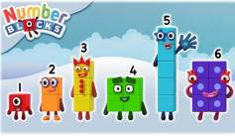  Activity – Practice number formation with you children. Here are the rhymes that we use in the classroom to help your child remember how to write the numbers.  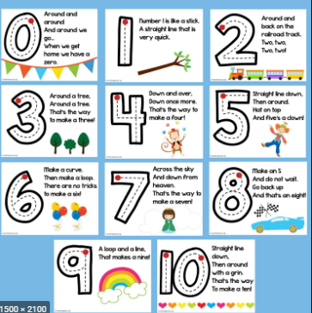  Follow the White Rose Week 8 using the story Oliver’s Vegetables– patterns, positional language, addition and subtraction- adding more, taking away, counting and doubling.  You may also want to look on Oak National Academy. The 5 lessons this week are on measures. Reception Click on the link below to access 5 lessons on measure. This includes describes capacities of objects, compare volumes of liquids, estimate lengths of objects, compare weights of objects and measure objects. Click the link to take you to all the maths activities on Oak National Academy Measures. Please scroll down to the bottom of the link to find the 5 lessons.  Practise counting up to 20. This can be done through playing hide and seek, singing number songs, chanting, board games etc. Remember to also practise counting back from 20 to 0.  If you wish to do some more activities taken from Robin Hood Multi academy trust learning projects. These are on Take Away.  Watch this video to support counting back from 10. CHALLENGE: Ask your child to start at 10 and take away 1. Repeat this until they get to zero. Do they recognise the amount is getting smaller?  Generate your own subtraction number stories. Use real life objects at home to show this e.g. ‘I have 4 bananas. I eat one. How many are left?  Use a teddy and count backwards making deliberate mistakes. Can your child spot the mistakes? Mistakes can include omitted numbers, repeated numbers or a number in the wrong place. CHALLENGE: Ask your child to spot the mistake when the numbers are written down.  Look at these pictures of flags from around the world with your child. Can they spot any shapes in the flags and can they name them?  Use the tens frames (here) to subtract/take away numbers. CHALLENGE: Ask your child to write the accompanying number sentence e.g. 10-1= 9.
R.E. | OTHER
The theme is: Universal Church – Our World  This is the second week on the Our World topic. The activities are taken from the CAFOD website. This week it is a time for your child to think about how everyone shares in God’s world.  Task 1- Explain to the children that God created the world. Share God’s Story 1, pages 4−5. And God said, “Indeed it is very good!” (Larger image at the bottom)  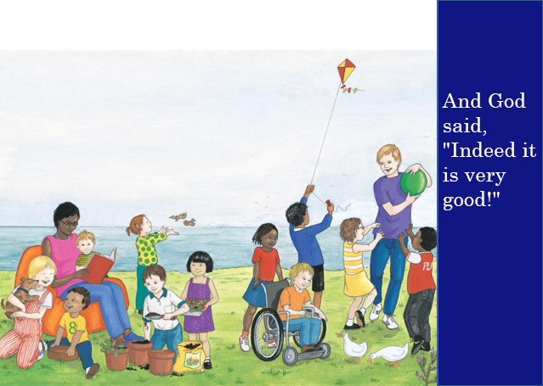  Ask your child these questions:  What is good?  Why do you think God said this?  Why do you think the world is very good?  What could we do to make it even better?  Task 2-Share this photo (larger image at the bottom of the page) and ask your child these questions:  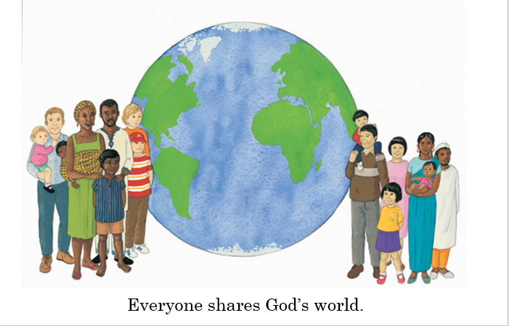  Can you tell me what this means?  What could we do to help each other to share God’s world?  Task 3 – Discuss basic concept of Fairtrade (people gaining a fair price for their produce so that they have enough to feed themselves and their families). Show your child the Fair trade symbol, Can they find any products in your home with this symbol on? (Larger image at the bottom)  Task 4- Ask your child to paint, draw or make a collage of the wonderful things in God’s world.  CAFOD also have Kidz-Zone area (click on the link). Here you will find more information about the work of CAFOD, online games, things to do and children’s prayers. Click on the link then scroll down below the world map. | Understanding the World  - Look at flags from around the world. Discuss which are your child’s favourites and why? Ask your child to design and make their own flag using 2d shapes.  Expressive Arts and Design  Make your own Handa’s Surprise character puppet.  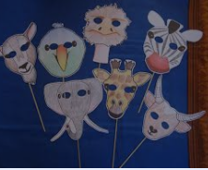  Understanding the World  Look at this photography project of children with their toys from around the world. Discuss how life is the same and how life is different in other countries. Can your child draw their favourite toy and write a sentence explaining why this is their favourite  Understanding the World-  Engineering Around the World – Bridges  A bridge helps people move over obstacles like a river, a valley or a busy road. The world’s longest bridge is in China and is 164.8km long. It would take more than two days to walk the length of this bridge. Do you have any bridges near your home? What do they look like?  Try building a bridge out of paper, Lego or any other building materials you might have at home. Your bridge needs to be big enough for a toy car or small toy to travel over.  Wellbeing - try cosmic kids yoga Click on the link and choose from one of the videos.  Take some time to be quiet and still, listen to some calming music and think about your week. What has gone well? What has not gone so well?  .

Your own number rhyme sheet.

RE

Task 3

Inference Activity
What can you see in the picture?
What can you see in the picture?
What are the children carrying?
Do you think it is hot or cold?
What can you see in the picture?
Who do you think has left it there?
What would you build with the toys?
Do you think the weather is hot or cold?

Phonics
When revisiting the sounds with the children sing the song.
i.e when revisiting a sound.
An (insert the sound here) together make one sound.
What is it?
An (insert the sound here) together make one sound.
What is it?
It’s in (insert 4 words with the sound in here)
An (insert the sound here) together make one sound.
What is it?

If you need support with the song when recapping sounds with your child, please do not hesitate to get in contact with Mrs Gill via see-saw.

After singing the song ask the children which sound did we hear in each of the words. Repeat the words slowly if you need to. Then repeat the song again but where we sing what is it? The children say the sound the letters make together.

Resources for Phonics
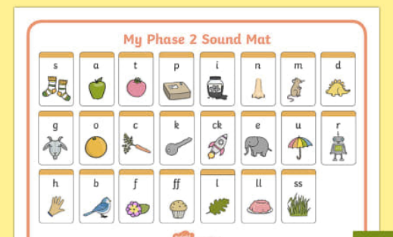
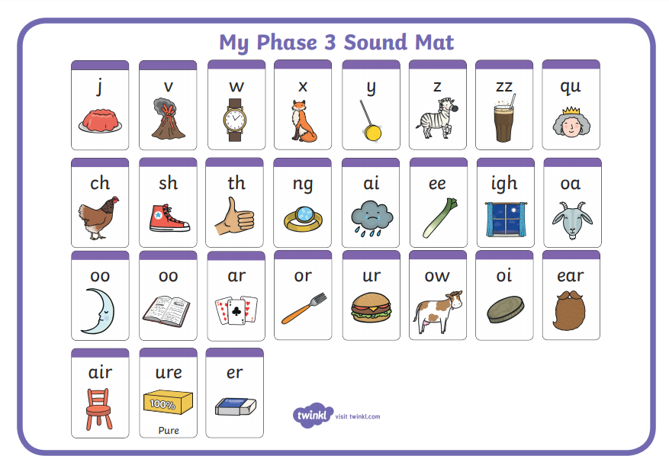

Phase 2, 3 and 4 tricky words for you to practise.
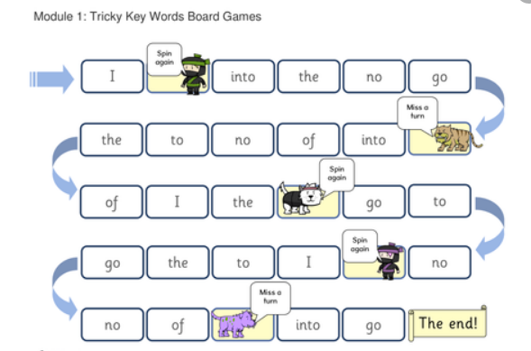

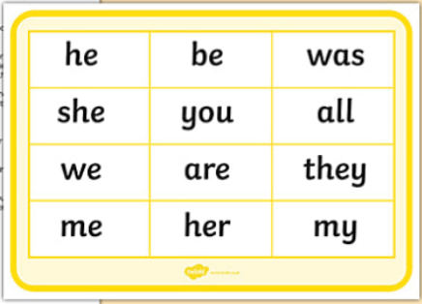
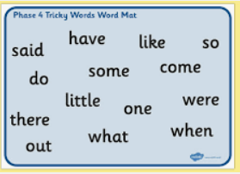
Phonics sentences
- Were there some chimps at the zoo?

- Yuck! There was a paint brush in the coffee cup.

- One little brown toad got stuck down a drain.

- You put a shampoo sandwich in my lunchbox.

- Ring the helpdesk and tell them my cat is stuck.

- I stuck a little windmill in this sandpit.

- Can lightning hit a windmill?

- The chimpanzee did a handstand.

- This frog is chomping on pondweed.

- They all had a sandwich and some crisps for a snack.

- The windmills are all near the farm.

- They are all jumping for joy.

